**Source code:**

class Welcome

{

public static void main(String args[])

{

System.out.println("WELCOME JAVA");

}

}

**Output:**

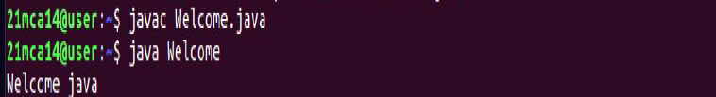

**Source code:**

class Rectangle

{

double length, breadth;

void setdata(double l,double b)

{

length = l;

breadth = b;

}

double getArea()

{

return length*breadth;

}

}

class findArea

{

public static void main(String args[])

{

Rectangle r = new Rectangle();

r.setdata(12.48,13);

System.out.println("Area of Rectangle: "+ r.getArea());

}

}

**Output:**

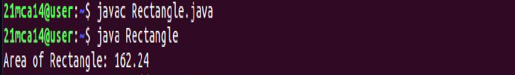

**Source Code:**

import java.util.Scanner;

class OddEven

{

public static void main(String args[])

{

Scanner sc=new Scanner(System.in);

System.out.println("Enter the number:");

int num = sc.nextInt();

if(num%2==0)

{

System.out.println(num + " is a Even number");

}

else

{

System.out.println( num + " is an Odd ");

}

}

}

**Output:**

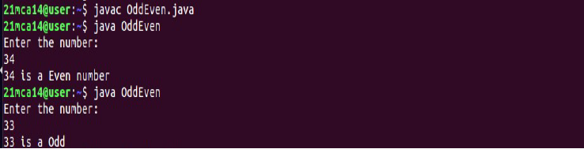

**Source Code:**

import java.util.Scanner;

class Product

{String pcode, pname;

int price;

Product(String pcode_get, String pname_get, int price_get)

{

pcode = pcode_get; pname = pname_get; this.price = price_get;

}

void compare(Product b,Product c)

{

if(price<=b.price && price<=c.price)

System.out.println("Lowest price of product is "+pname+" and price is "+pcode);

if(b.price<=c.price && b.price<=price)

System.out.println("Lowest price of product is "+b.pname+" and price is "+b.pcode);

if(c.price<=price && c.price<=price)

System.out.println("Lowest price of product is "+c.pname+" and price is "+c.pcode);

}

}

class Productdet

{

public static void main(String args[])

{

Product p_1=new Product("A123","Radio",887);

Product p_2=new Product("B123","Cooler",587);

Product p_3=new Product("C123","TV",1000);

p_1.compare(p_2,p_3);

}

}

**Output:**

**Source Code:**

import java.util.Scanner;

class MatrixAdd

{

public static void main(String args[])

{

int i,j,rows,cols;

Scanner n=new Scanner(System.in);

System.out.println("Enter the no of rows: ");

rows=n.nextInt();

System.out.println("Enter the no of cols: ");

cols=n.nextInt();

int A[][]= new int[rows][cols];

int B[][]=new int[rows][cols];

System.out.println("Enter the elements of Matrix A: ");

for(i=0;i<rows;i++)

{

for(j=0;j<cols;j++)

{

A[i][j]=n.nextInt();

}

}

System.out.println("Enter the elements of Matrix B: ");

for(i=0;i<rows;i++)

{

for(j=0;j<cols;j++)

{

B[i][j]=n.nextInt();

}

}

int C[][]=new int[rows][cols];

System.out.println(" The sum of Matrix A and B: ");

for(i=0;i<rows;i++)

{

for(j=0;j<cols;j++)

{

C[i][j]=A[i][j]+B[i][j];

System.out.print(C[i][j]+" ");

}

System.out.println();

}

}

}

**Output:**

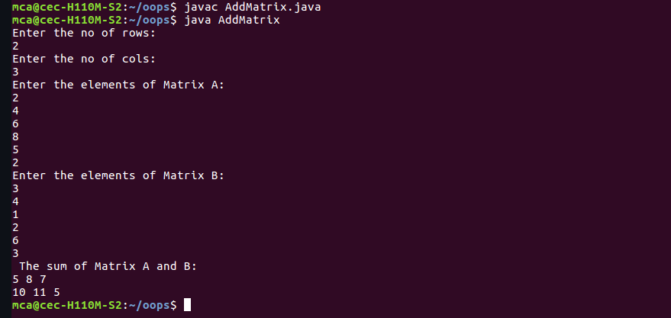

**Source Code:**

import java.util.Scanner;

public class Complex {

double real;

double imag;

public Complex(double real, double imag) {

this.real = real;

this.imag = imag;

}

public static void main(String[] args) {

Scanner s = new Scanner(System.in);

System.out.println("Enter the 1st complex no: ");

double a1 = s.nextDouble();

double b1 = s.nextDouble();

System.out.println("Enter the 2nd complex no: ");

double a2 = s.nextDouble();

double b2 = s.nextDouble();

Complex n1 = new Complex(a1, b1),

n2 = new Complex(a2, b2),

temp;

temp = add(n1, n2);

System.out.printf("Sum = "+temp.real+" + "+temp.imag+"i ");

}

public static Complex add(Complex n1, Complex n2)

{

Complex temp = new Complex(0.0, 0.0);

temp.real = n1.real + n2.real;

temp.imag = n1.imag + n2.imag;

return(temp);

}

}

**Output:**

**Source Code:**

import java.util.Scanner;

class Matrix

{

public static void main(String args[])

{

int i,j,rows,cols,f=0;

Scanner n=new Scanner(System.in);

System.out.println("Enter the no of rows: ");

rows=n.nextInt();

System.out.println("Enter the no of cols: ");

cols=n.nextInt();

if(rows!=cols)

System.out.print(" Not symmetric");

else

{

int num[][]= new int[rows][cols];

System.out.println("Enter the elements of Matrix: ");

for(i=0;i<rows;i++)

{

for(j=0;j<cols;j++)

{

num[i][j]=n.nextInt();

}

}

for(i=0;i<rows;i++)

{

for(j=0;j<cols;j++)

{

if(num[i][j]!=num[j][i])

{

f=1;

break;

}

}

}

if(f==1)

System.out.println("Not Symmetric");

else

System.out.print(" Symmetric");

}

}

}

**Output:**

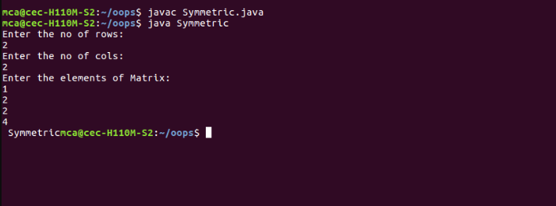

**Source Code:**

import java.util.Scanner;

class Leapyr

{

public static void main(String args[])

{

Scanner sc=new Scanner(System.in);

int start,end;

System.out.println("Enter the begining year: ");

start = sc.nextInt();

System.out.println("Enter the end year: ");

end = sc.nextInt();

System.out.println("Leap years: ");

for(int i=start;i<=end;i++)

{

if(i%4==0||(i%100!=0)&&(i%400==0))

System.out.println(i);

}

}

}

**Output:**

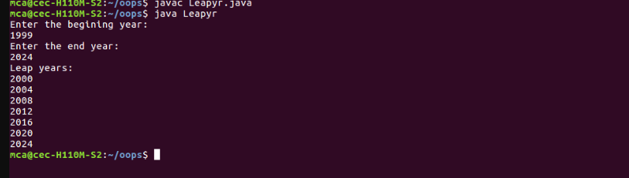

**Source Code:**

import java.util.Scanner;

class Test

{

public static void main(String args[])

{

CPU o1 = new CPU();

o1.display1();

CPU.RAM o3 = new CPU.RAM();

o3.set();

o3.display();

}

}

class CPU

{ int price;

Scanner kb = new Scanner(System.in);

void display1()

{

Processor o2 =new Processor();

o2.read();

o2.display2();

}

class Processor

{ int ncores;

String manft;

void read()

{System.out.println("Enter the price of CPU ");

price = kb.nextInt();

System.out.println("Enter the no: of cores ");

ncores = kb.nextInt();

System.out.println("Enter the name of CPU manufacturer ");

manft = kb.next();

}

void display2()

{

System.out.println("Manufacturer: " +manft);

System.out.println("Number of cores: " +ncores);

System.out.println("Price: " +price);

}

}

public static class RAM

{

Scanner kb = new Scanner(System.in);

String manf;

int mm;

void set()

{

System.out.println("Enter the memory size ");

mm = kb.nextInt();

System.out.println("Enter the name of manufacturer ");

manf = kb.next();

}

void display()

{ System.out.println("Memory Size " +mm+"GB");

System.out.println("Memory manufacturer " +manf);

}

}

}

**Output:**

