ONLINE COMPLAINT REGISTRATION
Full Stack Development Documentation
ResolveHub — Complaint Management System
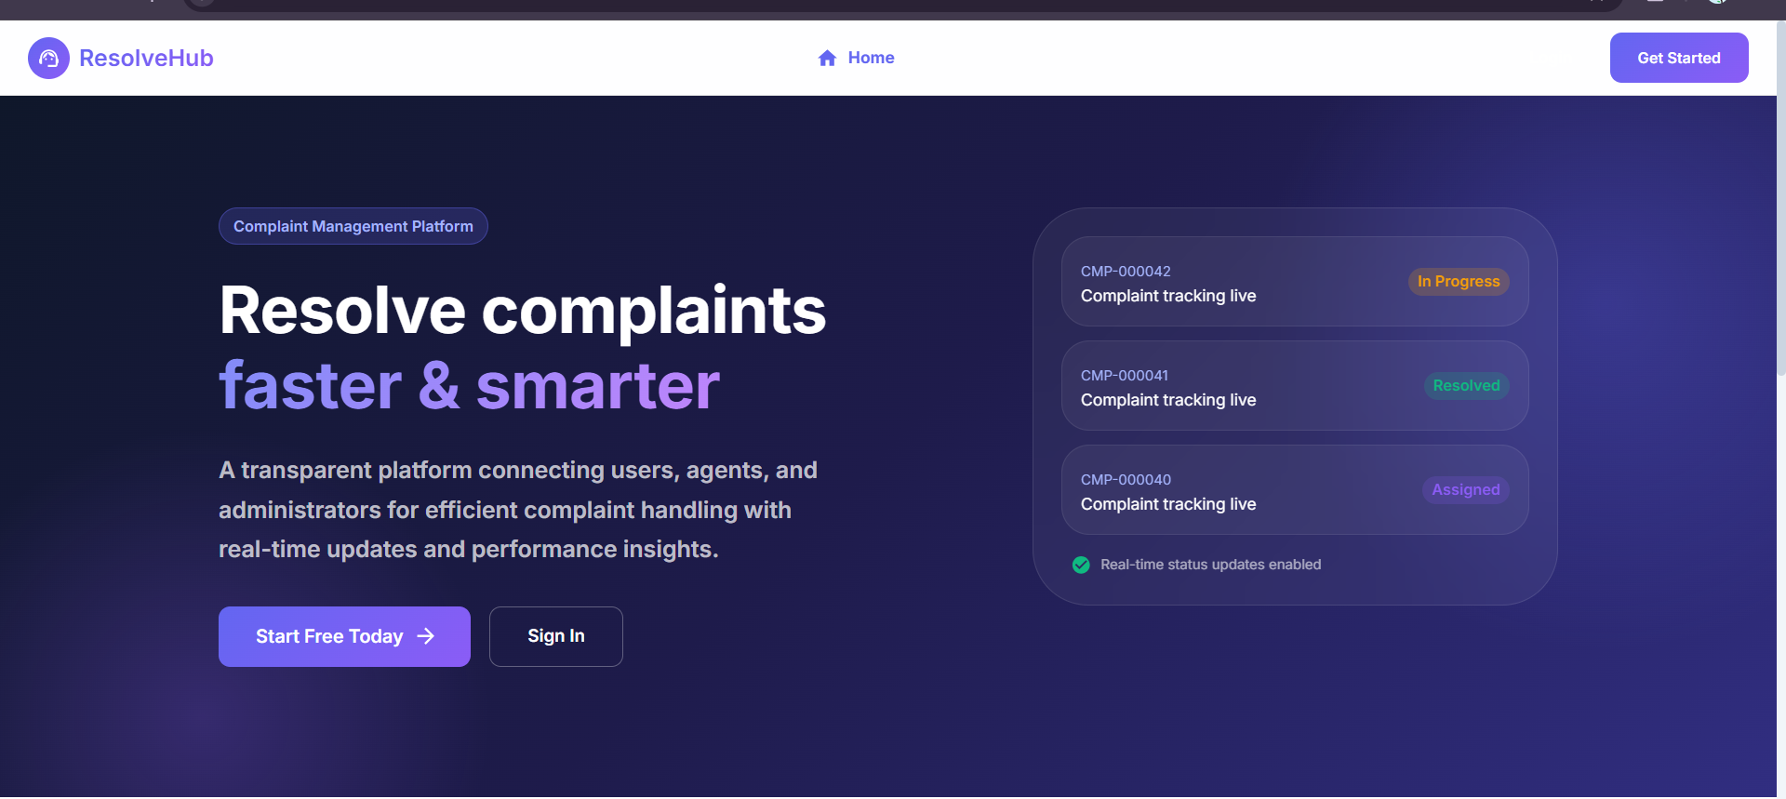

Team Members:
Lakshmi Prasanna Kolli | Poojitha Kopparthi
Technology Stack: MongoDB • Express.js • React.js (Vite) • Node.js
Date: 6 July 2026 | Version: 1.0

1. Introduction
This document describes the full stack development of ResolveHub, a web-based complaint management system built using the MERN stack (MongoDB, Express.js, React.js with Vite, and Node.js). The system was developed as part of an academic project to solve the real-world problem of unorganized, hard-to-track complaint handling faced by both customers and businesses.
ResolveHub enables three distinct roles — Users, Agents, and Administrators — each with their own dashboard and set of responsibilities, creating a transparent end-to-end complaint resolution workflow.

Field | Details
Project Title | Online Complaint Registration (ResolveHub)
Team Members | Lakshmi Prasanna Kolli, Poojitha Kopparthi
Technology Stack | MongoDB, Express.js, React.js (Vite), Node.js (MERN)
Submission Date | 6 July 2026
Version | 1.0

2. Project Overview
The core problem this project addresses is that customers who raise complaints with a company typically have no way to know what is happening with their issue, no direct communication channel with the person handling it, and no means of giving feedback on the outcome. On the other side, support agents and administrators work without a structured system, relying on emails or spreadsheets that make it difficult to prioritize, assign, and track complaints efficiently.
ResolveHub solves this by providing a single platform where users can submit complaints and track them in real time, agents can manage and resolve their assigned cases, and administrators can oversee the entire system and measure service quality through analytics.
Features Implemented
- User registration and login with JWT-based authentication and bcryptjs password hashing
- Three role-specific dashboards: User (My Dashboard), Agent (Agent Dashboard), Admin (Admin Dashboard)
- Complaint submission with title, description, category, and priority fields
- Full complaint status lifecycle: Submitted → Assigned → In Progress → Resolved → Closed
- Real-time chat between a User and their assigned Agent using Socket.io WebSockets
- Feedback and star-rating system (1–5 stars) after a complaint is resolved
- Admin analytics dashboard with a status distribution donut chart and a complaints-by-category bar chart
- Secure HTTP headers using Helmet.js; CORS restricted to the known frontend origin
- Email notification infrastructure using Nodemailer (integrated in the codebase and available for future use — see Section 13)

3. System Architecture
ResolveHub follows a three-tier architecture with a clear separation between the presentation layer (React frontend), the application layer (Express backend), and the data layer (MongoDB).
Frontend
The frontend is a single-page application (SPA) built with React.js 18 using Vite as the build and development server. Material UI (MUI) provides the component library. Navigation is handled by React Router v6 with role-protected routes that redirect unauthorized users automatically. Axios is used for all HTTP calls, with a request interceptor that attaches the JWT bearer token to every request. Global state for the logged-in user and complaints is managed through React Context API rather than a third-party library, keeping the dependency footprint light.
Backend
The backend is a Node.js server running Express.js and follows an MVC (Model-View-Controller) architecture. Routes are kept thin — they validate inputs and call the appropriate controller. Controllers contain all business logic. A Socket.io server runs alongside the Express HTTP server on the same port, authenticated via the same JWT middleware. Morgan logs every incoming request in the console during development. Helmet.js sets secure HTTP response headers on every response.
Database
MongoDB is used as the primary database through the Mongoose ODM. The schema design uses document references (ref) rather than embedding to keep documents small and allow efficient population queries. The five collections are described in the table below.

Collection | Purpose | Key Fields
Users | All accounts across all roles | name, email, password (hashed), role, phone
Complaints | Core complaint records and lifecycle | title, description, category, priority, status, user (ref), assignedAgent (ref), resolutionNotes, resolvedAt
Agents | Agent profile linked to a User | user (ref), department, assignedComplaints[ ], resolvedCount
Feedback | Post-resolution ratings | complaint (ref), user (ref), agent (ref), rating, comment
Messages | Chat messages per complaint | complaint (ref), sender (ref), message, createdAt

4. Setup Instructions
Prerequisites
- Node.js v18 or above — download from https://nodejs.org
- MongoDB Community Server (local installation) — https://www.mongodb.com/try/download/community
- npm (comes bundled with Node.js)
- Git — https://git-scm.com
Installation Steps
Step 1 — Clone or download the project and open the project-cursor folder in VS Code.
Step 2 — Install backend dependencies. Open a terminal and run:
cd backend
npm install
Step 3 — Create the backend environment file. Copy .env.example to .env and fill in the values:
PORT=5000
MONGODB_URI=mongodb://127.0.0.1:27017/resolvehub
JWT_SECRET=your_secret_key
JWT_EXPIRE=7d
CLIENT_URL=http://localhost:5173
NODE_ENV=development
Step 4 — Seed the database with sample data and demo accounts:
npm run seed
This creates the following login credentials for testing:
  - Admin: admin@resolvehub.com / Rh!Admin2026Secure
  - Agent: agent@resolvehub.com / Rh!Agent2026Secure
  - User: user@resolvehub.com / Rh!User2026Secure
Step 5 — Install frontend dependencies. Open a second terminal and run:
cd frontend
npm install

5. Folder Structure
Backend
backend/
server.js Express + Socket.io entry point
config/db.js MongoDB connection
controllers/ Business logic (auth, complaint, message, feedback, admin)
middleware/ JWT auth, role authorization, error handler
models/ Mongoose schemas (User, Complaint, Agent, Feedback, Message)
routes/ Express route definitions
utils/email.js Nodemailer email utility (see Section 13)
utils/seed.js Database seeder script
Frontend
frontend/
index.html Vite entry HTML
vite.config.js Vite configuration
src/
main.jsx React entry point
App.jsx Router and layout wrapper
context/ AuthContext, ComplaintContext
pages/ HomePage, LoginPage, RegisterPage,
UserDashboard, AgentDashboard,
AdminDashboard, ComplaintDetails, FeedbackPage
components/ Navbar, ComplaintCard, ChatBox, StatsCard,
StatusChip, ProtectedRoute
services/api.js Axios instance with auth interceptor

6. Running the Application
Two terminals need to be kept open simultaneously — one for the backend and one for the frontend.
Backend
cd backend
npm run dev
The terminal should show: Server running on port 5000 and MongoDB Connected: 127.0.0.1
Frontend
cd frontend
npm run dev
Open http://localhost:5173 in a browser. The Vite dev server will print the URL to the terminal when ready.

7. API Documentation
All endpoints are prefixed with /api. Every protected endpoint requires the HTTP header: Authorization: Bearer <token>. The token is obtained from the login or register response.
Authentication ( /api/auth )
Method | Endpoint | Auth Required | Description
POST | /api/auth/register | None | Register a new user or agent account
POST | /api/auth/login | None | Login and receive a signed JWT
GET | /api/auth/me | JWT | Return the currently logged-in user

Complaints ( /api/complaints )
Method | Endpoint | Auth Required | Description
POST | /api/complaints | USER | Submit a new complaint
GET | /api/complaints | JWT | Get complaints filtered by role (own / assigned / all)
GET | /api/complaints/:id | JWT | Get full details of a single complaint
PUT | /api/complaints/:id/status | AGENT or ADMIN | Update complaint status and resolution note
PUT | /api/complaints/:id/assign | ADMIN | Assign an agent to a complaint

Messages ( /api/messages )
Method | Endpoint | Auth Required | Description
POST | /api/messages | JWT | Send a chat message on a complaint
GET | /api/messages/:complaintId | JWT | Retrieve all messages for a complaint

Feedback ( /api/feedback )
Method | Endpoint | Auth Required | Description
POST | /api/feedback | USER | Submit a star rating and comment after resolution
GET | /api/feedback/agent/:agentId | ADMIN or AGENT | Get all feedback for a specific agent

Admin ( /api/admin )
Method | Endpoint | Auth Required | Description
GET | /api/admin/stats | ADMIN | System-wide stats: users, complaints, satisfaction score
GET | /api/admin/users | ADMIN | List all users with optional role filter
PUT | /api/admin/users/:id/role | ADMIN | Change a user's role

8. Authentication and Security
Authentication is handled using JSON Web Tokens (JWT). The system is entirely stateless — no server-side sessions are maintained, which means the API can scale horizontally without any shared session store.
When a user registers, their password is hashed using bcryptjs with a salt factor of 10 before it is saved to MongoDB. The plain-text password is never stored. On login, the submitted password is compared against the stored hash. If they match, the server signs a JWT containing the user's id and role, with an expiry of 7 days. This token is returned to the client and stored in React Context (in memory), then attached to every API request via an Axios interceptor.
Every protected route passes through two middleware functions. The first (protect) extracts the bearer token from the Authorization header, verifies its signature, and attaches the decoded user to the request object. The second (authorize) checks that the user's role matches the roles permitted for that specific route, returning an HTTP 403 if not. Helmet.js is applied globally and sets secure HTTP response headers on every request.

Role | Capabilities
USER | Register, log in, submit complaints, view own complaints, chat with assigned agent, submit feedback after resolution
AGENT | Log in, view only assigned complaints, update complaint status and add resolution notes, chat with users
ADMIN | All user and agent capabilities, plus: view all complaints, assign agents, access analytics dashboard, manage user roles

9. User Interface
Home Page
The landing page introduces the platform with a hero section describing its purpose. A live preview panel on the right shows complaint status cards (In Progress, Resolved, Assigned) to illustrate the real-time tracking feature to new visitors.

Figure 1 — Home / Landing Page
Register Page
New accounts are created through this form, which collects the user's full name, email address, an optional phone number, role (User or Agent), and a password of at least 6 characters. All validation runs both on the client and server sides.
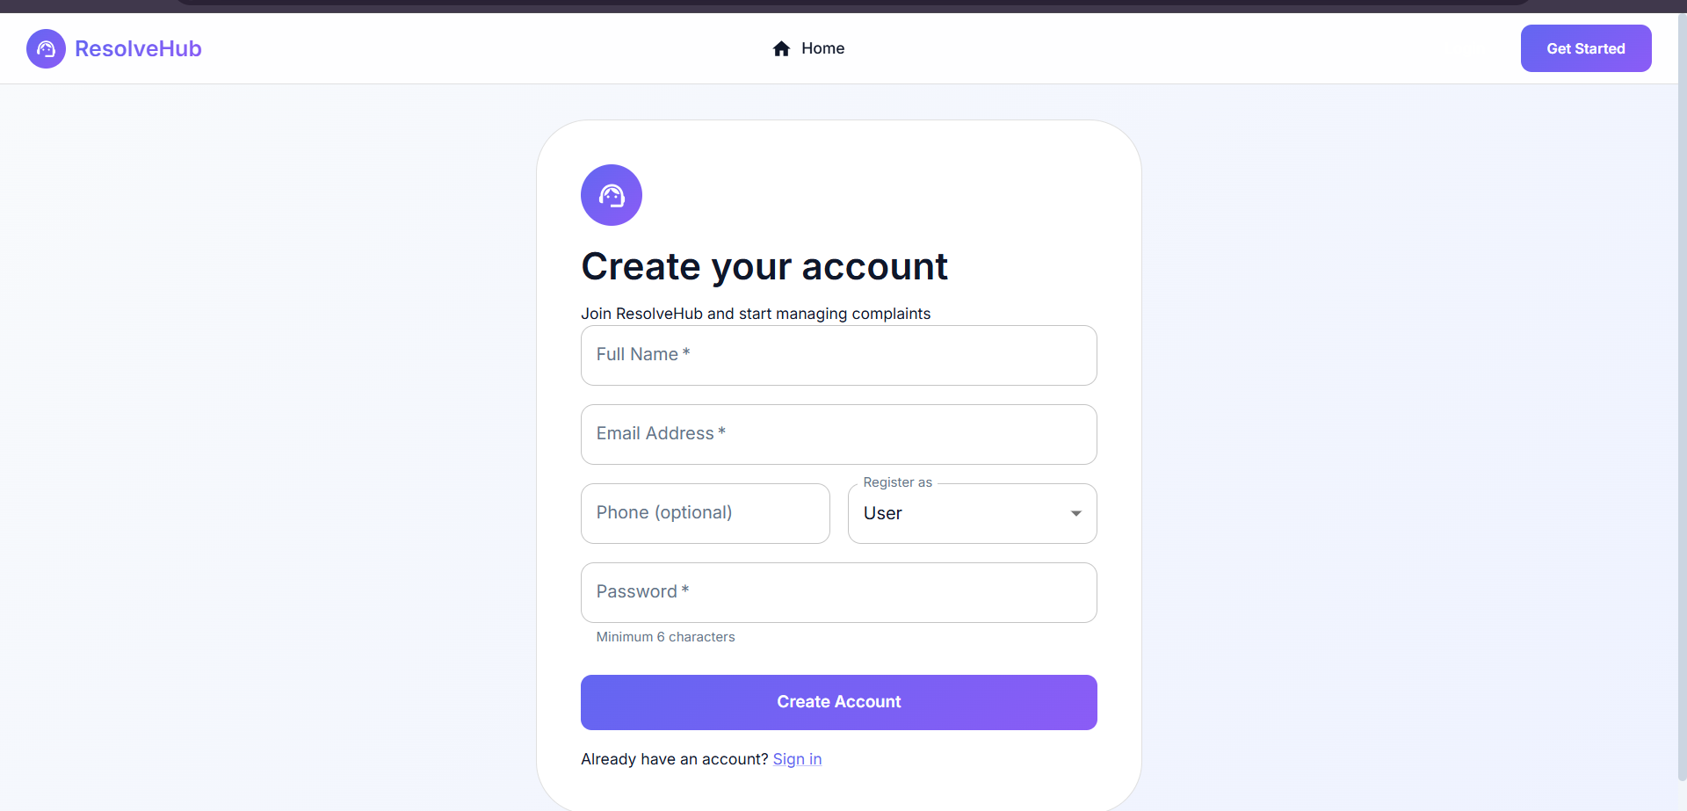
Figure 2 — Registration Page
User Dashboard
After logging in, a user lands on their personal dashboard. Four stat cards at the top show at a glance how many complaints they have in total, how many are active, how many are resolved, and how many are still awaiting an agent assignment. Below this, all complaints are displayed as cards showing the complaint ID, title, description, category, priority badge, submitter name, and current status.
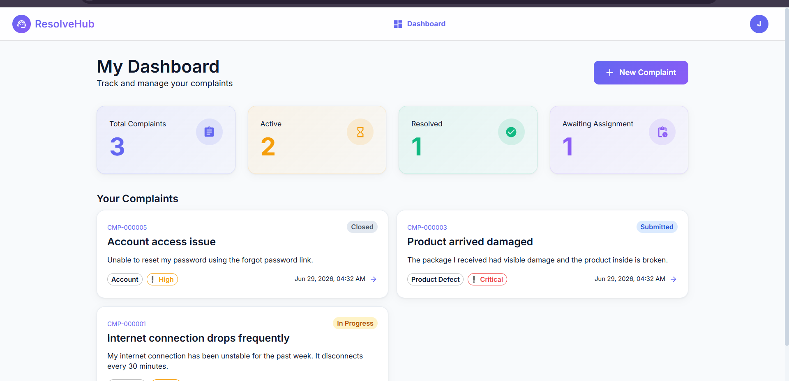
Figure 3 — User Dashboard (My Dashboard)
Admin Dashboard
The admin dashboard gives a full system overview. The top row shows four KPI cards: Total Users, Active Agents, Total Complaints, and Average Satisfaction score. Below these, a donut chart visualizes the breakdown of complaints by status (Submitted, Assigned, In Progress, Resolved, Closed), and a bar chart shows complaints grouped by category (Delivery, Billing, Technical, Product Defect, Account).
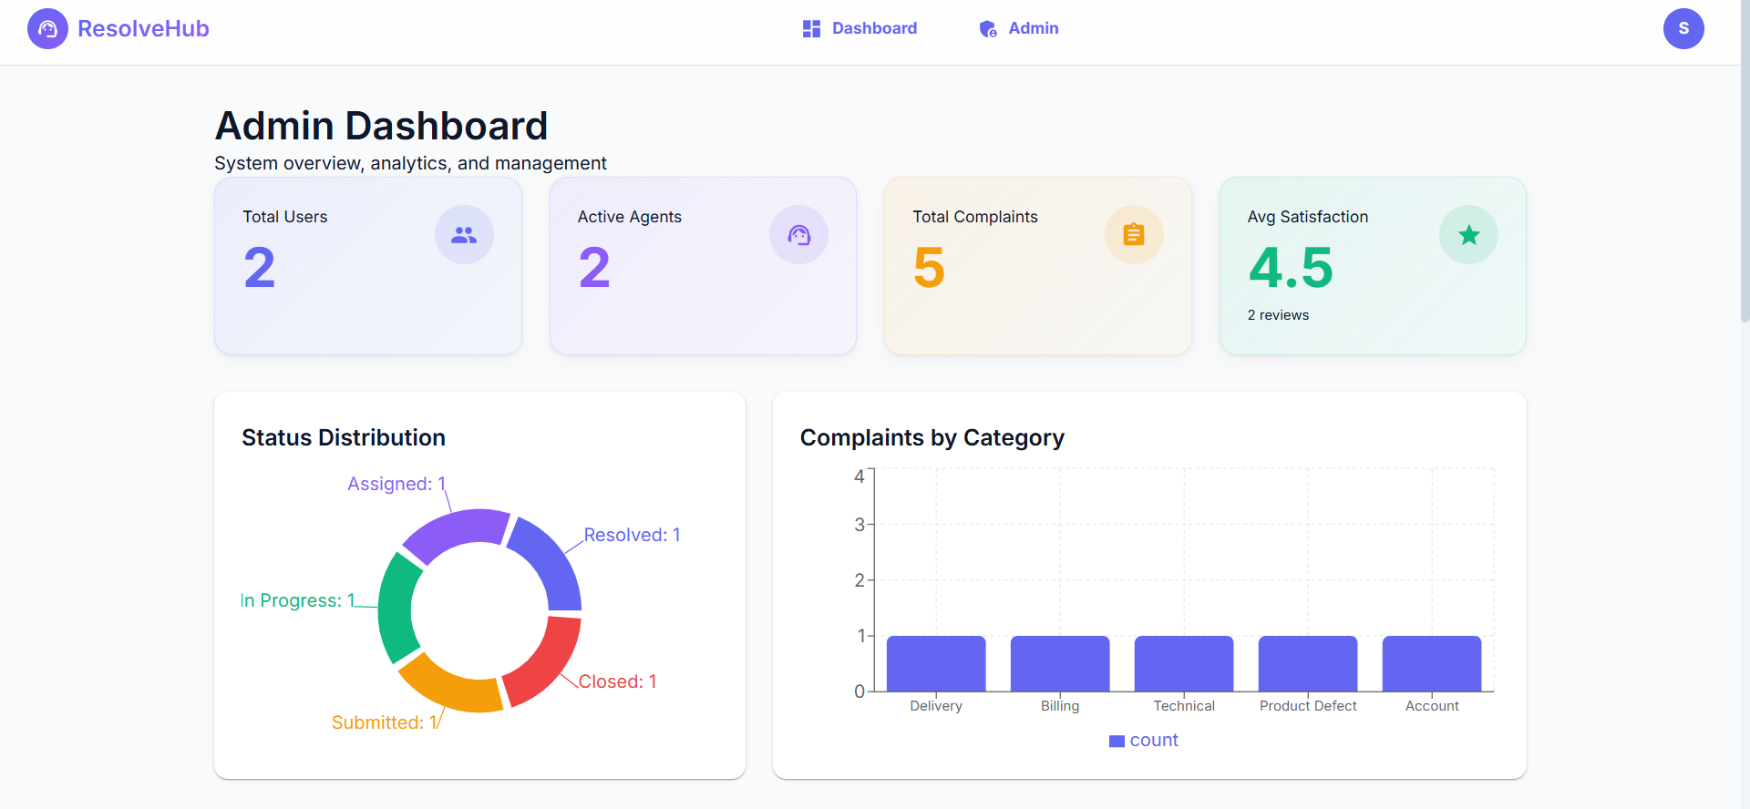
Figure 4 — Admin Dashboard
Admin Complaints View
Scrolling down on the admin dashboard reveals the full complaint list. Each card shows the complaint details along with an "Assign Agent" button for unassigned complaints, allowing the admin to assign a support agent directly from the list view.
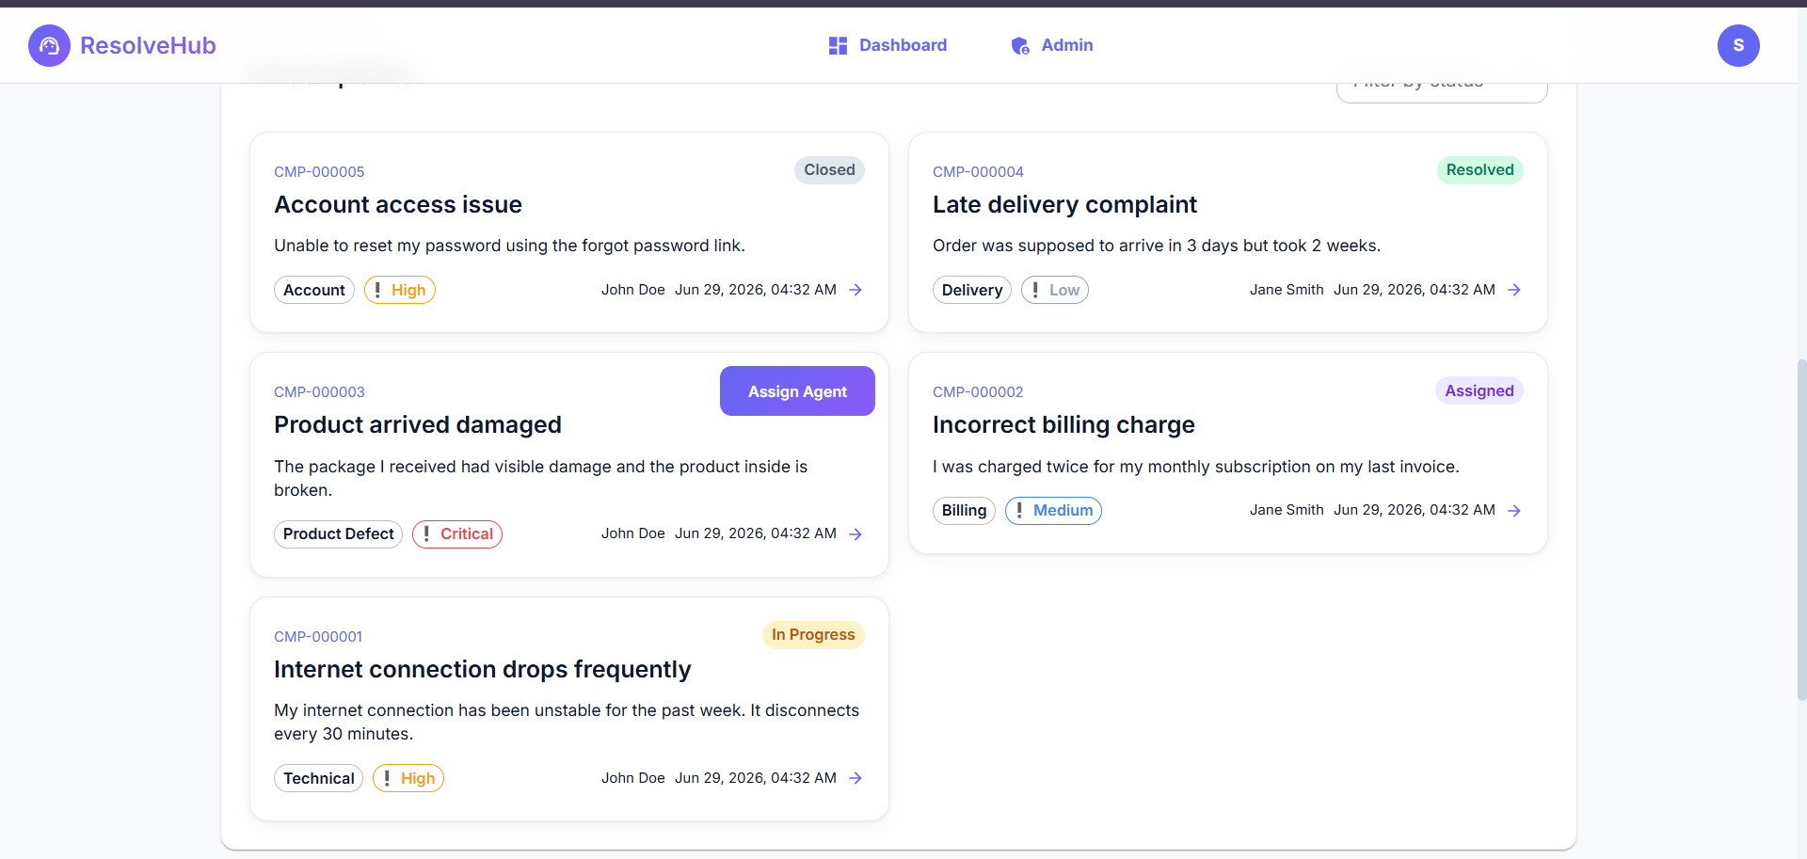
Figure 5 — Admin Complaints Management
Agent Dashboard
Agents see only the complaints that have been assigned to them. The dashboard header shows four stats: Assigned Cases, In Progress, Resolved, and Average Rating from user feedback. The complaint cards below work the same way as the user dashboard, each linking to the complaint detail page where the agent can update the status and chat with the user.
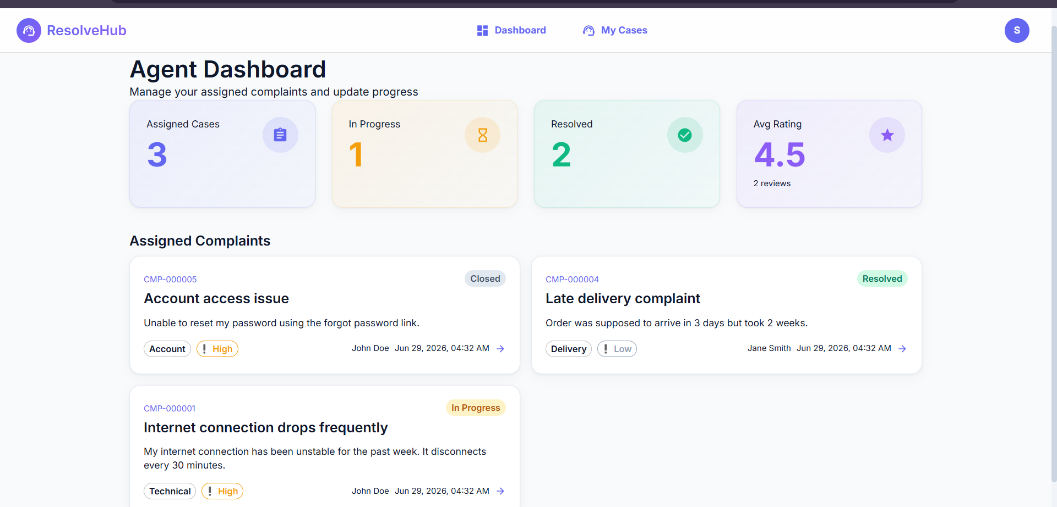
Figure 6 — Agent Dashboard

10. Testing
Testing was carried out in two stages: manual API testing using Postman, and structured User Acceptance Testing (UAT). A full UAT document was produced separately as part of the project submission.
API Testing
All REST endpoints were tested in Postman for correct behavior under both valid and invalid conditions. HTTP status codes were verified against expectations: 200 or 201 for successful operations, 400 for validation failures, 401 for missing or invalid tokens, 403 for role-based access violations, and 404 for resource not found.
User Acceptance Testing
Ten UAT test cases were executed covering: user registration, login with valid credentials, login with invalid credentials, complaint submission, admin agent assignment, agent status update, real-time chat between user and agent, feedback submission, admin analytics display, and role-based route protection. All ten test cases passed with actual results matching expected results.
Bugs Found and Resolved
Bug ID | Description | Severity | Resolution
BG-001 | Demo credentials were visible on the public login page, which would expose test accounts to anyone | Low | Removed the demo credentials block from LoginPage.jsx before submission
BG-002 | Seed script used weak passwords such as admin123, which triggered Chrome's password breach warning during the demo | Medium | Updated seed.js to use strong unique passwords for all demo accounts
BG-003 | Backend crashed immediately on a fresh npm install because several required packages were missing from package.json | High | Added all missing dependencies (morgan, socket.io, nodemailer) to package.json and reinstalled

11. Demo Walkthrough
The following four-step sequence demonstrates all major features of the application end-to-end and was used as the basis for UAT verification on 29 June 2026.
- Step 1 — Admin logs in and views the analytics dashboard showing system-wide stats and charts. The admin then locates a pending complaint in the list view and assigns an agent to it using the dropdown.
- Step 2 — The assigned agent logs in and sees the newly assigned complaint in their dashboard. The agent opens it, sends a chat message to the user, updates the status to In Progress, and later marks it as Resolved with a resolution note.
- Step 3 — The original user logs in, opens their dashboard, and sees the complaint's status has changed to Resolved. They open the complaint, read the agent's chat message, and submit a 5-star rating with a comment.
- Step 4 — The admin refreshes the dashboard and confirms the Average Satisfaction score has updated to reflect the new rating.

12. Known Issues
- Real-time chat only works while both parties are online at the same time. Messages sent while the other party is offline are saved to MongoDB and displayed on their next load, but there is no notification or alert to inform them that a new message arrived.
- The complaints-by-category bar chart on the admin dashboard does not update live without a page refresh after new complaints are added. The underlying data is correct — only the chart display requires a refresh to reflect recent changes.
- The application is configured for local development only. There is no production deployment setup included in this version.
- File or image attachments for complaints are not supported in the current version. The Complaint model includes an attachments array field as a placeholder reserved for a future upload feature.

13. Future Enhancements
Email Notifications — Implemented but Not Active
Nodemailer has been integrated into the backend codebase. The email utility is written and available at backend/utils/email.js, and it is imported in the complaint controller. However, the email-sending calls are currently commented out in the controller logic because this application does not require a live SMTP service for the academic demo. The feature is complete at the infrastructure level and can be activated by configuring a valid SMTP provider in .env (such as a Gmail App Password, SendGrid API key, or a testing service like Mailtrap) and uncommenting the relevant lines in the controller.
The three trigger points where email notifications would fire once enabled are: when a user successfully submits a complaint (submission confirmation), when an agent is assigned to a complaint (notification to the agent), and when a complaint is marked as resolved (notification to the user).
Other Planned Improvements
- File attachments for complaints — allow users to upload images or PDFs when submitting a complaint, stored using a service such as AWS S3 or Cloudinary
- Push notifications or browser alerts so users and agents are informed of status changes and new messages without having to refresh the page
- Resolution time tracking and an agent performance leaderboard visible to admins, with SLA breach alerts when complaints are left unresolved beyond a threshold
- Full-text search and filtering across all complaint fields — category, date range, priority, assigned agent, and keyword in the title or description
- A mobile application built with React Native that shares the same Express backend API
- Multi-tenant support so the platform can serve multiple organizations as separate, isolated workspaces
- Cloud deployment configuration targeting MongoDB Atlas for the database and a Node.js hosting platform such as Render or Railway for the server

