Alliance School of Advanced Computing
Course Name: Graph Analytics
Course Code: E1ITC 302
Assignment No: 1
Name of the Student: G. Lakshmi Prasanna
Registration Number: 2411021060312
A. Title of The Problem:
Find if Path Exists in Graph
B. Problem Statement in details:
You are given n vertices labelled from 0 to n - 1 in an undirected graph, along with a list of edges where each edge connects two of these vertices. You are also given a source vertex and a destination vertex. Determine whether there is a valid path of edges that starts at the source vertex and ends at the destination vertex — that is, whether the two vertices lie within the same connected component of the graph.
C. Student's Github link of report and code upload, along with the readme file:
Leetcode-problem/Find if Path Exists in Graph at main · lakshmiprasanna200507/Leetcode-problem
D. Solution Steps/Algorithm:
1. Read the number of vertices n and the list of edges connecting pairs of vertices, along with the source and destination vertices.
2. If the source vertex is the same as the destination vertex, a path trivially exists, so return True immediately.
3. Build an adjacency list graph of size n from the edge list, adding each edge to both endpoints since the graph is undirected.
4. Initialize a boolean visited array of size n set to False, mark the source vertex as visited, and push it onto a queue to start BFS.
5. While the queue is not empty, remove the front vertex and look at each of its neighbours in the adjacency list.
6. If a neighbour is the destination vertex, a valid path has been found, so return True right away.
7. Otherwise, if the neighbour has not yet been visited, mark it visited and enqueue it so its neighbours are explored later.
8. If the queue empties without ever reaching the destination, no path connects the two vertices, so return False.
E. Code developed:
from collections import deque

class Solution:
def validPath(self, n, edges, source, destination):
if source == destination:
return True

graph = [[] for _ in range(n)]
for u, v in edges:
graph[u].append(v)
graph[v].append(u)

queue = deque([source])
visited = [False] * n
visited[source] = True

while queue:
node = queue.popleft()
for neighbor in graph[node]:
if neighbor == destination:
return True
if not visited[neighbor]:
visited[neighbor] = True
queue.append(neighbor)

return False
F. Test case passed Screenshot or Output screenshot (Mandatory):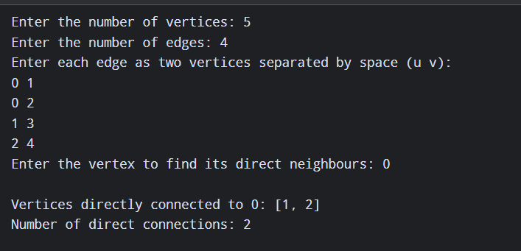
G. Observation:
This problem models the vertices and edges as an undirected graph and asks whether two given vertices lie within the same connected component. The solution builds an adjacency list from the edge list and then performs a standard BFS starting from the source vertex, marking each vertex as visited the moment it is discovered so that no vertex is processed more than once. As soon as the destination vertex turns up among a node's neighbours, the search returns True immediately without exploring the rest of the graph. If the BFS exhausts every reachable vertex without ever encountering the destination, the two vertices belong to different components and the function returns False. Since every vertex and edge is examined at most once, the approach runs in O(V + E) time, which is optimal for this kind of graph connectivity query.

