Alliance School of Advanced Computing
Course Name: Graph Analytics
Course Code: E1ITC 302
Assignment No: 3
Name of the Student: Gali Lakshmi Prasanna
Registration Number: 2411021060312
- Title of The Problem:
NETWORK DELAY TIME
B. Problem Statement in details:
You are given a network of n nodes, labeled from 1 to n. You are also given times, a list of travel times as directed edges times[i] = (u_{i}, v_{i}, w_{i}), where u_{i} is the source node, v_{i} is the target node, and w_{i} is the time it takes for a signal to travel from source to target.
We will send a signal from a given node k. Return the minimum time it takes for all the n nodes to receive the signal. If it is impossible for all the n nodes to receive the signal, return -1.

C.Student's Github link of report and code upload, along with the readme file:
Leetcode-problem/Network delay time at main · lakshmiprasanna200507/Leetcode-problem
D. Solution Steps/Algorithm:
- Create an adjacency list from the given times.
- Set the starting node k with distance 0.
- Put (0, k) into a priority queue.
- Remove the node with the smallest travel time.
- If the node is already visited, skip it.
- Mark the node as visited and store its shortest time.
- For each neighboring node, calculate:
new time = current time + edge weight
- Add the neighboring node and its new time to the priority queue.
- Repeat until the priority queue is empty.
- If all n nodes are reached, return the maximum shortest time.
- If some node is not reached, return -1.

E. Code developed:
import heapq

class Solution:
def networkDelayTime(self, times, n, k):
graph = {}

for u, v, w in times:
if u not in graph:
graph[u] = []
graph[u].append((v, w))
pq = [(0, k)]
distance = {}

while pq:
time, node = heapq.heappop(pq)

if node in distance:
continue

distance[node] = time
for next_node, weight in graph.get(node, []):
if next_node not in distance:
heapq.heappush(
pq,
(time + weight, next_node)
)
if len(distance) != n:
return -1
return max(distance.values())

F. Leetcode test case passed Screenshot or Output screenshot (Mandatory):
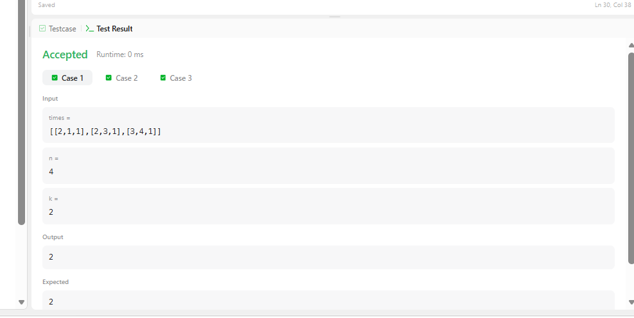
G. Observation:
- The problem uses Dijkstra’s algorithm to find the shortest travel time from the source node k to all other nodes.
- A priority queue (min-heap) is used to process the node with the smallest current time first.
- The graph is represented using an adjacency list.
- The maximum of all shortest travel times gives the time required for the signal to reach every node.
- If any node cannot be reached from k, the output is -1.
- The algorithm efficiently handles graphs with positive edge weights.

