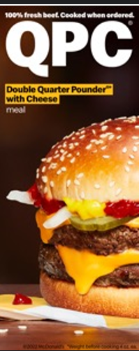  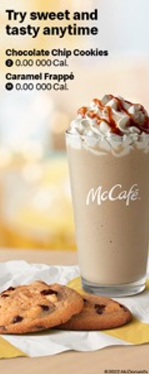 | Combo Meals  Meals include medium fries and medium soft drink, pick a different drink for an additional charge. Promotion pricing may be lower than meal pricing  1 Cheese 3.00 000-0000 Cal Ala carte 5.00 000 Cal Deluxe 3.00 000-0000 Cal Ala carte 5.00 000 Cal 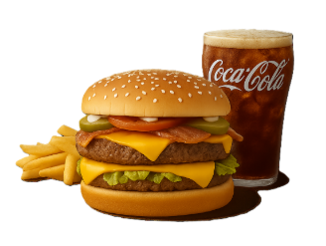  2 Quarter Pounder®tt Cheese 3.00 000-0000 Cal Ala carte 5.00 000 Cal Cheese & Bacon 3.00 000-0000 Cal Ala carte 5.00 000 Cal Deluxe 3.00 000-0000 Cal Ala carte 5.00 000 Cal 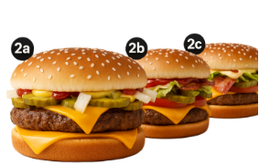  3 Double Quarter Pounder® with Cheese 3.00 000-0000 Cal Ala carte 5.00 000 Cal 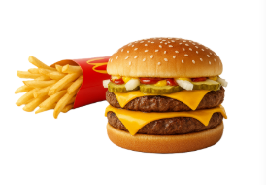  4 10 pc. Chicken McNuggets® 3.00 000-0000 Cal Ala carte 5.00 000 Cal 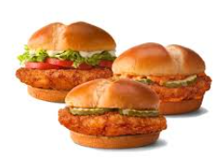  5 2 Cheeseburgers 3.00 000-0000 Cal Ala carte 5.00 000 Cal 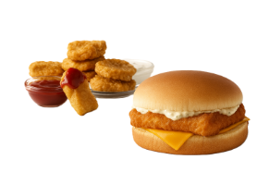 | McCafe Cinnamon Roll 3.00 000 Cal Iced Coffee CaramelM3.00 000 Cal Frappe CaramelM3.00 000 Cal Smoothie Strawberry Banana 3.00 000 Cal Premium Roast Coffee M3.00 000 Cal Apple Fritter M3.00 000 Cal 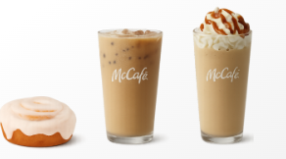 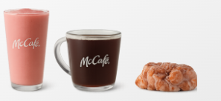 Sides & More 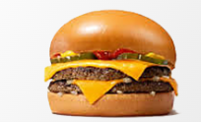 Sweets & Treats 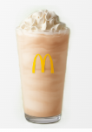 $1 $2 $3 Dollar Menu Value Beverages Any Size Sweet Tea S3.00 0-000 Cal M3.00 0-000 Cal L3.00 0-000 Cal Soft Drinks M3.00 0-000 Cal Premium Roast Coffee M3.00 0 Cal Everyday Value McChicken® 3.00 000 Cal Double 4 pc. Chicken McNuggets® 3.00 000-0000 Cal sauces add 30-000 Cal na Basket of Fries 3.00 000 Cal More Deals 4 Hot'n Spicy McChicken®, 20 pc. Chicken McNuggets®t & Basket of Fries M3.00 000-0000 Cal 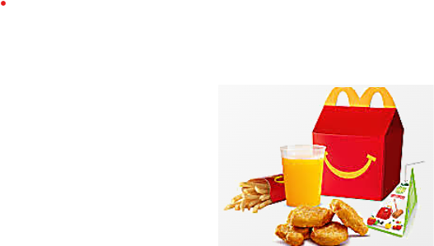  Fan Favourites  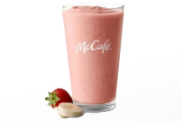 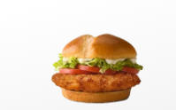 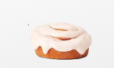  Medium Straberry bannana smoothie 3.00 000-0000 Cal Deluxe Crispy Chicken Sandwich 3.00 000-0000 Cal Cinnamon Roll 3.00 000 Cal

