Columns

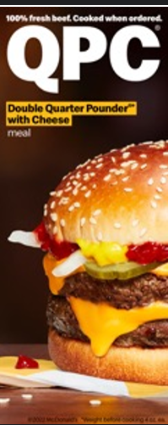  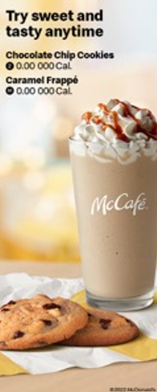 | Combo Meals  Meals include medium fries and medium soft drink, pick a different drink for an additional charge. Promotion pricing may be lower than meal pricing  1 Cheese 3.00 000-0000 Cal Ala carte 5.00 000 Cal Deluxe 3.00 000-0000 Cal Ala carte 5.00 000 Cal 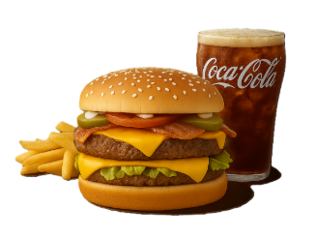  2 Quarter Pounder®tt Cheese 3.00 000-0000 Cal Ala carte 5.00 000 Cal Cheese & Bacon 3.00 000-0000 Cal Ala carte 5.00 000 Cal Deluxe 3.00 000-0000 Cal Ala carte 5.00 000 Cal 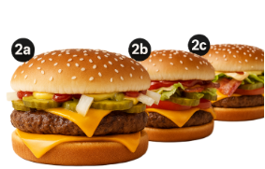  3 Double Quarter Pounder® with Cheese 3.00 000-0000 Cal Ala carte 5.00 000 Cal 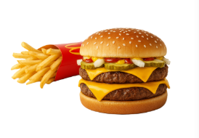  4 10 pc. Chicken McNuggets® 3.00 000-0000 Cal Ala carte 5.00 000 Cal 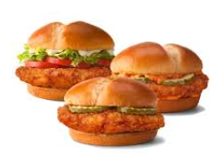  5 2 Cheeseburgers 3.00 000-0000 Cal Ala carte 5.00 000 Cal 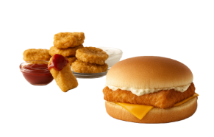 |  | $1 $2 $3 Dollar Menu  Value Beverages  - Any Size Sweet Tea  S3.00 0-000 Cal  M3.00 0-000 Cal  L3.00 0-000 Cal  - Soft Drinks  M3.00 0-000 Cal  - Premium Roast Coffee  M3.00 0 Cal  Everyday Value  - McChicken®  3.00 000 Cal  - McDouble®  3.00 000 Cal  - Small Fries  3.00 000 Cal  - 4 pc. Chicken McNuggets®  3.00 000-0000 Cal  sauces add 30-000 Cal na  - Basket of Fries  3.00 000 Cal  $3 Bundle - Choose One  includes small fries  - Double Cheeseburger  3.00 000 Cal  - Hot'n Spicy McChicken®  3.00 000-0000 Cal  - 4 pc. Chicken McNuggets®  3.00 000-0000 Cal  sauces add 30-000 Cal na  - Basket of Fries  3.00 000 Cal  More Deals  - 4 Hot'n Spicy McChicken®, 20 pc. Chicken McNuggets®t & Basket of Fries  M3.00 000-0000 Cal

