ALLIANCE UNIVERSITY
Alliance School of Advanced Computing

Micro–Project Report Format

Course Code: E1CSA348 Course Title: Advanced Python Programming

Name of Course In-charge: Dr. Chetan Shelke
Student Team Members
- Baby Rao Metta
- Harshita Chhabra
- Rajasree G
- B Lakshmi Priya

Personal Expense Analytics and Budget Management System

1.0 Rationale
Most people record their day-to-day spending in scattered notes, bank SMS alerts or generic spreadsheets, so overspending is usually noticed only at the end of the month, when it is too late to correct. Without a consolidated view, it is also hard to compare actual spending with a planned budget or to spot recurring habits that quietly drain savings.
This micro-project addressed that visibility problem by building a Personal Expense Analytics and Budget Management System in Python. Every expense is modelled as a Transaction object (date, category, amount, description), while separate Budget, Database and ExpenseAnalytics classes keep the budget rules, storage and analytics reusable. Pandas and NumPy summarise spending by category and month, Matplotlib turns the summaries into charts, Tkinter provides the desktop interface and SQLite stores the data.
Academically, the project integrates object-oriented programming, data manipulation, visualization and application development from the Advanced Python Programming course (CO1, CO4, CO5). Practically, the same design carries over to real personal-finance and fintech tools.
2.0 Competency of the Course
The course Advanced Python Programming (E1CSA348, B.Tech CSE, Semester V, 3 credits) develops strong programming skills using advanced Python concepts and real-world applications: object-oriented and functional programming, concurrency, data handling and visualization, and hands-on work with databases, APIs and GUI development using modern Python libraries. On completion, the learner is competent to design and build robust, modular and efficient Python applications, using NumPy, Pandas and Matplotlib for data work and integrating databases and user interfaces to solve real-world problems.
3.0 Course Outcomes Addressed in this Micro Project
- CO1: Use object-oriented programming constructs to design modular and reusable Python applications. (BTL3)
- CO4: Use data manipulation and visualization libraries to process and present data effectively. (BTL4)
- CO5: Use Python to build full-fledged applications integrating APIs, databases, and user interfaces for real-world problem solving. (BTL4)
4.0 Information Collection
Personal budgeting is a widely studied problem, and applications such as Mint, YNAB (You Need A Budget) and Walnut have shown how tracking, categorising and visualising expenses helps users stay in control. Reviewing them showed the features a functional expense tracker needs – categorised transactions, monthly summaries, budget limits with overspend warnings and simple charts – and the gaps a self-built system can still address, such as working fully offline without linking any bank account. These tools are built around well-known principles: the 50/30/20 rule, which divides income into needs, wants and savings, and zero-based budgeting, in which every rupee is given a purpose in advance. The same ideas guided the choice of category-wise monthly limits and the three-level budget status (within budget, near limit, over budget) used in this project.
On the programming side, the course plan of Advanced Python Programming (Module I – object-oriented programming; Module IV – NumPy, Pandas and Matplotlib; Module V – Tkinter and database connectivity using SQLite) and its prescribed books were the main sources. Lutz’s Learning Python and Ramalho’s Fluent Python explain how classes, constructors, encapsulation, inheritance, special methods and iterators allow a real-world entity such as a transaction or a budget to be modelled as an object that keeps its data and behaviour together. McKinney’s Python for Data Analysis shows how records are loaded into Pandas DataFrames, grouped by category or month and plotted with Matplotlib, while Chun’s Core Python Programming covers database programming. The official documentation of Python (tkinter, sqlite3, csv), Pandas, NumPy and Matplotlib was used to confirm exact method behaviour, and the Coursera course on Applied Python for Developers, GeeksforGeeks and Real Python provided worked examples of aggregation, chart creation and Tkinter layouts.
This study led to four design decisions: (i) a Transaction object as the single record shared by every module; (ii) SQLite for storage, because it needs no database server, with CSV import and export for moving data in and out; (iii) Pandas and NumPy for aggregation, with Matplotlib charts embedded in the Tkinter window; and (iv) a 730-day demo dataset covering 24 monthly periods, to test the system on a realistic volume of records.
5.0 Theory and Design of the Micro Project
5.1 Problem Statement and Objectives
Day-to-day expenses are spread across notes, bank messages and spreadsheets, so there is no single view of what is actually being spent. Overspending is noticed only at the end of the month, when correction is much harder, and without category and time analysis, recurring habits stay hidden. The core problem is therefore visibility, not spending. The micro-project proposes one structured system in which every transaction is recorded once and then turned into decisions the user can see. Its four objectives are given in Table 5.1.
Table 5.1: Objectives of the micro-project
Objective | What the system does
Record | Captures the date, category, amount and description of every expense, by manual entry or CSV import.
Analyse | Summarises spending by category, day and month using structured data (Pandas and NumPy).
Control | Compares spending with user-defined monthly limits for each category and flags overspending.
Visualise | Presents spending patterns through a KPI dashboard and monthly, daily and category charts.

5.2 Theory: Python Concepts and Libraries Applied
The design rests on the Advanced Python Programming concepts summarised in Table 5.2. Its central idea is that one Transaction object is the single source of truth: the same object is validated on entry, stored in SQLite, converted into a DataFrame for analysis and finally drawn on the dashboard.
Table 5.2: Python concepts and libraries applied in the project
Concept / library | How it is used in the project
Classes, objects and encapsulation | Transaction, Budget, Database and ExpenseAnalytics keep their data and the operations on it together; the static method Transaction.valid_date() validates dates without needing an object.
Inheritance | ExpenseApp extends tk.Tk to become the main window; MetricCard and ActionCard extend tk.Frame to give reusable dashboard widgets.
Functional programming and iterators | map() with lambda converts Transaction objects into records for a DataFrame; reduce() cross-checks the total; TransactionIterator implements __iter__() and __next__().
NumPy | np.sum, np.mean and np.max give the total, average and largest expense.
Pandas | A DataFrame holds all transactions; to_datetime and to_period extract months; groupby produces category, daily and monthly totals; read_csv handles import.
Matplotlib | A filled line chart (monthly trend), a date-axis line chart (daily trend) and a donut chart (category breakdown) are embedded in the Tkinter window through FigureCanvasTkAgg.
Tkinter | Frames, ttk.Treeview tables, Combobox filters, a Toplevel entry form, message boxes and file dialogs form the five-page interface.
SQLite3 | Two tables are created with CREATE TABLE IF NOT EXISTS; parameterised SQL (? placeholders) is used for every write; INSERT OR IGNORE seeds and INSERT OR REPLACE updates budgets.
csv module and file handling | Transactions are exported with csv.writer; imported files are validated row by row.

Budget status rule. For a category with limit L and monthly spending S, Budget.status() returns NO BUDGET if L ≤ 0, OVER BUDGET if S > L, NEAR LIMIT if S ≥ 0.80 × L, and WITHIN BUDGET otherwise. For a whole month, the dashboard shows the percentage used (month total ÷ sum of all category limits × 100), coloured green below 80%, amber from 80% to 100% and red beyond that. The Smart Insights panel reports the highest-spending category and its share of the month’s spending (category total ÷ month total × 100).
5.3 System Architecture
The application is organised in four layers (Figure 5.1). The user-interface layer (Tkinter) shows five pages and collects input; the application-logic layer holds the Transaction and Budget classes and validates every entry; the analytics and visualization layer turns transactions into totals and charts using Pandas, NumPy and Matplotlib; and the storage layer keeps the data in SQLite and exchanges CSV files. Data flows in one direction – manual entry or CSV import → Transaction object → SQLite → DataFrame → charts, KPIs and budget status. Layers talk to each other only through simple data structures (Transaction objects, lists and DataFrames), which gives the design high cohesion and low coupling: the interface never writes SQL, and the analytics class never touches the database.
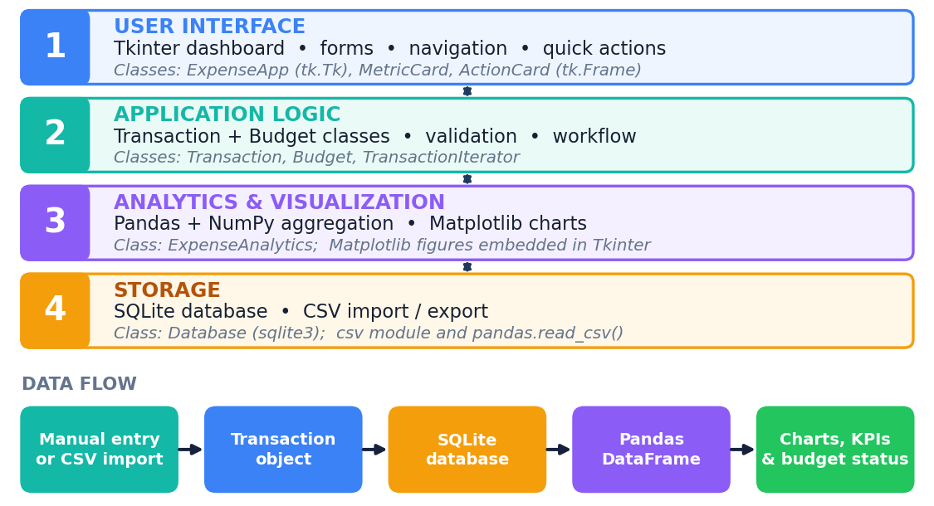
Figure 5.1: Layered architecture and data flow of the system
5.4 Class Design
Eight classes implement the system (Figure 5.2 and Table 5.3). Transaction and Budget hold the data and rules, Database and ExpenseAnalytics provide services, TransactionIterator implements the iterator protocol, and ExpenseApp, MetricCard and ActionCard form the interface.
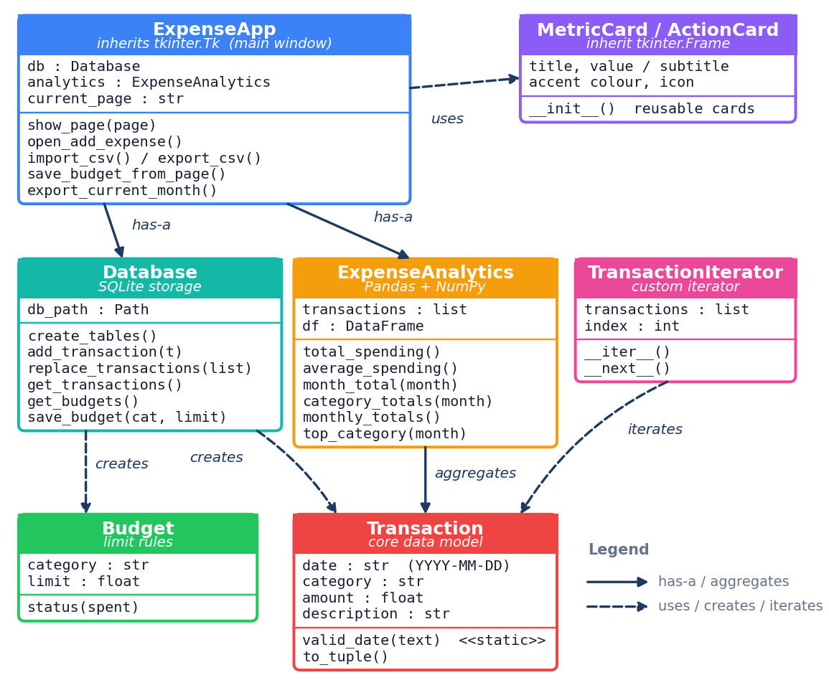
Figure 5.2: Class diagram of the application
Table 5.3: Responsibilities of the classes
Class | Responsibility
Transaction | One expense: date (YYYY-MM-DD text), category, amount (float) and description. valid_date() checks the date format; to_tuple() returns the values for SQL insertion and CSV writing.
Budget | Monthly limit of one category; status(spent) returns WITHIN BUDGET, NEAR LIMIT, OVER BUDGET or NO BUDGET.
Database | All SQLite access: creates the tables (and migrates an older budgets table), seeds default budgets, adds or replaces transactions, reads transactions and budgets and saves a budget limit.
TransactionIterator | Custom iterator over a list of transactions (__iter__, __next__), used while exporting data.
ExpenseAnalytics | Converts transactions into a DataFrame and provides the total, average, largest expense, month list, month totals, category totals, daily totals, monthly totals and top category.
ExpenseApp | Main window (inherits tk.Tk): builds the sidebar, header and five pages, handles add, import and export actions and rebuilds the analytics object whenever a page is opened.
MetricCard, ActionCard | Reusable tk.Frame widgets for KPI cards and clickable quick-action cards.

5.5 Database Design
SQLite was chosen because it needs no database server and keeps everything in a single file. Two tables are used (Table 5.4). The category column links them logically: one budget row exists for each of the ten categories, and spending is compared with it by category name. The categories and their default monthly limits are listed in Table 5.5 (combined limit ₹31,800); the user can change any limit from the Budget page, and the new value is saved with INSERT OR REPLACE.
Table 5.4: Tables of the SQLite database
Table | Column | Type | Description
transactions | id | INTEGER, primary key, autoincrement | Unique record number
 | date | TEXT, not null | Date in YYYY-MM-DD format
 | category | TEXT, not null | One of the ten categories
 | amount | REAL, not null | Amount spent in rupees
 | description | TEXT | Short note about the expense
budgets | category | TEXT, primary key | Category name
 | limit_amount | REAL, not null | Monthly limit for the category

Table 5.5: Categories and default monthly limits (₹)
Category | Limit | Category | Limit
Food | 5,000 | Rent | 10,000
Transport | 2,500 | Health | 2,000
Education | 2,500 | Personal Care | 1,500
Entertainment | 2,000 | Other | 1,000
Utilities | 1,800 | Shopping | 3,500

5.6 Module Design: Cohesion and Coupling
The code is split into modules that each do one clear job (Table 5.6). Modules communicate through Transaction objects, lists and DataFrames rather than through shared global state, so each one can be changed or tested on its own.
Table 5.6: Modules of the system
Module | Implemented by | Job
Data input | open_add_expense(), import_csv(), load_demo_data() | Collect and validate manual entries and CSV rows; create Transaction objects.
Storage | Database | Persist and retrieve transactions and budgets in SQLite.
Analytics | ExpenseAnalytics | Aggregate by category, day and month; compute the KPIs.
Visualization | Analytics page charts, dashboard bars and budget ring | Draw the trend, daily and category charts and progress bars.
Budget control | Budget, Budget page | Define limits and report the status of each category and of the month.
Reporting | Reports page, export_current_month(), export_csv() | Show a monthly summary and export data as CSV.
User interface | ExpenseApp, MetricCard, ActionCard | Navigation, layout, styling and event handling.

5.7 Algorithm and Workflow
Figure 5.3 shows the workflow that runs whenever data enters the system; Pseudocode 5.1 and 5.2 summarise the two entry routes.
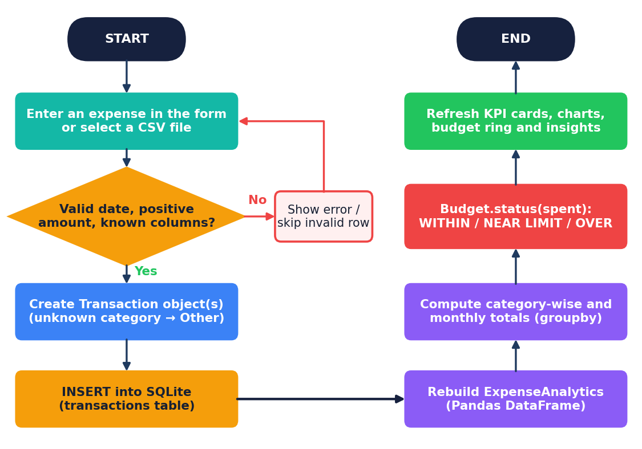
Figure 5.3: Workflow for adding or importing expenses
Pseudocode 5.1: Adding an expense through the form
ADD_EXPENSE(date, category, amount, description)
1. IF amount is not a positive number THEN show error and STOP
2. IF date does not match YYYY-MM-DD THEN show error and STOP
3. t <- Transaction(date, category, amount, description)
4. Database.add_transaction(t) # INSERT INTO transactions
5. analytics <- ExpenseAnalytics(Database.get_transactions())
6. totals <- analytics.category_totals(month)
7. FOR EACH category c: status <- Budget(c, limit_c).status(totals[c])
8. Redraw KPI cards, charts, budget ring and insights

Pseudocode 5.2: Importing a CSV file
IMPORT_CSV(path)
1. Read the file with pandas; IF a required column is missing THEN raise error
2. FOR EACH row: skip it (invalid <- invalid + 1) if the date is invalid,
or the amount is not numeric or not greater than zero
3. IF category is not one of the ten categories THEN category <- "Other"
4. Database.replace_transactions(valid rows); report loaded and skipped counts

5.8 User Interface Design
The interface uses a sidebar layout: a dark navigation panel lists the five workspace pages (Dashboard, Transactions, Analytics, Budget and Reports); a header shows the page title, the latest month and the Add, Import and Demo Data buttons; and the content area changes with the page. A consistent colour palette is used – navy for structure, teal for primary actions and a fixed colour for every spending category – so the same category looks the same on bars, charts and reports. Reusable card widgets keep the pages consistent, and every form validates its input before anything is saved.
6.0 Methodology Followed
The group undertook the micro-project in six phases that follow the action plan of the approved proposal (Figure 6.1 and Table 6.1). Each phase ended with a review by the course in-charge, and the review suggestions were incorporated before the final submission.
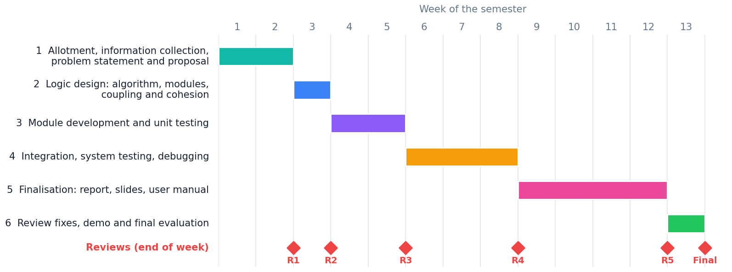
Figure 6.1: Phases and reviews of the micro-project (weeks of the semester)
Table 6.1: Work carried out in each phase
No. | Weeks | Work carried out | Review
1 | 1–2 | Micro-project allotted (CO1, CO4, CO5); information collected from the course books, library documentation and existing budgeting applications; problem statement, objectives, scope and expected outcomes defined; week-wise plan and responsibilities fixed; proposal submitted. | 1st review, end of week 2
2 | 3 | Logic developed as algorithm, flowchart and pseudocode; program modules and functions identified; cohesion and coupling of the modules designed. | 2nd review, end of week 3
3 | 4–5 | Modules implemented in Python – Transaction and Budget classes, Database, ExpenseAnalytics and the Tkinter pages – and unit-tested with different inputs; code readability, comments and versions improved. | 3rd review, end of week 5
4 | 6–8 | Modules integrated into one application; system testing on the 730-day dataset; errors debugged, outputs validated, interaction and performance improved; documentation updated. | 4th review, end of week 8
5 | 9–12 | Implementation finalised; report, presentation slides and user manual prepared. | 5th review, end of week 12
6 | 13 | Review suggestions incorporated; final demonstration with complete execution; report submission, group seminar presentation and oral examination. | Final evaluation, end of week 13

How the work started. The group first fixed the scope: a personal expense-tracking application with ten configurable categories, a monthly budget limit for every category and a running log of transactions. Each transaction records a date, category, amount and short description and can be entered manually or imported from a CSV file, so the initial dataset and any later additions could come from either source.
The data structures were then designed – the Transaction and Budget classes, a two-table SQLite schema and a Pandas DataFrame for aggregation – and the modules (data input, storage, analytics, visualization, budget control, reporting and interface) were built and tested one at a time. They were finally integrated into a single Tkinter application in which, whenever a transaction is added, it (a) is stored in the database, (b) triggers recalculation of the category-wise and monthly totals, (c) is compared with the budget limit of its category and (d) updates the on-screen summary and charts. Responsibilities were divided by module – transaction and budget classes; analytics and aggregation; visualization; storage and GUI – and all members took part in integration and testing.
Refinements in the final code. (i) The daily-trend chart uses a real date axis instead of hundreds of text labels, which keeps the 730-day view fast and readable. (ii) The Matplotlib figure and canvas are stored on the application object and destroyed before every redraw, so charts neither disappear nor pile up when the user switches views. (iii) The database layer migrates an older budgets table to the current schema, so earlier database files keep working. (iv) CSV import validates every row, maps unknown categories to “Other” and reports how many invalid rows were skipped.
7.0 Outputs of the Micro–project
7.1 Prototype Developed
The working prototype is a desktop application with five pages (Table 7.1). Figures 7.1 and 7.2 show the Dashboard and Analytics pages running on the 730-day demo dataset.
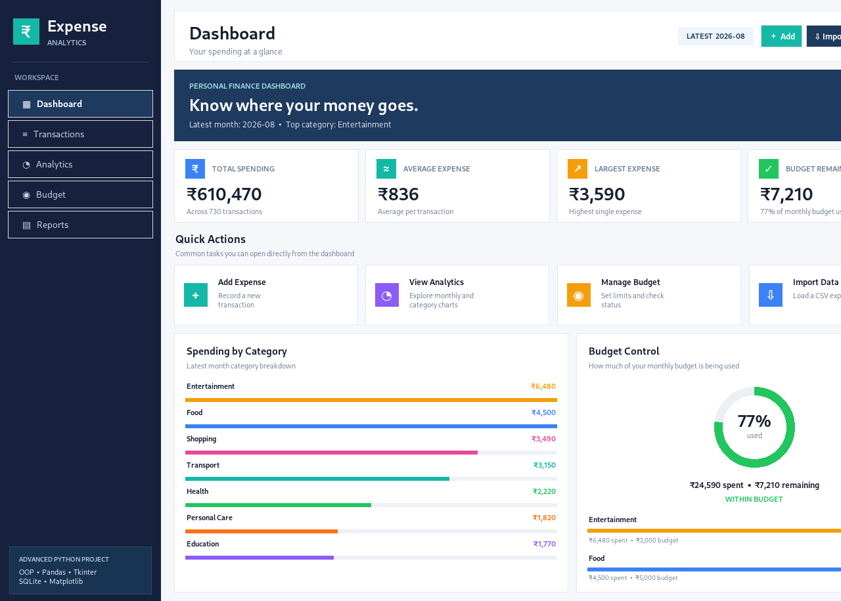
Figure 7.1: Dashboard page: KPI cards, quick actions, category bars and budget control
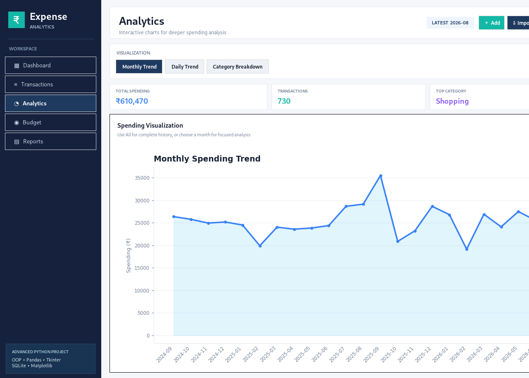
Figure 7.2: Analytics page: monthly spending trend over 24 months
Table 7.1: Pages of the application
Page | What it provides
Dashboard | Banner with the latest month and its top category; KPI cards (total spending, average expense, largest expense, budget remaining); quick actions; category bars for the seven highest-spending categories; a budget ring showing the percentage of the monthly budget used; a recent-activity table; Smart Insights.
Transactions | The full ledger with a search box and month and category filters, a count of matching records, and buttons to add an expense, import a CSV file and export a CSV file.
Analytics | Monthly trend, daily trend and category breakdown (donut) charts with summary chips and a month selector.
Budget | A form to set the limit of any category; cards for the combined limit, month spending and amount remaining; a table of limit, spent, percentage used and status for each category.
Reports | A month selector with month total, transaction count, average and top category; category-wise bars; an Export Current Month button that saves the month’s transactions as a CSV file.

7.2 Data Used for Validation
The prototype was validated with a demo dataset of 730 daily records covering 24 monthly periods, from 2024-09 to 2026-08. Table 7.2 summarises the figures reported by the application.
Table 7.2: Summary of the validation dataset as reported by the application
Measure | Value
Number of transactions | 730 (daily records)
Period covered | 24 monthly periods, 2024-09 to 2026-08
Total spending | ₹610,470 (about ₹6.10 lakh)
Average expense per transaction | ₹836
Largest single expense | ₹3,590
Average monthly spending (total ÷ 24) | about ₹25,400
Highest-spending category overall | Shopping
Latest month (2026-08): spending | ₹24,590 of the combined limit of ₹31,800 (77% used, ₹7,210 remaining)
Latest month (2026-08): highest category | Entertainment (₹6,480)

7.3 Presentation of Collected Data and Findings
For the latest month, the spending of each category was compared with its default monthly limit (Table 7.3 and Figure 7.3). The dashboard lists the seven highest-spending categories; the other three (Utilities, Rent and Other) together account for the remaining ₹1,160 of the month’s ₹24,590.
Table 7.3: Spending against category limits in 2026-08 (values read from the dashboard)
Category | Spent (₹) | Limit (₹) | Used | Status
Entertainment | 6,480 | 2,000 | 324.0% | OVER BUDGET
Food | 4,500 | 5,000 | 90.0% | NEAR LIMIT
Shopping | 3,490 | 3,500 | 99.7% | NEAR LIMIT
Transport | 3,150 | 2,500 | 126.0% | OVER BUDGET
Health | 2,220 | 2,000 | 111.0% | OVER BUDGET
Personal Care | 1,820 | 1,500 | 121.3% | OVER BUDGET
Education | 1,770 | 2,500 | 70.8% | WITHIN BUDGET
All categories (month) | 24,590 | 31,800 | 77.3% | WITHIN BUDGET (overall)

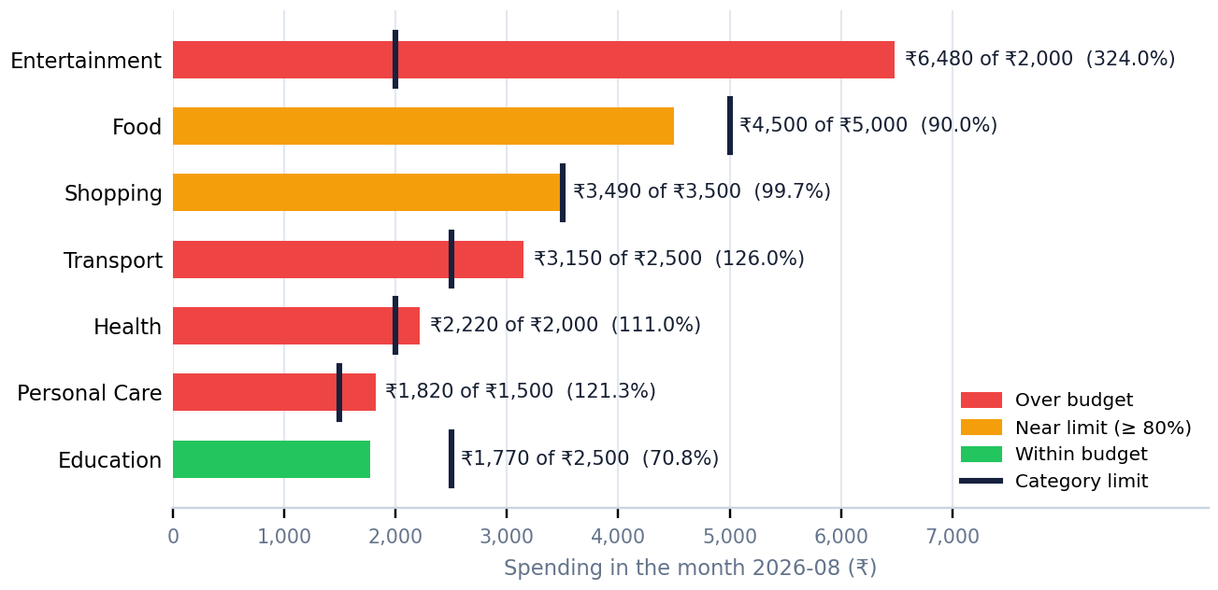
Figure 7.3: Spending against category limits in 2026-08 (limits are the application’s default budgets)
Finding 1 – the overall budget hides category overspending. At the month level, 77% of the combined budget was used and ₹7,210 remained, so the dashboard showed WITHIN BUDGET. Category by category, however, four of the seven highest-spending categories – Entertainment (324% of its limit), Transport (126%), Personal Care (121%) and Health (111%) – had exceeded their limits, and Food (90%) and Shopping (99.7%) were close to theirs; only Education (71%) was comfortably within budget. This is exactly the late, hidden overspending that the project set out to make visible.
Finding 2 – one category dominated the month. Entertainment alone accounted for about 26% of the month’s spending (₹6,480 of ₹24,590), and the Smart Insights panel highlights it as the highest-spending category.
Finding 3 – long-term pattern. Over the 24 months the system recorded ₹610,470 in 730 transactions – an average of ₹836 per transaction and about ₹25,400 per month – with Shopping as the highest-spending category overall. In the months shown in Figure 7.2, monthly spending moves between roughly ₹19,000 and ₹35,500, with a clear peak around 2025-09 and dips in 2025-02, 2025-10 and 2026-02; such patterns are invisible in a plain list of transactions.
7.4 Testing and Validation
The logic layer (Transaction, Budget, Database, TransactionIterator, ExpenseAnalytics and the CSV reader) was tested with the cases in Table 7.4, using small hand-made datasets whose correct answers could be worked out by hand. All twelve cases produced the expected result. The complete application was also validated on the 730-day dataset: the charts, budget status, CSV import and SQLite storage worked as intended (Figures 7.1 to 7.3).
Table 7.4: Test cases and results for the logic layer
No. | Test case and input | Expected result | Observed result | Result
1 | Date validation – 2026-08-15; 15/08/2026; 2026-13-40 | True; False; False | True; False; False | Pass
2 | Budget status thresholds – Limit 5000: spent 2500, 4000, 5200; limit 0: spent 100 | WITHIN BUDGET; NEAR LIMIT; OVER BUDGET; NO BUDGET | WITHIN BUDGET; NEAR LIMIT; OVER BUDGET; NO BUDGET | Pass
3 | Default budgets seeded – New database created | 10 categories, total limit 31,800 | 10 categories, total limit 31,800 | Pass
4 | Custom budget saved – save_budget('Food', 6000) | Food limit = 6,000 | Food limit = 6,000 | Pass
5 | Transaction persisted – add_transaction(2026-08-15, Food, 250, Lunch) | 1 stored row with same values | 1 row: ('2026-08-15', 'Food', 250.0, 'Lunch') | Pass
6 | CSV import with valid and invalid rows – 6 rows: 2 valid, 1 unknown category, bad date, negative amount, non-numeric amount | 3 loaded (unknown category stored as Other); 3 skipped | 3 loaded (Food, Rent, Other); 3 skipped | Pass
7 | CSV with missing columns – CSV having only date and amount columns | Import rejected with a clear message | CSV must contain: date, category, amount, description | Pass
8 | Analytics totals – 5 sample transactions (total 10,700) | Total 10,700; mean 2,140; max 10,000; reduce() total equals NumPy total | Total 10,700; mean 2,140; max 10,000; reduce total 10,700 | Pass
9 | Category and month aggregation – Same 5 transactions; month 2026-08 | Months sorted; Food is top for 2026-08 (350); monthly totals 10,200 and 500 | Months ['2026-07', '2026-08']; top Food (350); monthly 10,200 and 500 | Pass
10 | Custom iterator – Iterate over 5 transactions with TransactionIterator | All 5 returned in order, then StopIteration | 5 returned in order: True; StopIteration raised: True | Pass
11 | Empty dataset – ExpenseAnalytics with no transactions | Zero totals, latest month '-', no exception | Total 0.0; latest month '-'; top category '-' | Pass
12 | Import replaces existing data – replace_transactions() with 3 records on a database holding 1 | Database holds exactly 3 records | 3 records | Pass

7.5 Attainment of Course Outcomes
Table 7.5: Evidence for the Course Outcomes addressed
CO | Evidence from the micro-project
CO1 | Eight classes (Transaction, Budget, Database, TransactionIterator, ExpenseAnalytics, ExpenseApp, MetricCard, ActionCard) with constructors, encapsulated data, a static method, inheritance from tk.Tk and tk.Frame and a custom iterator. The layered design separates data model, rules, storage, analytics and interface, so every part is modular and reusable.
CO4 | Pandas DataFrames and groupby for category, daily and monthly aggregation; NumPy for the statistics; CSV import with cleaning (invalid rows skipped, unknown categories mapped to “Other”); three Matplotlib charts and a KPI dashboard that present the data (Figures 7.1 to 7.3).
CO5 | A complete application with a Tkinter interface (five pages and an entry form), SQLite persistence, CSV import and export, input validation and a monthly report, built to solve a real-world problem. The data is entered or imported locally, so no external API was needed.

The use of map(), reduce(), lambda and a custom iterator also touches the functional-programming topics of CO2, although CO2 is not claimed for assessment in this micro-project.
7.6 Conclusions
The micro-project met its four objectives. The system records every expense as a Transaction object, stores it in SQLite, analyses it by category, day and month with Pandas and NumPy, compares it with user-defined category budgets and presents the result through a KPI dashboard and Matplotlib charts. On the 730-day dataset it exposed overspending that the overall monthly figure hid: four of the seven highest-spending categories had exceeded their limits in the latest month even though only 77% of the combined budget was used. The project also showed that a layered, object-oriented design with one shared data model keeps a medium-sized Python application (about 1,500 lines of code) easy to extend and test.
7.7 Limitations
Single-user, local application. The data lives in one SQLite file on one computer; there is no login, cloud synchronisation or bank-account linking, so every transaction is entered manually or imported from a CSV file.
Limited record editing. The interface can add, import and export transactions, but individual records cannot yet be edited or deleted, and importing a CSV file replaces the existing data instead of merging with it.
Fixed categories and flat budgets. The ten categories are defined in the code, and each category has one monthly limit that applies to every month.
Rule-based insights. Smart Insights are simple rules (the highest category and its share); the system does not forecast spending or detect unusual transactions.
Evaluation scope. Validation used a demo dataset and hand-made test cases rather than a long-term study with real users.
8.0 Benefits of this Micro–project
For users, the system provides one structured record of spending and turns it into clear category-wise and month-wise insights, so overspending can be noticed and corrected while there is still time. For the team, it brought object-oriented design, Pandas and NumPy data handling, Matplotlib visualization, SQLite persistence and Tkinter GUI development together in one working application, and strengthened teamwork, testing and documentation skills. The design is reusable and extends naturally to real personal-finance and data-analytics applications.
9.0 Area of Future Improvement
Smart categorization could suggest a category from past descriptions, and recurring expenses such as subscriptions could be detected automatically. Budget alerts could warn the user when a category nears its limit, and monthly reports could be exported as PDF or Excel files. The interface could also allow editing and deleting of transactions, month-specific budgets and merging of imported files instead of replacing existing data, while bank statements or UPI/SMS feeds could be imported through APIs, with login and cloud backup for use on several devices.
10.0 References
- Lutz, Mark (2025) – ‘Learning Python’, 6th Edition, O’Reilly Media, Sebastopol, CA.
- Ramalho, Luciano (2022) – ‘Fluent Python: Clear, Concise, and Effective Programming’, 2nd Edition, O’Reilly Media, Sebastopol, CA.
- McKinney, Wes (2022) – ‘Python for Data Analysis: Data Wrangling with Pandas, NumPy, and Jupyter’, 3rd Edition, O’Reilly Media, Sebastopol, CA.
- Chun, Wesley J. (2006) – ‘Core Python Programming’, 2nd Edition, Prentice Hall, Upper Saddle River, NJ.
- Warren, Elizabeth; Tyagi, Amelia Warren (2005) – ‘All Your Worth: The Ultimate Lifetime Money Plan’, Free Press, New York.
- Alliance School of Advanced Computing (2025–26) – ‘Course Delivery and Assessment Plan: Advanced Python Programming (E1CSA348)’, Alliance University, Bengaluru.
- Python Software Foundation – ‘tkinter — Python interface to Tcl/Tk’, https://docs.python.org/3/library/tkinter.html
- Python Software Foundation – ‘sqlite3 — DB-API 2.0 interface for SQLite databases’, https://docs.python.org/3/library/sqlite3.html
- Python Software Foundation – ‘csv — CSV File Reading and Writing’, https://docs.python.org/3/library/csv.html
- pandas development team – ‘pandas documentation’, https://pandas.pydata.org/docs/
- NumPy Developers – ‘NumPy documentation’, https://numpy.org/doc/
- Matplotlib Development Team – ‘Matplotlib documentation’, https://matplotlib.org/stable/
- Coursera – ‘Applied Python for Developers’ (Alliance University course), https://www.coursera.org/learn/allianceuniversity-560c4555-54f7-4b2f-a2f2-d01f3f0df42b/
- GeeksforGeeks – Python programming tutorials, https://www.geeksforgeeks.org/
- Real Python – Python tutorials, https://realpython.com/

