Docker Documentation for Integrating UI Screens with Backend
(BookStore)

Step 1 : Pull the Docker image provided by Backend.

=> docker pull lakshmipriyach/bookstore (It will change when the code changes)

Step 2 : Setup in VS-Code Create docker-compose.yml file
version: "3"

services:

mysqldb:
image: mysql
environment:
MYSQL_ROOT_PASSWORD: root
MYSQL_DATABASE: bookstoredb
ports:
- "3306:3306"

bookstore:
image: lakshmipriyach/bookstore
ports:
- "8080:8080"

environment:
- SPRING_DATASOURCE_URL=jdbc:mysql://mysqldb:3306/bookstoredb
- SPRING_DATASOURCE_USERNAME=root
- SPRING_DATASOURCE_PASSWORD=root
- APP_BASIC_AUTH_USERNAME=admin
- APP_BASIC_AUTH_PASSWORD=admin

depends_on:
- mysqldb
=> This is the format of docker compose file please use the same port or else you may have communication link failure issue while running docker

Step 3 : Navigate to the 'src' folder in the terminal where the 'docker-compose.yml' is located.
Execute the 'docker-compose up' command to access the backend code.
You can test the APIs through Postman using the API documentation.

Note : You need to run the Docker image in parallel to access the website for posting or retrieving data.
Step 4 : Mysql Database setup

Setting up the database: As the Docker image is not a server, you need to set up the database to access the backend data.

After a successful run of the Docker image, open a new tab in the same terminal

=> docker ps – mysql and docker should run and show their container id’s

=> Copy the 4-digit MySQL container ID.

=> docker exec -it 4-digit Id bash
mysql -u root -p - password : root
show databases;
use bookstoredb;
show tables;

INSERT INTO roles (id, name) VALUES (1, 'ROLE_ADMIN'), (2, 'ROLE_USER');

INSERT INTO user_login (id, password, user_id, user_name, register_id) VALUES ('1', '$2a$10$72I3bfz61oVw5Joi0jPoqOEdBOu4pmYAHuAB56.aYzklqhn0HzHMG', 'C6EH5', 'admin', NULL);

INSERT INTO user (id, user_id, user_name)VALUES ('1', 'C6EH5', 'admin');

INSERT INTO user_login_roles (login_id, roles_id) VALUES (1, 1);

You can check the data by using
select * from tablename;

Note : These are sample commands to insert the data into the database for more commands you can insert these commands for this project.

For a better understanding of commands, check out https://www.w3schools.com/sql/sql_syntax.asp.

Here are some frequently used Docker commands:

docker images - Lists Docker images on the local machine.
docker ps - Displays running Docker containers.
docker ps -a - Lists all Docker containers.
docker network ls - Lists Docker networks.

If the image is already present, follow these steps:

# List Docker images
docker images

# Remove the existing image using either container ID or image name
docker rmi -f container_id_or_image_name

# List all Docker containers
docker ps -a

# Remove the existing container using either container ID or container name
docker rm container_id_or_container_name

# List Docker networks
docker network ls

# Remove the existing network using either network ID or network name
docker network rm network_id_or_network_name
If the image is already there, you should delete these existing components. Afterward, pull the latest Docker image and execute docker-compose up to run."
Note: Replace "container_id_or_image_name," "container_id_or_container_name," and "network_id_or_network_name" with the actual IDs or names you want to remove.

If your facing these type of issues follow the below steps :

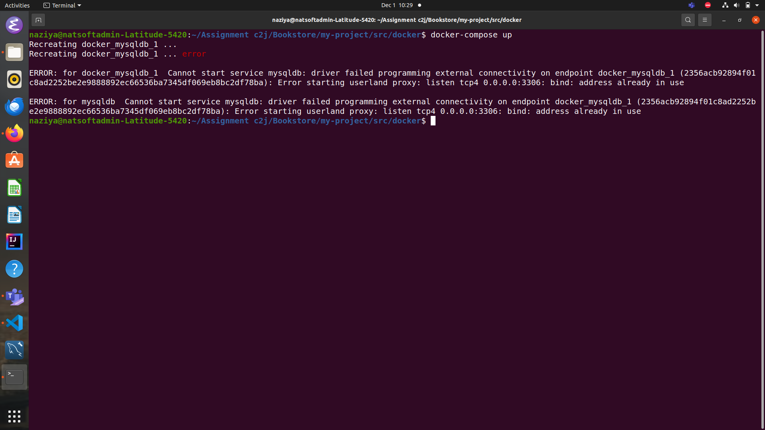

sudo lsof -i :3306 # If the error is on port 3306
sudo lsof -i :8080 # If the error is on port 8080

Note: check the port error before doing these commands
# Replace PID with the actual process ID
sudo kill PID

# Verify if the process is terminated
sudo lsof -i :3306 # Check for port 3306
sudo lsof -i :8080 # Check for port 8080

Note : If the process was successfully terminated, the lsof command should not return any results for the specified port.

If the container is already in use, additional steps may be required. However, to stop and remove the container, use the following commands:

# Stop the running container using either container name or container ID
docker stop container_name_or_id

# Remove the stopped container using either container name or container ID
docker rm container_name_or_id

Note : These commands will effectively stop and remove a Docker container. Make sure to replace container_name_or_id with the actual name or ID of the container you want to stop and remove.

