# Google Maps Inaccuracies in India: Risks, Incidents, and Solutions

## Overview

Many users in India experience frustration and even danger due to Google Maps providing inaccurate routes, outdated road info, or incorrect arrival times. These issues can cause delays, getting lost, or lead to unsafe situations—sometimes with tragic consequences.

## Key Issues

### Inaccurate Routing

* Users are often sent through remote, unsafe, or under-construction roads, especially when the app prioritizes the shortest or “fastest” route without considering local realities.
* Two-wheeler mode can direct riders onto extremely narrow or unsafe paths, sometimes unsuitable even for cycles.

### Outdated or Incorrect Road Information

* Maps may not reflect recent changes like new flyovers, road closures, or construction zones, leading to confusion and risk.
* Official road names used in directions may not match what’s visible on the ground, making navigation harder.

### Incorrect Arrival Times

* Estimated times can be off due to outdated traffic data or odd routing choices, leading to delays and frustration.

## Real-Life Consequences

### Fatal Accidents

* Multiple incidents where users, following Google Maps, drove onto unfinished bridges, into rivers, or down unsafe roads, resulting in deaths and injuries.
* Over-reliance on GPS without local knowledge can be dangerous, especially at night or in rural areas.

## Why Does This Happen?

### India’s Road Network Complexity

* Rapidly changing road infrastructure, informal paths, and inconsistent signage make mapping challenging.
* Heavy reliance on user-generated updates, which can be slow or inaccurate in less-populated areas.

### Data Limitations

* Maps depend on a mix of satellite imagery, user feedback, and government data, but updates may lag behind real-world changes.

## Recent Improvements

### AI-Driven Features

* Google is rolling out AI models to better estimate road width, avoid narrow roads, and provide clearer instructions (e.g., “take the flyover” instead of “take the ramp”).
* New features warn about narrow sections and show flyover callouts in major Indian cities.

### EV Charging Station Info

* Expanded to include two-wheeler EV charging stations, reflecting India-specific needs.

## Solutions & Recommendations

### For Users

* Cross-check routes, especially in unfamiliar or rural areas, and avoid over-reliance on navigation apps at night or during adverse weather.
* Use the “report a problem” feature to flag incorrect directions, helping improve map accuracy for others.

### For Map Providers

* Collaborate with local authorities and communities for real-time updates.
* Implement hyperlocal reporting and verification systems, similar to Waze’s community-sourced model.

### For Policymakers

* Develop national standards for mapping accuracy and timely updates.
* Encourage the creation of homegrown mapping solutions tailored to India’s unique road conditions.

While Google Maps is indispensable for millions in India, its inaccuracies can lead to serious risks. Addressing these challenges requires better technology, local partnerships, and increased user awareness to ensure navigation is both reliable and safe.

Apply Product Thinking

**Chosen Solution:** A Community-Enhanced Navigation Layer

After analyzing user complaints and real-world cases of Google Maps inaccuracies, I focused on a solution that not only fixes the problem but empowers users. The idea is a real-time, user-driven reporting layer that works alongside or within navigation apps.

It answers the key question:

“Does this remove the pain quickly and realistically?”

Yes—it does so by enabling quick user reporting and smart trust-based routing corrections.

Key Features:

* One-tap issue reporting (road closed, detour, hazard)
* Visual road overlays showing recent reports
* A trust score system that prioritizes credible data
* Community-driven rerouting triggers when issues are verification
* Optional photo or voice input to increase report reliability

This solution leverages existing user behavior (using Maps) and adds minimal friction to turn frustration into contribution.

Value Proposition Canvas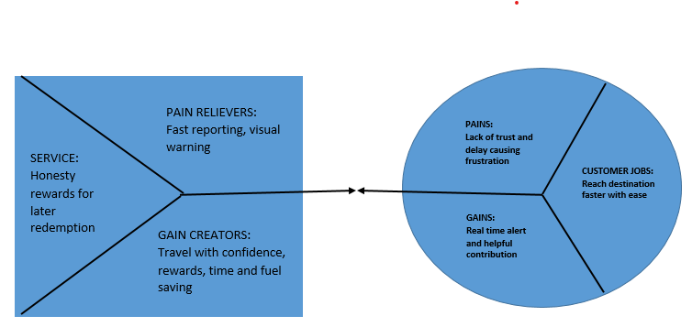

Jobs:

* Navigate efficiently and safely
* Reach destinations on time
* Avoid obstacles or confusing detours

Pains:

* Being routed through closed/dangerous roads
* Delayed arrival due to outdated traffic data
* Lack of trust in map accuracy
* No quick way to flag and fix bad data

Gains:

* Accurate, up-to-date routes
* Real-time alerts from nearby users
* Avoid frustration, delays, and unsafe paths
* Feel empowered and helpful by contributing

Pain-Relievers:

* Fast, frictionless issue reporting
* Community verification for accuracy
* Immediate visual feedback (color-coded road warnings
* Optional notifications if a user’s current route gets flagged mid-journey

Gain-Creators:

* Points and recognition for verified reports (gamified trust system)
* Confidence in navigation with real-world user support
* Time and fuel savings through smarter reroutes
* Greater trust in a collaborative map experience

Problem-Solution Fit Test: Community-Enhanced Navigation System

Problem Statement

While Google Maps is a widely trusted navigation tool, users frequently face issues such as:

* Inaccurate routing (wrong turns, blocked roads)
* Outdated or missing data (newly closed/opened roads)
* Misinformation (temporary detours, hazards)

These inaccuracies lead to delays, inconvenience, and safety concerns. A significant gap exists in real-time, hyperlocal reporting that could improve route accuracy dynamically.

Proposed Solution

We propose a Community-Enhanced Navigation System that integrates into existing maps with features like:

Real-time issue reporting by users (closures, hazards, detours)

* Instant alerts for nearby drivers
* Trust rating system (upvotes, verification by other users)
* Automatic suggestions for alternative routes based on verified reports

This system empowers users to keep the navigation tool up to date collaboratively.

Prototype & Metrics

Our clickable prototype will demonstrate:

* How users submit reports (UI/UX)
* How alerts are displayed live
* How trust scores are visualized

Test Group

We will recruit 10 users with diverse driving habits:

* 3 Daily commuters
* 3 Delivery drivers (food/package)
* 2 Ride-share drivers
* 2 Personal drivers (city use)

Success Criteria

Success is defined by meeting these thresholds:

* At least 80% find the feature easy to use
* At least 80% feel more confident using alerts
* At least 60% intend to use it regularly
* At least 1 real-life scenario shared where it would have been beneficial

Test Methodology

We will conduct the following:

1. Live Usability Test (20 mins each):

* Task 1: Submit a sample report (simulate road closure)
* Task 2: View & interpret live alerts
* Task 3: Rate report credibility

1. Survey & Interview (10 mins):

* Usability feedback
* Trustworthiness perceptions
* Real-world relevance
* Suggestions for improvement