**1. Product Vision & Mission**

**Vision:**  
Empower first-time earners to gain lifelong financial confidence and control through simple, supportive tools that foster better habits from day one.

**Mission:**  
To provide a lightweight, intuitive micro-saving and budgeting tool that helps users build discipline and reduce anxiety around money—without jargon, pressure, or complexity.

**2. Problem Statement**

"When I start earning, I want to save and manage my money effectively, but I struggle because I don’t know where to begin and feel overwhelmed by complex financial concepts—leading to stress, poor saving habits, and impulsive spending."

**3. Jobs-To-Be-Done (JTBD)**

**Functional Job:**  
"When I get my first paycheck, I want to set aside money easily and track my basic expenses so I can stay in control."

**Emotional Job:**  
"I want to feel confident and stress-free about my financial choices, even if I’m not a financial expert."

**4. User Research Plan**

* **Target Users:**
  + Young salaried employees (21–30)
  + Gig workers (delivery agents, freelancers)
* **Method:**
  + 1:1 qualitative interviews (5–8 users)
  + 1 short Google Form survey (20+ responses)
* **Goals:**
  + Understand pain points around saving and budgeting
  + Learn what users find intimidating or frustrating in finance apps
  + Identify language or features that users find reassuring or simple

**5. Persona Creation**

**Persona 1: Nikhil (Gig Worker, 24)**

* **Goals:** Consistently save part of his income; avoid cash shortfalls.
* **Behaviors:** Gets paid weekly, manages most expenses in cash or UPI, avoids banking apps.
* **Frustrations:** Irregular income, no structured savings, doesn't understand financial jargon.
* **Context:** Lives in a shared rental, supports family occasionally, rides for a delivery platform.

**Persona 2: Riya (Young Salaried Employee, 26)**

* **Goals:** Build an emergency fund, track spending, and control impulse buys.
* **Behaviors:** Uses one bank app, shops online, tries to budget manually.
* **Frustrations:** Finds budgeting apps too detailed or complex; unsure how much to save.
* **Context:** Lives independently in a metro city, works in marketing, has student debt.

**6. Flow Design**

**Selected: Task Flow - Setting a Weekly Savings Goal**

Home screen → Tap “Set Weekly Goal” → Choose amount to save → Pick auto-deduction day (optional) → Confirm and get motivational feedback

**7. Wireframes (Low-Fidelity)**

1. **Home Screen:** Balance overview, "Set Goal" CTA, weekly summary.
2. **Set Goal Screen:** Simple slider + text input.
3. **Auto-Deduction Setup:** Day and frequency selector.
4. **Confirmation Screen:** “You're all set!” message with confetti.
5. **Progress Tracker:** Shows how much saved this week + habit streak.

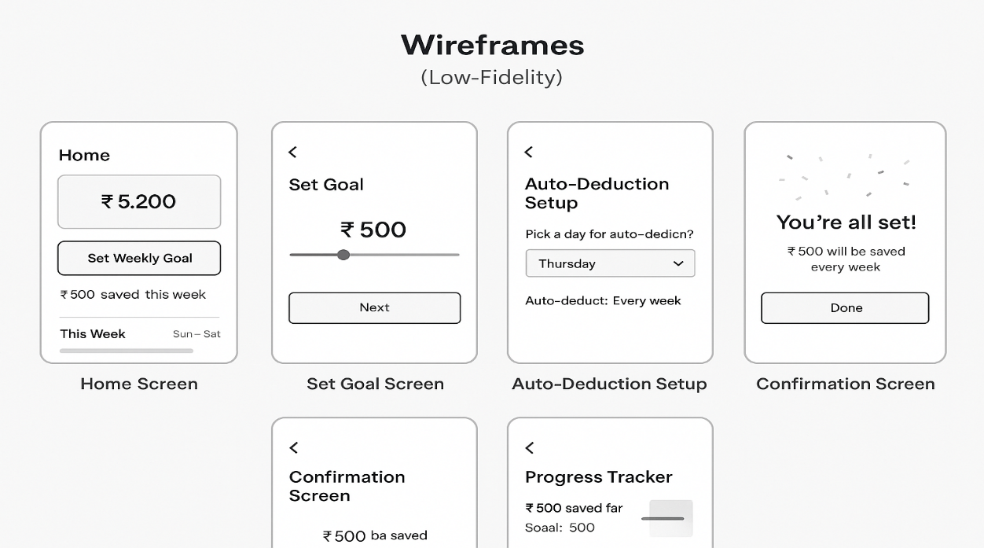

**8. User Stories + Acceptance Criteria**

**Story 1**

As a gig worker, I want to set a weekly savings goal, so that I can save without stress.  
**Acceptance Criteria:**

* Given the user is on the home screen
* When they tap “Set Weekly Goal”
* Then they should be able to set an amount and confirm within 3 steps

**Story 2**

As a young employee, I want to view my savings progress, so that I stay motivated.  
**Acceptance Criteria:**

* Given a goal is set
* When the user opens the app
* Then they see progress as a bar or streak with savings breakdown

**9. Effort Estimation (Story Points)**

|  |  |  |
| --- | --- | --- |
| **User Story Description** | **Story Points** | **Rationale** |
| Setting Weekly Goal UI + Logic | 5 | Involves input validation, storage, and feedback UI |
| Progress Tracker Screen + Integration | 3 | Data visualization and fetching weekly history |

**10. Minimum Viable Product (MVP)**

* One core flow: Set weekly savings goal → Track weekly progress
* Simple, distraction-free UI with motivational feedback
* No advanced analytics or integrations—focus on *habit creation*

**11. Roadmap**

**Now**

* Conduct user interviews and define MVP scope
* Build goal-setting flow and savings tracker

**Next**

* Add notifications, motivational nudges
* Introduce weekly reflections or mini-rewards

**Later**

* Integrate with bank accounts/UPI
* Smart AI suggestions for how much to save

**12. Usability Testing Plan**

**Tasks:**

* Set a savings goal
* Check progress after 2–3 simulated days
* Try editing or cancelling goal

**Metrics:**

* Task success rate
* Average time to complete goal setup
* Post-task rating (ease of use, satisfaction)

**13. Bonus: AI Thinking**

**AI Use Cases:**

* **Personalized Suggestions:** Based on income pattern, suggest ideal weekly saving amount.
* **Spending Pattern Analysis:** Show insights like “You spend 30% on food. Consider cutting by 5%.”
* **Automated Feedback:** Celebrate milestones (“You've saved for 4 weeks straight!”) or issue nudges after inactivity.