**EC2 -- Elastic Compute Cloud**

Amazon Elastic Compute Cloud (Amazon EC2) provides scalable computing capacity in the Amazon Web Services (AWS) cloud. Using Amazon EC2 eliminates your need to invest in hardware up front, so you can develop and deploy applications faster.

**Synonyms**

Computer, machine, box, PC, Server = As per AWS terminology - **Instance**

**Ex 1: Launching a Windows Instance**

**Step 1:** Login to AWS. Go to the AWS website and log in to your account.

**Step 2:** Choose a region where you launch your instance will determine the latency of your application. Choose a region that is close to your users or where you have a data center.

**Step 3:** Services > EC2 > Instances > Launch Instances

**Name and tags**

MyWindows

**Amazon Machine Image**

AMI is a template that contains the operating system and software that you want to run on your instance.

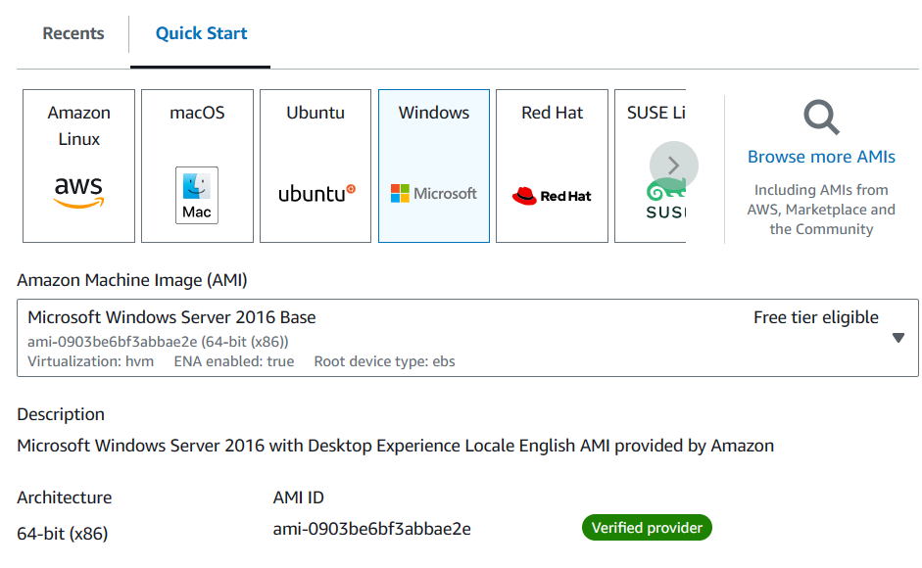

**Instance type ---** t2.micro (free tier)

An instance type is a set of hardware specifications for your instance. Choose an instance that is appropriate for your workload.

**Key pair (login)**

Create new keypair – MyWindowsKP

A key pair is a set of public and private keys that you can use to securely connect to your instance. Download key pair and save the .pem file to a secure location.

**Network settings – edit**

Security group name *–*required --- MyWindowsSG

A security group is a way to control the traffic that is allowed to enter your instance.

**Inbound security groups rules** (It deals with ports)

We have 0 to 65535 ports

Every port is dedicated to special purpose

RDP -- 3389

SSH -- 22

HTTP -- 80

HTTPS - 443

For windows machine, we need to open RDP port (Remote Desktop Protocol)

Here by default, we have RDP

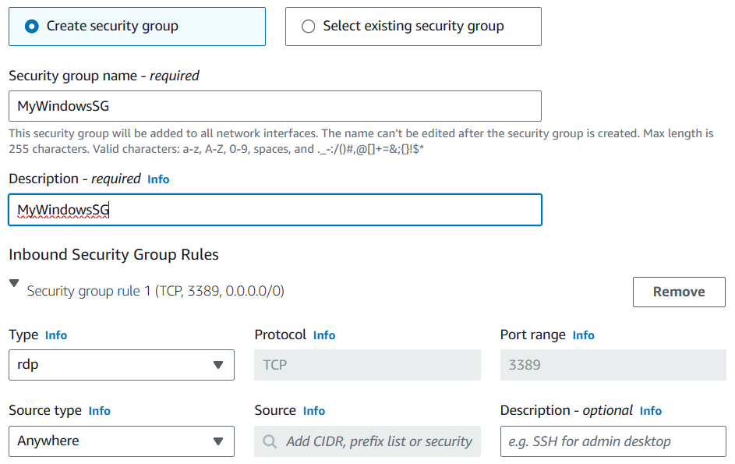

**Configure storage – 30 (default)**

Storage (volumes)

1 volume(s) - 30 GiB

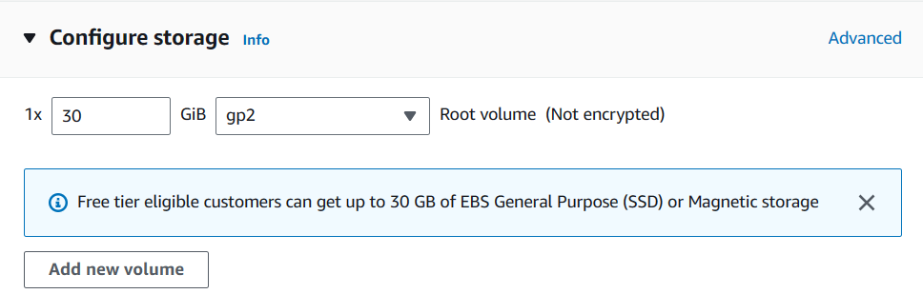

There are two main types of GiB (gibibyte) in EC2:

**Root volume GiB:**

The root volume is the default storage device for an instance. When you launch an instance, the operating system and other boot files are automatically loaded onto the root volume. The size of the root volume can be varied depending on the needs of the instance.

**EBS volume GiB:**

EBS volumes are additional storage volumes that can be attached to instances. EBS volumes are persistent, meaning that they will not be deleted when the instance is terminated. EBS volumes can be used to store data that needs to be accessed by multiple instances, or to store data that needs to be replicated in multiple Availability Zones. The size of an EBS volume can be varied from 1 gibibyte to 16 tebibytes (16,000 gibibytes).

**Number of instances** – 1

**Launch instance**

We get the instance ID. View all Instances.

**Observation:**

The new windows machines, is having its own DNS Name, Username and password

We need to provide all the above 3 details in our laptop, so that we can connect.

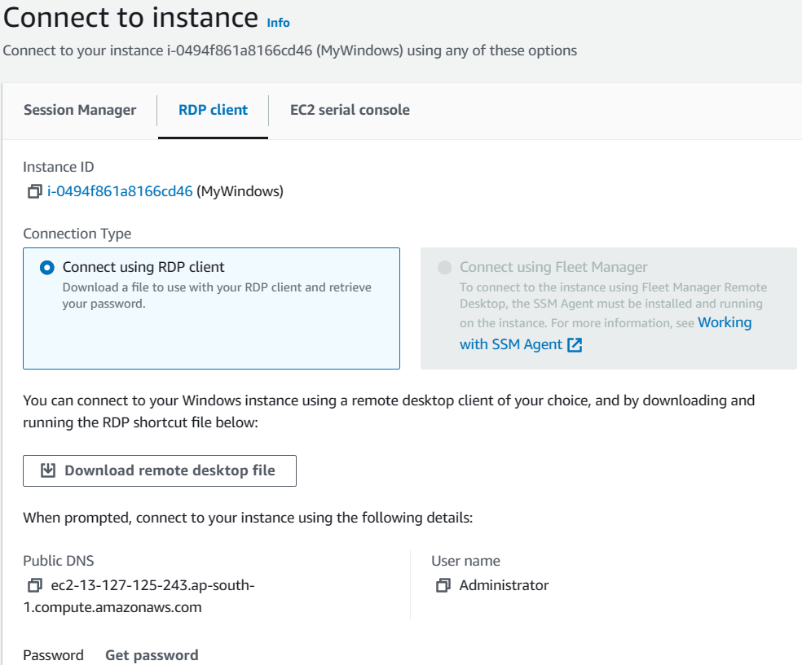

**Connecting to your instance**

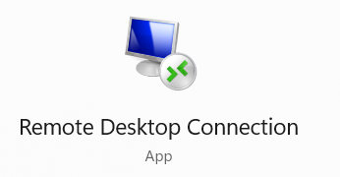

To connect to your instance, you will need to use the Remote Desktop Connection (RDC) application. To do this, open the RDC and enter the following information:

Computer - Provide public DNS

User name -- Administrator

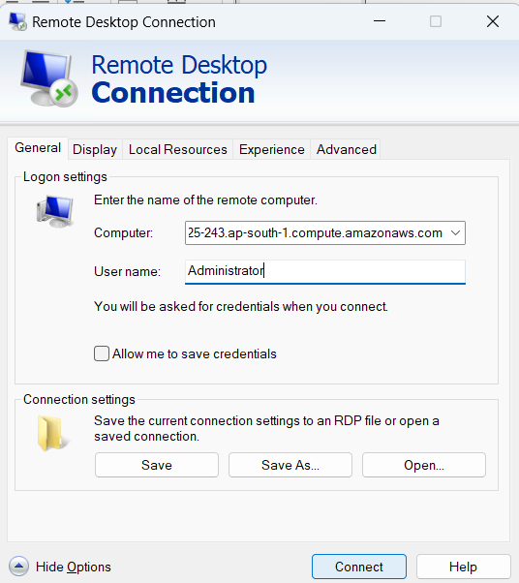

AWS, gives us DNS name, username, it does not give the password.

Instead of password, AWS has given us .pem file. But, to connect to Window, we need password. AWS gives an option to convert .pem to password

Connect to instance – RDP Get password -- upload pem file -- Decrypt

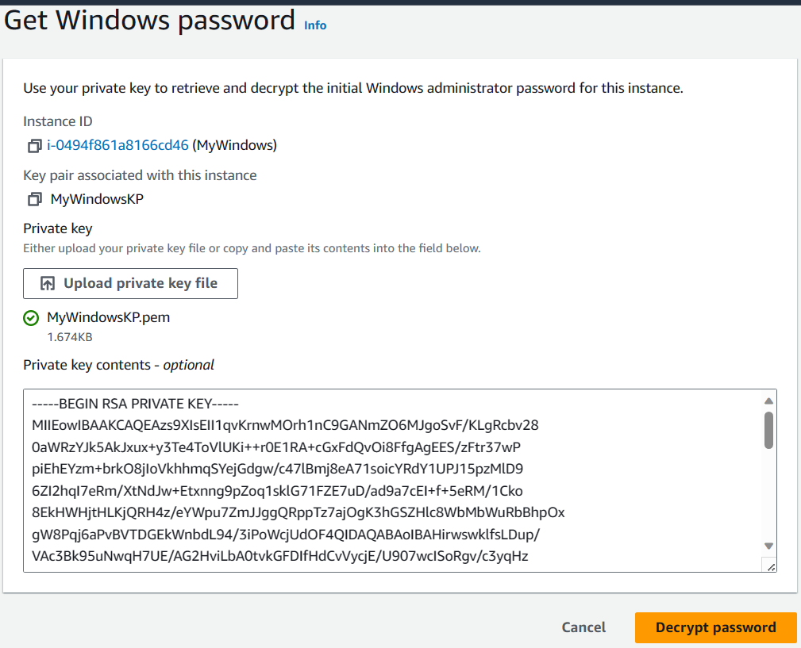

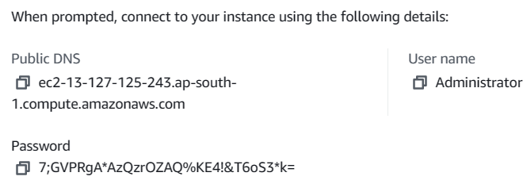

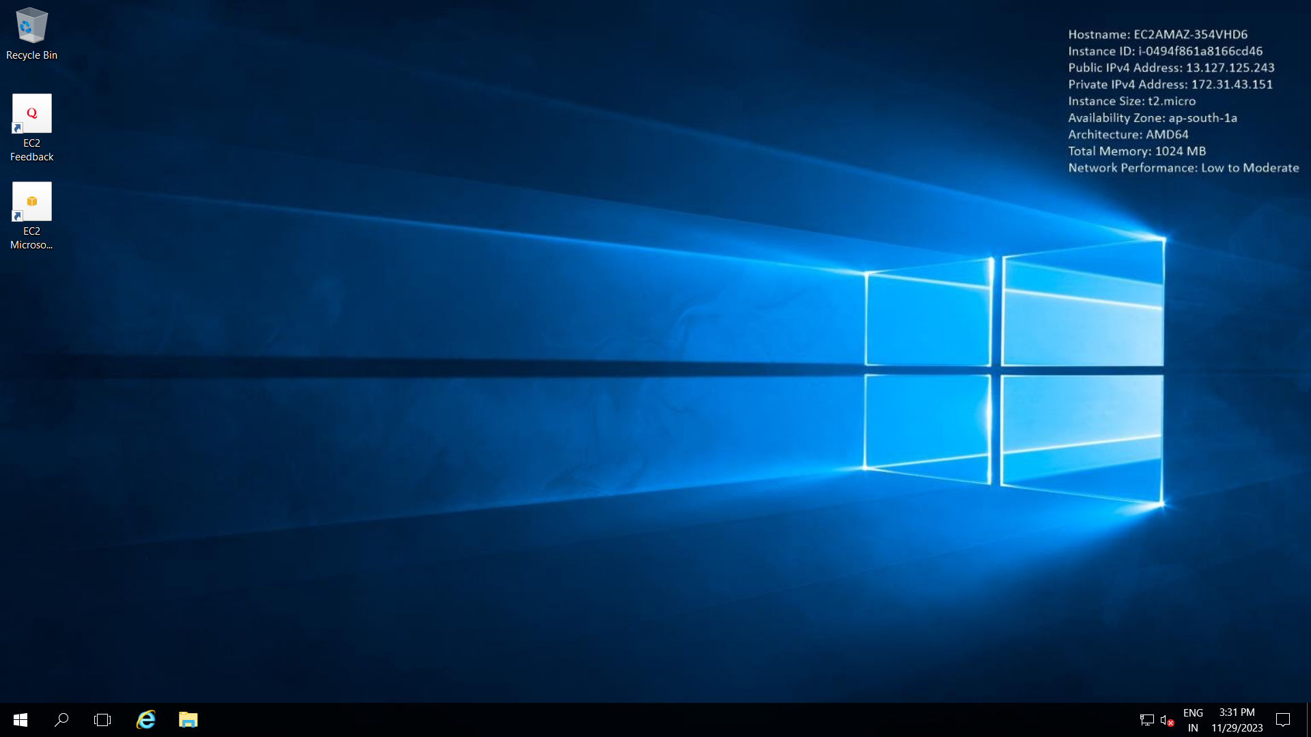

Hurray!! We are connected.

Let’s check the hardware configuration

Check hard disk, Ram

You can copy paste file from laptop to win server!!

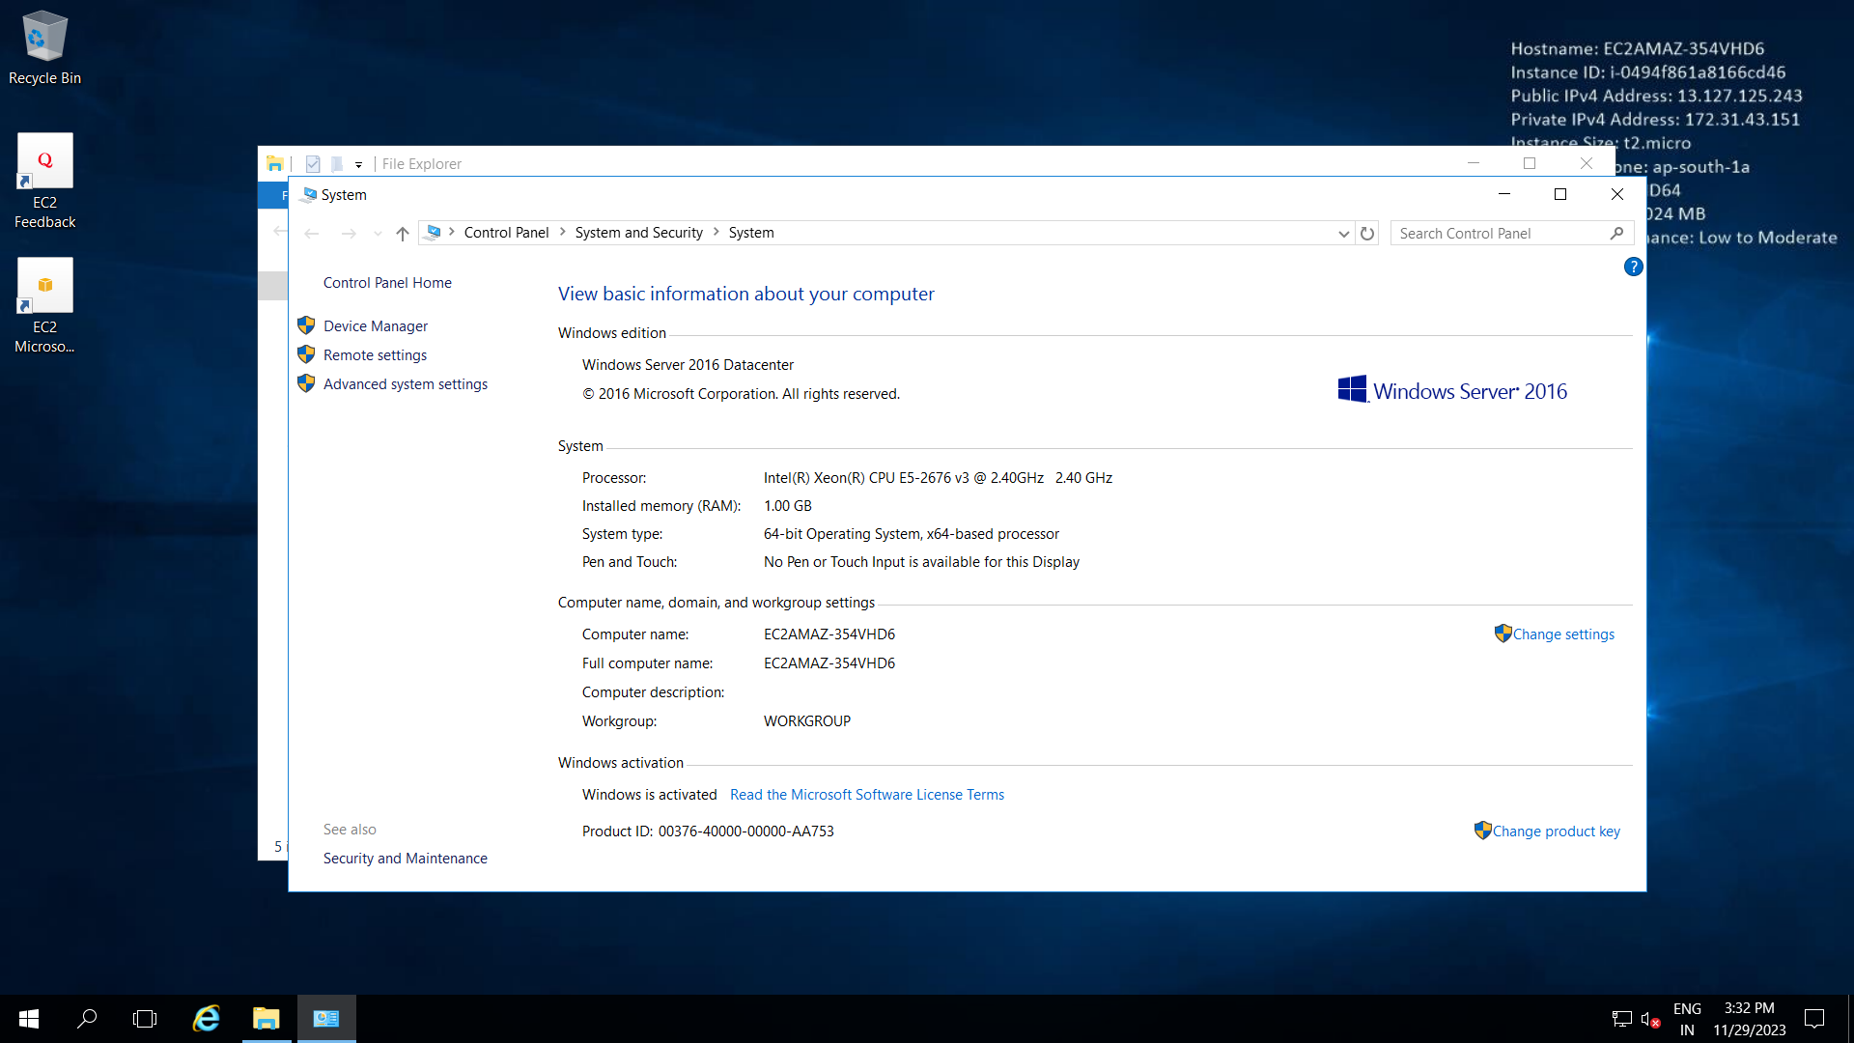

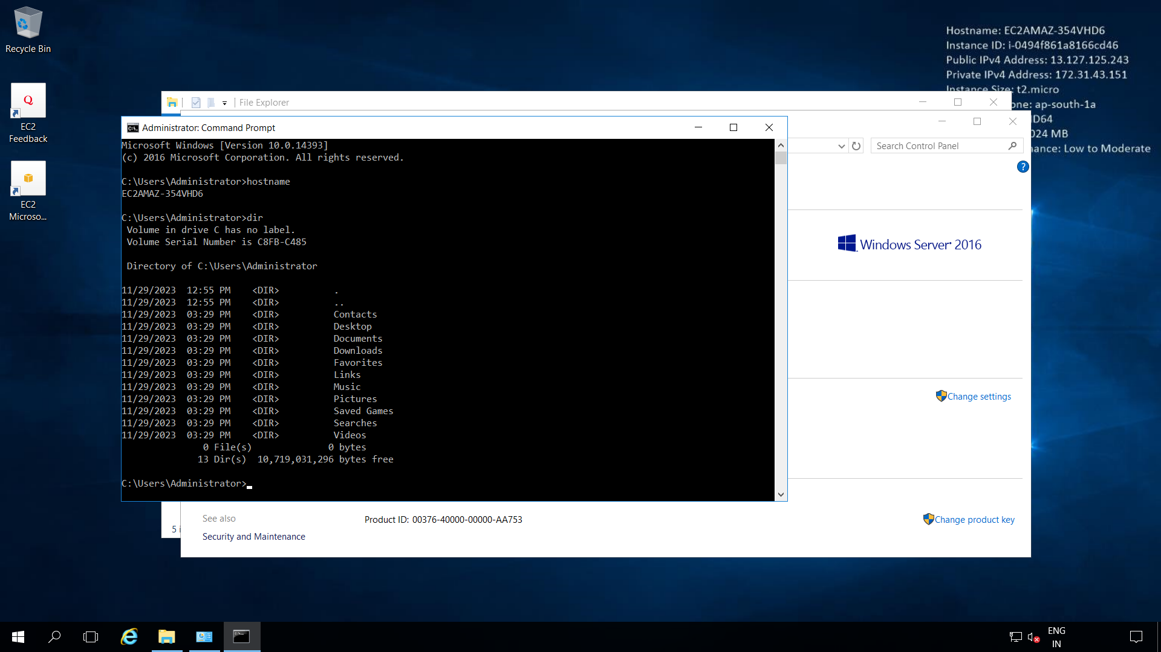

To disconnect, just close the remote desktop window.

**Stop and Terminate Instances**

It is important to stop and terminate your instance to avoid billing.

EC2 > Instances > Select instance > Instance State > Stop instance > Terminate instance.

Delete Security group except default. And delete Key pair too.