**AWS ─ Amazon S3**

**S3(Simple Storage Service)**

* S3 is a secure, durable and highly-scalable object storage.
* It is easy to use, with a simple web service interface to store and retrieve any amount of data. from anywhere on the web.
* S3 is a safe place to store your files.
* It is Object based storage.
* Files can be from 0 bytes to 5 TB (Graphical/ Console)
* Files can be from 0 bytes to 5GB (CLI)
* There is unlimited storage.
* Objects are stored in buckets.
* S3 bucket names must be unique globally.
* Built for 99.99% availability for the S3 platform.
* Amazon Guarantee 99.999999999% durability.
* Tiered Storage Available.
* Lifecycle Management.
* Versioning
* Encryption
* Secure your data using Access control lists and Bucket policy.

**S3 Storage Classes/ Tiers**

* S3 Standard
* S3 Intelligent Tiering
* S3 Standard IA
* S3 One Zone-IA (Infrequently Access)
* S3 Glacier (To get data, need to wait for 2-5 hours)
* S3 Glacier Deep archive (To get data, need to wait for 12 hours)

**S3 Charges**

Charged for:

* Storage
* Requests
* Storage Management Pricing (Tiers)
* Data Transfer Pricing (Manual)
* Transfer Acceleration
* Cross Region Replication (Automatic)

**Transfer Acceleration**

* S3 Transfer Acceleration enables fast, easy and secure transfers of files over long distances between your end users and as S3 bucket.
* Transfer Acceleration takes advantage of Amazon Cloud Front’s globally distributed edge locations.
* As the data arrives at an edge location, data is routed to Amazon S3 over an optimized network path.

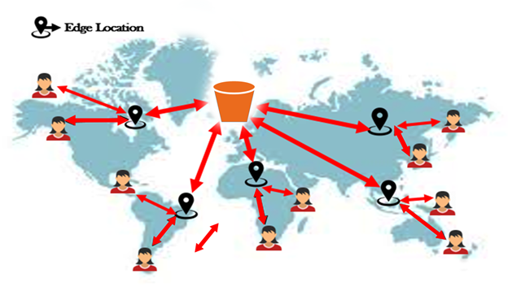

**Practicals:**

**Creating bucket**

Services à Storage à S3

**Create Bucket**

Bucket Name –  should be unique globally, No uppercase, should not contain invalid char like ‘ , [ # )

Check bucket name restriction in google

Bucket name – my-test-demo-bucket01

Regions – Mumbai

Uncheck block public access à Create bucket. (publicly accessible)

Note: buckets created are available global. Not like EC2 machines

Observation: We can see global in dashboard

**Create another bucket**

Bucket name – my-test-demo-bucket02

Select region as Singapore

Observe: Both the buckets are available in the dashboard.

**To upload the objects (data) in the bucket:**

Click on the bucket

Upload à Add files à select any image or file à manage public permissions à grant public read access à upload

Note: As bucket is public, and object is also public, anyone in the world can access the content.

Click on the object à get Object URL

Using Object URL anyone can access.

Copy the URL and paste it in browser you can access the object because it is publicly readable.

**To make the object private:**

Edit permissions à untick everyone (public access)

If you check the URL, the access is denied now.

Edit properties tab à Enable versioning à Save changes

To make it available again:

Edit permissions à Grant public access

**Advantage of versioning**

* We can recover deleted object.
* We can maintain different versions of the file

Select the check box à actions à delete

**How can we recover?**

Enable list version

We can see the object and its delete marker.

**Note**: When we delete, the object is not deleted. It is marked as deleted. If you remove the delete marker, we will get the object.

Select the delete marker check box à actions à delete

Now disable list version

Our object is back!!!

Edit the file à open the same file in file explorer à add another line à upload the same file again

Get the object URL, and check it from browser, we will get the latest file.

**Where can we see the older versions of the file?**

Show list version

We can see both the versions and we can download the older versions of the file.

Even if you delete the file, we can recover both the versions.

Select the object à actions à delete à delete

Select show button

We can see both versions and if you delete individual versions, we cannot recover.

**Note**: If you delete bucket, we cannot recover.

**Static Website Hosting**

Select bucket à Properties à Static Website Hosting à  Edit à Enable à Host a static website

Index document – index.html

Error document – error.html

Save

Upload index.html and error.html

Go to the properties of the bucket à static website hosting à get the URL of the website (endpoint)

Note: Individual files should have public access.

Use of error.html – In case of any reason, if index.html is not accessible then error page will be displayed.

Let’s make the index.html page as private.

Select index.html à ACL à Edit à public access – read à uncheck à Save changes

Refresh the URL à We will get the error.html page!!

**Cross Region Replication**

Let’s say, we have two buckets (1st bucket in Mumbai and 2nd bucket in Singapore)

When we upload the object in Mumbai, the object should also be available in Singapore.

As we are replicating an object in another region, it is called cross region replication.

Vice-versa will not happen.

If we delete the object in Mumbai, it will not be deleted in Singapore. If you still wish to delete in other region also. Bucket à Management à Replication rules à add delete replication and save it.

If we edit the object in Mumbai, it will not be edited in Singapore.

Enable Cross Region Replication in Mumbai Region bucket

Select Mumbai region bucket à Management à Replication rules à create replication rule à enable bucket versioning à replicate rule name

Destination bucket à Singapore bucket à enable versioning à IAM role.

To establish connection between two regions, we need an IAM role. Create new role and save it.

upload object in Mumbai region and it will be replicated in Singapore bucket.

**Transfer Acceleration**

When we enable transfer acceleration, data will be transferred to edge location and then from edge location data will be transferred to bucket.

Select Mumbai bucket à properties à transfer acceleration à edit à enabled à save changes

How can we check the speed?

Properties à transfer acceleration à learn more

Amazon S3 Transfer Acceleration Speed Comparison Tool à want to compare your data transfer speed by region (open in new tab) We can compare

S3 direct upload speed

S3 accelerated transfer upload speed

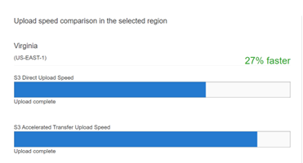

**Encryption**

There are two types of encryptions.

1. AES -  256 (Advanced Encryption Standard) – Single encryption
2. AWS – KMS (Key Management Service) – Double encryption (more secured)

Select the required encryption.

Select the bucket à properties à default encryption à edit à enable

**Metadata and Tags**

Metadata – to provide more information about the object in key-value pairs.

Keys are pre-defined. Eg: Content-type, Content-language etc

Tags – to provide more information about the object in key-value pairs.

Keys and Values we need to provide.

Select the object à properties, we can see the metadata and tags.

**ACL and Bucket policy**

Select the bucket à permissions tab

ACL Edit à add grantee

Enter canonical ID – save changes

Note: ACL we can apply at bucket level and object level

Select the object and provide the access by entering canonical ID

Bucket policy, we can apply only to bucket.

Select the bucket ---> Permission, we can see bucket policy. Bucket Policy are written in JSON Code.

Bucket policy should be defined in JSON code. It’s the job of AWS administrator.

Select any object ---> Permissions tab

Observe: We do not have bucket policy. As bucket policy, we need to apply at bucket level only.

**Life cycle management**

Let’s create a new bucket   
Select the bucket --> Management tab --> Create lifecycle rule   
Rule name - Demorule

This rule applies to all objects -- I Acknowledge

Transit current version of objects between storage classes   
Standard IA -- 30 Days

Add transition

One Zone-IA -- 60 Days

Add transition

Glacier Flexible – 130 Days

Create Rule   
From now, any object uploaded in the bucket will follow the rule for transition.

At last, delete all S3 buckets and IAM roles that you have created for your s3 buckets to avoid billing.