Lecture Supplement
Econ 335;
Professor lakshmi K. Raut

This material is relevant for understanding chapter 3 material in your text book. This material is not in your text book.
Concepts:
- PPC or PPF
- Slope of the PPF denoting opportunity cost of producing one good in terms of the other good.
- Revenue maximizing output supply or production point on the PPF
- Utility maximizing consumption point on the budget line.
- Trade triangle describing import and export of goods in the economy at different prices.

Consider a Ricardian model with the following data

Country | Labor required to produce a unit of Wine | Labor required to produce a unit of Cloth | Labor availability
US | 4 | 3 | 120
Foreign | 2 | 1 | 100

Figure 1: PPF of US

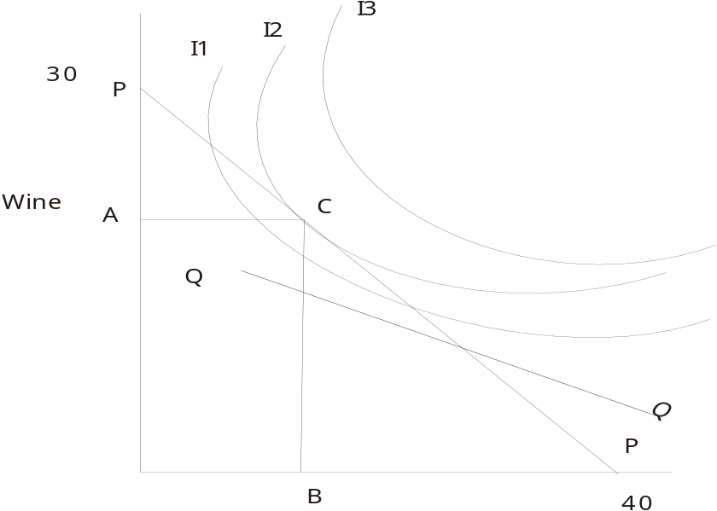

To answer the following questions, use the above PPF for US to answer the following questions:
- The slope of the PPF is 1) ½, 2) 2/3, 3) 3/4, 4) 2 5) 1
- (T/F) The opportunity cost of producing one unit of cloth in terms of foregone production of wine is the slope of the above PPF line.
- (T/F) The opportunity cost of producing one unit of wine in terms of foregone production of cloth is the slope of the above PPF line.
- Suppose we normalize price of wine (the y-axis good) to 1, i.e., p_{w} = 1, and denote the price of cloth in terms of wine as p_{c|w}. Then p_{c|w} in autarky is given by 1) ½, 2) 2/3, 3) 3/4, 4) 2 5) 1

- What will be autarky equilibrium price of wine in terms of cloth?
Ans: 1/ p_{c|w}.

- The autarky equilibrium consumption point is 1) A 2) B 3)C,

- What is the autarky equilibrium income level, when income is measured in terms of wine?
Ans: 30

- What is the autarky equilibrium income level, when income is measured in terms of cloth?
Ans: 40

- Suppose the autarky equilibrium consumption of wine, i.e., A=20, what is the autarky equilibrium consumption level of cloth, i.e., value of B?
Ans: 13.33

- Suppose the international price p’_{c|w} is as depicted by the line QQ in the graph above. Is international price of cloth in terms of wine is higher or lower than the autarky equilibrium price?
Ans: lower, since it is less steep than the autarky equilibrium price level which is the slope of the PPF.

- If QQ is the new price line how much of cloth and how much of wine the producers will supply to the market to maximize their revenue?

Ans: Make the price line shift parallel to the right as far as you can go until you go out of the PPF, that will be the point P on the y-axis, i.e., they will produce 30 units of wine and 0 units of cloth.

- What will be the new maximized revenue of the producers which is also the total income of the residents in terms of wine?
Ans: 30.

- What will be the new maximized revenue of the producers which is also the total income of the residents in terms of cloth?
Ans in the graph, where the new line QQ that is passing through the new production point P=(30,0) touches the x-axis, it is not shown.

- Suppose the slope of QQ is –3/5. What will be the maximized revenue or income in terms of cloth?
Ans: 30*5/3 = 50.

- If the international price is given by the slope of the line QQ, Would US specialize in production of wine?
Ans: Yes.

- Us will export wine or import wine?
Ans: export wine.

- What will be the level of utility that US can achieve at the autarky: 1) I1, 2)I2, 3) I3?

Consider the following diagram for the PPF of US with increasing marginal cost of production, explain how the answers going to change in the above questions when we have the this PPF. (if some of them could not be answered, just say so).

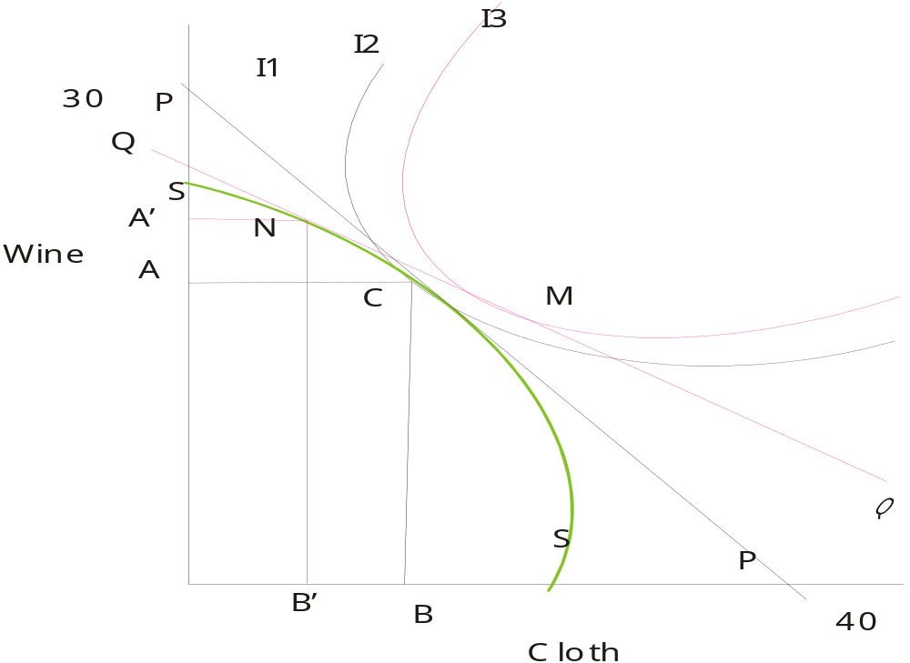

In the above diagram, red lines indicate situations with trade. A’ and B’ is the production of wine and cloth at the international price represented by the red line QQ.

