SECURE CODING REVIEW REPORT

Name: Lakshmi Sai

Project: Secure Coding Review

1.INTRODUCTION

This project reviews a simple login application to identify security vulnerabilities and recommend secure coding practices.

2.VULNERABILITY IDENTIFIED

SQL Injection

The application directly inserts user input into SQL queries without validation, making it vulnerable to SQL Injection attacks.

3.VULNERABLE CODE EXAMPLE

query = "SELECT * FROM users WHERE username='" + username + "' AND password='" + password + "'"

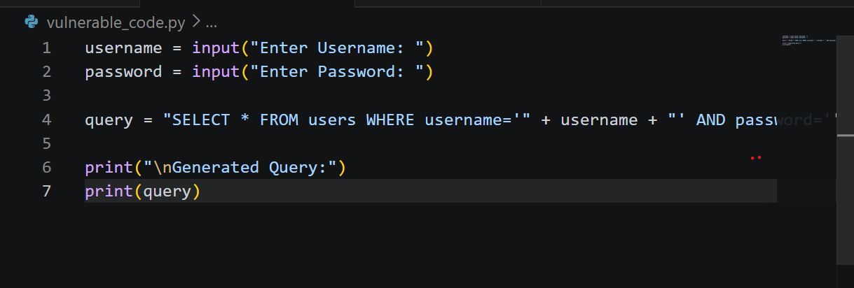

4.ATTACK DEMONSTRATION

Malicious Input:

Username: ' OR '1'='1

Password: anything

Generated Query:

SELECT * FROM users WHERE username='' OR '1'='1' AND password='anything'

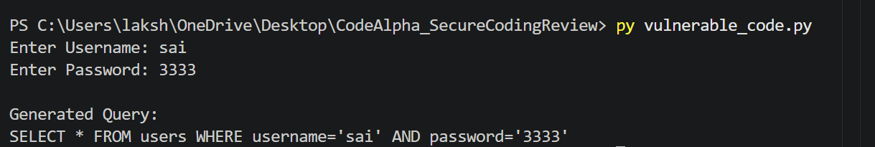

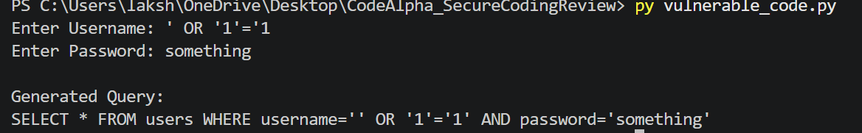

This input can manipulate the SQL query and potentially bypass authentication.

5.RISKS

Unauthorized Access

Login Bypass

Data Theft

Database Manipulation

6.SECURE SOLUTION

Parameterized Queries

Example:

query = "SELECT * FROM users WHERE username=? AND password=?"

Parameterized queries separate user input from SQL commands and prevent SQL Injection attacks.
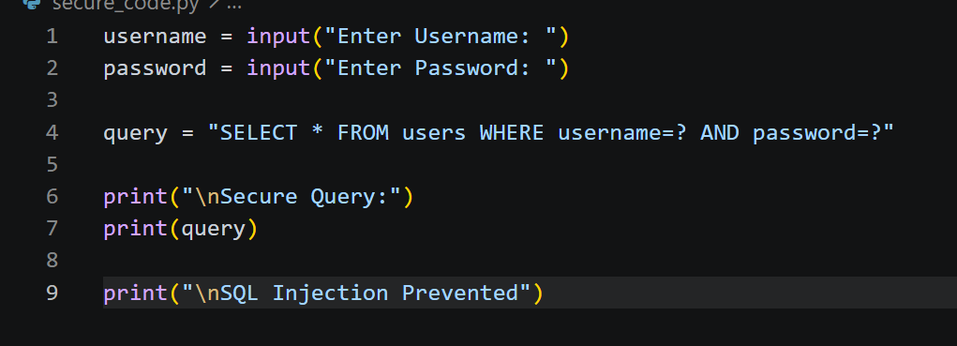
OUTPUT :

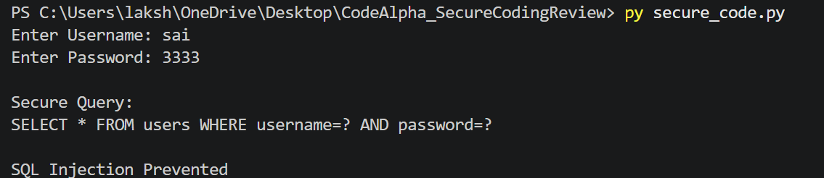

7.SECURE CODING BEST PRACTICES

Validate user input

Use parameterized queries

Avoid hardcoded credentials

Follow the principle of least privilege

Keep software updated

8.CONCLUSION

The SQL Injection vulnerability can be prevented using secure coding techniques such as parameterized queries and proper input validation.

