
DATA STRUCTURES AND ALGORITHMS
23CSE203
LAB MANUAL
SUBMITTED BY
NAME | Lakshmi Sai Ram K
ROLL NO | AV.SC.U4CSE25213
YEAR/SEM/SECTION | 2ND YEAR/SEM-3/CSE-C
CREDITS | 05

SUBMITTED TO | Dr Gayathri Parasad
DESIGNATION | Asst. Professor (Sr. Gr)
DEPARTMENT | SCHOOL OF COMPUTING

INDEX
S.NO | TITLE | PAGE NO
1. | WEEK 1:  1(A). A rocket launch system displays a countdown before launch. Instead of using a loop, implement the countdown using recursion. Write a recursive python program to display a countdown from n to 1, followed by “Launch!”.  1(B). Banks calculate the growth of an investment using compound interest. The formula requires calculating powers, which can be implemented recursively. Write a recursive program to calculate P^{n}(power) where: P= principal growth factor, n= number of years.  1(C). A HR department stores employee ID’s in a list. Develop a recursive program to search for a given employee ID. Write a recursive function to search for an employee ID in a list.  1(D). In a logistics company, the number of possible ways to arrange n different parcels are calculated using the factorial formula (n!). Develop a recursive program to calculate the factorial of a given number.  1(E). Write a recursive python program to print the first n terms of the Fibonacci series. | 5-13
2. | WEEK 2:  2(A). Write a python program to implement linear search.  2(B). Write a python program to implement binary search with and without sorted array as an input. | 14-19
3. | WEEK-3:  3(A). Write a python program to implement bubble sort.  3(B). Write a python program to implement insertion sort.  3(C). Write a python program to implement selection sort. | 20-25
4. | WEEK-4:  4(A). Write a python program to implement quick sort.  4(B). Write a python program to implement merge sort. | 26-29
5. | WEEK-5:  5(A). Write a python program to implement a Singly Linked List with the below operations.  - Create Linked List  - Insert Beginning  - Insert End  - Insert at Index  - Delete by Value  - Delete First Node  - Delete Last Node  - Count number of nodes  - Sort the data of SLL  - Search data in SLL  - Display or Traverse  - Exit | 30-38
6. | WEEK-6:  Write a python program to implement a Double Linked List with the below operations.  - Create Linked List  - Insert Beginning  - Insert End  - Insert at Index  - Delete by Value  - Delete First Node  - Delete Last Node  - Count number of nodes  - Display or Traverse  - Exit | 39-49
7. | WEEK-7:  7(A). Write a python program to implement stack operations such as push, pop, peek, display using an array.  7(B). Write a python program to implement stack operations such as push, pop, peek, display using a linked list. | 49-59
8. | WEEK-8:  8(A). Write a python program to implement Queue and its operations such as enqueue, dequeue, peek, display with a menu driven approach. Implement using array, and linked list data structures.  8(B). Write a python program to implement Circular Queue and its operations such as enqueue, dequeue, peek, display with a menu driven approach. Implement using array, and linked list data structures. | 60-79
9. | WEEK-9:  Write a python program to implement a Binary Search Tree (BST) and perform the following operations.  1. Insertion  2. Deletion  3. Tree Traversals – in-order, pre-order and post-order  4. Count Leaf Nodes  5. Count Internal Nodes  6. Height of the Tree | 80-91
10. | WEEK-10:  Write a menu driven python program to implement an AVL Tree and perform the following operations.  1. Insertion  2. Deletion  3. Tree Traversals  4. Count Leaf Nodes  5. Count Internal Nodes  6. Height of the Tree | 92-99
11. | WEEK-11:  Write a menu-driven Python program to implement a Binary Heap (Max Heap and Min Heap) and perform the following operations:  - Insertion of an element into the Heap.  - Deletion of the root element from the Heap.  - Display the array representation of the Heap.  - Exit the program. | 100-104
12. | WEEK-12:  Write a program to implement the following three collision resolution techniques in a Hash Table:  - Separate Chaining  - Linear Probing  - Quadratic Probing | 105-117

WEEK – 1
PROGRAM-1(A):

AIM: A rocket launch system displays a countdown before launch. Instead of using a loop, implement the countdown using recursion. Write a recursive python program to display a countdown from n to 1, followed by “Launch!”.

CODE:
def countdown(n):
if n == 0:
print("Launch!")
return
print(n)
countdown(n - 1)

n = int(input("Enter countdown value: "))
countdown(n)

OUTPUT:
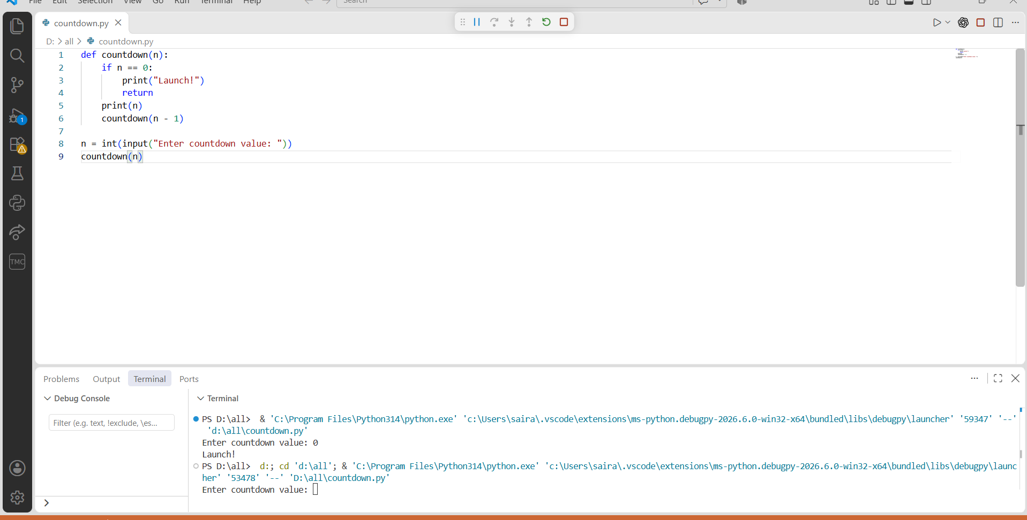

PROGRAM-1(B):

AIM: Banks calculate the growth of an investment using compound interest. The formula requires calculating powers, which can be implemented recursively. Write a recursive program to calculate P^{n}(power) where: P= principal growth factor, n= number of years.

CODE:
def power(p, n):
if n == 0:
return 1
else:
return p * power(p, n - 1)

p = float(input('get me the amount:\t'))
n = int(input('agreed years:\t'))
print(power(p, n))

OUTPUT:

PROGRAM-1(C):

AIM: A HR department stores employee ID’s in a list. Develop a recursive program to search for a given employee ID. Write a recursive function to search for an employee ID in a list.

CODE:
def recursive_search(arr, key, index):
if index == len(arr):
return -1
if arr[index] == key:
return index
return recursive_search(arr, key, index + 1)

arr = list(map(int, input("Enter elements: ").split()))
key = int(input("Enter employee ID to search: "))

result = recursive_search(arr, key, 0)

if result == -1:
print("Employee ID not found")
else:
print("Employee ID found at index", result)

OUTPUT:
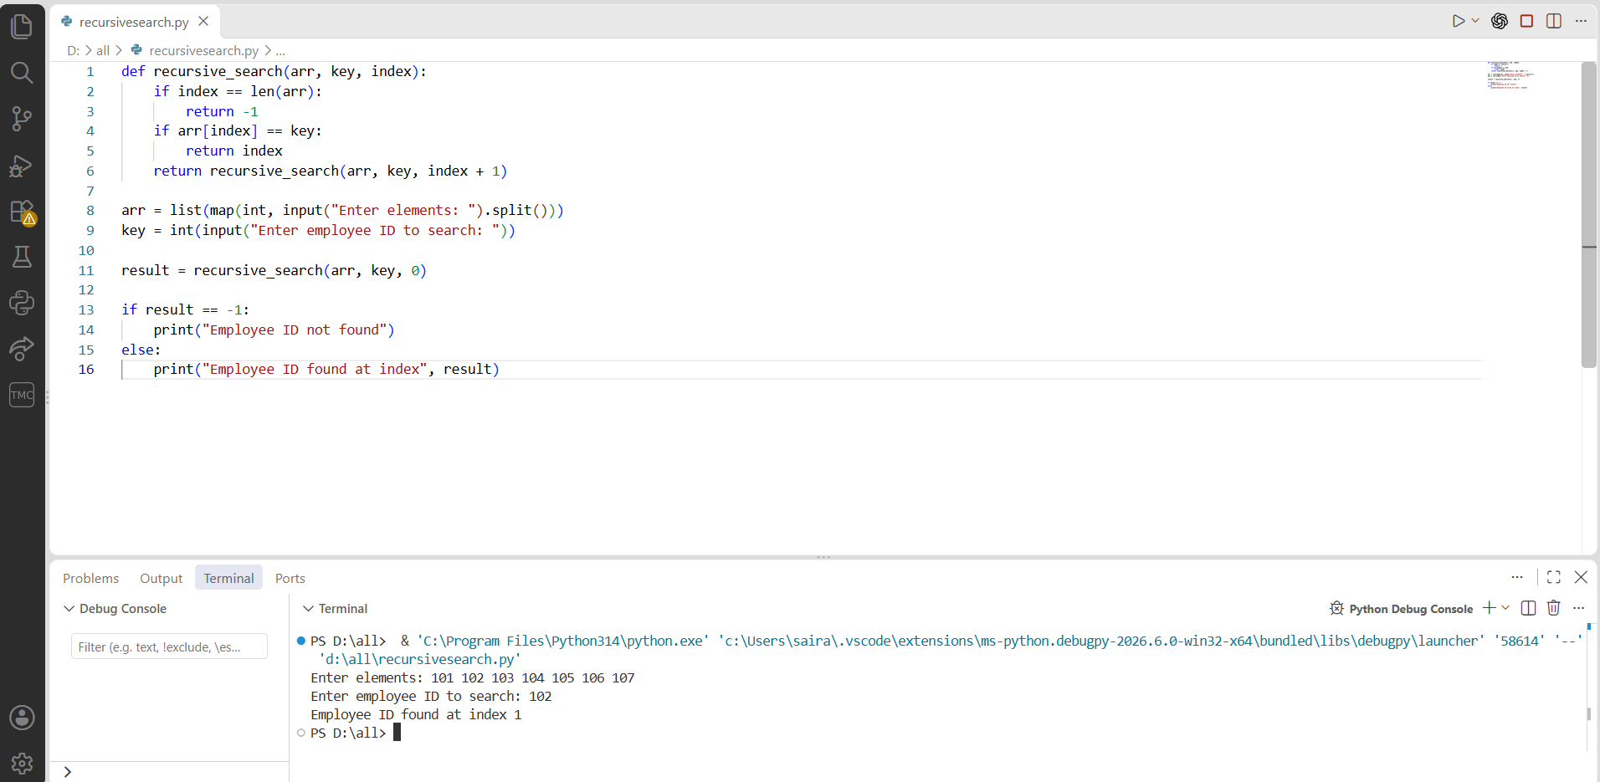

PROGRAM-1(D):

AIM: In a logistics company, the number of possible ways to arrange n different parcels are calculated using the factorial formula (n!). Develop a recursive program to calculate the factorial of a given number.

CODE:
def factorial(n):
if n == 0 or n == 1:
return 1
return n * factorial(n - 1)

n = int(input("Enter a number: "))
print("Factorial =", factorial(n))

OUTPUT:
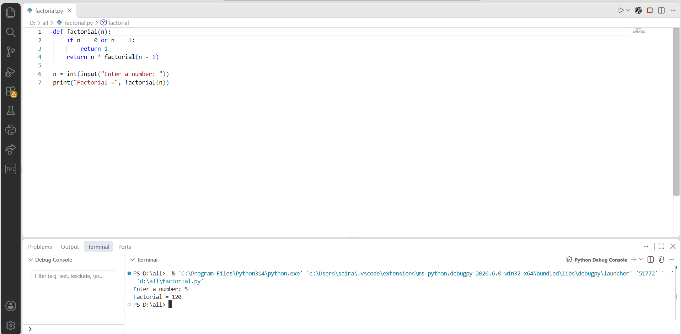

PROGRAM-1(E):

AIM: Write a recursive python program to print the first n terms of the Fibonacci series.

CODE:
def fibonacci(n):
if n == 0:
return 0
elif n == 1:
return 1
return fibonacci(n - 1) + fibonacci(n - 2)

n = int(input("Enter number of terms: "))

print("Fibonacci Series:")
for i in range(n):
print(fibonacci(i), end=" ")

OUTPUT:
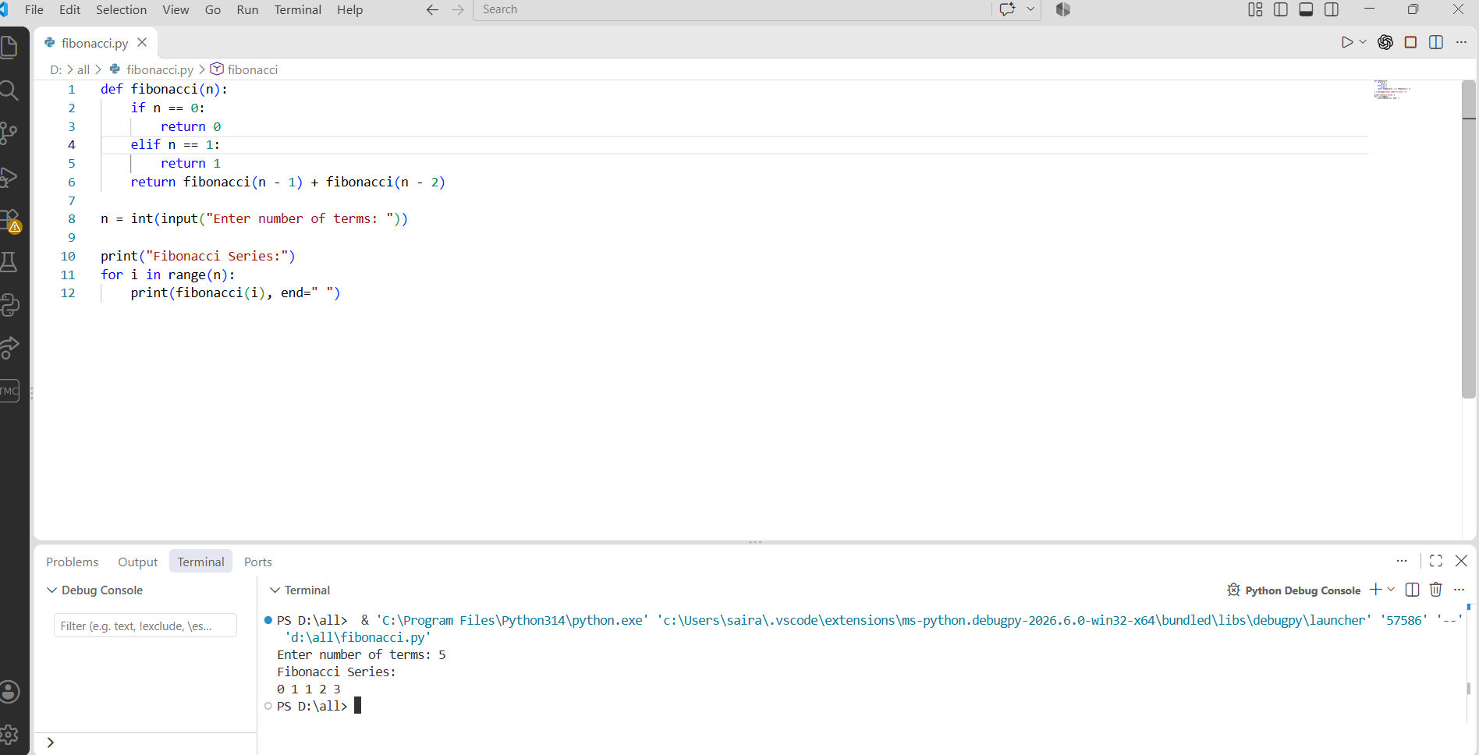

PROGRAM-2(A):

AIM: Write a python program to implement linear search.
CODE:
def linear_search(arr,key):
for i in range(len(arr)):
if arr[i] == key:
return i
return -1
n = int(input("Enter number of elements"))
arr = []
print("Enter the elements")
for i in range(n):
arr.append(int(input()))
key= int(input("Enter element to search"))
result = linear_search(arr,key)
if result != -1:
print("Element found at index",result)
else:
print("Element not found")

OUTPUT:
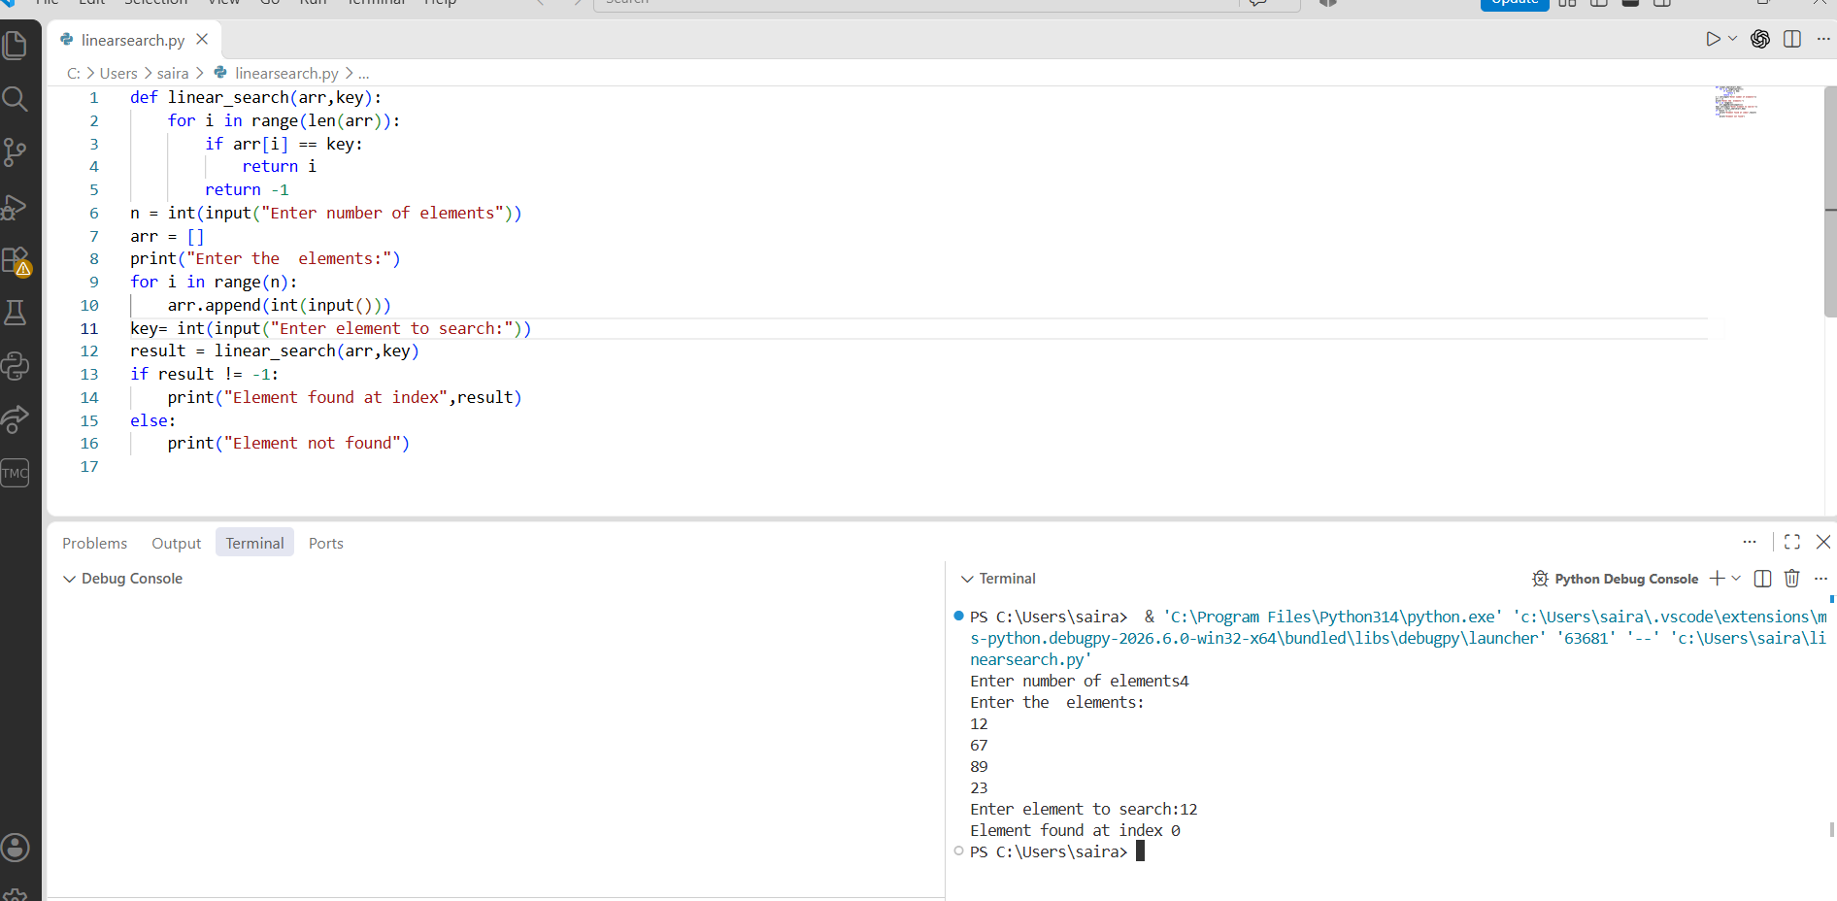

PROGRAM-2(B):

AIM: Write a python program to implement binary search with and without sorted array as an input.
With sorted Array

CODE:
def binary_search(arr,key):
low = 0
high = len(arr)-1
while low<=high:
mid = (low+high)//2
if arr[mid]== key:
return mid
elif arr[mid]<key:
low = mid+1
else:
high = mid-1
return -1
n = int(input("Enter the number of elements:"))
arr = []
print("Enter elements in sorted order:")
arr = list(map(int,input().split()))
key = int(input("Enter element to search:"))
result = binary_search(arr,key)
if result != -1:
print("Element found at index",result)
else:
print("Element not found")

OUTPUT:
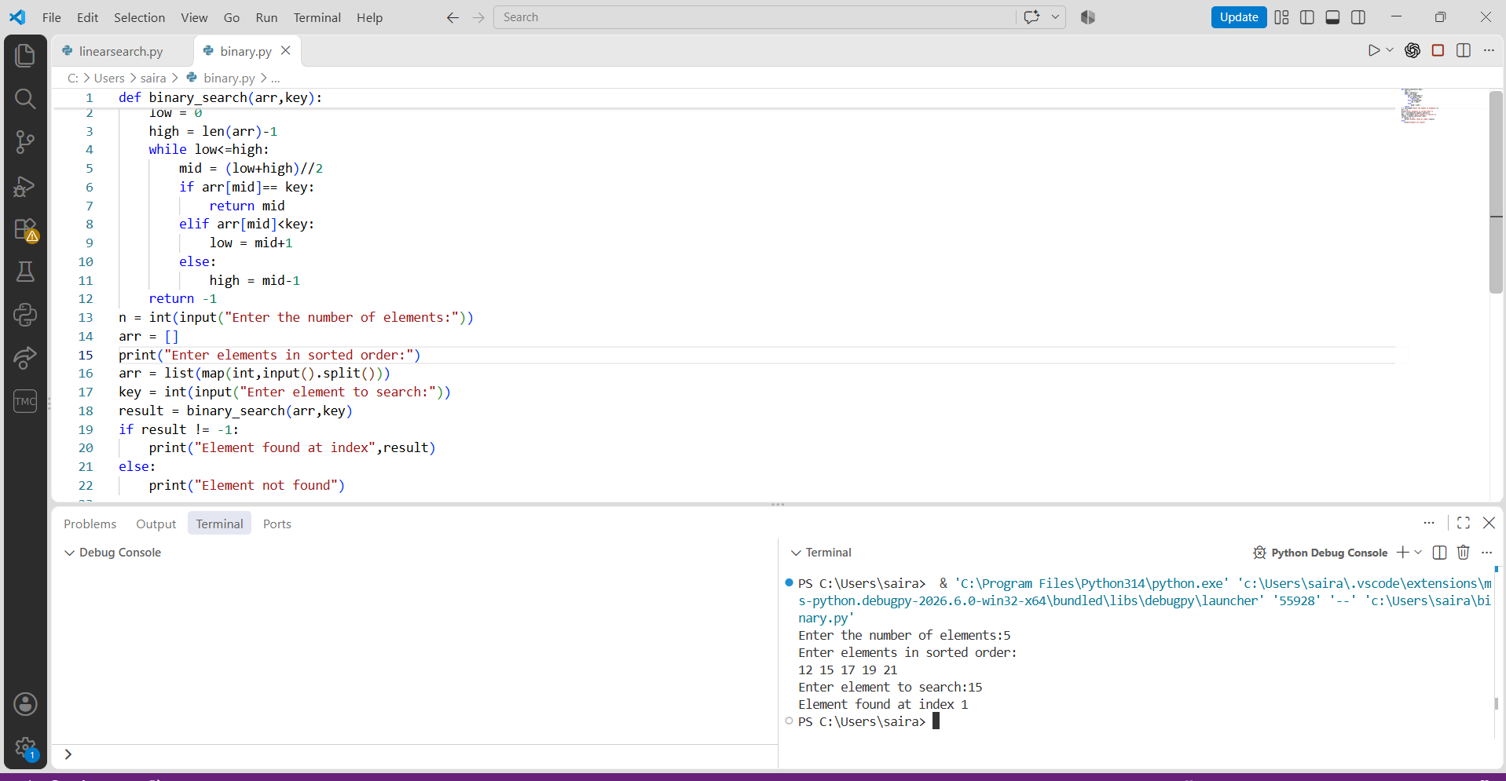

With unsorted array
Code:
def binary_search(arr,key):
low = 0
high = len(arr)-1
while low<=high:
mid = (low+high)//2
if arr[mid]== key:
return mid
elif arr[mid]<key:
low = mid+1
else:
high = mid-1
return -1
arr = list(map(int, input("Enter the elements: ").split()))

if arr == sorted(arr):
print("Array is already sorted.")
else:
print("Array is unsorted.")
arr.sort()
print("Array after sorting:", arr)

key = int(input("Enter the element to search: "))

result = binary_search(arr, key)

if result != -1:
print("Element found at index:", result)
else:
print("Element not found.")

OUTPUT:
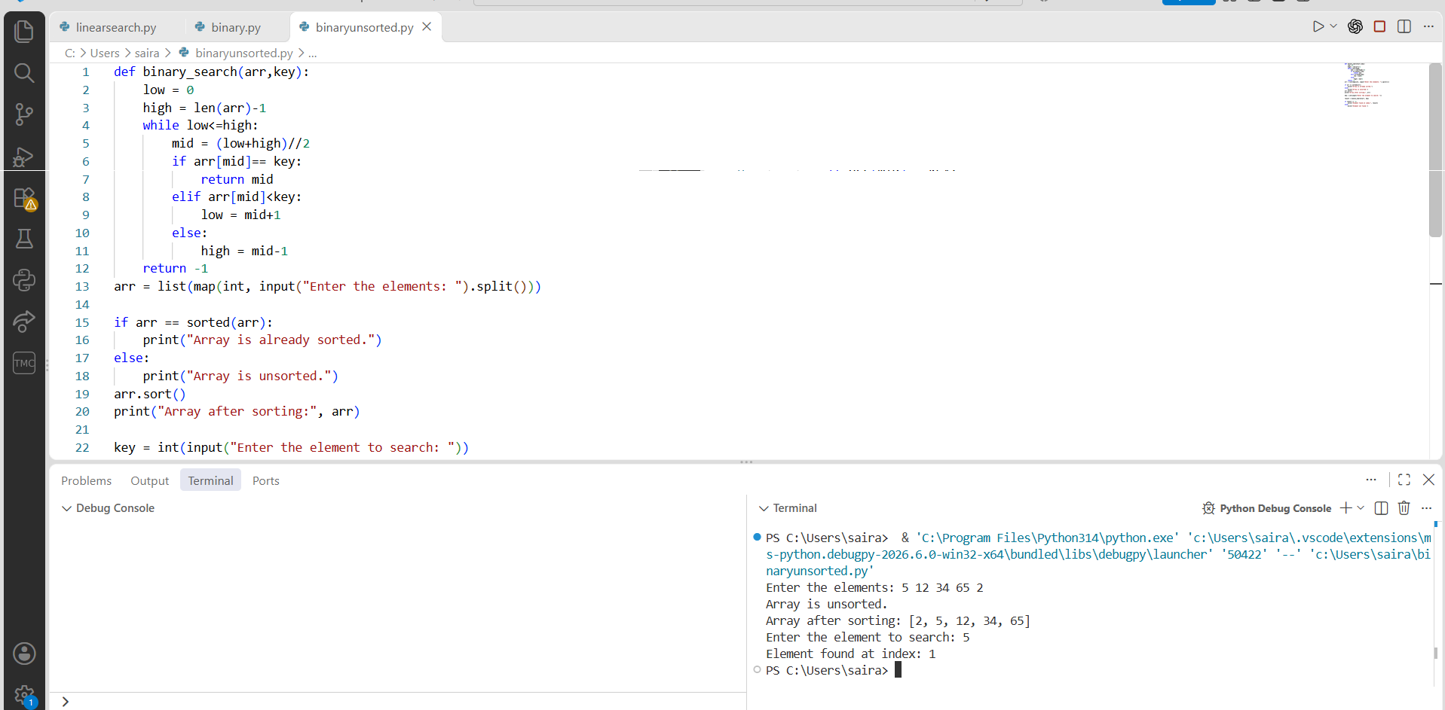

PROGRAM-3(A):

AIM: Write a python program to implement bubble sort.
CODE:
def bubble_sort(arr):
n = len(arr)
for i in range(n):
for j in range(0,n-i-1):
if arr[j]>arr[j+1]:
arr[j],arr[j+1]=arr[j+1],arr[j]
n = int(input("Enter the number of elements:"))
arr = []
print("Enter the elements:")
arr = list(map(int,input().split()))
bubble_sort(arr)
print("Sorted array")
print(arr)

OUTPUT:
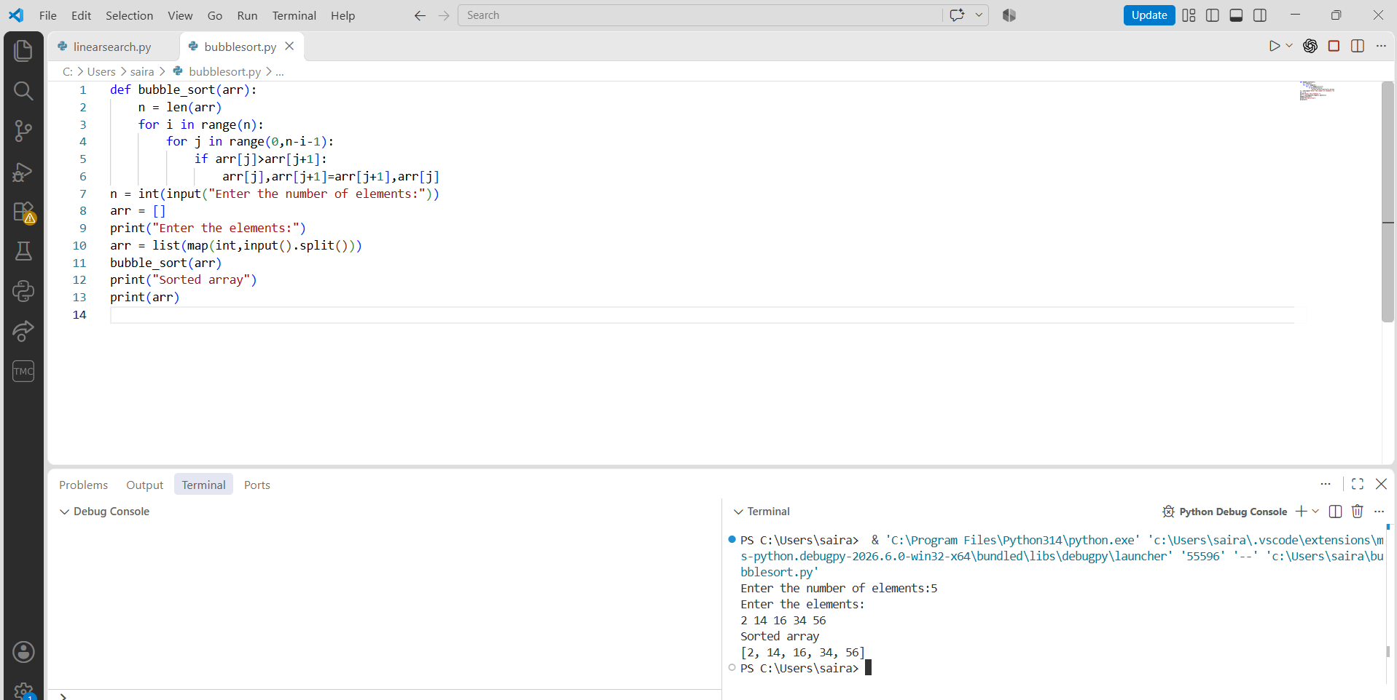

PROGRAM-3(B):

AIM: Write a python program to implement insertion sort.
CODE:
def insertion_sort(arr):
n = len(arr)
for i in range(1,n):
key = arr[i]
j = i-1
while j>=0 and arr[j]>key:
arr[j+1] = arr[j]
j -= 1
arr[j+1] = key
n = int(input('Enter the number of elements:'))
arr = []
print("Enter the elements:")
arr = list(map(int,input().split()))
insertion_sort(arr)
print("Sorted array")
print(arr)

OUTPUT:
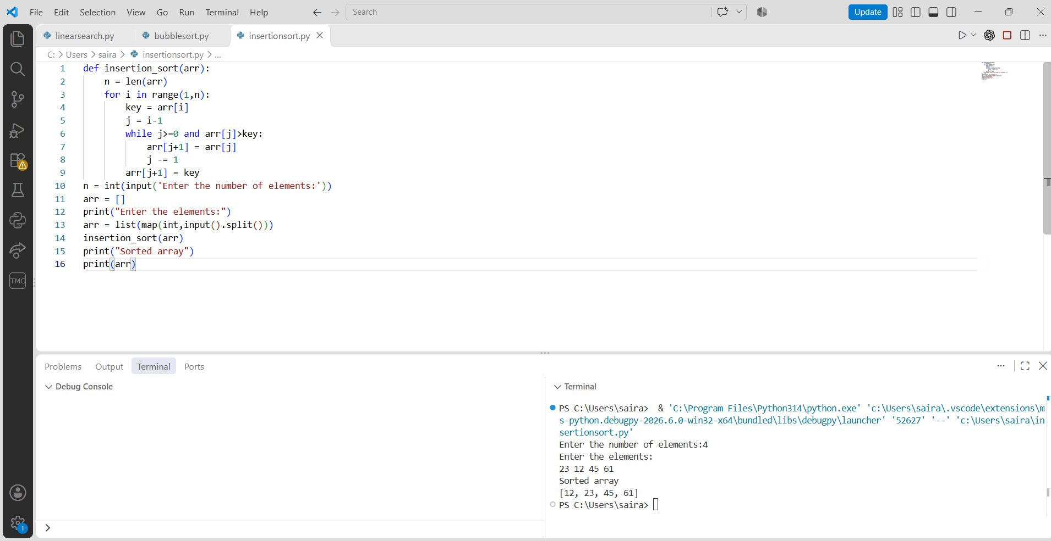

PROGRAM-3(C):

AIM: Write a python program to implement selection sort.
CODE:
def selection_sort(arr):
n = len(arr)
for i in range(n):
min_index = i
for j in range(i+1,n):
if arr[j] < arr[min_index]:
min_index = j
arr[i], arr[min_index] = arr[min_index], arr[i]
n = int(input("Enter the number of elements:"))
arr = []
print("Enter the elements:")
arr = list(map(int, input().split()))
selection_sort(arr)
print("Sorted array:")
print(arr)

OUTPUT:
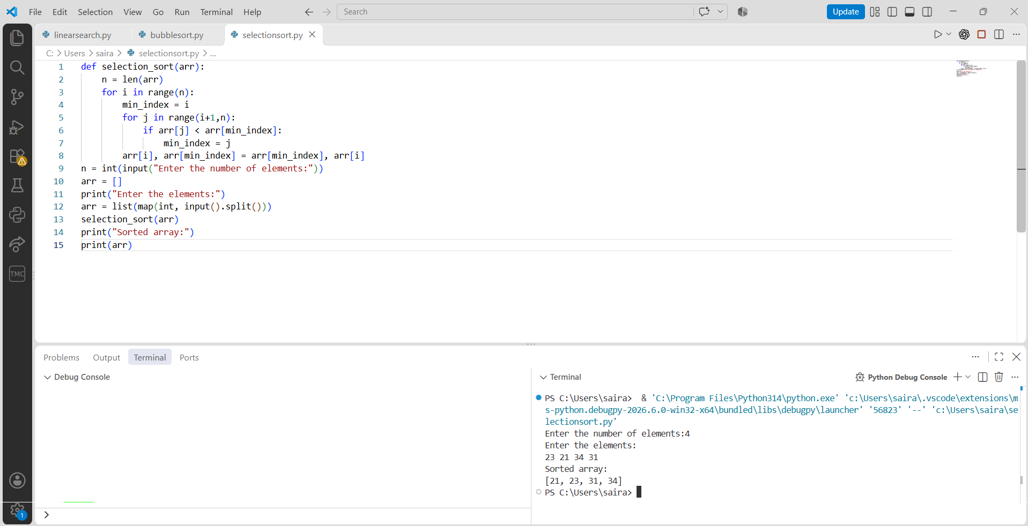

PROGRAM-4(A):

AIM: Write a python program to implement quick sort.
CODE:
def partition(arr, low, high):
pivot = arr[low]
i = low + 1
j = high
while True:
while i <= high and arr[i] <= pivot:
i += 1
while j >= low and arr[j] > pivot:
j -= 1
if i >= j:
break
arr[i], arr[j] = arr[j], arr[i]
arr[low], arr[j] = arr[j], arr[low]
return j

def quick_sort(arr, low, high):
if low < high:
pivot_index = partition(arr, low, high)
quick_sort(arr, low, pivot_index - 1)
quick_sort(arr, pivot_index + 1, high)

arr = list(map(int, input("Enter the elements: ").split()))
quick_sort(arr, 0, len(arr) - 1)
print("Sorted array:")
print(arr)

OUTPUT:
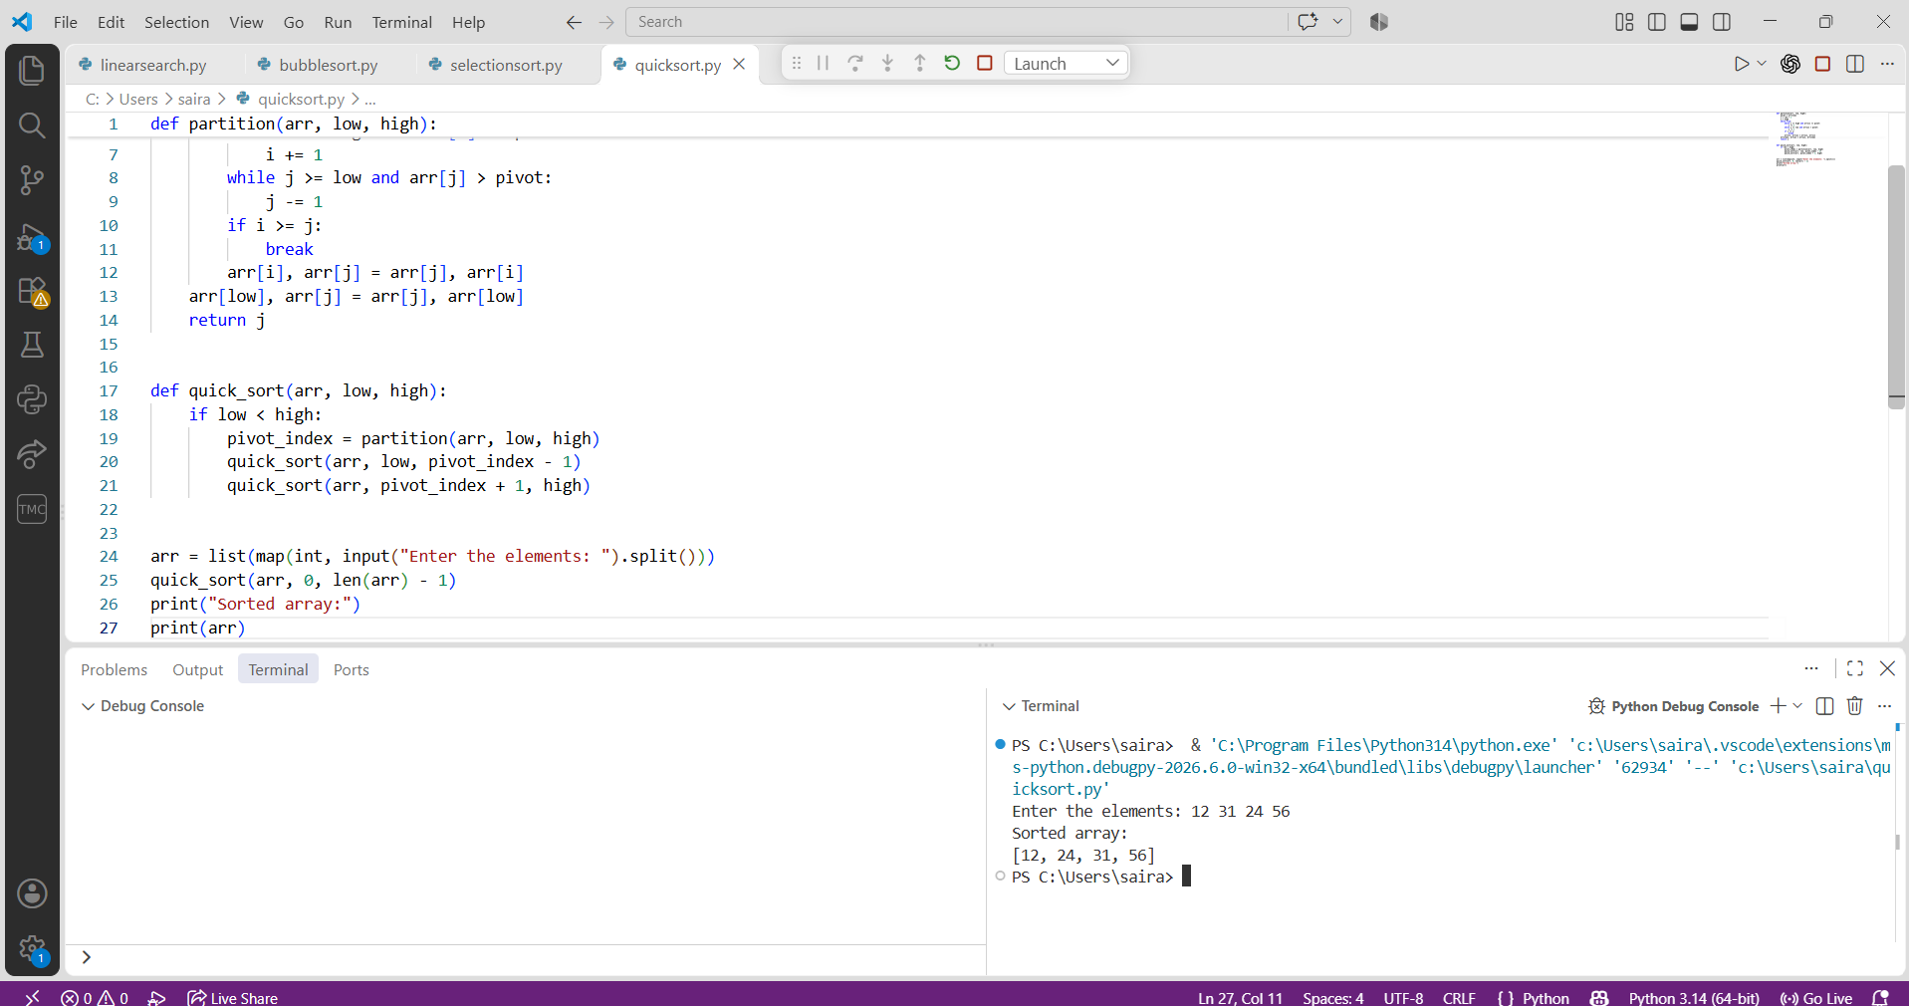

PROGRAM-4(B):

AIM: Write a python program to implement merge sort.
CODE:
def merge_array(left,right):
result = []
i = j = 0
n,m = len(left),len(right)
while i<n and j<m:
if left[i] <= right[j]:
result.append(left[i])
i+=1
else:
result.append(right[j])
j+=1
if i<n:
while i<n:
result.append(left[i])
i+=1
if j<m:
while j<m:
result.append(right[j])
j+=1
return result
def merge_sort(arr):
if len(arr) <=1:
return arr
mid = len(arr)//2
left_arr = arr[:mid]
right_arr = arr[mid:]
left = merge_sort(left_arr)
right = merge_sort(right_arr)
return merge_array(left,right)
arr = list(map(int,input("Enter the elements:").split()))
result = merge_sort(arr)
print("Sorted array:", result)

OUTPUT:
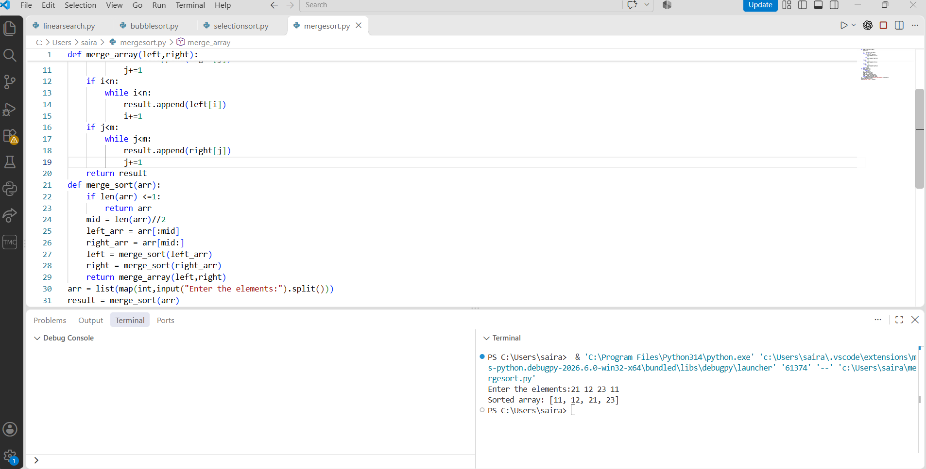

PROGRAM-5(A):

AIM: Write a python program to implement a Singly Linked List with the below operations.
- Create Linked List
- Insert Beginning
- Insert End
- Insert at Index
- Delete by Value
- Delete First Node
- Delete Last Node
- Count number of nodes
- Sort the data of SLL
- Search data in SLL
- Display or Traverse
- Exit

CODE:
class Node:
def __init__(self,data):
self.data = data
self.next = None
class SinglyLinkedList:
def __init__(self):
self.head = None
def create(self):
n = int(input("Enter number of nodes"))
for i in range(n):
data = int(input("Enter data"))
self.insert_end(data)
def insert_begin(self,data):
new =Node(data)
new.next = self.head
self.head = new
def insert_end(self,data):
new = Node(data)
if self.head is None:
self.head = new
else:
temp = self.head
while temp.next:
temp = temp.next
temp.next = new
def insert_index(self,data,index):
if index < 0:
print("Invalid Index")
return
if index == 0:
self.insert_begin(data)
return
temp = self.head
for i in range(index-1):
if temp is None:
print("Invalid index")
return
temp = temp.next
if temp is None:
print("Invalid index")
return
new = Node(data)
new.next = temp.next
temp.next = new
def delete_begin(self):
if self.head is None:
print("there is no node to delete")
else:
temp = self.head
self.head = temp.next
print("Deleted value=",temp.data)
def delete_end(self):
if self.head is None:
print("there is no node to delete")
elif self.head.next is None:
print("Deleted value=",self.head.data)
self.head = None
else:
temp = self.head
while temp.next.next:
temp = temp.next
print("Deleted value=",temp.next.data)
temp.next = None
def delete_value(self,value):
if self.head is None:
print("there is no node to delete")
return
if self.head.data == value:
print("Deleted value=",self.head.data)
self.head = self.head.next
return
temp = self.head
while temp.next and temp.next.data != value:
temp = temp.next
if temp.next is None:
print("Value not found")
return
else:
print("Deleted value=",temp.next.data)
temp.next = temp.next.next
def display(self):
if self.head is None:
print("List is empty")
else:
temp = self.head
while temp:
print(temp.data,end=" ")
temp = temp.next
print()
def count(self):
temp = self.head
count = 0
while temp:
count += 1
temp = temp.next
print("Number of nodes in the list:",count)
def search(self,value):
temp = self.head
index = 0
while temp:
if temp.data == value:
print("Value found at index",index)
return
temp = temp.next
index += 1
print("Value not found")
def sort(self):
if self.head is None:
print("List is empty")
return

temp = self.head

while temp:
curr = temp.next

while curr:
if temp.data > curr.data:
temp.data, curr.data = curr.data, temp.data

curr = curr.next

temp = temp.next

print("Linked list sorted successfully.")
sll = SinglyLinkedList()
while True:
print("1. Create a linked list")
print("2. Insert at the beginning")
print("3. Insert at the end")
print("4. Insert at a specific index")
print("5. Delete from the beginning")
print("6. Delete from the end")
print("7. Delete a specific value")
print("8. Display the linked list")
print("9. Count the number of nodes")
print("10. Search for a value")
print("11. Sort the linked list")
print("12. Exit")

choice = int(input("Enter your choice: "))

if choice == 1:
sll.create()
elif choice == 2:
data = int(input("Enter data to insert at the beginning: "))
sll.insert_begin(data)
elif choice == 3:
data = int(input("Enter data to insert at the end: "))
sll.insert_end(data)
elif choice == 4:
data = int(input("Enter data to insert: "))
index = int(input("Enter index to insert at: "))
sll.insert_index(data, index)
elif choice == 5:
sll.delete_begin()
elif choice == 6:
sll.delete_end()
elif choice == 7:
value = int(input("Enter value to delete: "))
sll.delete_value(value)
elif choice == 8:
sll.display()
elif choice == 9:
sll.count()
elif choice == 10:
value = int(input("Enter value to search for: "))
sll.search(value)
elif choice == 11:
sll.sort()
elif choice == 12:
break

OUTPUT:
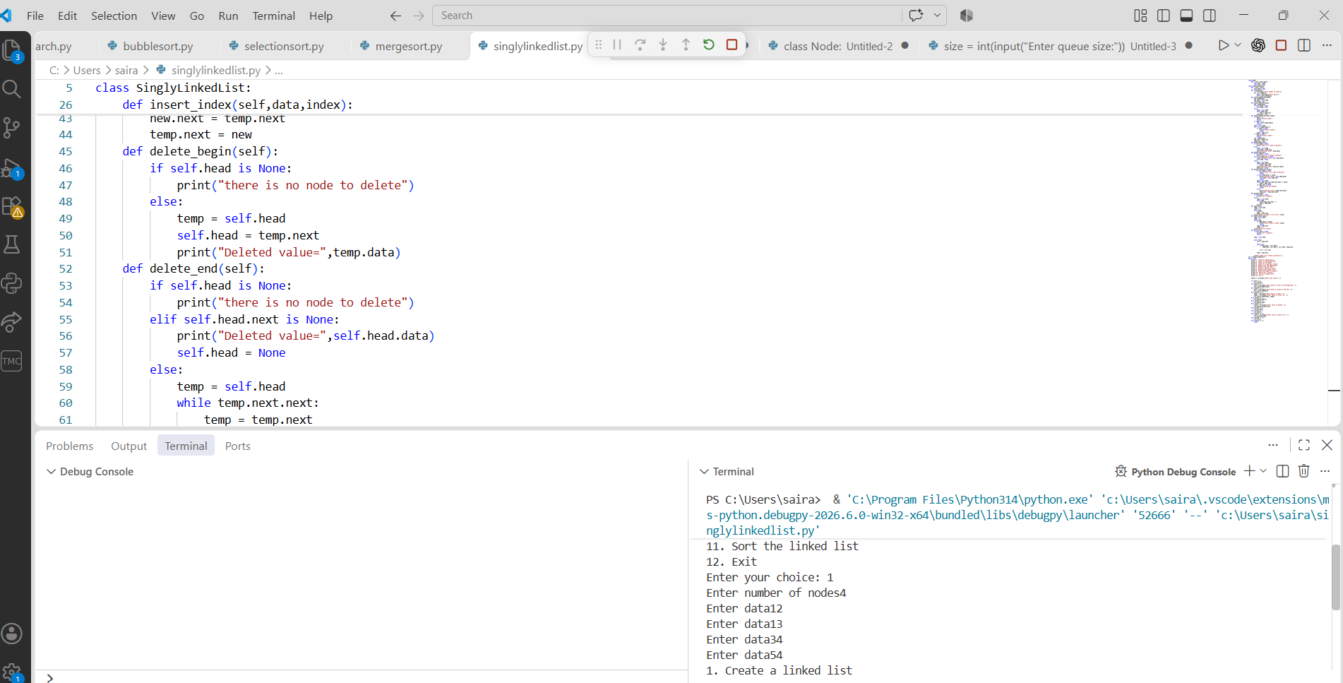

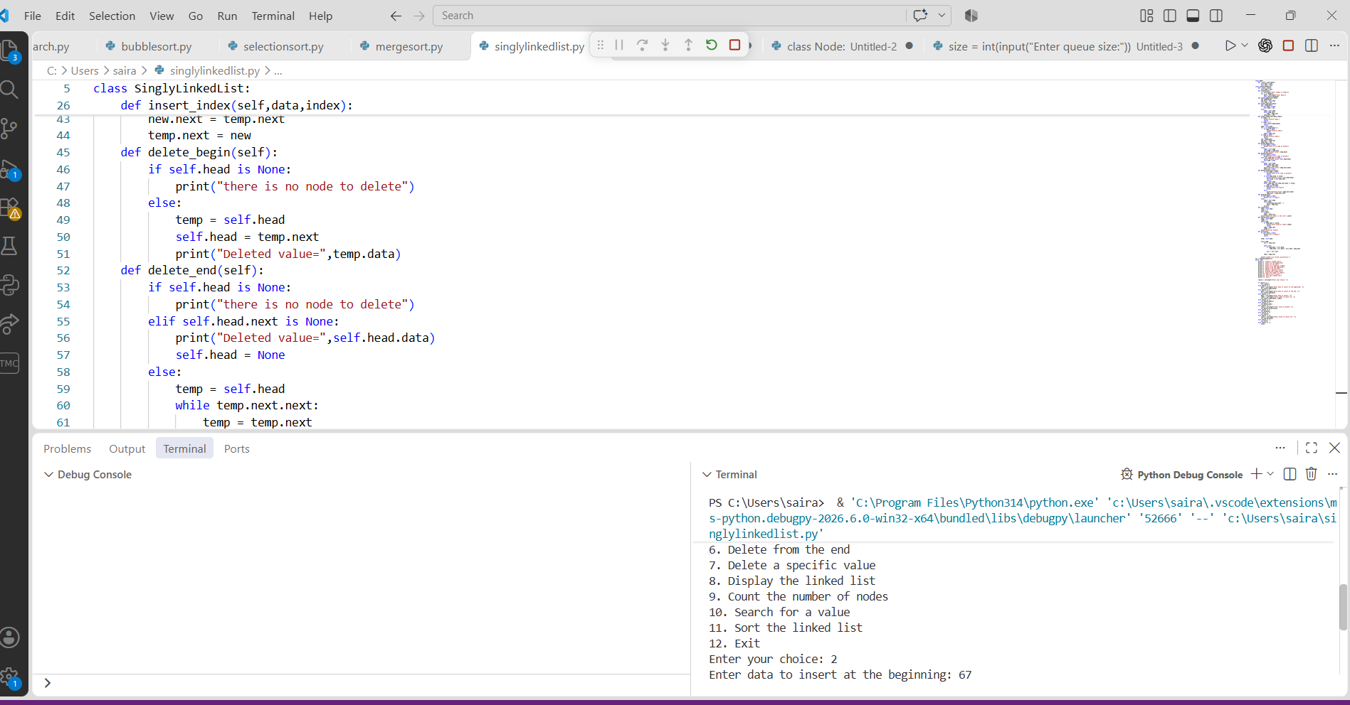

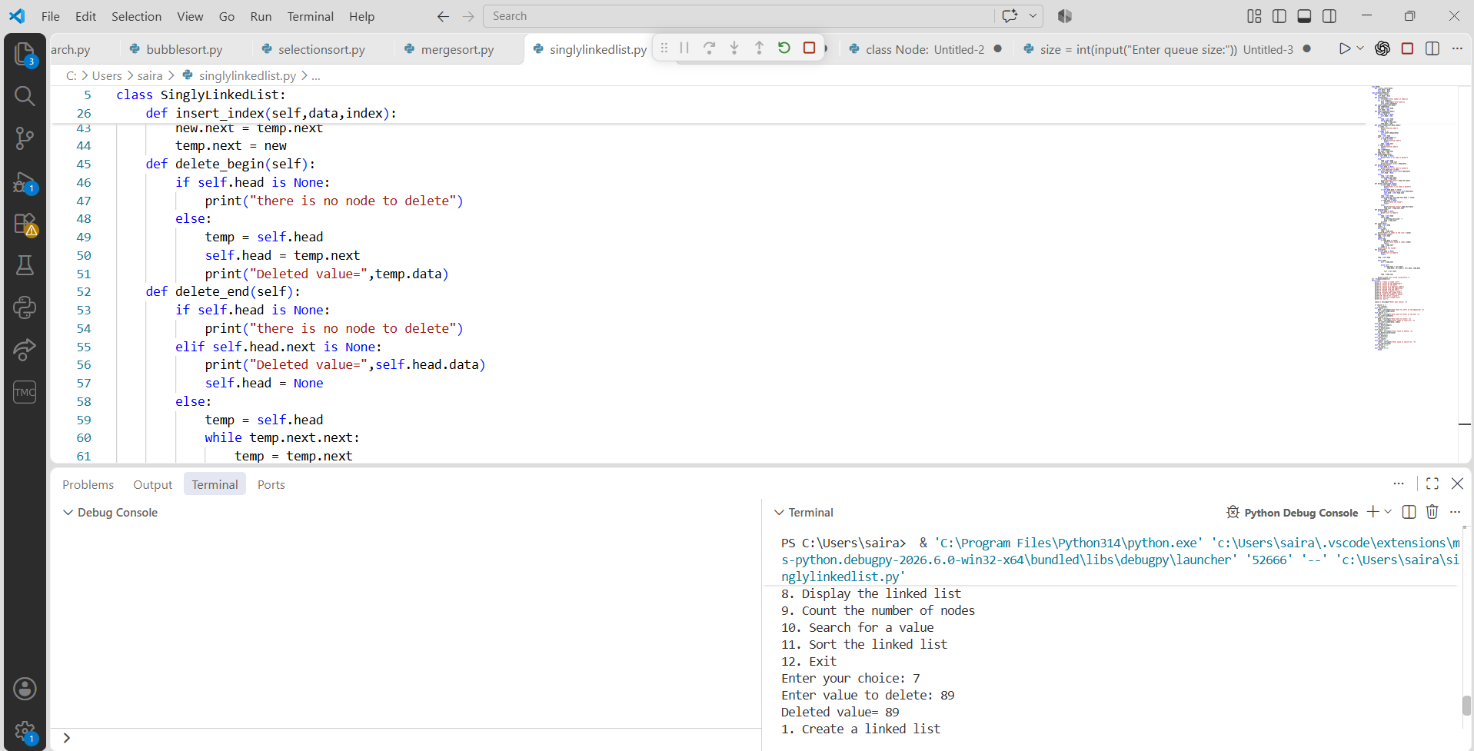

PROGRAM-6:

AIM: Write a python program to implement a Double Linked List with the below operations.
- Create Linked List
- Insert Beginning
- Insert End
- Insert at Index
- Delete by Value
- Delete First Node
- Delete Last Node
- Count number of nodes
- Display or Traverse
Exit

CODE:
class Node:
def __init__(self, data):
self.data = data
self.prev = None
self.next = None

class DoublyLinkedList:
def __init__(self):
self.head = None

def create(self):
n = int(input("Enter number of nodes: "))
for i in range(n):
data = int(input("Enter data: "))
self.insert_end(data)

def insert_beginning(self, data):
new_node = Node(data)

if self.head is not None:
new_node.next = self.head
self.head.prev = new_node

self.head = new_node
print("Node inserted at beginning")

def insert_end(self, data):

new_node = Node(data)

if self.head is None:
self.head = new_node
return

temp = self.head
while temp.next:
temp = temp.next

temp.next = new_node
new_node.prev = temp
print("Node inserted at end")

def insert_at_index(self, data, index):
if index < 0:
print("Invalid index")
return

if index == 0:
self.insert_beginning(data)
return

temp = self.head
for i in range(index - 1):
if temp is None:
print("Invalid index")
return
temp = temp.next

if temp is None:
print("Invalid index")
return

new_node = Node(data)
new_node.next = temp.next
new_node.prev = temp

if temp.next:
temp.next.prev = new_node

temp.next = new_node
print("Node inserted at index", index)

def delete_by_value(self, value):
temp = self.head

while temp and temp.data != value:
temp = temp.next

if temp is None:
print("Value not found")
return

if temp.prev:
temp.prev.next = temp.next
else:
self.head = temp.next

if temp.next:
temp.next.prev = temp.prev

print("Node deleted")

def delete_first(self):
if self.head is None:
print("List is empty")
return

self.head = self.head.next

if self.head:
self.head.prev = None

print("First node deleted")

def delete_last(self):
if self.head is None:
print("List is empty")
return

temp = self.head

if temp.next is None:
self.head = None
print("Last node deleted")
return

while temp.next:
temp = temp.next

temp.prev.next = None
print("Last node deleted")

def count_nodes(self):
count = 0
temp = self.head

while temp:
count += 1
temp = temp.next

print("Number of nodes:", count)
def display(self):
if self.head is None:
print("List is empty")
return

temp = self.head
print("Doubly Linked List:", end=" ")

while temp:
print(temp.data, end=" <-> ")
temp = temp.next

print("None")

dll = DoublyLinkedList()

while True:
print("\n--- Doubly Linked List Menu ---")
print("1. Create Linked List")
print("2. Insert Beginning")
print("3. Insert End")
print("4. Insert at Index")
print("5. Delete by Value")
print("6. Delete First Node")
print("7. Delete Last Node")
print("8. Count Number of Nodes")
print("9. Display or Traverse")
print("10. Exit")

choice = int(input("Enter your choice: "))

if choice == 1:
dll.create()

elif choice == 2:
data = int(input("Enter data: "))
dll.insert_beginning(data)

elif choice == 3:
data = int(input("Enter data: "))
dll.insert_end(data)

elif choice == 4:
data = int(input("Enter data: "))
index = int(input("Enter index: "))
dll.insert_at_index(data, index)

elif choice == 5:
value = int(input("Enter value to delete: "))
dll.delete_by_value(value)

elif choice == 6:
dll.delete_first()

elif choice == 7:
dll.delete_last()

elif choice == 8:
dll.count_nodes()

elif choice == 9:
dll.display()

elif choice == 10:
print("Exiting program...")
break

else:
print("Invalid choice")

OUTPUT:
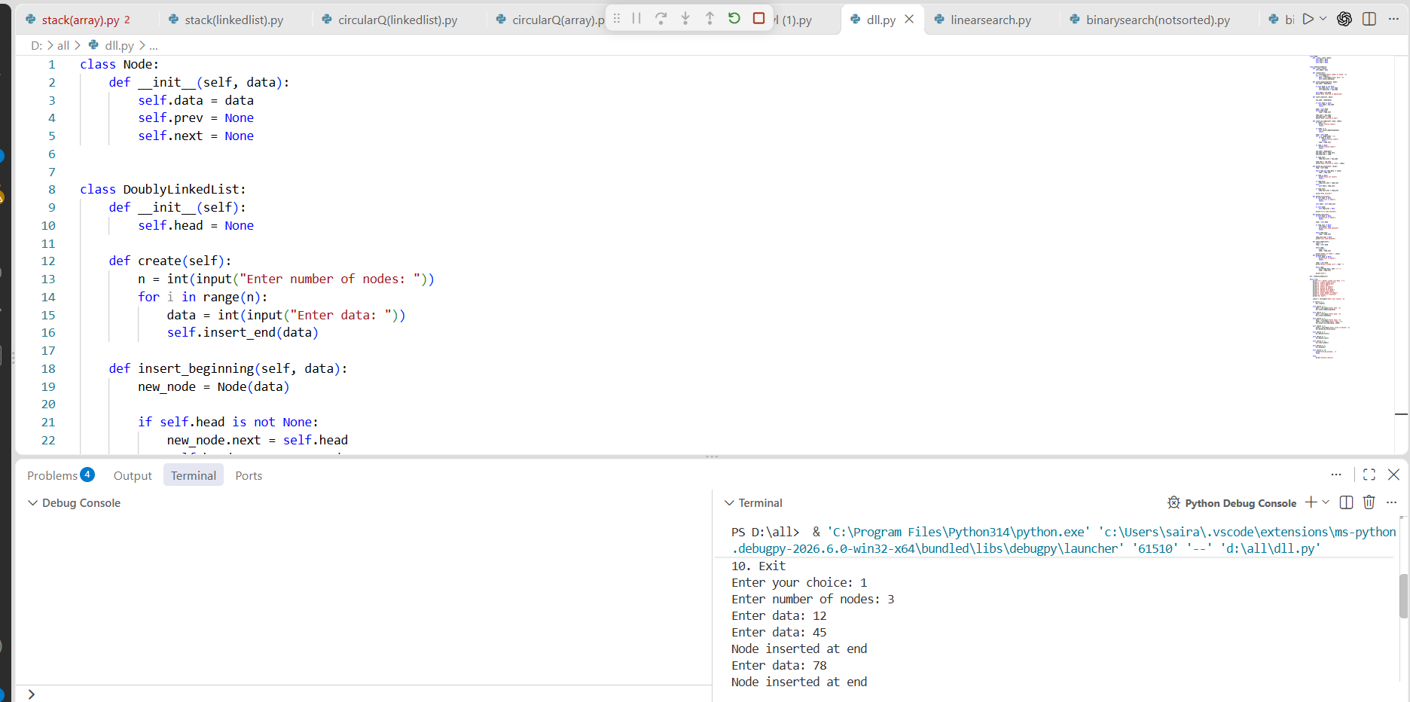

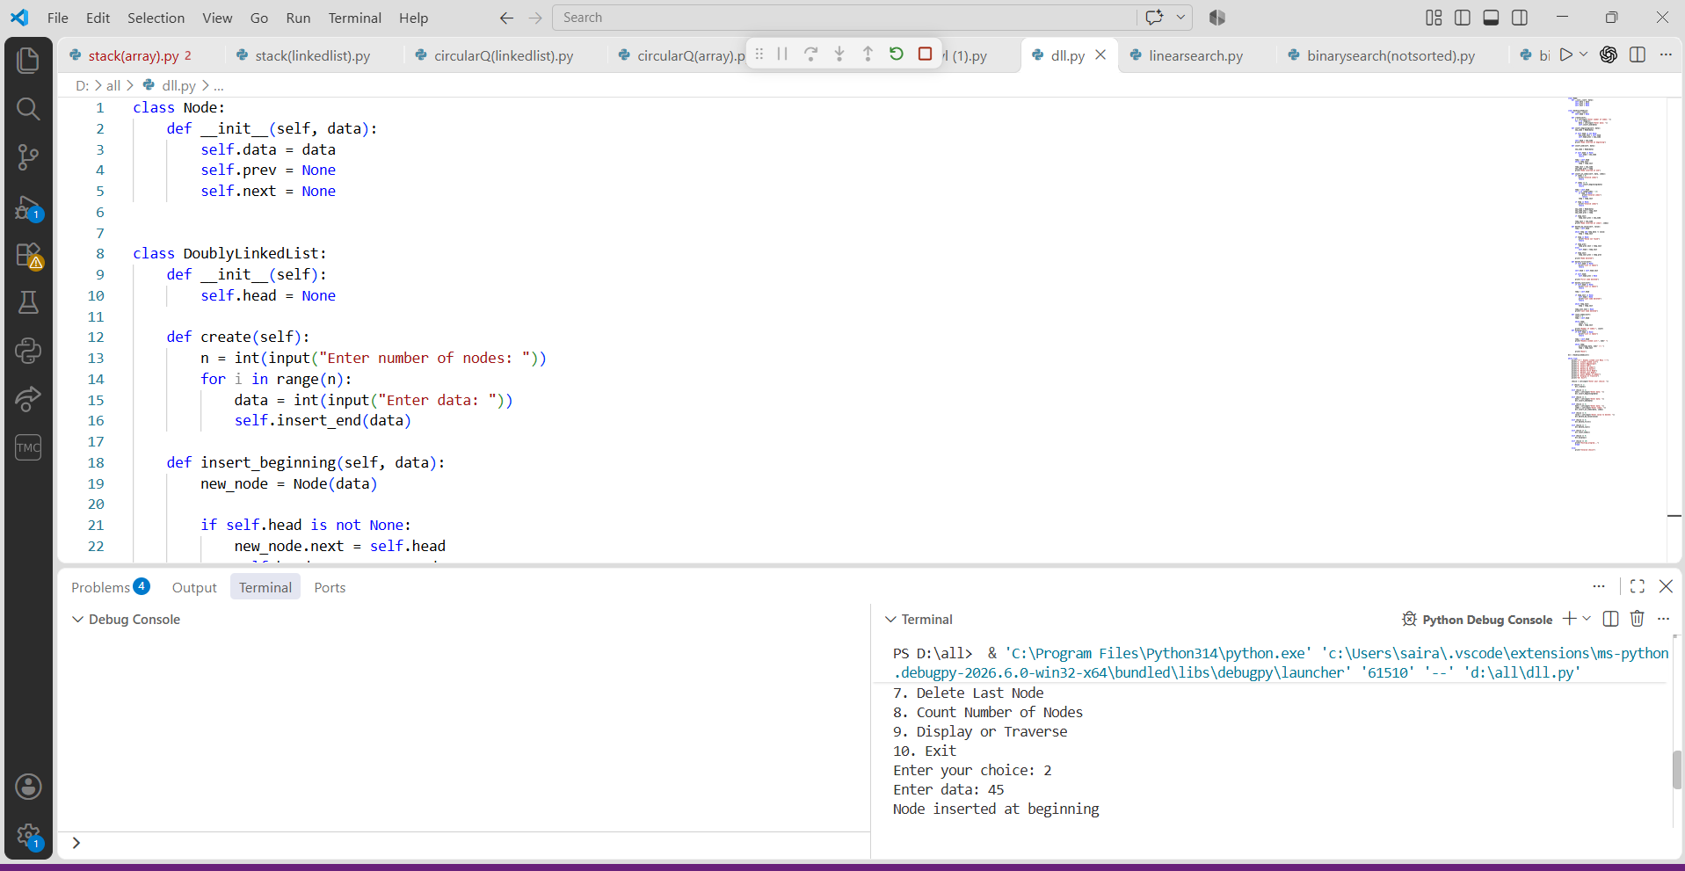

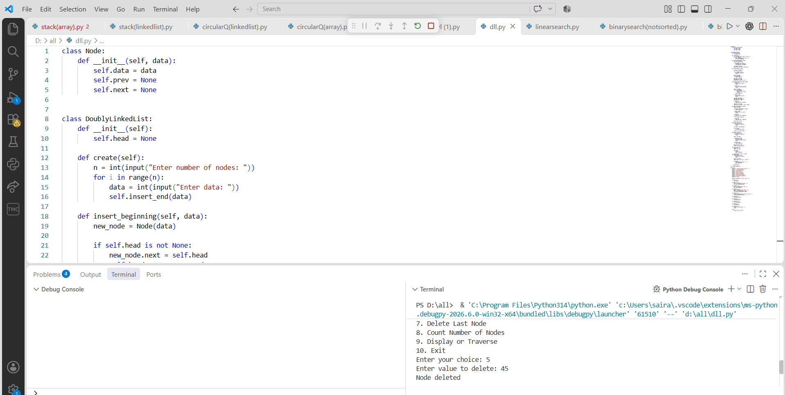
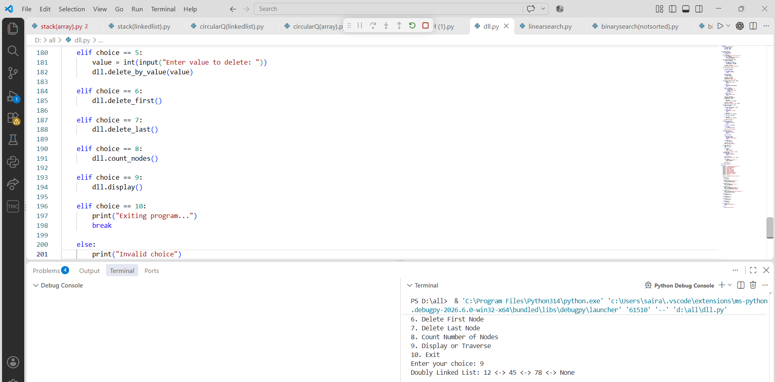

PROGRAM-7(A):

AIM: Write a python program to implement stack operations such as push, pop, peek, display using an array.
CODE:
stack = []
size = int(input("Enter stack size: "))

while True:
print("\n1. Push")
print("2. Pop")
print("3. Peek")
print("4. Display")
print("5. Exit")

choice = int(input("Enter your choice: "))

if choice == 1:
if len(stack) == size:
print("Stack Overflow")
else:
item = int(input("Enter element: "))
stack.append(item)
print("Element pushed")

elif choice == 2:
if len(stack) == 0:
print("Stack Underflow")
else:
print("Popped element:", stack.pop())

elif choice == 3:
if len(stack) == 0:
print("Stack is empty")
else:
print("Top element:", stack[-1])

elif choice == 4:
if len(stack) == 0:
print("Stack is empty")
else:
print("Stack:", stack[::-1])

elif choice == 5:
print("Exiting program...")
break

else:
print("Invalid choice")

OUTPUT:
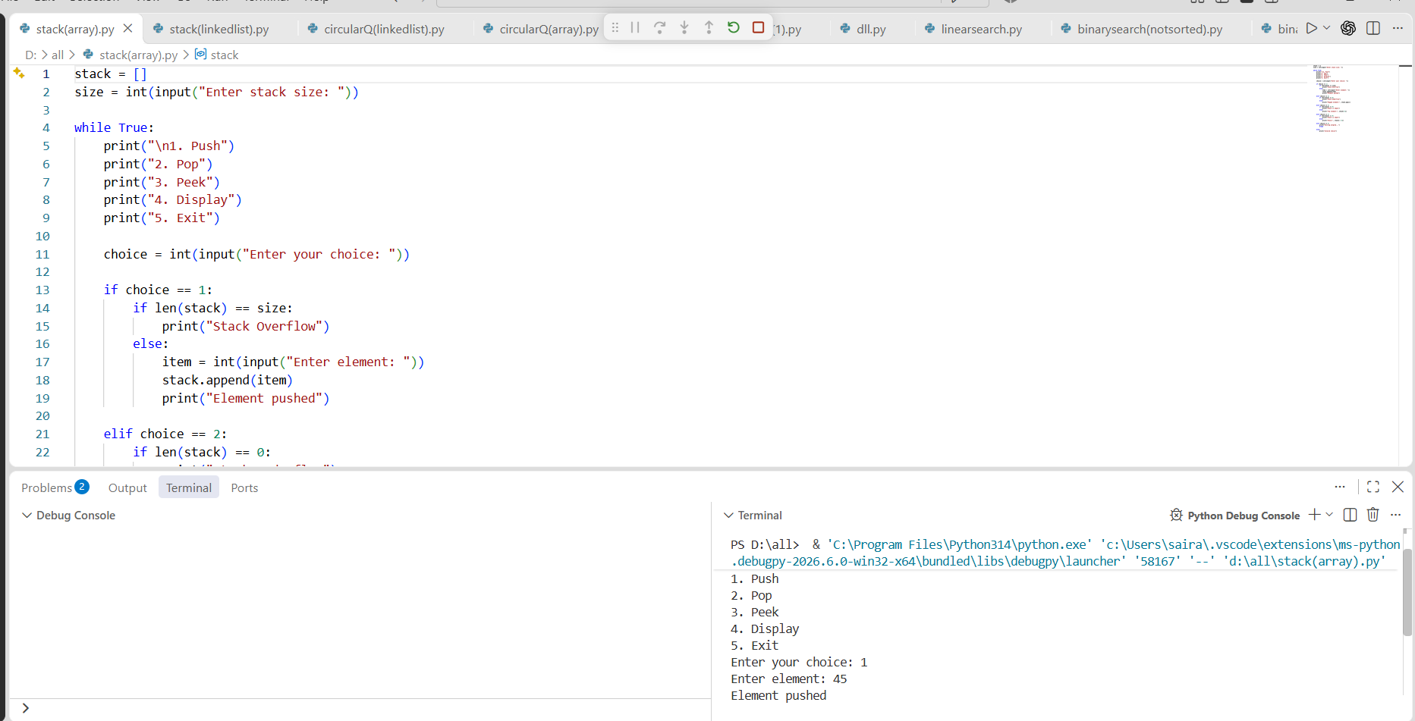

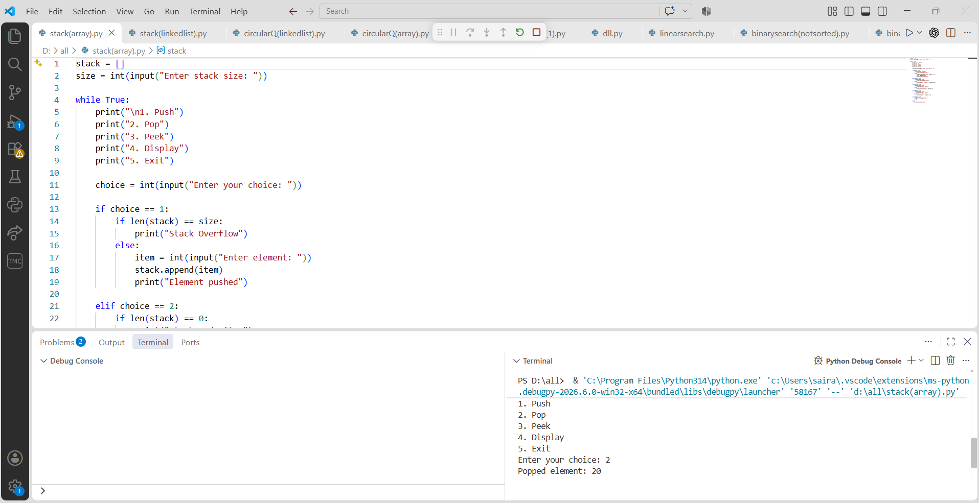

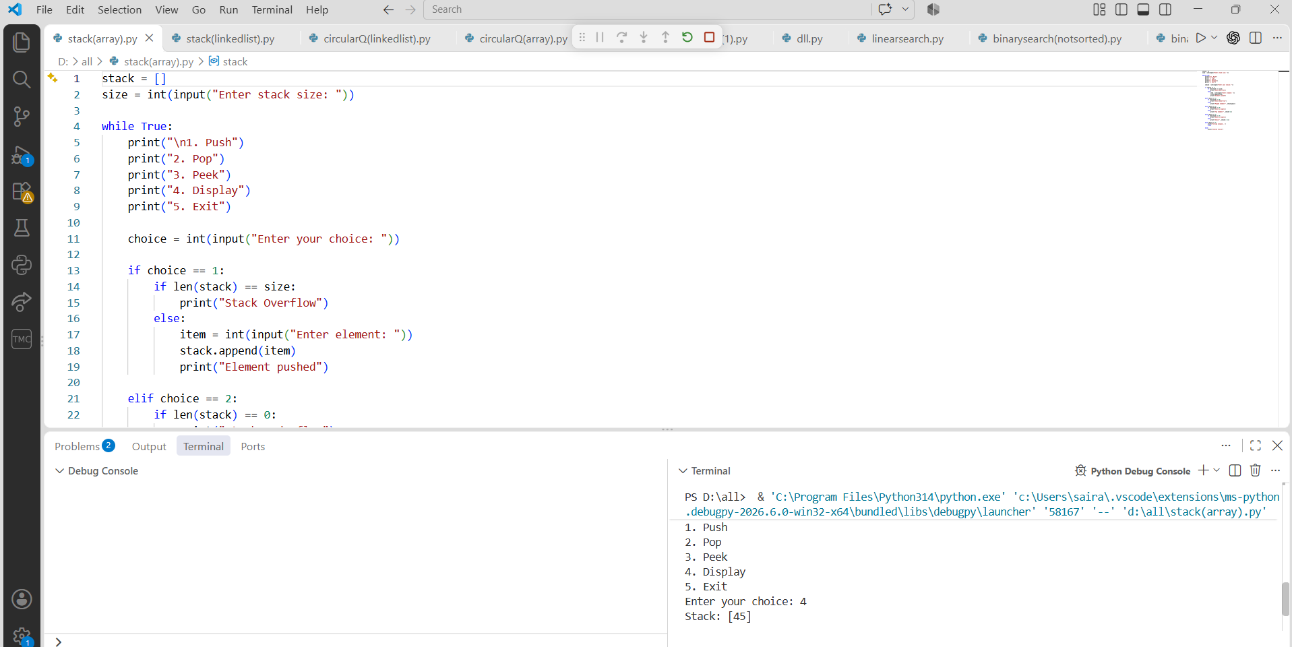

PROGRAM-7(B):

AIM: Write a python program to implement stack operations such as push, pop, peek, display using a linked list.
CODE:
class Node:
def __init__(self, data):
self.data = data
self.next = None

class Stack:
def __init__(self):
self.top = None

def push(self, data):
new_node = Node(data)
new_node.next = self.top
self.top = new_node
print("Element pushed")

def pop(self):
if self.top is None:
print("Stack Underflow")
else:
print("Popped element:", self.top.data)
self.top = self.top.next

def peek(self):
if self.top is None:
print("Stack is empty")
else:
print("Top element:", self.top.data)

def display(self):
if self.top is None:
print("Stack is empty")
else:
temp = self.top
print("Stack:", end=" ")
while temp:
print(temp.data, end=" ")
temp = temp.next
print()

s = Stack()

while True:
print("\n1. Push")
print("2. Pop")
print("3. Peek")
print("4. Display")
print("5. Exit")

choice = int(input("Enter your choice: "))

if choice == 1:
item = int(input("Enter element: "))
s.push(item)

elif choice == 2:
s.pop()

elif choice == 3:
s.peek()

elif choice == 4:
s.display()

elif choice == 5:
print("Exiting program...")
break

else:
print("Invalid choice")

OUTPUT:

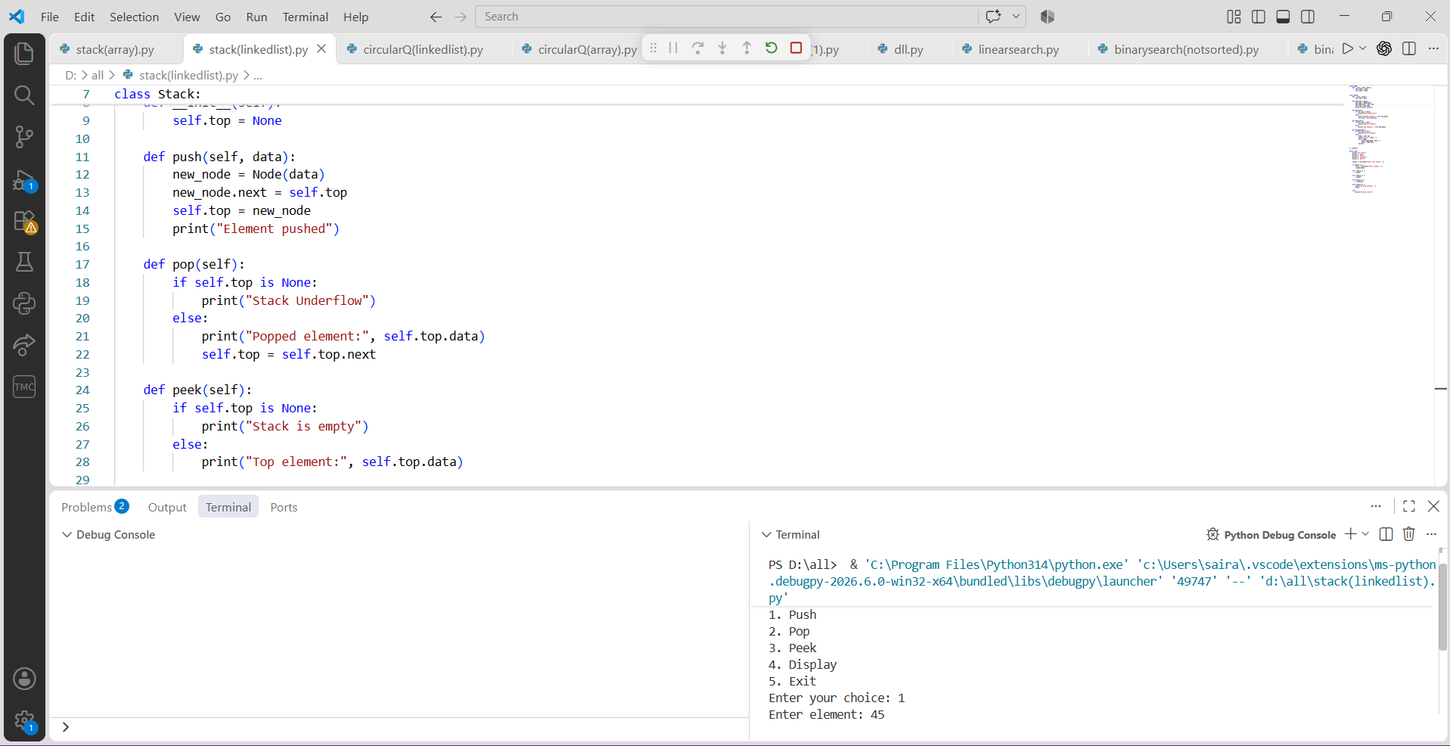

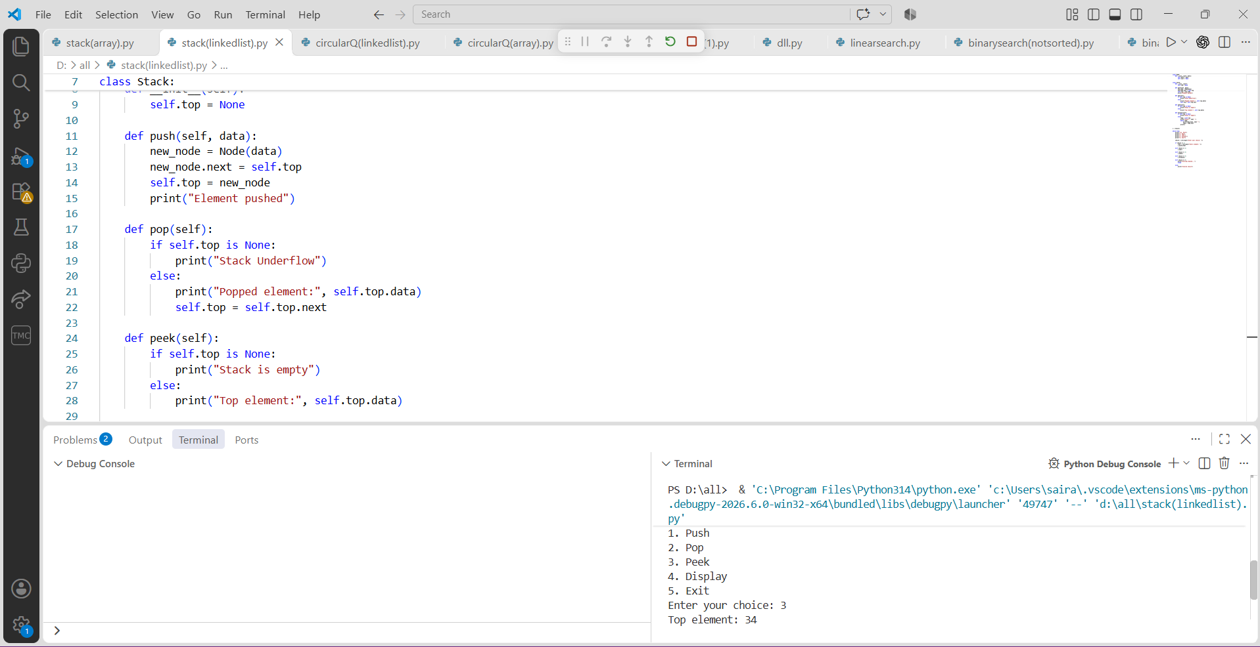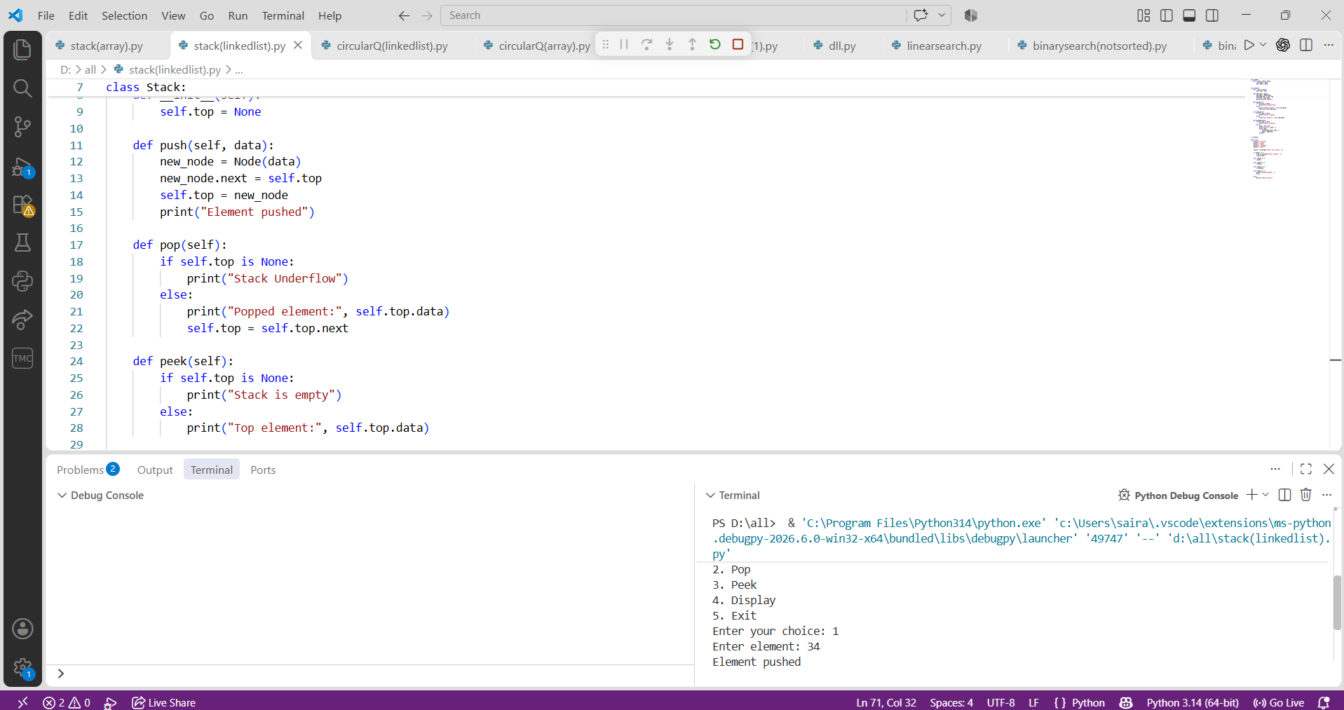

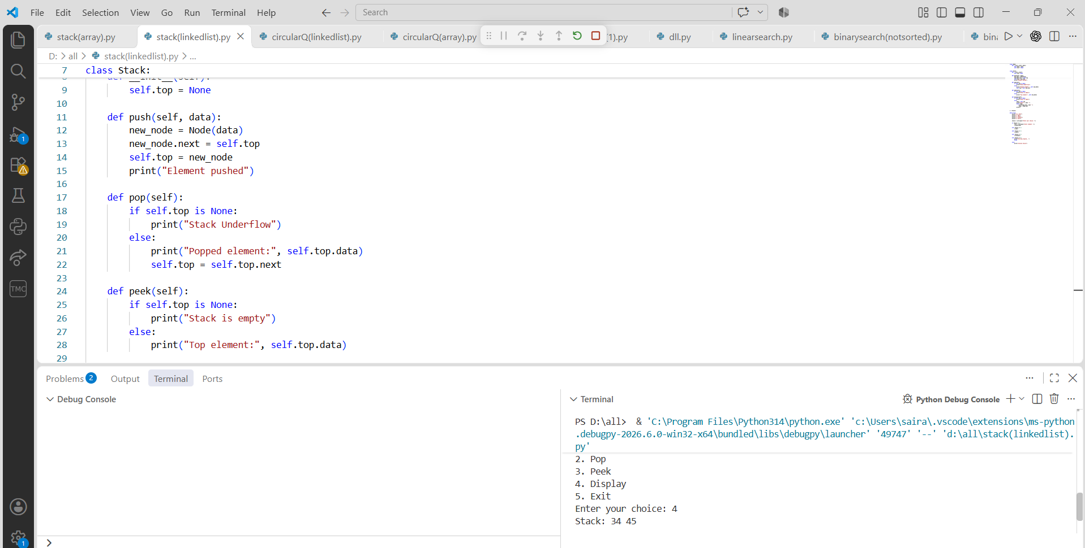

PROGRAM-8(A):

AIM: Write a python program to implement Queue and its operations such as enqueue, dequeue, peek, display with a menu driven approach. Implement using array, and linked list data structures.
Using Array
CODE:
queue = []
size = int(input("Enter queue size: "))

while True:
print("\n1. Enqueue")
print("2. Dequeue")
print("3. Peek")
print("4. Display")
print("5. Exit")

choice = int(input("Enter your choice: "))

if choice == 1:
if len(queue) == size:
print("Queue Overflow")
else:
item = int(input("Enter element: "))
queue.append(item)
print("Element inserted")

elif choice == 2:
if len(queue) == 0:
print("Queue Underflow")
else:
print("Deleted element:", queue.pop(0))

elif choice == 3:
if len(queue) == 0:
print("Queue is empty")
else:
print("Front element:", queue[0])

elif choice == 4:
if len(queue) == 0:
print("Queue is empty")
else:
print("Queue:", queue)

elif choice == 5:
print("Exiting program...")
break

else:
print("Invalid choice")

OUTPUT:
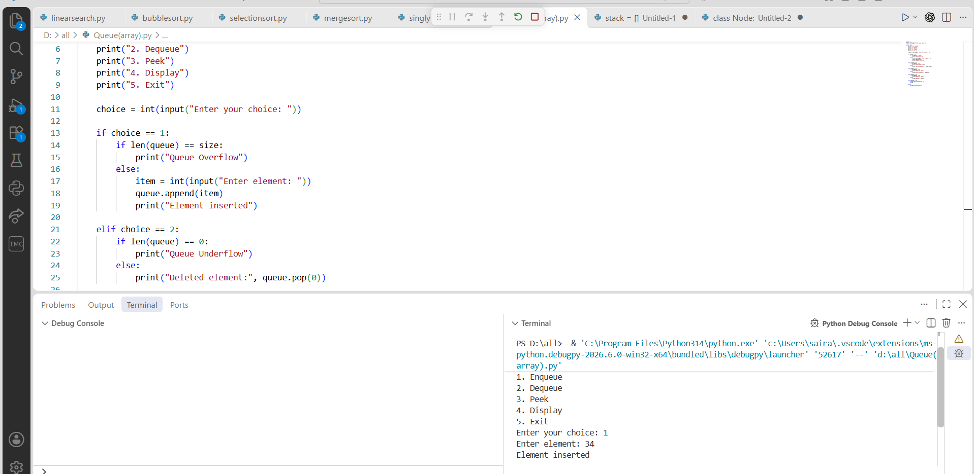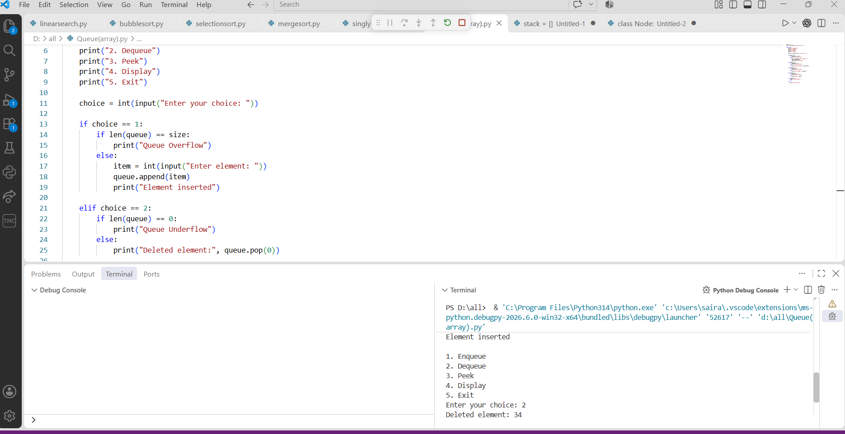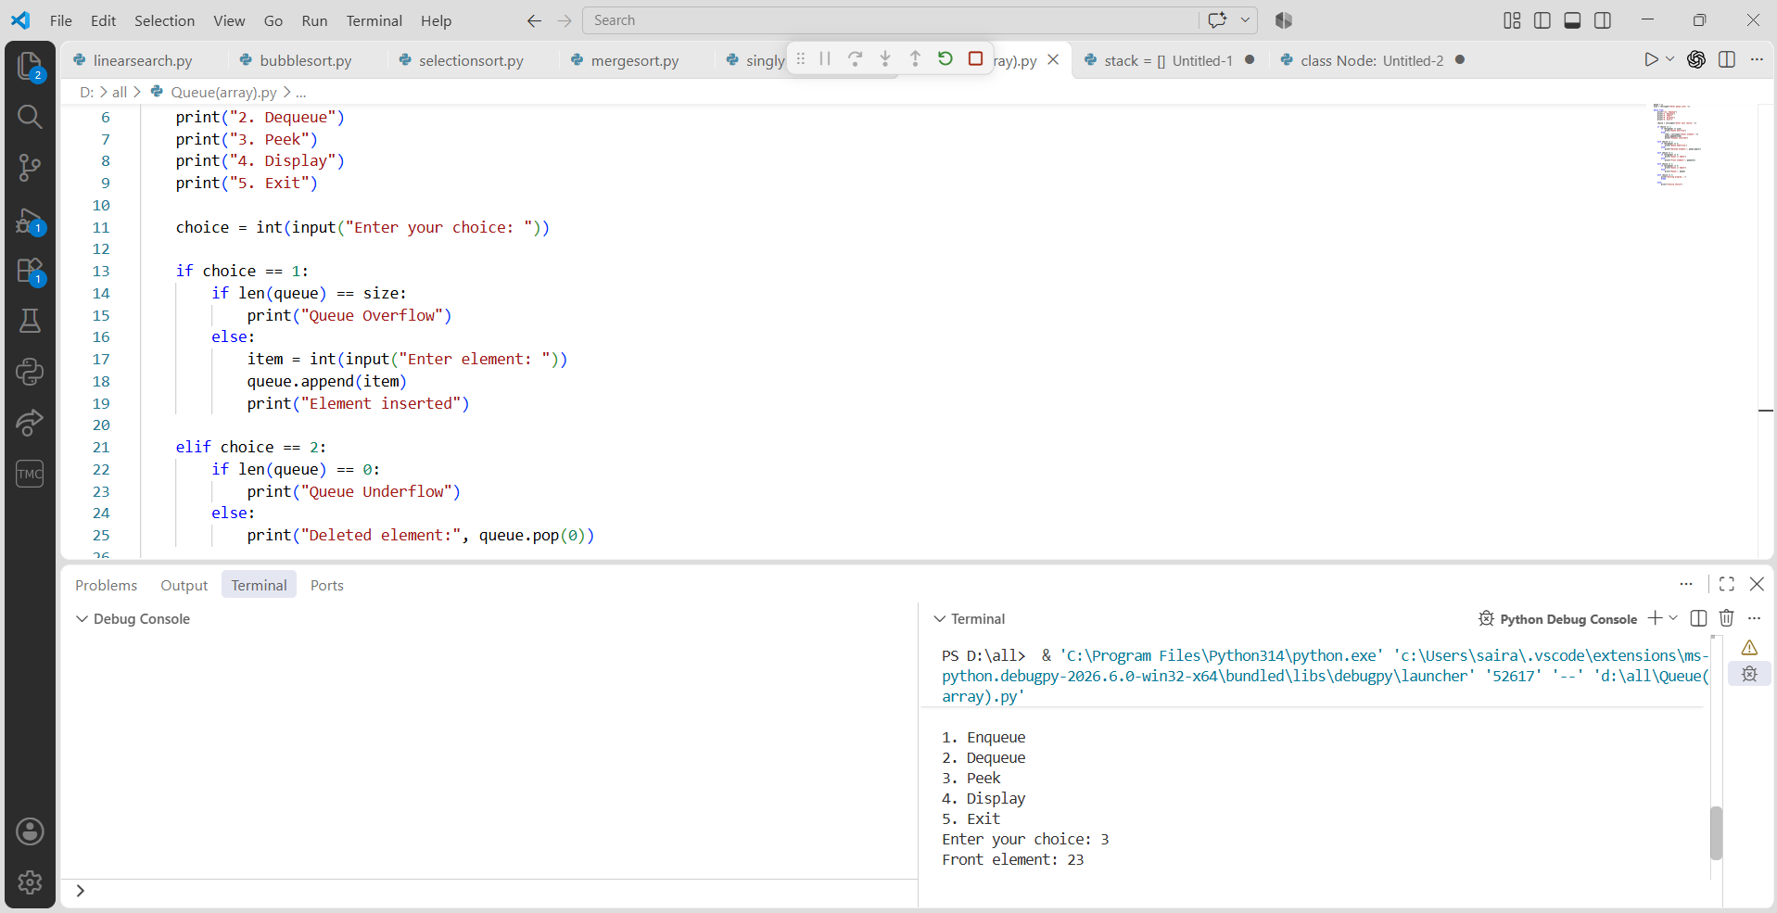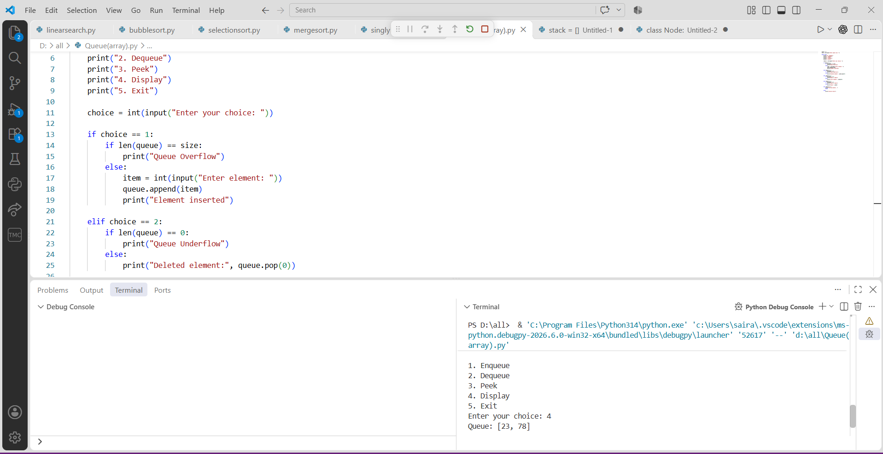

Using Linked List:
Code:
class Node:
def __init__(self, data):
self.data = data
self.next = None

class Queue:
def __init__(self):
self.front = None
self.rear = None

def enqueue(self, data):
new_node = Node(data)

if self.rear is None:
self.front = self.rear = new_node
else:
self.rear.next = new_node
self.rear = new_node

print("Element inserted")

def dequeue(self):
if self.front is None:
print("Queue Underflow")
else:
print("Deleted element:", self.front.data)
self.front = self.front.next

if self.front is None:
self.rear = None

def peek(self):
if self.front is None:
print("Queue is empty")
else:
print("Front element:", self.front.data)

def display(self):
if self.front is None:
print("Queue is empty")
else:
temp = self.front
print("Queue:", end=" ")

while temp:
print(temp.data, end=" ")
temp = temp.next

print()

q = Queue()

while True:
print("\n1. Enqueue")
print("2. Dequeue")
print("3. Peek")
print("4. Display")
print("5. Exit")

choice = int(input("Enter your choice: "))

if choice == 1:
item = int(input("Enter element: "))
q.enqueue(item)

elif choice == 2:
q.dequeue()

elif choice == 3:
q.peek()

elif choice == 4:
q.display()

elif choice == 5:
print("Exiting program...")
break

else:
print("Invalid choice")
OUTPUT:
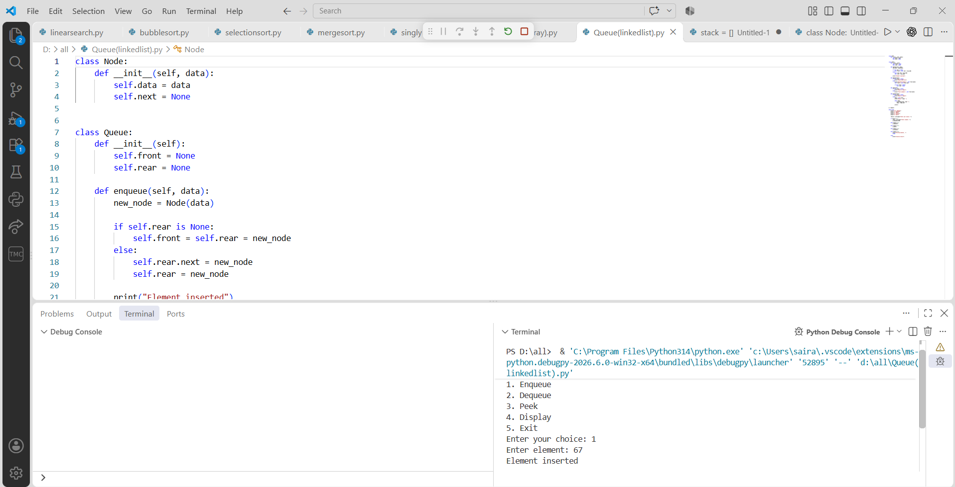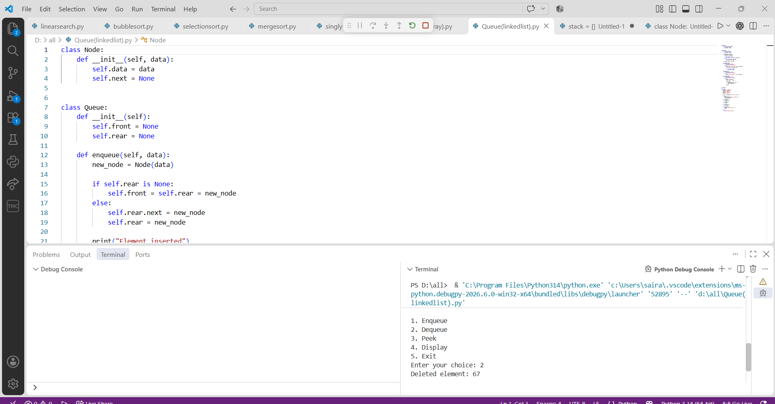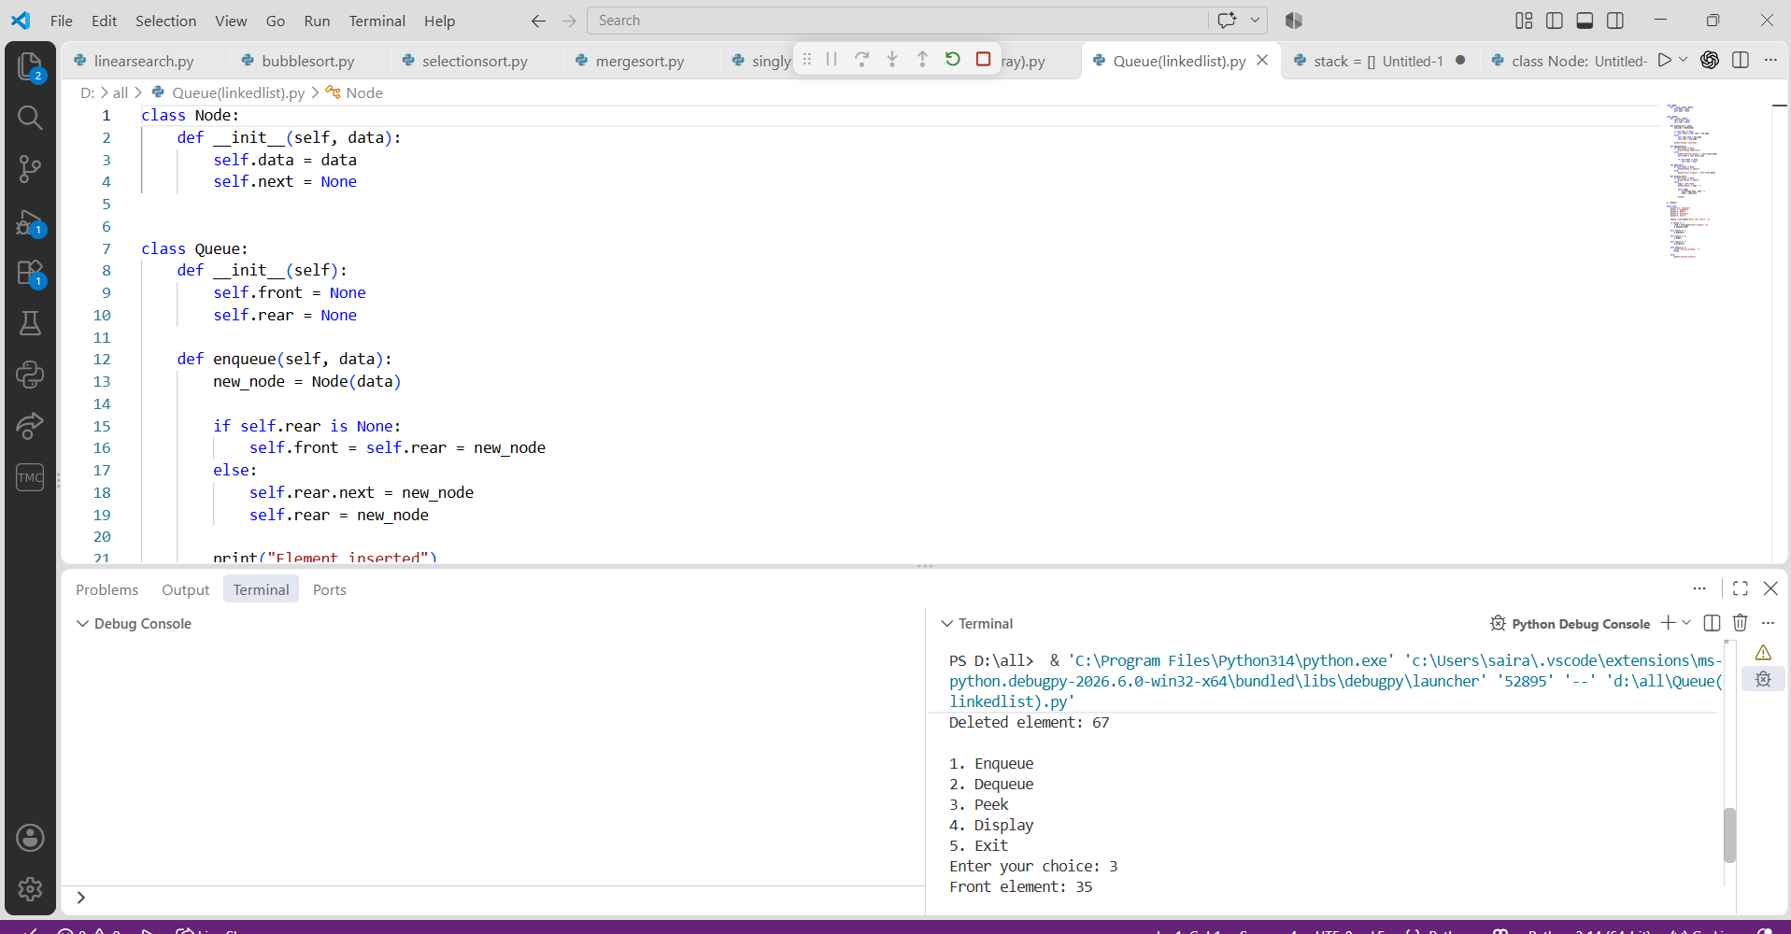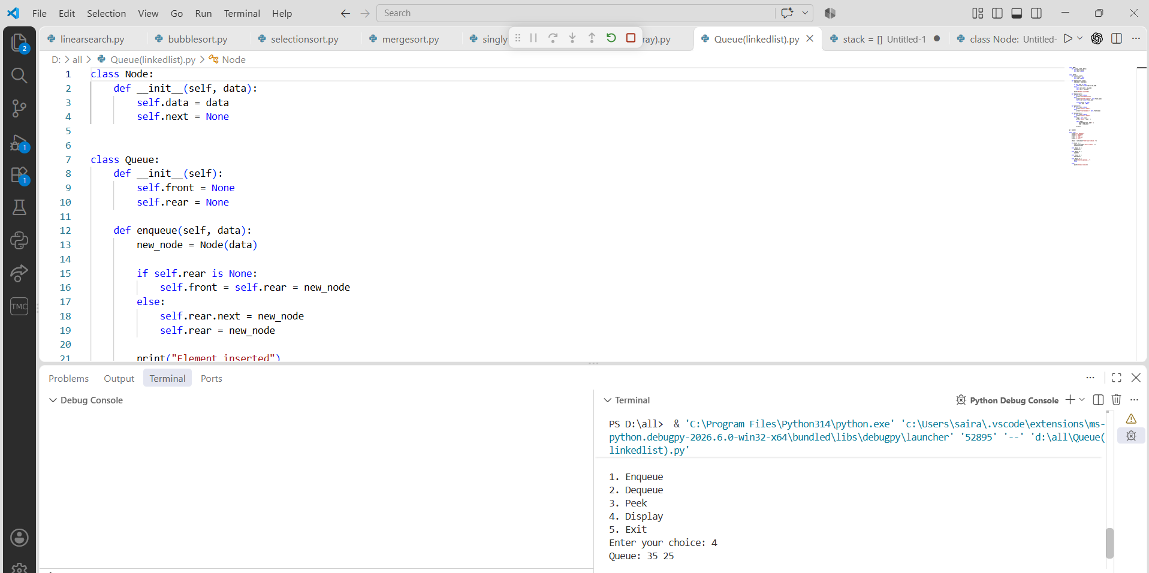

PROGRAM-8(B):

AIM: Write a python program to implement Circular Queue and its operations such as enqueue, dequeue, peek, display with a menu driven approach. Implement using array, and linked list data structures.
Using Array
CODE:
size = int(input("Enter queue size: "))
queue = [None] * size
front = -1
rear = -1

while True:
print("\n1. Enqueue")
print("2. Dequeue")
print("3. Peek")
print("4. Display")
print("5. Exit")

choice = int(input("Enter your choice: "))

if choice == 1:
if (rear + 1) % size == front:
print("Queue Overflow")
else:
item = int(input("Enter element: "))

if front == -1:
front = 0

rear = (rear + 1) % size
queue[rear] = item
print("Element inserted")

elif choice == 2:
if front == -1:
print("Queue Underflow")
else:
print("Deleted element:", queue[front])

if front == rear:
front = rear = -1
else:
front = (front + 1) % size

elif choice == 3:
if front == -1:
print("Queue is empty")
else:
print("Front element:", queue[front])

elif choice == 4:
if front == -1:
print("Queue is empty")
else:
print("Circular Queue:", end=" ")
i = front

while True:
print(queue[i], end=" ")
if i == rear:
break
i = (i + 1) % size

print()

elif choice == 5:
print("Exiting program...")
break

else:
print("Invalid choice")

OUTPUT:
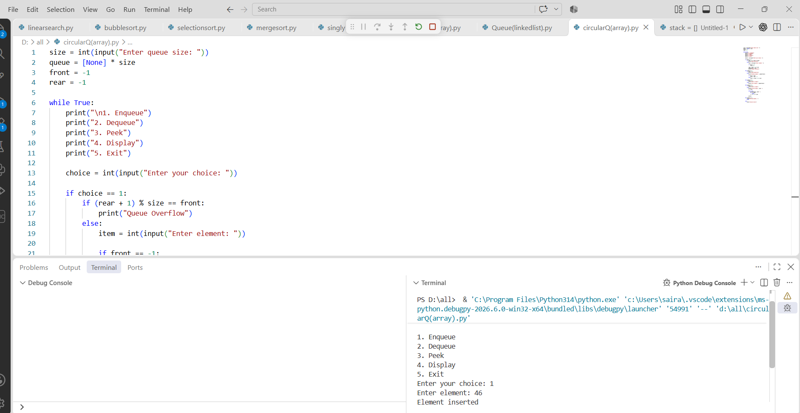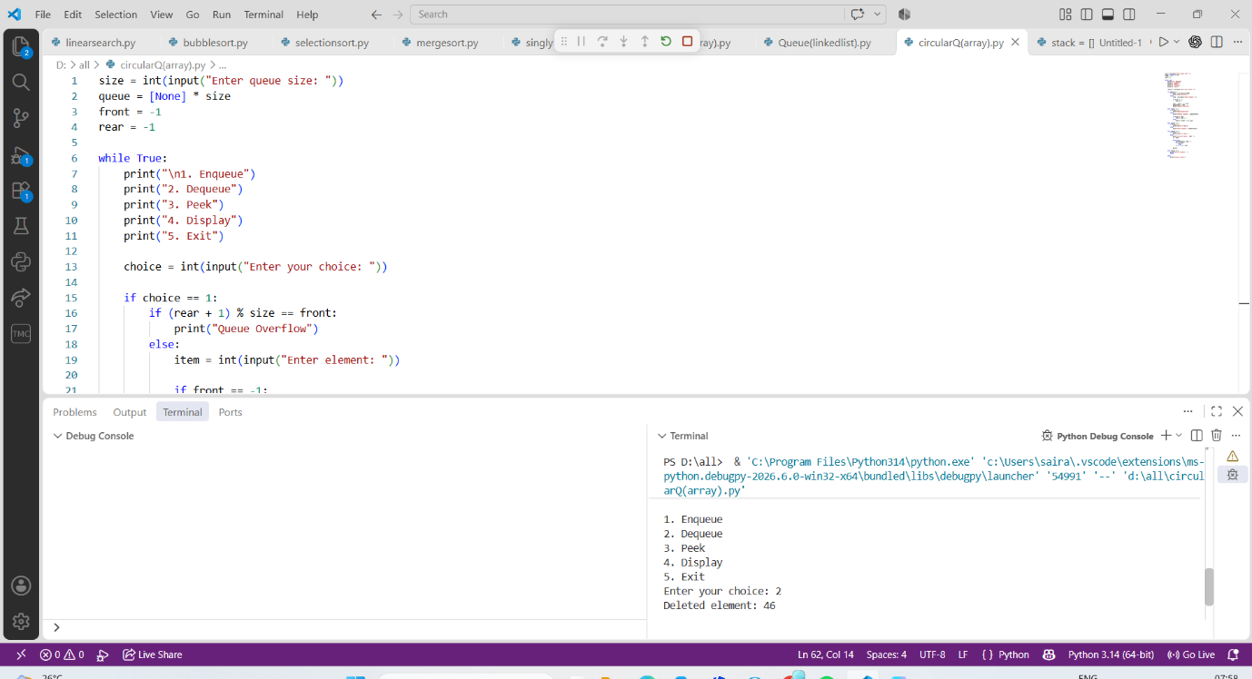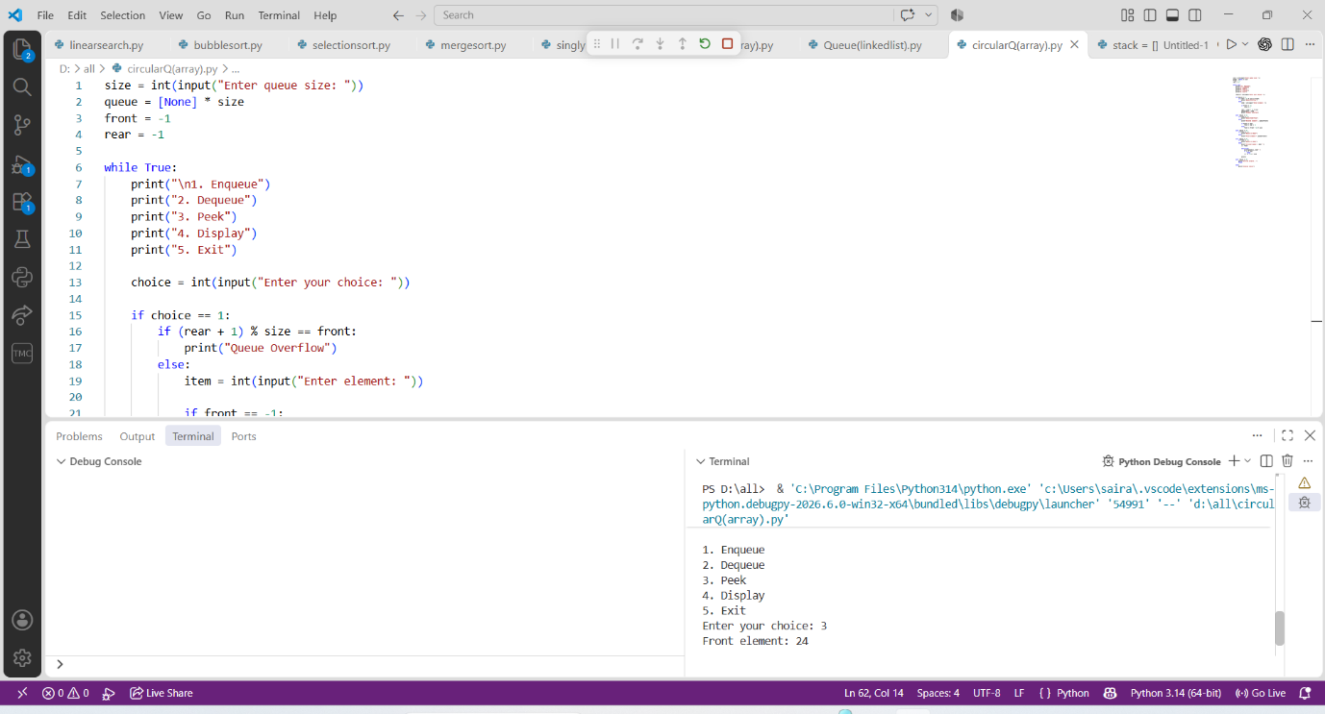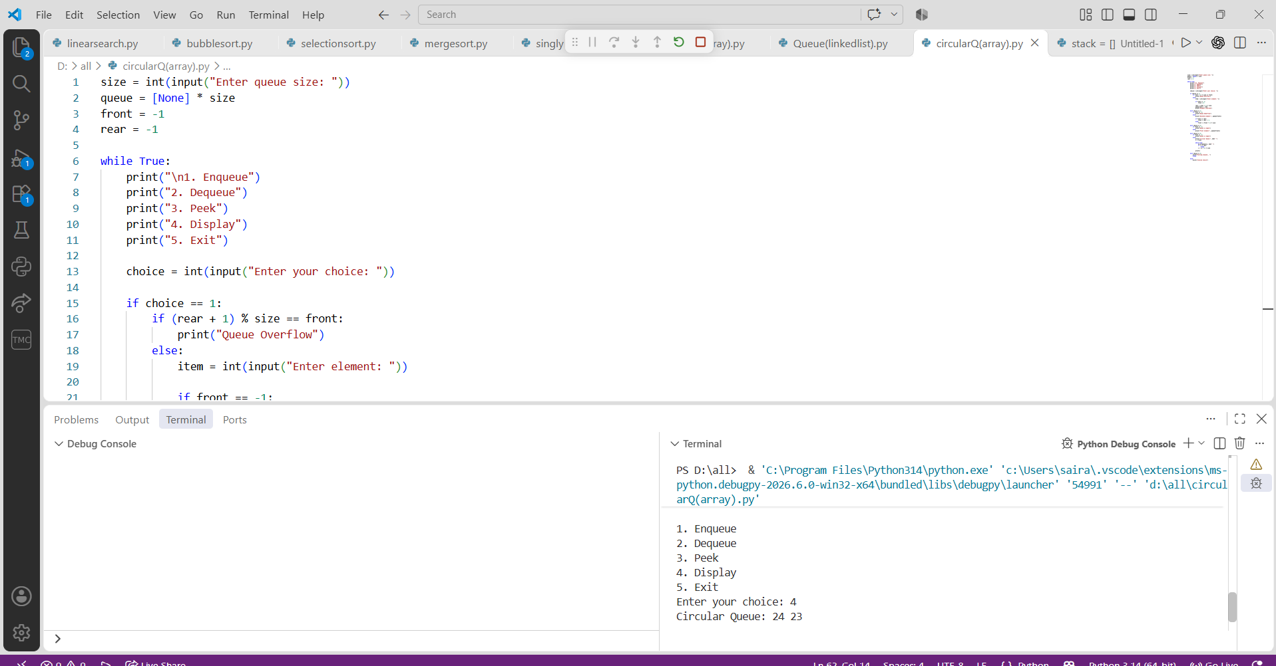

Using Linked List
CODE:
class Node:
def __init__(self, data):
self.data = data
self.next = None

class CircularQueue:
def __init__(self):
self.front = None
self.rear = None

def enqueue(self, data):
new_node = Node(data)

if self.front is None:
self.front = self.rear = new_node
new_node.next = new_node
else:
new_node.next = self.front
self.rear.next = new_node
self.rear = new_node

print("Element inserted")

def dequeue(self):
if self.front is None:
print("Queue Underflow")
elif self.front == self.rear:
print("Deleted element:", self.front.data)
self.front = self.rear = None
else:
print("Deleted element:", self.front.data)
self.front = self.front.next
self.rear.next = self.front

def peek(self):
if self.front is None:
print("Queue is empty")
else:
print("Front element:", self.front.data)

def display(self):
if self.front is None:
print("Queue is empty")
else:
temp = self.front
print("Circular Queue:", end=" ")

while True:
print(temp.data, end=" ")
temp = temp.next

if temp == self.front:
break

print()

q = CircularQueue()

while True:
print("\n1. Enqueue")
print("2. Dequeue")
print("3. Peek")
print("4. Display")
print("5. Exit")

choice = int(input("Enter your choice: "))

if choice == 1:
item = int(input("Enter element: "))
q.enqueue(item)

elif choice == 2:
q.dequeue()

elif choice == 3:
q.peek()

elif choice == 4:
q.display()

elif choice == 5:
print("Exiting program...")
break

else:
print("Invalid choice")

OUTPUT:
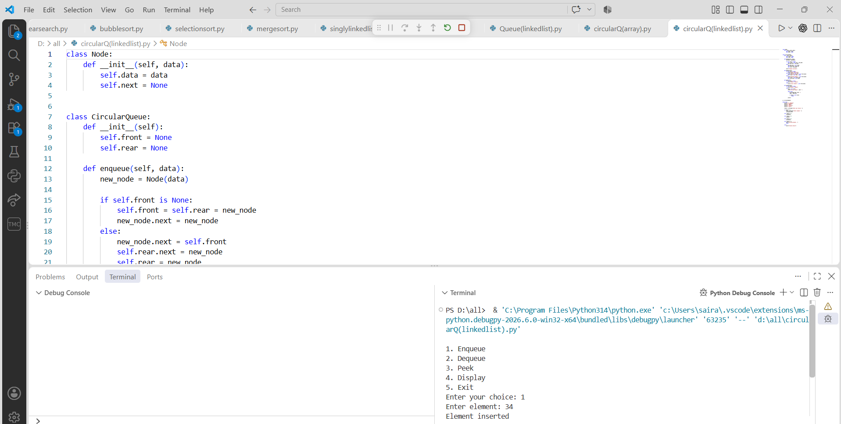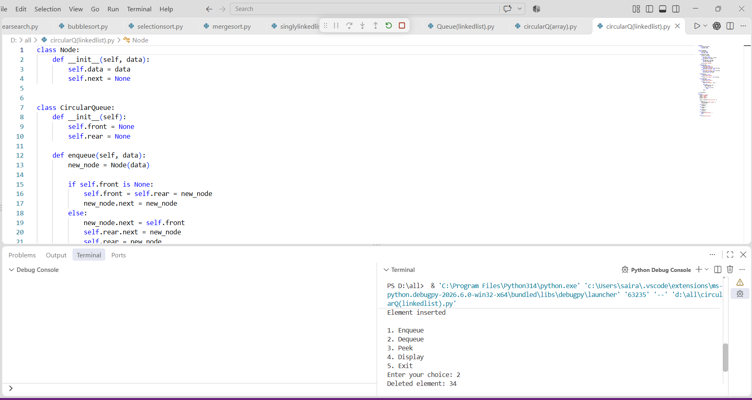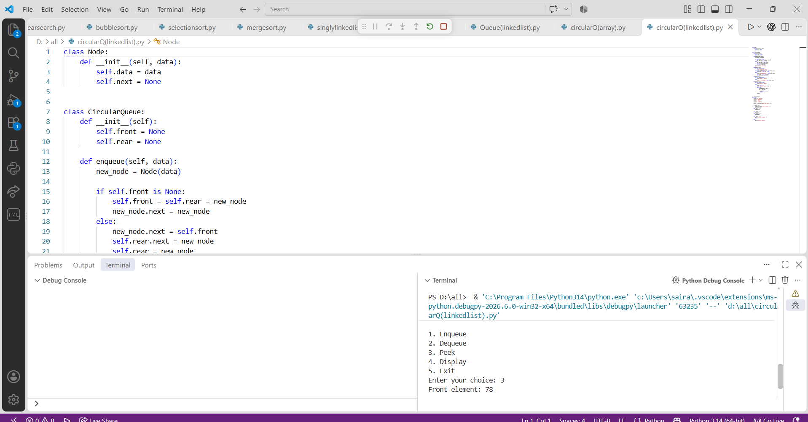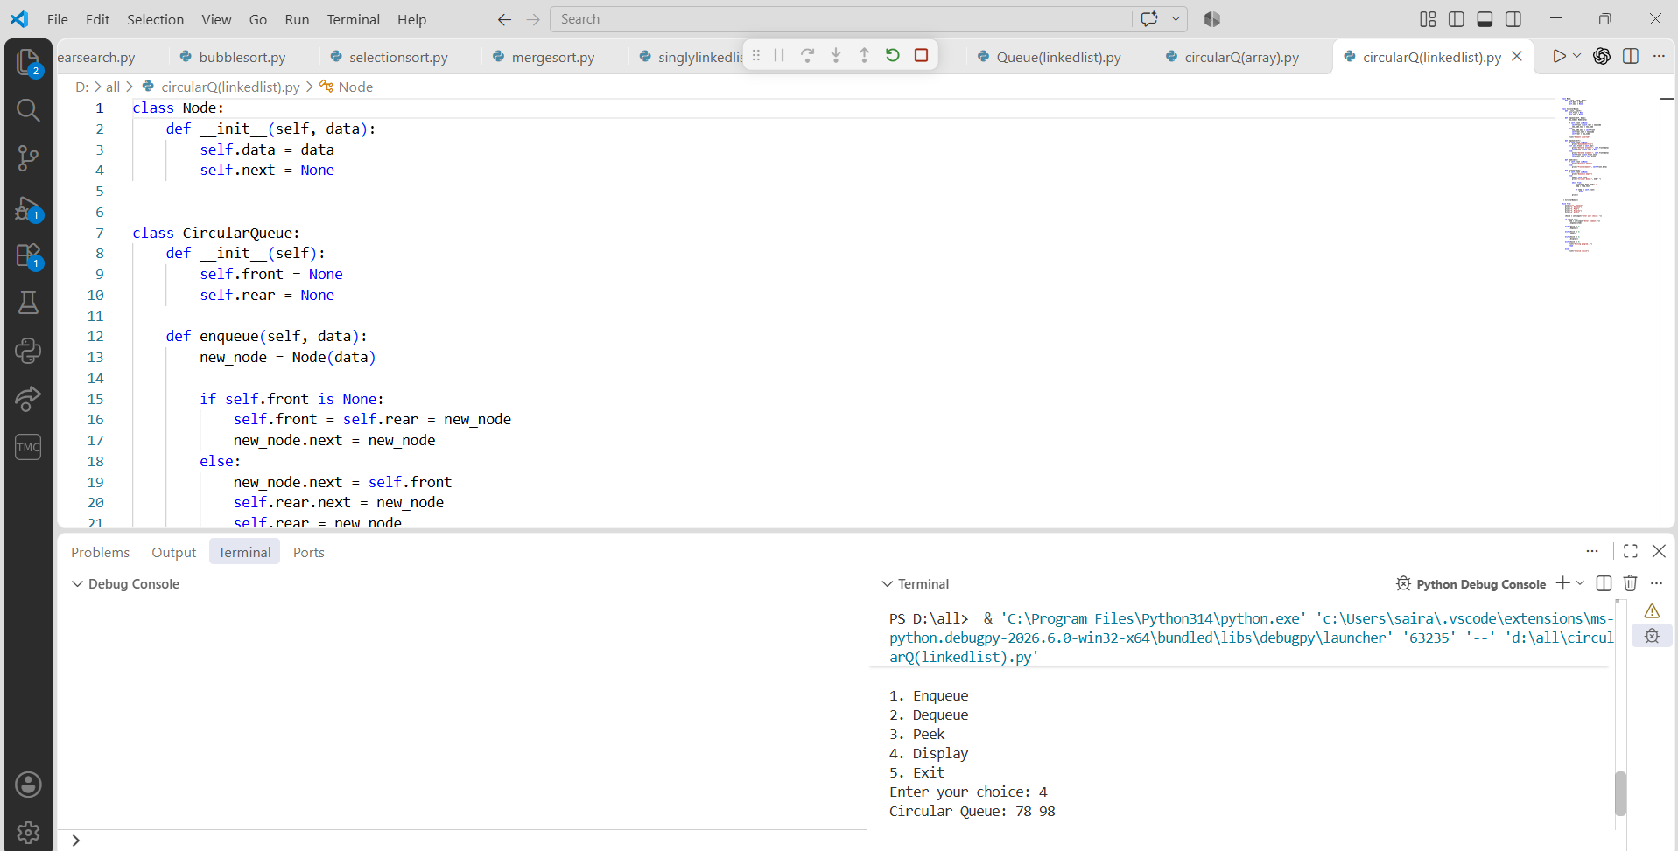

PROGRAM-9:

AIM: Write a python program to implement a Binary Search Tree (BST) and perform the following operations.
1. Insertion
2. Deletion
3. Tree Traversals – in-order, pre-order and post-order
4. Count Leaf Nodes
5. Count Internal Nodes
6. Height of the Tree

CODE:
class Node:
def __init__(self, data):
self.data = data
self.left = None
self.right = None

def insert(root, x):
if root is None:
return Node(x)
if x < root.data:
root.left = insert(root.left, x)
elif x > root.data:
root.right = insert(root.right, x)
else:
print("Duplicate value is not allowed.")
return root

def inorder(root):
if root is None:
return
inorder(root.left)
print(root.data, end=" ")
inorder(root.right)

def preorder(root):
if root is None:
return
print(root.data, end=" ")
preorder(root.left)
preorder(root.right)

def postorder(root):
if root is None:
return
postorder(root.left)
postorder(root.right)
print(root.data, end=" ")

def find_min(root):
if root is None:
return None
while root.left is not None:
root = root.left
return root

def find_max(root):
if root is None:
return None
while root.right is not None:
root = root.right
return root

def search(root, data):
if root is None:
return None
if data < root.data:
return search(root.left, data)
elif data > root.data:
return search(root.right, data)
else:
return root

def count_nodes(root):
if root is None:
return 0
return count_nodes(root.left) + count_nodes(root.right) + 1

def count_leaves(root):
if root is None:
return 0
if root.left is None and root.right is None:
return 1
return count_leaves(root.left) + count_leaves(root.right)

def count_internal(root):
if root is None:
return 0
if root.left is None and root.right is None:
return 0
return count_internal(root.left) + count_internal(root.right) + 1

def height(root):
if root is None:
return -1
left_height = height(root.left)
right_height = height(root.right)
return max(left_height, right_height) + 1

def delete(root, x):
if root is None:
print("Element not found.")
return None
if x < root.data:
root.left = delete(root.left, x)
elif x > root.data:
root.right = delete(root.right, x)
else:
# Case 1: Node has no children
if root.left is None and root.right is None:
root = None
# Case 2: Node has only right child
elif root.left is None:
root = root.right
# Case 3: Node has only left child
elif root.right is None:
root = root.left
# Case 4: Node has two children
else:
successor = find_min(root.right)
root.data = successor.data
root.right = delete(root.right, successor.data)
return root

def print_level(root, level):
if root is None:
return
if level == 0:
print(root.data, end=" ")
else:
print_level(root.left, level - 1)
print_level(root.right, level - 1)

def level_order(root):
h = height(root)
for level in range(h):
print_level(root, level)

# =====================================================
# MAIN PROGRAM
# =====================================================

root = None
while True:
print("\n\n******** BINARY SEARCH TREE ********")
print("1. INSERT")
print("2. PREORDER TRAVERSAL")
print("3. INORDER TRAVERSAL")
print("4. POSTORDER TRAVERSAL")
print("5. FIND MINIMUM")
print("6. FIND MAXIMUM")
print("7. SEARCH")
print("8. DELETE")
print("9. COUNT NODES")
print("10. COUNT LEAVES")
print("11. COUNT INTERNAL NODES")
print("12. HEIGHT")
print("13. LEVEL ORDER TRAVERSAL")
print("14. EXIT")

choice = int(input("Enter your choice: "))
if choice == 1:
data = int(input("Enter the data to be inserted: "))
root = insert(root, data)
print("Element inserted successfully.")
elif choice == 2:
print("Preorder Traversal:", end=" ")
if root is None:
print("Tree is empty.")
else:
preorder(root)
print()
elif choice == 3:
print("Inorder Traversal:", end=" ")
if root is None:
print("Tree is empty.")
else:
inorder(root)
print()
elif choice == 4:
print("Postorder Traversal:", end=" ")
if root is None:
print("Tree is empty.")
else:
postorder(root)
print()
elif choice == 5:
node = find_min(root)
if node is None:
print("Tree is empty.")
else:
print("Minimum element:", node.data)
elif choice == 6:
node = find_max(root)
if node is None:
print("Tree is empty.")
else:
print("Maximum element:", node.data)
elif choice == 7:
data = int(input("Enter the data to be searched: "))
node = search(root, data)
if node is None:
print("Element", data, "is not found.")
else:
print("Element", data, "is found.")
elif choice == 8:
data = int(input("Enter the data to be deleted: "))
root = delete(root, data)
elif choice == 9:
print("Number of nodes:", count_nodes(root))
elif choice == 10:
print("Number of leaf nodes:", count_leaves(root))
elif choice == 11:
print("Number of internal nodes:", count_internal(root))
elif choice == 12:
print("Height of BST:", height(root))
elif choice == 13:
print("Level Order Traversal:", end=" ")
if root is None:
print("Tree is empty.")
else:
level_order(root)
print()
elif choice == 14:
print("Program terminated.")
break
else:
print("Invalid choice. Please try again.")

OUTPUT:
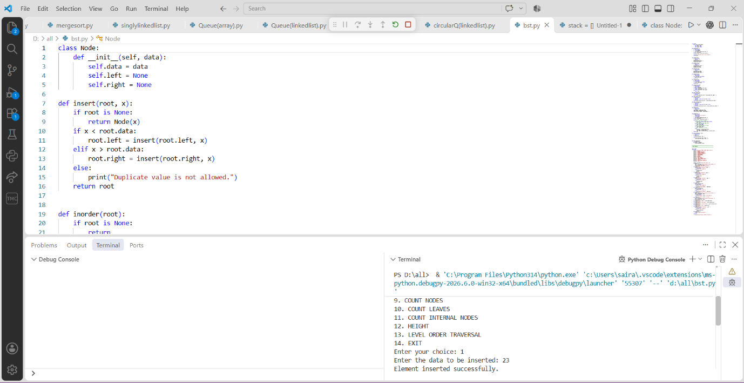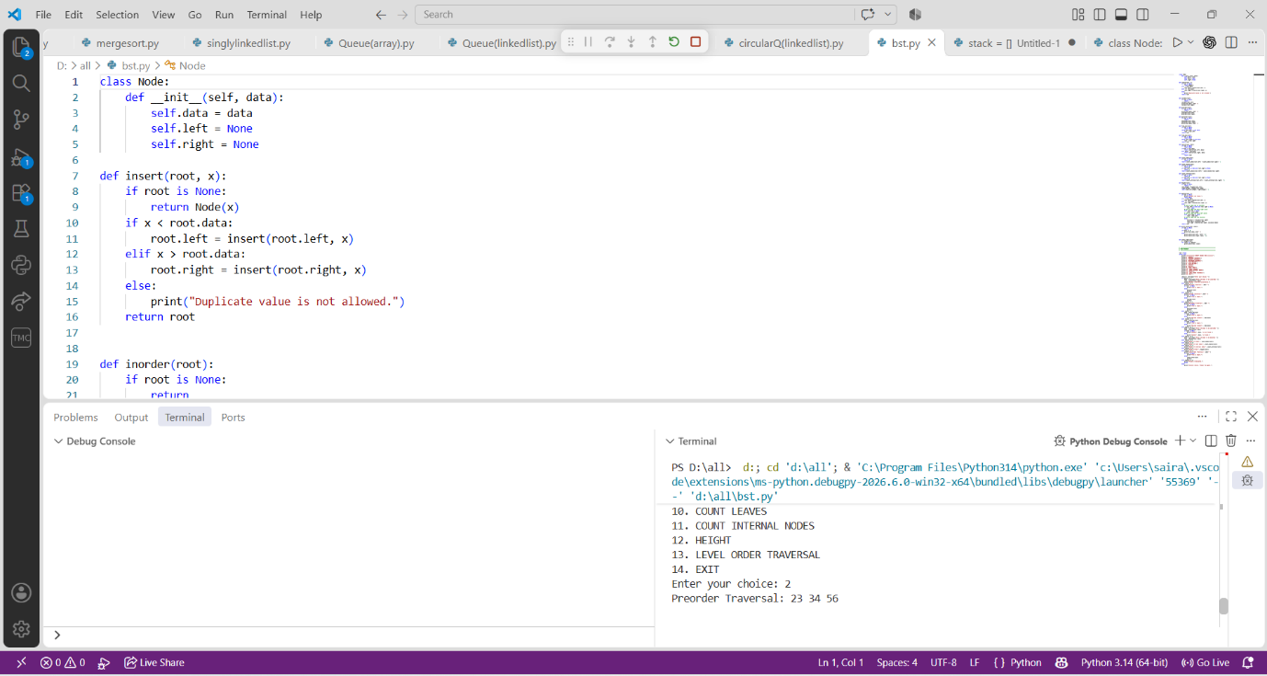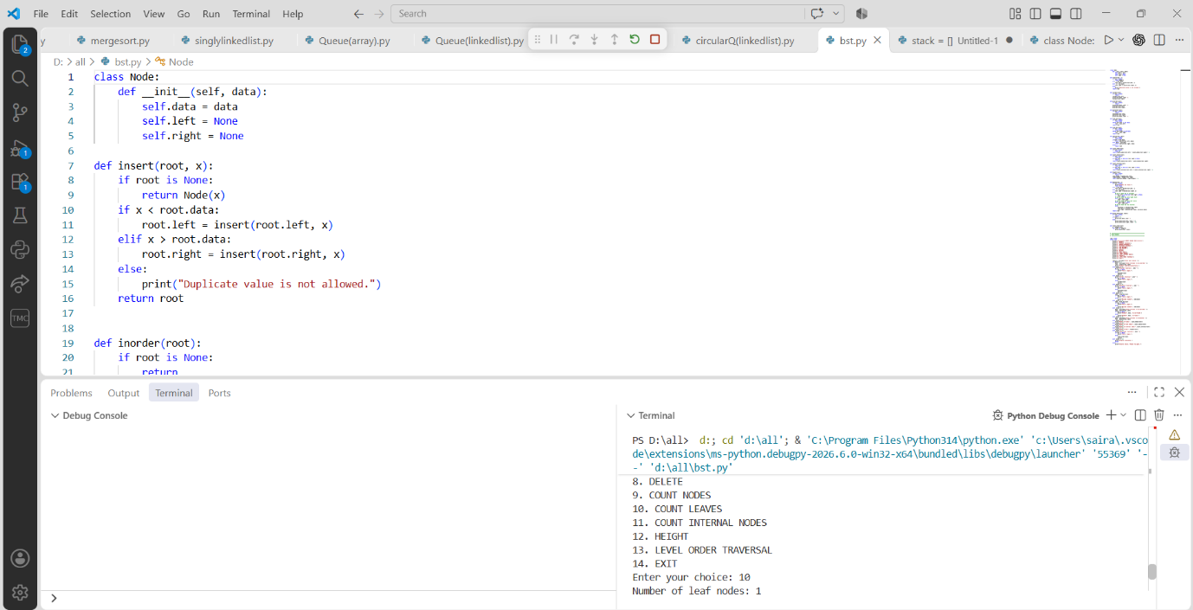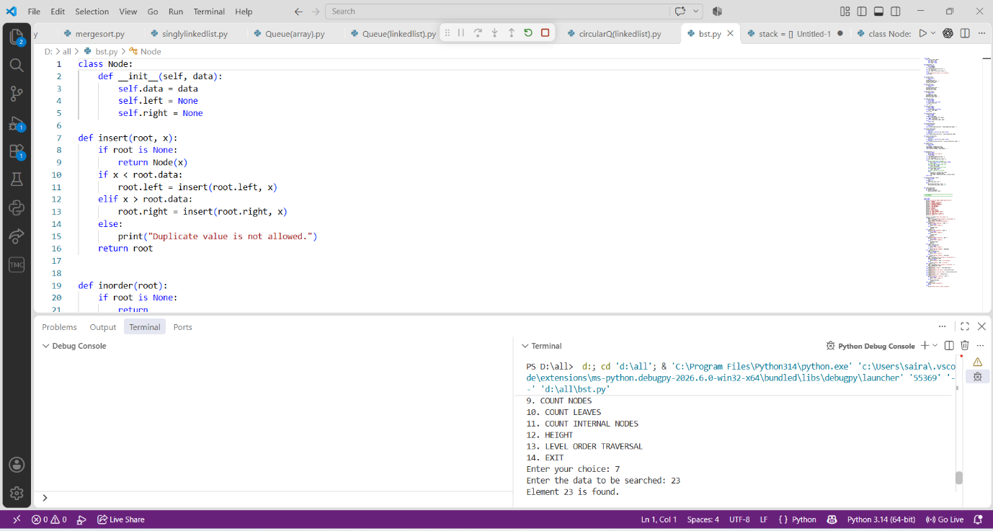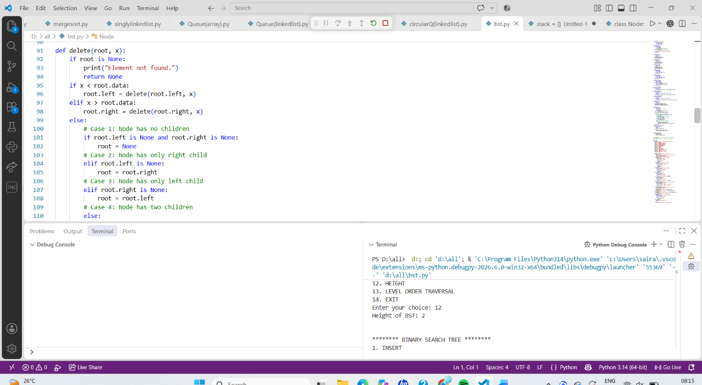

PROGRAM-10:

AIM: Write a menu driven python program to implement an AVL Tree and perform the following operations.
1. Insertion
2. Deletion
3. Tree Traversals
4. Count Leaf Nodes
5. Count Internal Nodes
6. Height of the Tree

CODE:
class Node:
def __init__(self, x):
self.left = None
self.data = x
self.right = None
self.h = 0

def height(root):
if root is None:
return -1
else:
return root.h

def LL(x):
y = x.left
x.left = y.right
y.right = x
x.h = max(height(x.left), height(x.right)) + 1
y.h = max(height(y.left), height(y.right)) + 1
return y

def RR(x):
y = x.right
x.right = y.left
y.left = x
x.h = max(height(x.left), height(x.right)) + 1
y.h = max(height(y.left), height(y.right)) + 1
return y

def LR(k3):
k3.left = RR(k3.left)
return LL(k3)

def RL(k3):
k3.right = LL(k3.right)
return RR(k3)

def inorder(root):
if root is not None:
inorder(root.left)
print(root.data, end=" ")
inorder(root.right)

def preorder(root):
if root is not None:
print(root.data, end=" ")
preorder(root.left)
preorder(root.right)

def postorder(root):
if root is not None:
postorder(root.left)
postorder(root.right)
print(root.data, end=" ")

def insert(root, x):
if root is None:
return Node(x)

if x < root.data:
root.left = insert(root.left, x)
if height(root.left) - height(root.right) == 2:
if x < root.left.data:
root = LL(root)
else:
root = LR(root)

elif x > root.data:
root.right = insert(root.right, x)
if height(root.right) - height(root.left) == 2:
if x > root.right.data:
root = RR(root)
else:
root = RL(root)
else:
print("Duplicates not allowed")
root.h = max(height(root.left),height(root.right)) + 1
return root

def delete(root, x):

if root is None:
return None

if x < root.data:
root.left = delete(root.left, x)
if height(root.left) - height(root.right) == 2:
if x < root.left.data:
root = LL(root)
else:
root = LR(root)

elif x > root.data:
root.right = delete(root.right, x)
if height(root.right) - height(root.left) == 2:
if x > root.right.data:
root = RR(root)
else:
root = RL(root)

else:
if root.left is None and root.right is None:
root = None
elif root.right is None:
root = root.left
elif root.left is None:
root = root.right
else:
successor = root.right
while successor.left is not None:
successor = successor.left
root.data = successor.data
root.right = delete(root.right, successor.data)

root.h = max(height(root.left), height(root.right)) + 1
return root

root = None

while True:

print("\n***** AVL TREE MENU *****")
print("1. INSERT")
print("2. PREORDER TRAVERSAL")
print("3. INORDER TRAVERSAL")
print("4. POSTORDER TRAVERSAL")
print("5. DELETE")
print("6. EXIT")

choice = int(input("Enter your choice: "))
if choice == 1:
data = int(input("Enter the data to be inserted: "))
root = insert(root, data)
elif choice == 2:
print("Preorder Traversal:")
preorder(root)
print()
elif choice == 3:
print("Inorder Traversal:")
inorder(root)
print()
elif choice == 4:
print("Postorder Traversal:")
postorder(root)
print()
elif choice == 5:
data = int(input("Enter the data to be deleted: "))
root = delete(root, data)
elif choice == 6:
print("Program terminated.")
break
else:
print("Invalid choice!")

OUTPUT:
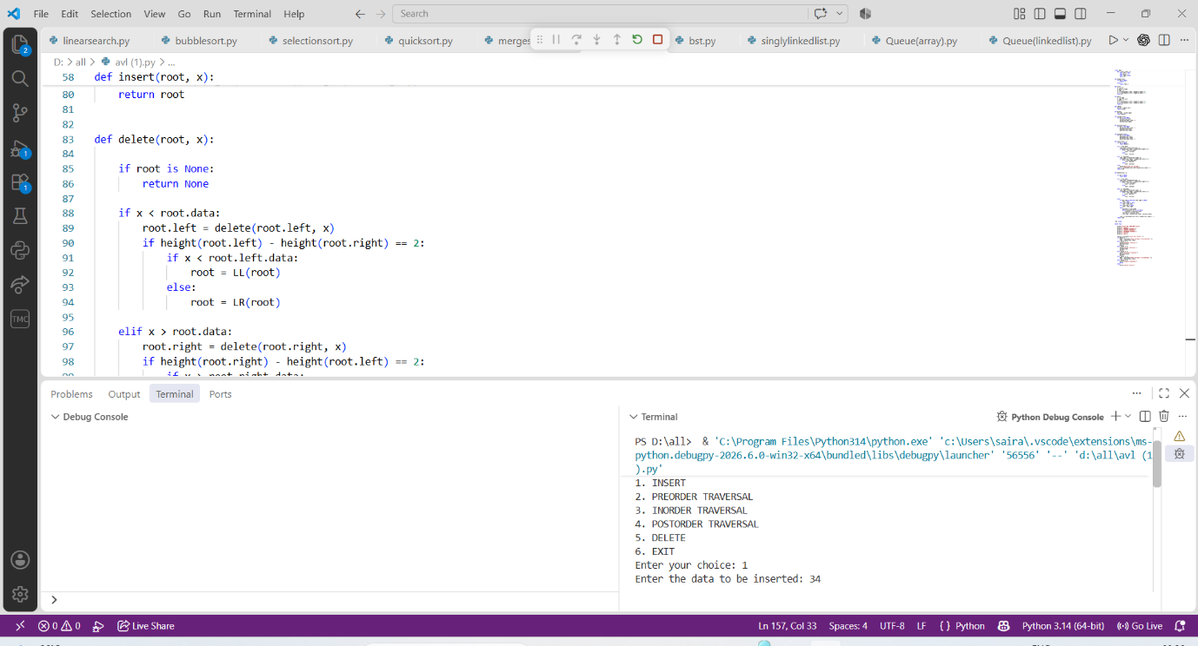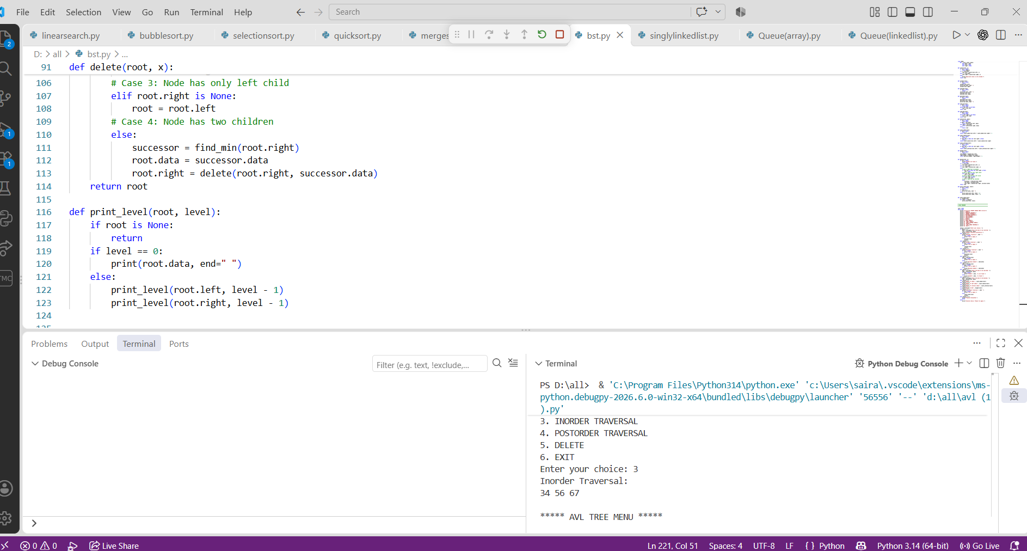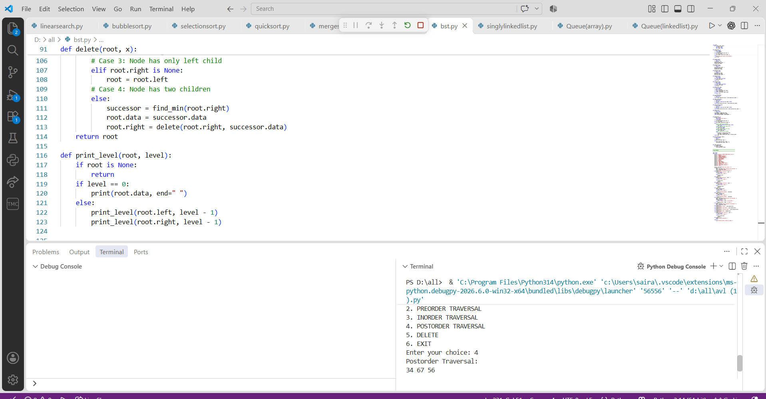

PROGRAM-11:

AIM: Write a menu-driven Python program to implement a Binary Heap (Max Heap and Min Heap) and perform the following operations:
- Insertion of an element into the Heap.
- Deletion of the root element from the Heap.
- Display the array representation of the Heap.
- Exit the program.

CODE:
def insert(heap, value):
heap.append(value)
i = len(heap) - 1
while i > 0:
parent = (i - 1) // 2
if heap[i] > heap[parent]:
heap[i], heap[parent] = heap[parent], heap[i]
i = parent
else:
break

def delete(heap):
if len(heap) == 0:
print("Heap is empty")
return
print("Deleted element:", heap[0])
heap[0] = heap[-1]
heap.pop()

n = len(heap)
i = 0
# Move the root downward
while True:
largest = i
left = 2 * i + 1
right = 2 * i + 2
if left < n and heap[left] > heap[largest]:
largest = left
if right < n and heap[right] > heap[largest]:
largest = right
if largest != i:
heap[i], heap[largest] = heap[largest], heap[i]
i = largest
else:
break

def display(heap):
if len(heap) == 0:
print("Heap is empty")
else:
print("Heap elements:", heap)

#Main Program
heap = []
while True:
print("\n--- MAX HEAP MENU ---")
print("1. Insert")
print("2. Delete")
print("3. Display")
print("4. Exit")
choice = int(input("Enter your choice: "))
if choice == 1:
value = int(input("Enter value to insert: "))
insert(heap, value)
elif choice == 2:
delete(heap)
elif choice == 3:
display(heap)
elif choice == 4:
print("Exiting program")
break
else:
print("Invalid choice")

OUTPUT:

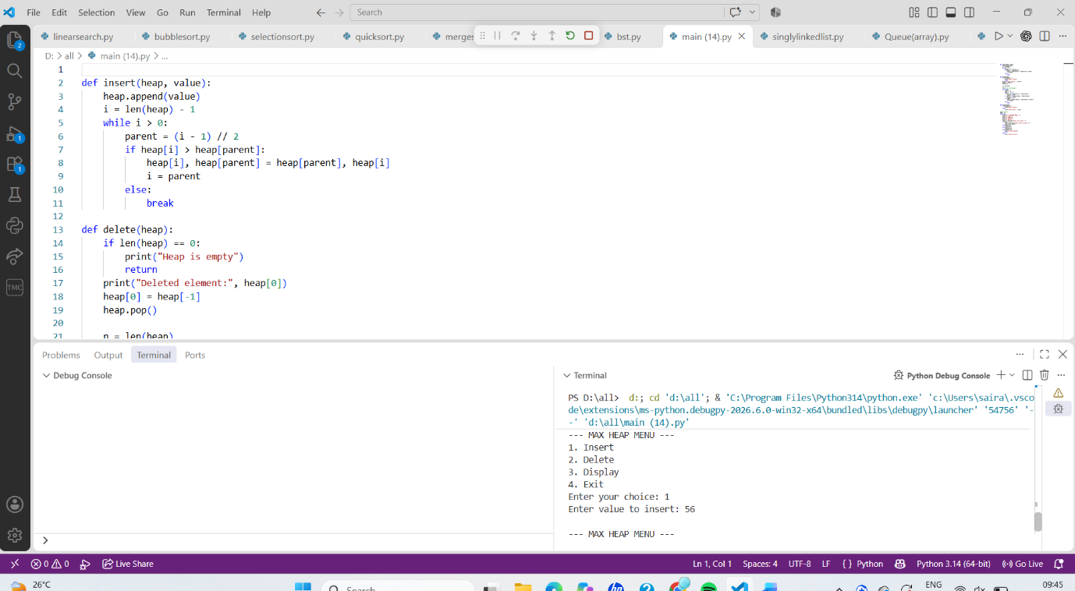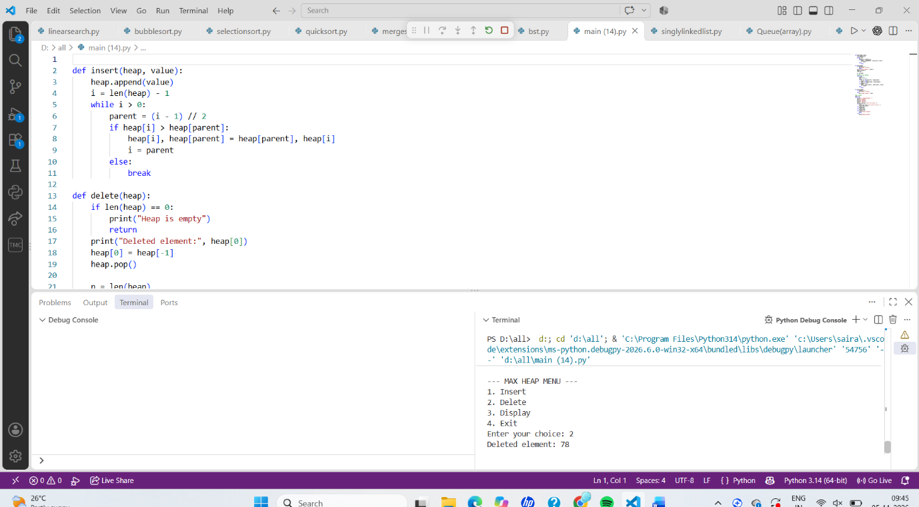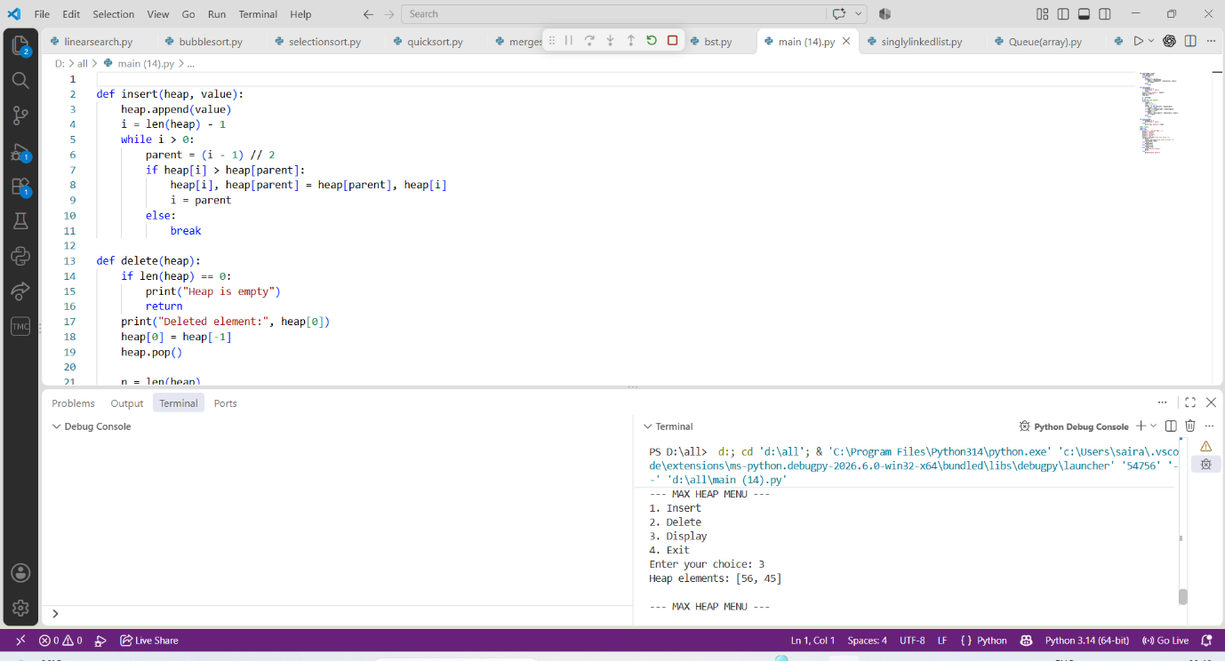

PROGRAM-12:

AIM: Write a program to implement the following three collision resolution techniques in a Hash Table:
- Separate Chaining
- Linear Probing
- Quadratic Probing

CODE:
Separate Chaining

class Node:
def __init__(self, data):
self.data = data
self.next = None

SIZE = 10
ht = [None] * SIZE

def insertValue(value):
index = value % SIZE
newnode = Node(value)
if ht[index] is None:
ht[index] = newnode
else:
temp = ht[index]
while temp.next is not None:
temp = temp.next
temp.next = newnode

def displayValue():
for i in range(SIZE):
print(i, end=": ")
temp = ht[i]
if temp is None:
print("None")
else:
while temp is not None:
print(temp.data, end=" -> ")
temp = temp.next
print("None")

repeat = True
while repeat:
print("\n1. Insert")
print("2. Display")
print("3. Exit")
ch = int(input("Enter your choice: "))
if ch == 1:
value = int(input("Enter value: "))
insertValue(value)
elif ch == 2:
print("\nHash table values:")
displayValue()
elif ch == 3:
repeat = False
else:
print("Invalid choice")

OUTPUT:
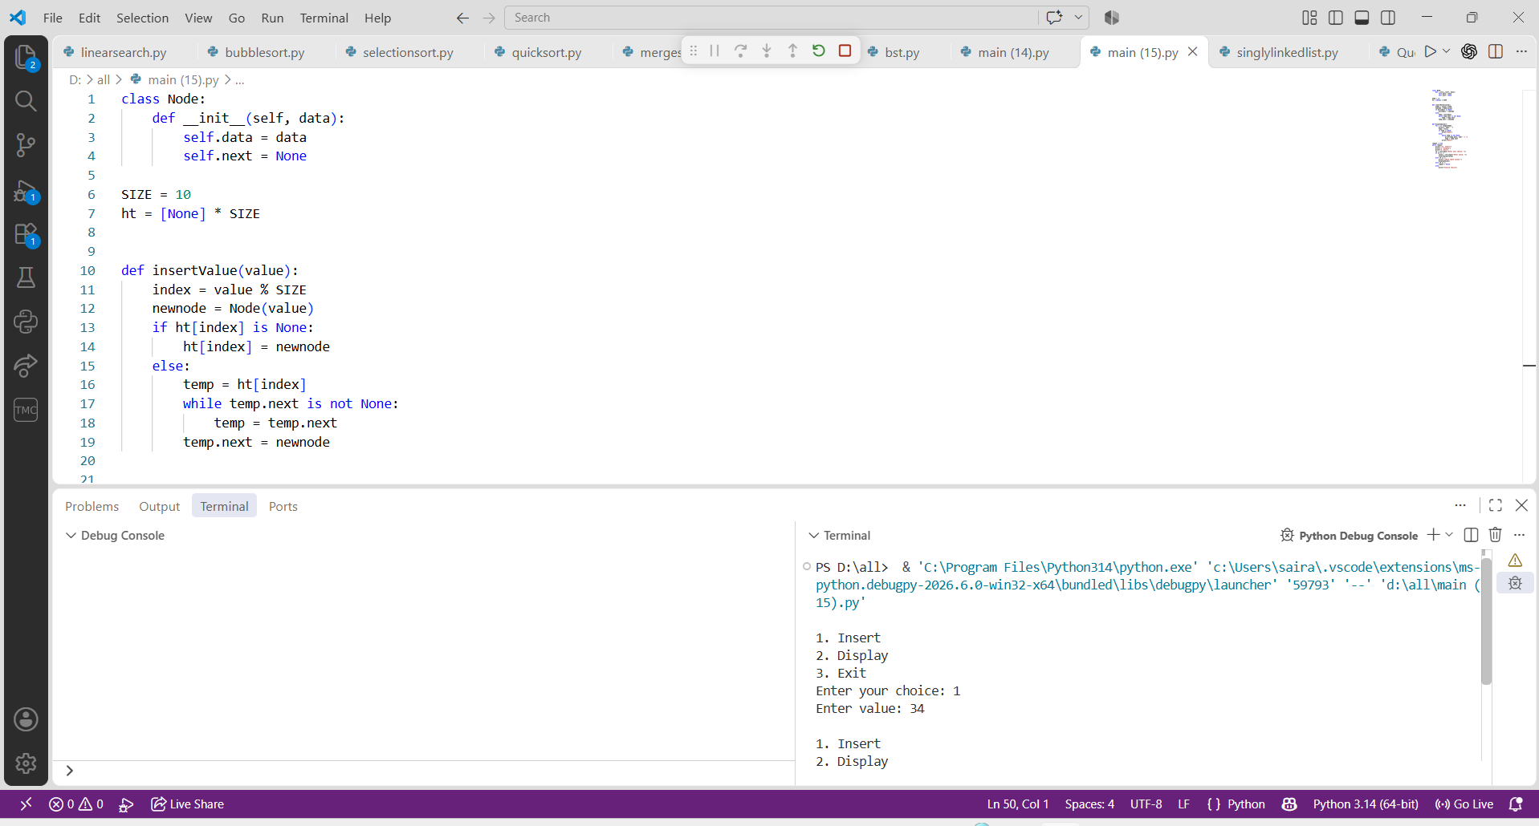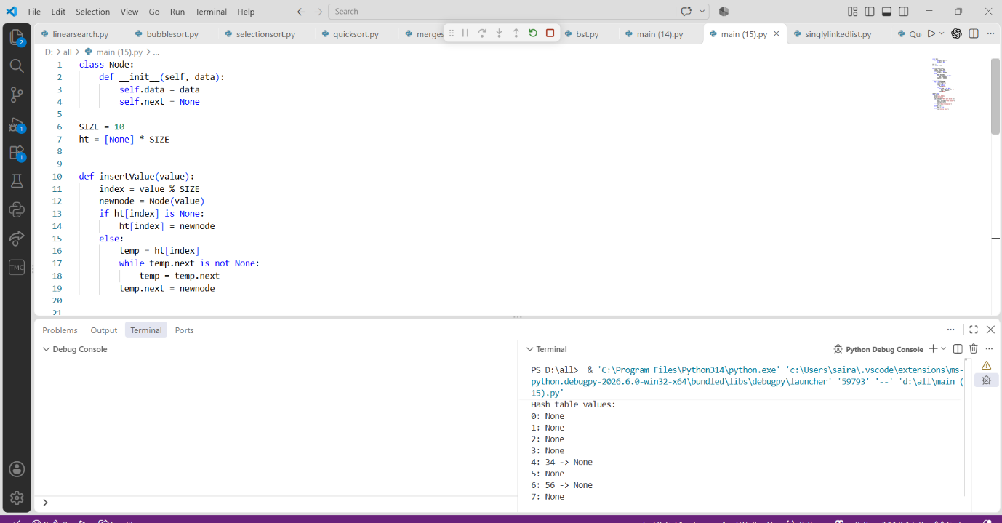

Linear probing
CODE:
SIZE = 10
a = [-1] * SIZE
def insertValue(x):
for i in range(SIZE):
index = ((x % SIZE) + i) % SIZE
if a[index] == -1:
a[index] = x
print("Element inserted")
return
print("Hash table is full")

def deleteValue(x):
for i in range(SIZE):
index = ((x % SIZE) + i) % SIZE
if a[index] == x:
a[index] = -1
print("Element deleted")
return
print("Element not found")

def search(x):
for i in range(SIZE):
index = ((x % SIZE) + i) % SIZE
if a[index] == x:
print("Element found at index", index)
return
if a[index] == -1:
break
print("Element not found")

def displayValue():
print("Index\tValue")
for i in range(SIZE):
print(i, "\t", a[i])

# Menu-driven program
repeat = True
while repeat:
print("\n1. Insert")
print("2. Display")
print("3. Delete")
print("4. Search")
print("5. Exit")
ch = int(input("Enter your choice: "))
if ch == 1:
value = int(input("Enter value: "))
insertValue(value)
elif ch == 2:
print("Values are:")
displayValue()
elif ch == 3:
value = int(input("Enter value to delete: "))
deleteValue(value)
elif ch == 4:
value = int(input("Enter value to search: "))
search(value)
elif ch == 5:
repeat = False
else:
print("Invalid choice")

OUTPUT:
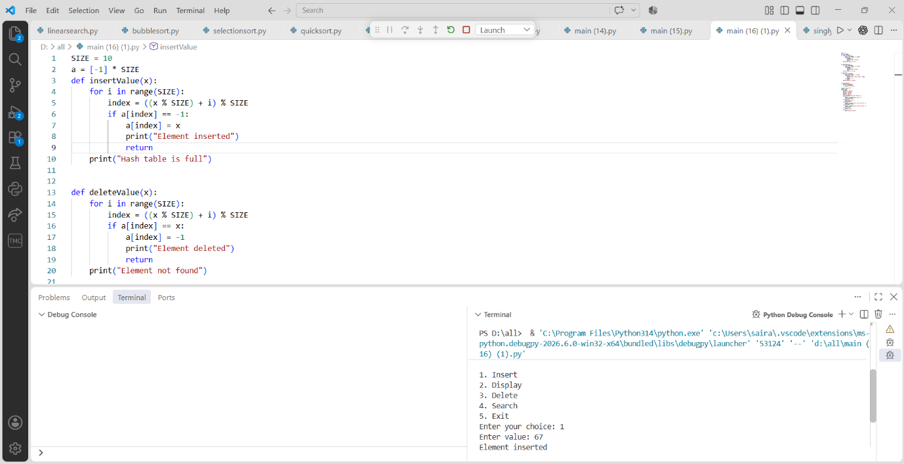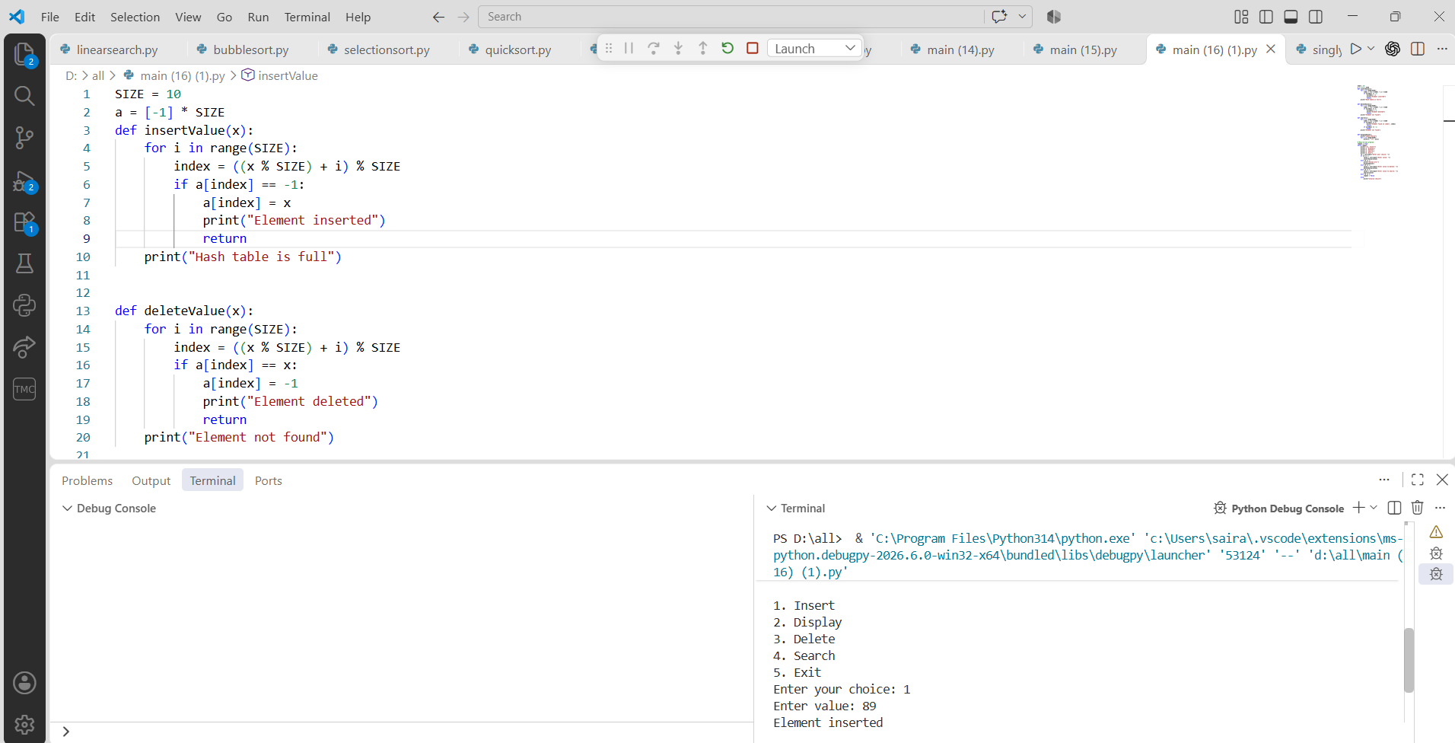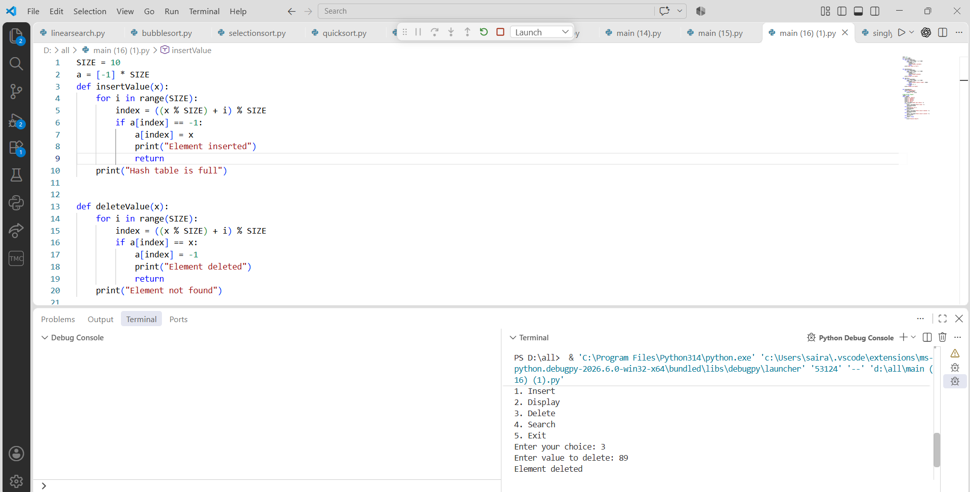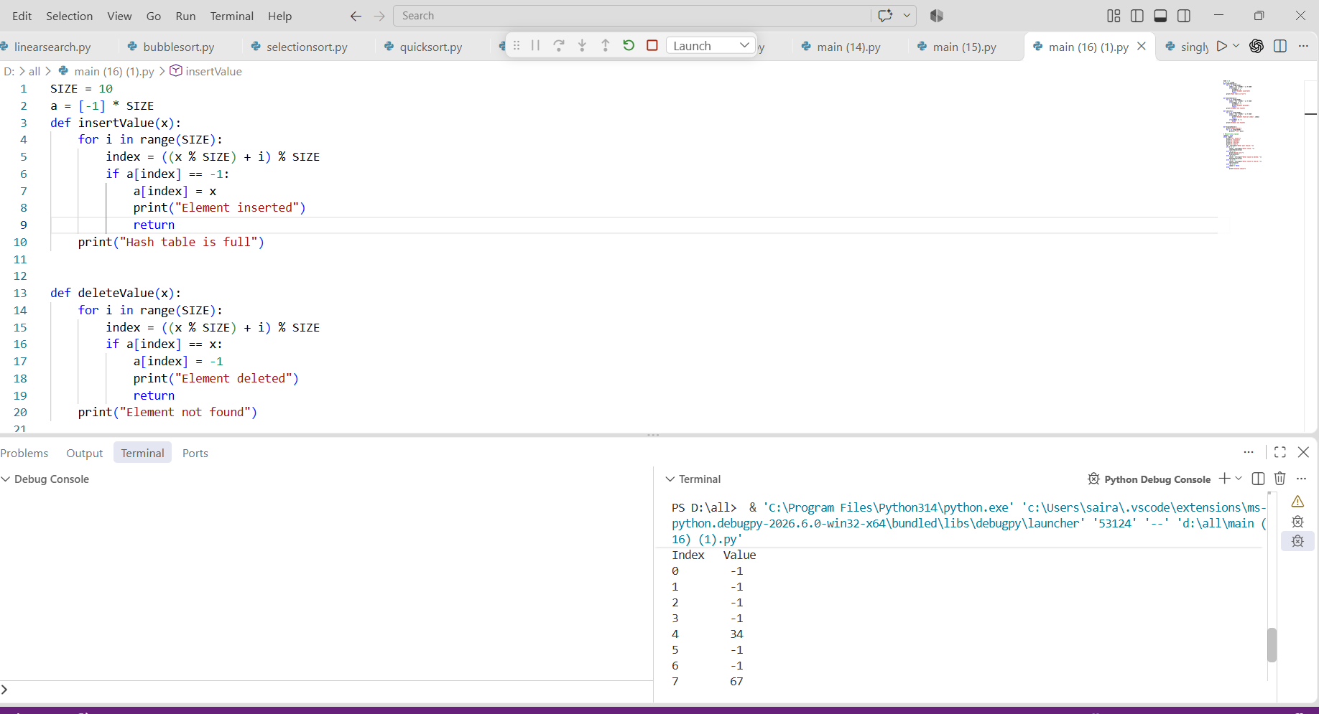

Quadratic probing
CODE:
SIZE = 10
a = [-1] * SIZE

def insertValue(value):
for i in range(SIZE):
index = ((value % SIZE) + i * i) % SIZE
if a[index] == -1:
a[index] = value
print("Element inserted at index", index)
return
print("No empty slot found in the probe sequence")

def displayValue():
print("Values are:")
for i in range(SIZE):
print(a[i])

# Menu-driven program
repeat = True
while repeat:
print("\n1. Insert")
print("2. Display")
print("3. Exit")
ch = int(input("Enter your choice: "))
if ch == 1:
value = int(input("Enter value: "))
insertValue(value)
elif ch == 2:
displayValue()
elif ch == 3:
repeat = False
else:
print("Invalid choice")

OUTPUT:


