CSA6303 - THREAT INTELLIGENCE AND NETWORK SECURITY
Assessment Tool 1: CONCEPT MAPPING
Faculty : Dr.V.ParthipanSLOT A

Topics: Network Security Fundamentals | Security Goals (CIA Triad) | Types of Network Threats |
Introduction to Threat Intelligence Types of Threat Intelligence (Strategic, Tactical, Operational) — Threat Intelligence Lifecycle — Applications in IT Industry
CO1: Interpret security principles, network threats, and the role of threat intelligence in cybersecurity.
Total: 50
Student Name : P Lakshmi Srinivasulu Reddy
Register number: 192465051
Code of Conduct:
I P Lakshmi Srinivasulu Reddy, 192465051 (Name / Reg No) certify that this submission is my original work and that I have adhered to the guidelines specified for this assessment. I understand that any violation of academic integrity rules will result in disciplinary action.
Signature of the student
P Lakshmi Srinivasulu Reddy

CO1 – Concept Mapping Questions
No. | Concept-Mapping Question
1 | Construct a comprehensive concept map explaining the foundations of Network Security. Connect network security fundamentals with security objectives, the CIA Triad (Confidentiality, Integrity, and Availability), network assets, vulnerabilities, threats, and protective measures, and explain how these concepts collectively support secure network operations.
2 | Develop a concept map illustrating the CIA Triad as the foundation of network security. Relate Confidentiality, Integrity, and Availability to different types of network threats and demonstrate how a single threat can affect one or more security goals.
Recommended Bloom's Levels
• Analyze (L4): Q1, Q2
These questions are deliberately framed so that students must connect concepts in a hierarchy/relationship map, rather than simply reproduce definitions.

Q1. Foundations of Network Security – Concept Map 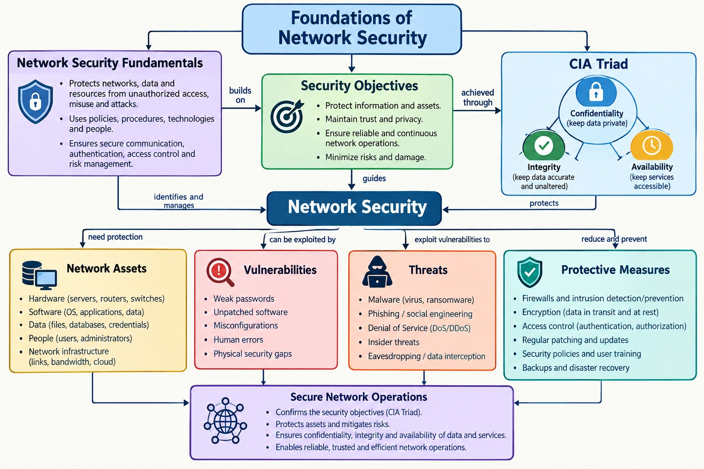
Concept Map Content

1. Network Security Fundamentals
- Protects networks, systems, and data from unauthorized access, misuse, modification, and disruption.
- Combines security policies, procedures, and technologies such as firewalls, encryption, access control, monitoring, and patching.
- Central idea that links objectives, assets, vulnerabilities, threats, and protective measures.

2. Security Objectives
- Protect sensitive data and network services.
- Allow only trusted users and devices to access resources.
- Maintain business continuity and meet policy and compliance requirements.
- Achieved by protecting network assets and enforcing the CIA Triad.

3. Security Goals – CIA Triad
- Confidentiality: Prevents unauthorized disclosure of information (encryption, access control, MFA).
- Integrity: Prevents unauthorized modification and keeps data accurate and trusted (hashing, digital signatures).
- Availability: Ensures systems and services remain accessible when needed (redundancy, backups, anti-DDoS).

4. Network Assets
- Data: customer, business, and intellectual property.
- Systems: servers and endpoints.
- Network devices: routers, switches, and firewalls.
- Applications and services; users and administrators.

5. Network Vulnerabilities
- Software flaws, misconfigurations, weak credentials, unpatched systems, and human error.
- Weaknesses in assets that can be exploited by threats and that weaken the CIA goals.

6. Network Threats
- Malware, phishing, DoS/DDoS, spoofing, eavesdropping, and unauthorized access.
- Exploit vulnerabilities in assets and violate one or more CIA goals.

7. Protective Measures
- Firewalls and IDS/IPS.
- Encryption and secure protocols (TLS, VPN).
- Access control and multi-factor authentication.
- Regular patching, vulnerability management, and monitoring.
- Backup, recovery, and incident response.

8. How the Concepts Support Secure Network Operations
- Security objectives define what must be achieved, and the CIA Triad turns them into measurable goals.
- Assets have vulnerabilities; threats exploit them, creating risk to confidentiality, integrity, and availability.
- Protective measures reduce the likelihood and impact of attacks and enforce the CIA goals.
- Risk management (identify assets, find vulnerabilities, assess threats, apply controls, monitor and improve) keeps the cycle continuous.
Result: Network security fundamentals, security objectives, the CIA Triad, assets, vulnerabilities, threats, and protective measures work together as a layered defence. This keeps the network confidential, accurate, available, and trusted, and supports secure network operations.

Q2. CIA Triad as the Foundation of Network Security – Concept Map
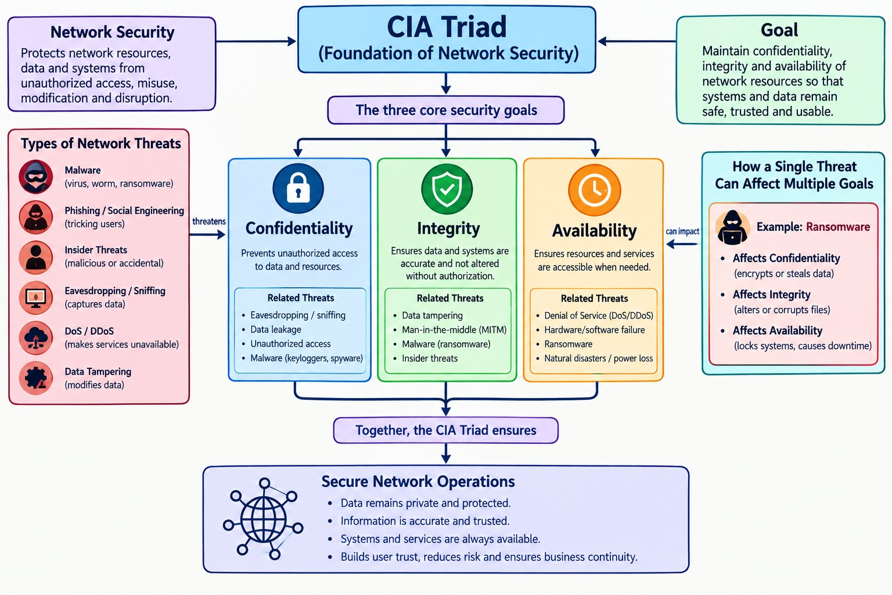
Concept Map Content

1. CIA Triad – Foundation of Network Security
- Three core goals: Confidentiality, Integrity, and Availability.
- Every threat, control, and security policy is judged by its effect on these three goals.

2. Security Goals
- Confidentiality: Protects information from unauthorized access and disclosure.
- Integrity: Prevents unauthorized modification and ensures data is accurate and complete.
- Availability: Ensures systems and services remain accessible to authorized users.

3. Types of Network Threats
- Malware: Viruses, worms, Trojans, ransomware — infects systems, steals data, and encrypts files.
- Phishing: Social engineering — tricks users into revealing credentials or installing malware.
- Denial of Service (DoS/DDoS): Floods network resources and disrupts services.
- Spoofing: ARP, IP, and DNS spoofing — falsifies identity and redirects traffic.
- Eavesdropping: Sniffing network traffic to capture confidential information.
- Unauthorized Access: Uses stolen credentials or weak configurations to access systems.

4. Relating Threats to the CIA Triad
- Malware → Confidentiality, Integrity, and Availability.
- Phishing → Confidentiality and potentially Integrity.
- DoS/DDoS → Availability.
- Spoofing → Integrity and potentially Confidentiality.
- Eavesdropping → Confidentiality.
- Unauthorized Access → Confidentiality, Integrity, and potentially Availability.

5. One Threat Affecting Multiple Security Goals
- Example – Ransomware attack:
  - Confidentiality: data is stolen before encryption (double extortion).
  - Integrity: files are encrypted or altered and can no longer be trusted.
  - Availability: systems and services are unavailable until data is restored.
- Example – Unauthorized access: exposes data (C), allows changes to configurations or records (I), and can disrupt services through misuse (A).
- Example – Spoofing / man-in-the-middle: falsified identity lets an attacker alter traffic (I) and read it (C).

6. Protective Measures Mapped to the CIA Triad
- Confidentiality: Encryption, access control, multi-factor authentication.
- Integrity: Hashing, digital signatures, change control, secure protocols.
- Availability: Redundancy, backups, anti-DDoS solutions, patching, incident response.
Result: The CIA Triad is the foundation for understanding network threats. Each threat can be mapped to the goals it endangers, and a single threat can violate more than one goal at once. Controls must therefore protect all three parts of the triad to maintain secure network operations.

