Lakeflow Spark Declarative Pipelines
Online Learning Enrollment Analytics Platform

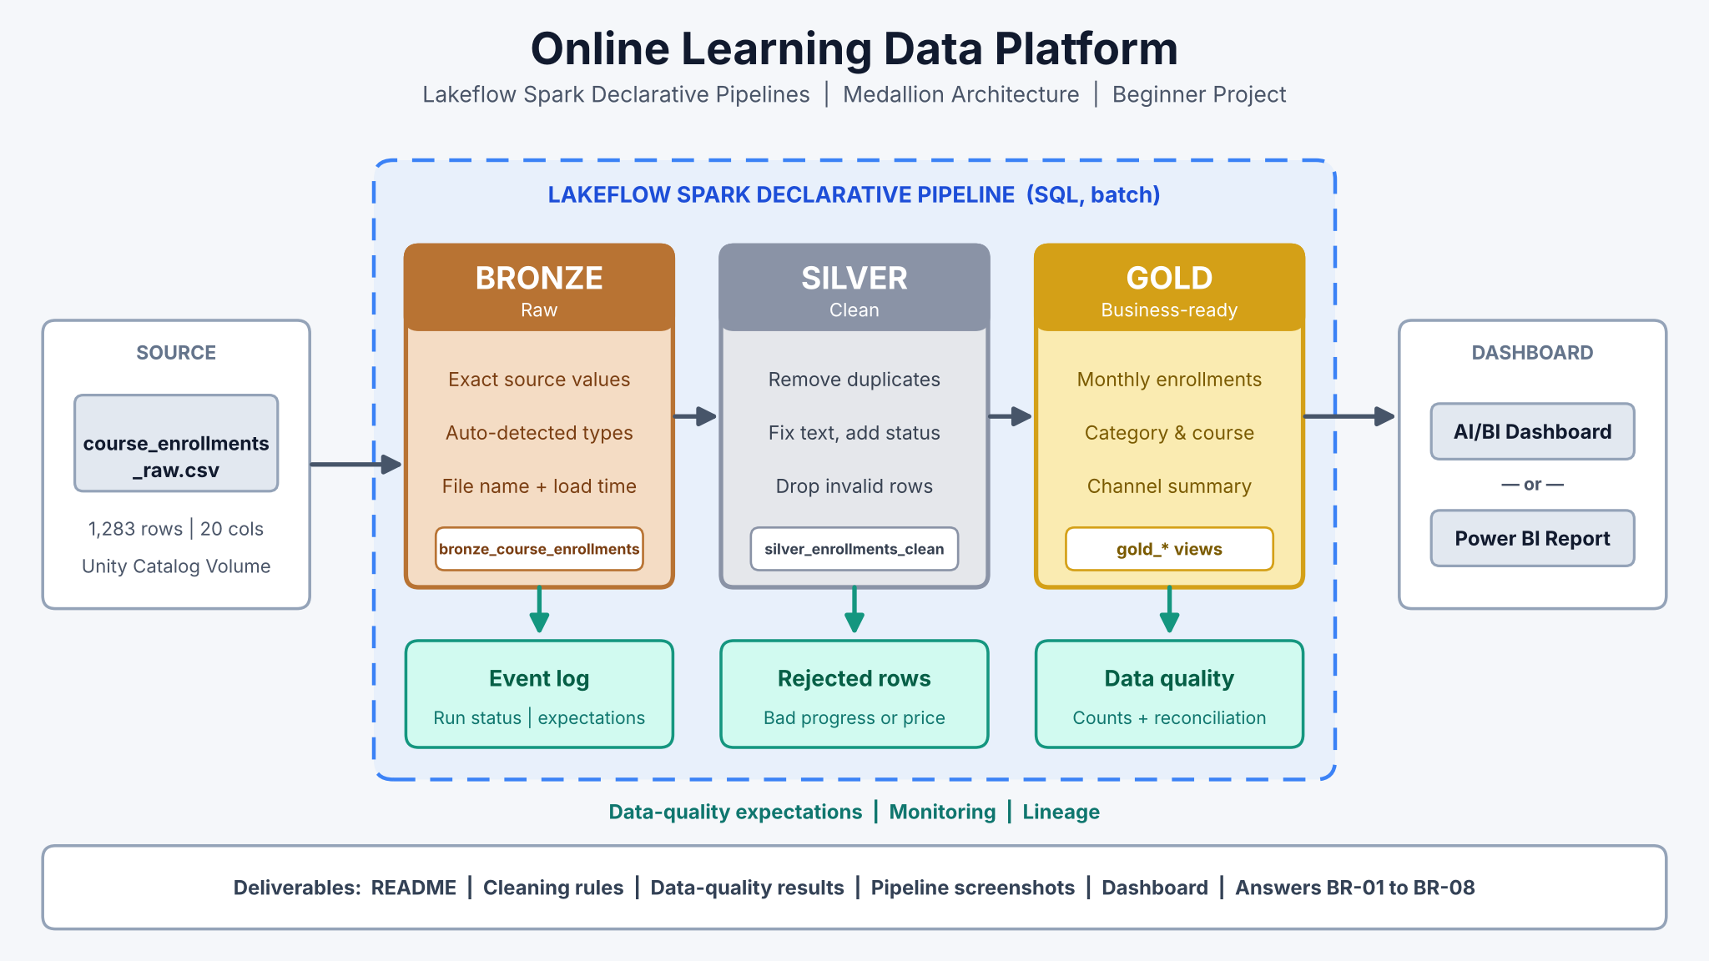
Project level: Beginner • Estimated time: 6–8 hours • SQL you need: SELECT, WHERE, GROUP BY, COUNT, SUM, AVG, DISTINCT, TRIM, INITCAP, LOWER, COALESCE, CASE WHEN, BETWEEN.

1. Executive Summary
An online learning platform sells video courses in data science, cloud, web development, design, business and marketing. It exports every course enrollment to a CSV file. Managers want simple, reliable reports on enrollments, revenue, course completion, learners and enrollment channels. The file has common problems: extra spaces, inconsistent capital letters, messy email addresses, blank values, duplicate enrollments, progress values above 100% and a few negative prices. You will build a Databricks Medallion Architecture that keeps the raw file, cleans it step by step, creates business-ready summary tables, and shows them in a dashboard.
Project goal: Transform a raw course enrollments CSV into trusted Gold-layer tables using Databricks SQL and Lakeflow Spark Declarative Pipelines, then build one dashboard on top of them.

2. Business Background
The platform offers 18 courses in six categories, taught by ten instructors at Beginner, Intermediate and Advanced level. Learners from ten Indian cities enroll through the Website, the Mobile App, a Referral or Social Media. Each enrollment has a list price, a discount, the price paid, the learner’s progress (0–100%), hours watched and an optional course rating. A learner who reaches 100% progress gets a certificate. The same learner can enroll in several courses.

Current business challenges
- Category, course level, learner city and enrollment channel values have extra spaces and mixed capital letters.
- Some learner emails have capital letters or extra spaces, so the same learner looks like two different people.
- Some enrollments are missing the category, learner city, learner ID or price paid.
- Some enrollments appear twice, which makes enrollments and revenue look bigger than they are.
- A few enrollments show progress below 0% or above 100%, or a negative price paid.

3. Business Problem and Objectives
The platform has no automatic way to turn the raw enrollments file into numbers it can trust. This project builds a repeatable pipeline that keeps the original file, cleans the data, prepares summary tables and shows them in a dashboard.

Project objectives
- Load the enrollments CSV into Databricks from a Unity Catalog Volume.
- Keep the raw data in a Bronze table.
- Clean the data in a Silver table, add a learner status, and keep the bad enrollments in a separate rejected table.
- Create Gold summary tables for monthly enrollments, categories, courses and enrollment channels.
- Count the data problems, including how many learners were double-counted because of messy emails.
- Build one dashboard in Databricks AI/BI or Power BI.

4. Dataset Overview
The learning dataset course_enrollments_raw.csv is synthetic (made up for this project). It has 1,283 rows and 20 columns covering course enrollments in 2025. It looks like a real EdTech export but the learners and emails are not real.
Course Enrollments Dataset :- Click Here to Download Dataset
Dataset attribute | Description | Why it matters
Grain | One row = one learner enrolled in one course. enrollment_id is unique for each real enrollment. | Tells you how to count enrollments and find duplicates
Learner fields | learner_id, learner_email, learner_city, age_group | Supports learner counts and city reports
Course fields | course_id, course_name, category, course_level, instructor_name | Supports category and course reports
Enrollment fields | enrollment_date, enrollment_channel, payment_method | Supports monthly and channel analysis
Money & progress fields | list_price, discount_amount, price_paid, progress_pct, hours_watched, course_rating, certificate_issued | Supports revenue and completion reports
Planted problems | Extra spaces, mixed case, messy emails, blanks, duplicates, progress outside 0–100, negative price | Gives you real cleaning practice

Column dictionary
Column | Example | Description
enrollment_id | EN500001 | Unique ID of one enrollment
learner_id | LR7123 | Learner ID (sometimes blank)
learner_email | arun.7123@gmail.com | Learner email (sometimes with capitals or spaces)
learner_city | Pune | Learner city (sometimes blank or messy)
age_group | 25-34 | 18-24, 25-34, 35-44, 45+
course_id | C102 | Course code
course_name | Machine Learning A to Z | Course title
category | Data Science | Course category (sometimes blank or messy)
course_level | Intermediate | Beginner, Intermediate, Advanced (sometimes messy)
instructor_name | Ravi Kumar | Course instructor
enrollment_date | 2025-05-09 | Date of enrollment
enrollment_channel | Mobile App | Website, Mobile App, Referral, Social Media (sometimes messy)
list_price | 4499 | Course price in ₹
discount_amount | 899.80 | Discount given
price_paid | 3599.20 | list_price − discount_amount (sometimes blank)
payment_method | UPI | UPI, Card, Net Banking, Wallet
progress_pct | 65 | Course progress from 0 to 100
hours_watched | 31.4 | Video hours watched
course_rating | 4 | Rating 1–5 (blank until 30% progress)
certificate_issued | Yes | Yes when progress is 100

Key business formulas
- price_paid = list_price − discount_amount
- learner_status = Completed (progress 100), In Progress (1–99) or Not Started (0)
- completion_rate_pct = Completed enrollments × 100 ÷ all enrollments
- unique learners = COUNT(DISTINCT learner_email) after cleaning the email

Important: enrollment_id should be unique. If the same enrollment_id appears more than once, the extra rows are duplicates. learner_email is NOT unique, because one learner can enroll in many courses.

5. Key Terms for Beginners
Term | Simple meaning
Unity Catalog Volume | A folder inside Databricks where you upload files such as CSVs.
Medallion Architecture | Organising data in three layers: Bronze (raw), Silver (clean), Gold (summaries).
Lakeflow Spark Declarative Pipelines | A Databricks feature where you write SQL that says what each table should contain; Databricks works out the order and runs it.
Streaming table | A table that reads new files incrementally. We use it for Bronze.
Materialized view | A saved query result that the pipeline keeps up to date. We use it for Silver and Gold.
Expectation | A data-quality rule, e.g. progress_pct BETWEEN 0 AND 100. With ON VIOLATION DROP ROW, bad rows are removed and counted.
INITCAP vs LOWER | INITCAP makes "data science" → "Data Science" (good for names). LOWER makes "Arun.7123@Gmail.com" → "arun.7123@gmail.com" (right for emails).
COUNT(DISTINCT ...) | Counts different values only once. Used to count unique learners.
Reconciliation | Checking that every input row is accounted for: kept, rejected or removed as a duplicate.

6. Proposed Architecture and Data Flow
Bronze keeps the raw enrollments. Silver cleans them and adds a learner status: good enrollments go to silver_enrollments_clean and bad enrollments go to silver_enrollments_rejected. Gold builds summary tables from the clean enrollments only, plus one data-quality table.
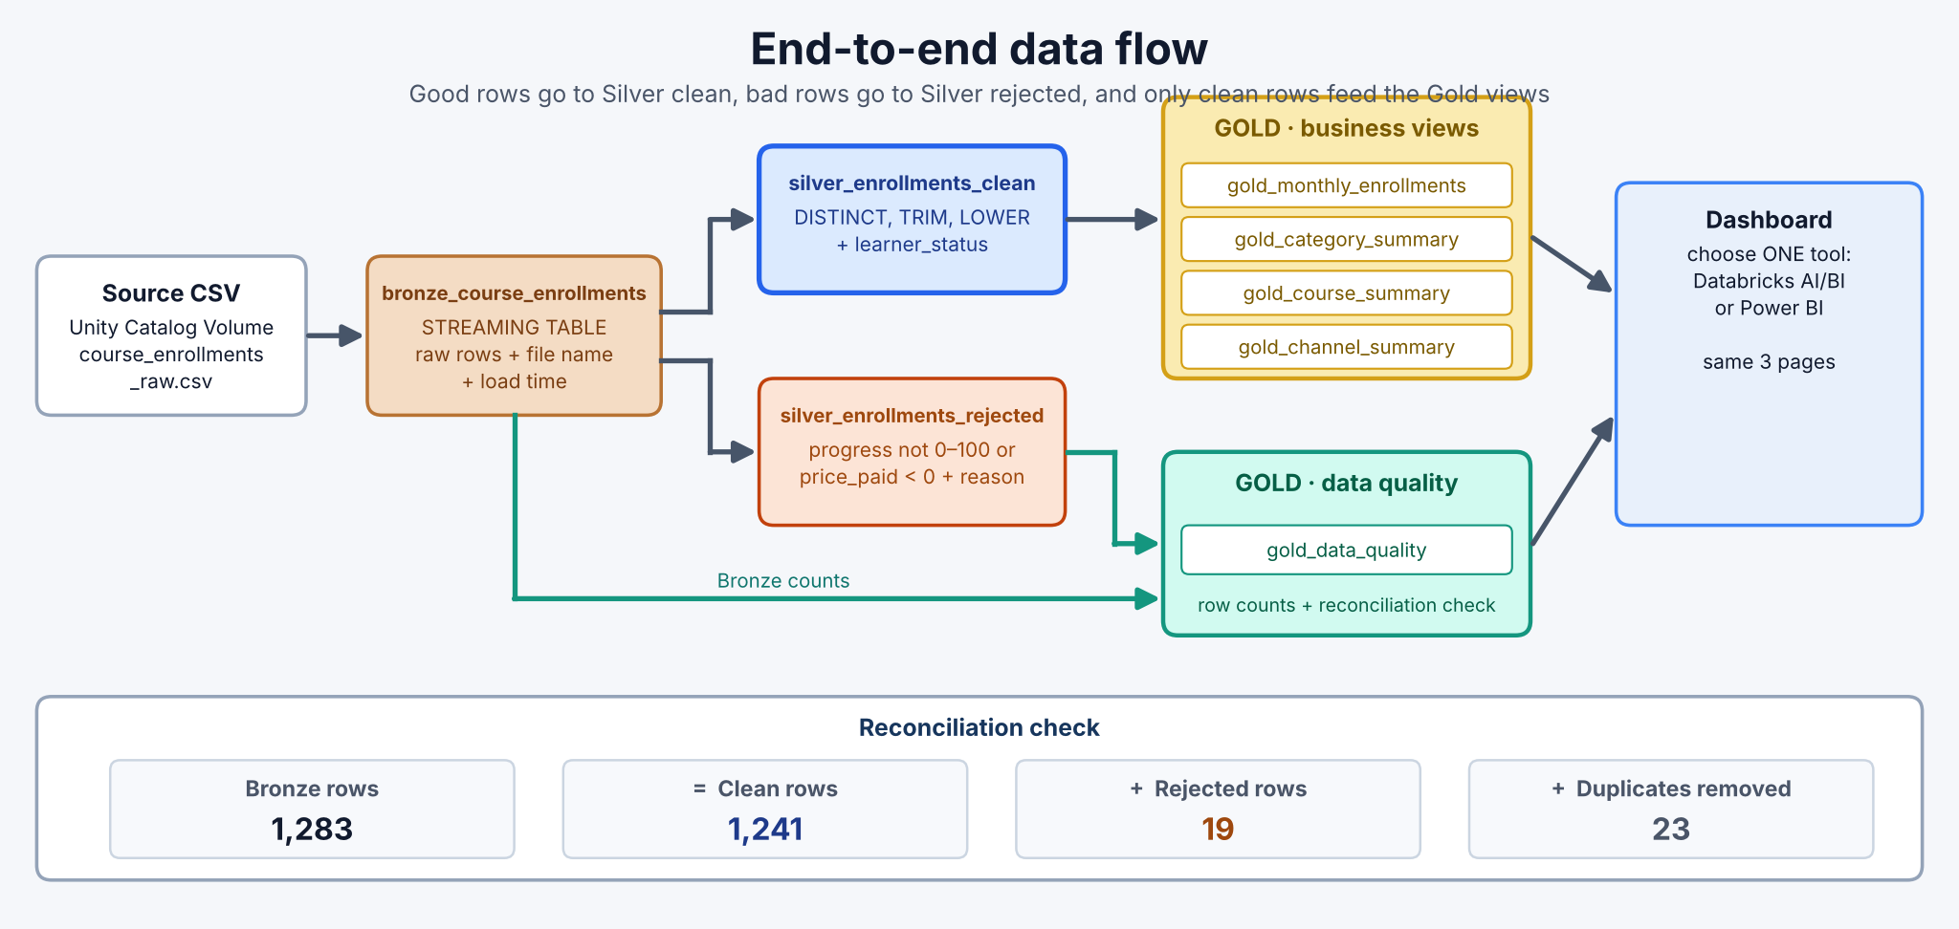
Figure 1 – End-to-end data flow and reconciliation check

7. Medallion Layer Responsibilities
Layer | Purpose | What you do | Result
Bronze | Keep the source data | Load the CSV as it is; add file name and load time | 1 raw table
Silver | Clean the data | Remove duplicates, fix text and emails, fill blanks, add learner_status, drop impossible rows (and keep them in a rejected table) | 1 clean table + 1 rejected table
Gold | Answer business questions | GROUP BY month, category, course and channel; calculate completion rate; count data problems | 5 summary tables
Dashboard | Show the results | Build 3 pages in Databricks AI/BI or Power BI | 1 dashboard

8. Business Requirements
ID | Requirement | Business expectation
BR-01 | Monthly trends | Show enrollments, unique learners, revenue, discount, completions and hours watched for each month.
BR-02 | Category performance | Compare enrollments, revenue, Completed / In Progress / Not Started counts and completion rate by category.
BR-03 | Course performance | Compare enrollments, revenue, completion rate, average rating and hours watched by course.
BR-04 | Channel analysis | Compare enrollments, revenue and completion rate by enrollment channel.
BR-05 | Data-quality visibility | Show how many rows had each problem, and how many learners were double-counted before the email fix.
BR-06 | Reconciliation | Prove that Bronze rows = clean rows + rejected rows + duplicates removed.
BR-07 | Repeatability | Run everything as a Databricks pipeline that can be re-run with one click.
BR-08 | Dashboard | Build one dashboard (Databricks AI/BI or Power BI) on the Gold tables.

9. Data Cleaning Rules
Silver cleaning is done in four simple steps. Each step uses one SQL idea.
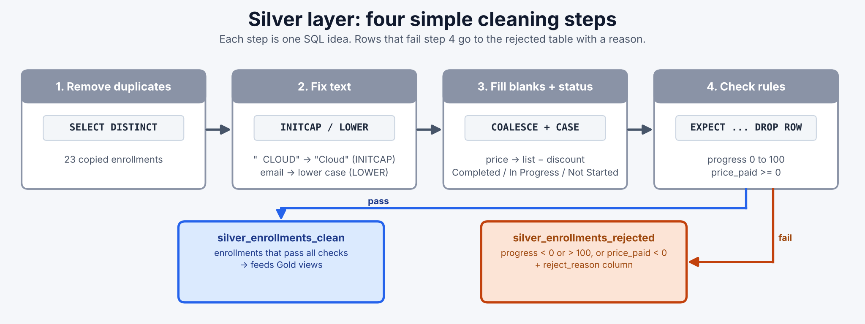
Figure 2 – The four Silver cleaning steps
Problem | Example | What to do | SQL hint
Duplicate enrollments | Same enrollment_id appears twice | Keep only one copy | SELECT DISTINCT
Extra spaces / mixed case | " cloud computing", "BEGINNER" | Remove spaces, use Title Case | INITCAP(TRIM(col))
Messy email | " Arun.7123@Gmail.com" | Remove spaces, use lower case | LOWER(TRIM(learner_email))
Blank category or city | category is empty | Replace with "Unknown" | COALESCE(col, 'Unknown')
Blank price paid | price_paid is empty | Calculate list_price − discount_amount | COALESCE(price_paid, list_price - discount_amount)
Blank rating or learner ID | course_rating is empty | Keep the row and leave it blank (AVG skips blanks) | No change
Impossible progress or price | progress_pct = 120 or -5; price_paid = -2999 | Remove from clean table, keep in rejected table | EXPECT (progress_pct BETWEEN 0 AND 100) ON VIOLATION DROP ROW

New column: learner status
Add one new column in Silver with CASE WHEN, so Gold and the dashboard can group learners easily:
progress_pct | learner_status
100 | Completed
1 to 99 | In Progress
0 | Not Started

Watch out: Progress of exactly 0 or exactly 100 is valid. Only values below 0 or above 100 are rejected. And never use INITCAP on emails: emails must be lower case.

10. Project Scope

Included
- One synthetic course enrollments CSV file.
- Batch loading from a Unity Catalog Volume.
- Bronze, Silver and Gold tables in one Lakeflow pipeline written in SQL.
- Simple data-quality checks and a reconciliation check.
- One dashboard in Databricks AI/BI or Power BI.

Not included
- Live video-watching events or real-time data.
- Refunds, subscriptions, quizzes or more than one source system.
- Real learner data and privacy controls (e.g. masking emails).
- Advanced data modelling (dimensions, SCD) and production alerting.

Scope note This is a learning project. Keep it simple, make it work end to end, and explain your choices.

11. Implementation Workflow
01 • Understand | Read the business questions and the 20 columns. Open the CSV and spot the problems yourself.
02 • Prepare | Create a catalog, schema and Volume. Upload the CSV.
03 • Ingest | Create the Bronze streaming table and check that 1,283 rows were loaded.
04 • Clean | Create the Silver clean and rejected tables using the four cleaning steps and the learner status.
05 • Curate | Create the four Gold business tables with GROUP BY.
06 • Validate | Create the Gold data-quality table and check the reconciliation.
07 • Publish & Visualize | Build one dashboard: Databricks AI/BI or Power BI.
08 • Explain | Present your pipeline, cleaning rules, results and dashboard.
Create a new ETL pipeline (Lakeflow Spark Declarative Pipelines), set the default catalog to edtech_catalog and schema to learning, and add a SQL file with:

13. Expected Deliverables
- A pipeline with Bronze, Silver (clean + rejected) and Gold tables.
- A short list of your cleaning rules and why you chose them.
- The gold_data_quality result showing the reconciliation check passed and the learner count before and after the email fix.
- One dashboard with three pages (Databricks AI/BI or Power BI).
- A README explaining how to set up and run the project.
- Screenshots of the pipeline graph, the Gold tables and the dashboard.

14. Acceptance Criteria / Definition of Done
- The CSV loads from the Volume and Bronze has 1,283 rows.
- Silver clean has no duplicate enrollments, no extra spaces, lower-case emails, no blank category or price, and no progress outside 0–100.
- Every clean enrollment has a learner_status of Completed, In Progress or Not Started.
- Rejected enrollments are saved with a reason.
- The four Gold business tables answer BR-01 to BR-04.
- gold_data_quality shows that bronze rows = clean + rejected + duplicates.
- The pipeline runs again with one click and the dashboard numbers match the Gold tables.

15. Questions for Project Review
- Why do we keep the raw data in Bronze instead of cleaning the file directly?
- Why do we use LOWER for emails but INITCAP for category names?
- How many learners were double-counted before the email fix, and why does it matter?
- Why can enrollment_id find duplicates but learner_email cannot?
- Why are progress values of 0 and 100 valid, but 120 is rejected?
- Why do we leave a blank rating as NULL instead of replacing it with 0?
- Which category earns the most revenue, and which has the best completion rate?
- Which dashboard tool did you choose, and why?

16. Final Business Outcome
At the end of the project, the learning platform has a repeatable pipeline that turns a messy enrollments file into clean, trusted summary tables and a simple dashboard. You can explain where the data came from, what problems you found, how you fixed them, why clean emails change the learner count, and how you proved the numbers are correct.
Key takeaway Medallion Architecture means each layer makes the data a little more trustworthy: Bronze keeps it, Silver cleans it, Gold summarises it, and the dashboard shares it.

