Lakeflow Spark Declarative Pipelines
Retail Sales Analytics Platform

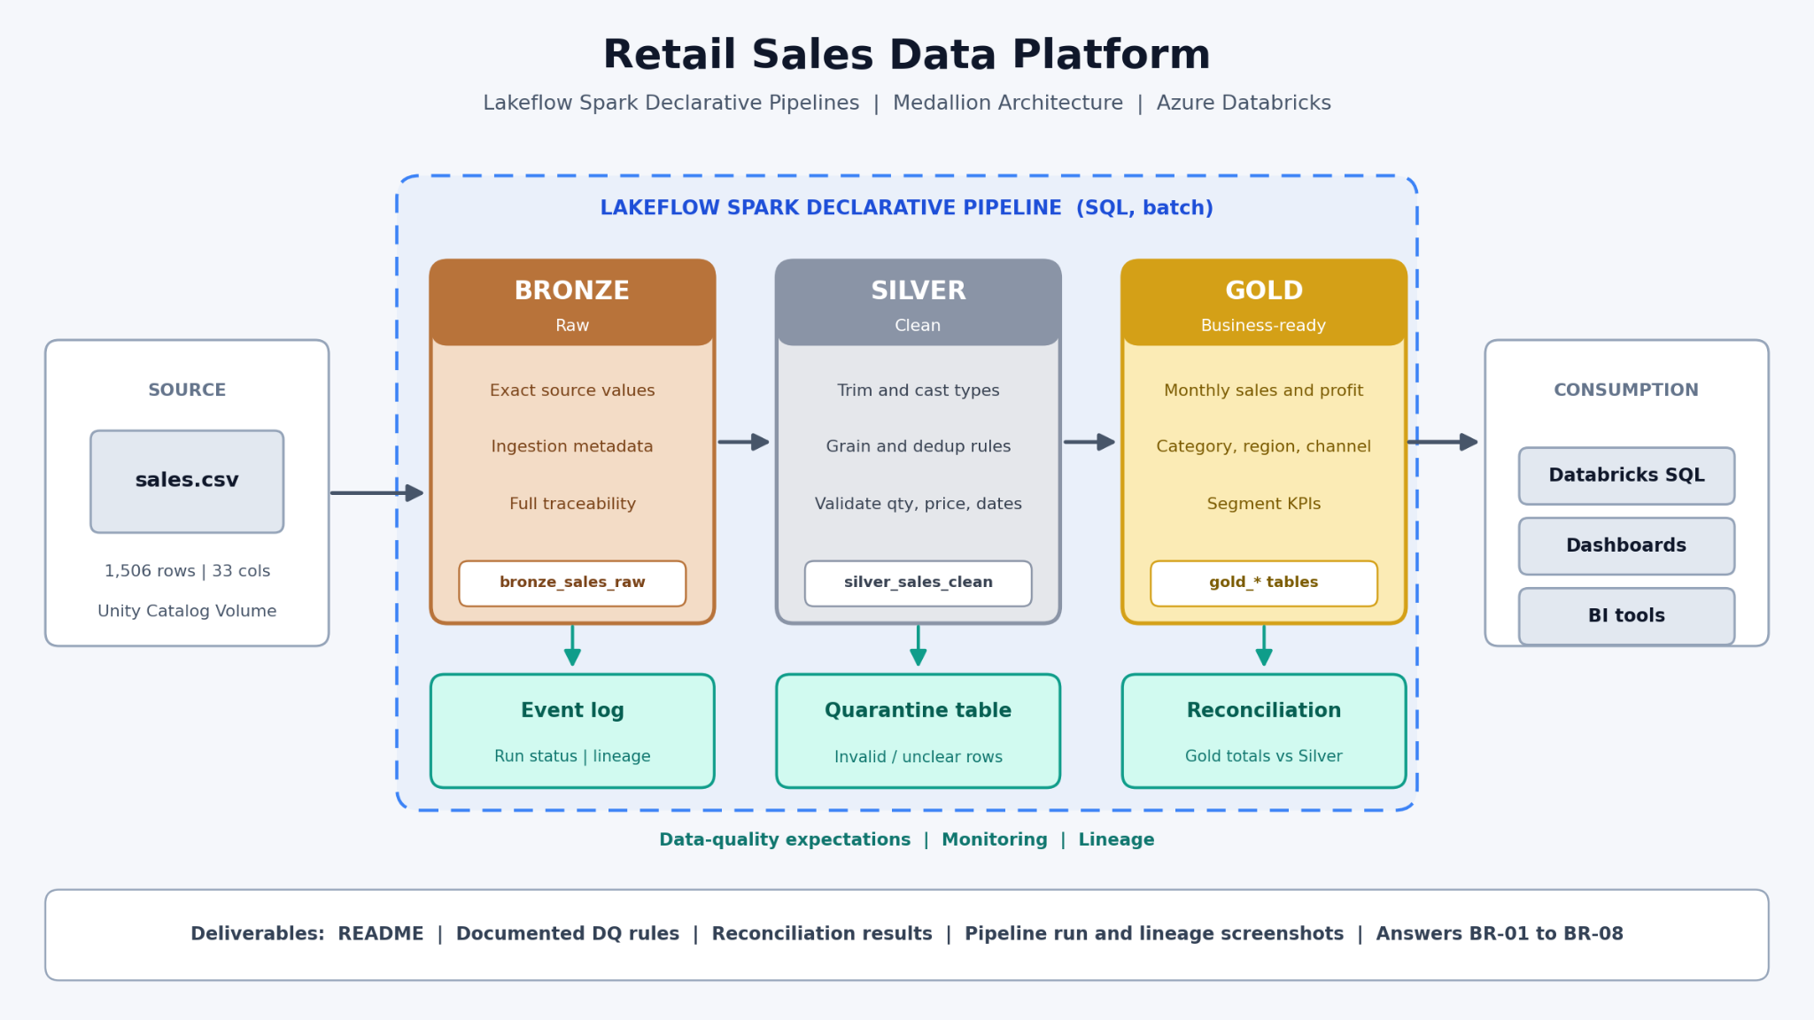

1. Executive Summary
A retail business receives sales data in CSV format and wants reliable, repeatable reporting for sales, profit, products, customers, geography, and sales channels. The source file contains common data-quality problems—such as inconsistent category text, missing values, duplicate records, and invalid numeric values. The team will build a Databricks Medallion Architecture to preserve the source, improve data quality, and publish business-ready datasets.
Project goal: Transform a raw retail sales CSV into trusted Gold-layer reporting tables using Databricks SQL concepts and Lakeflow Spark Declarative Pipelines.

2. Business Background
Imagine a mid-sized omnichannel retailer selling products across several categories and subcategories. Orders come from different regions, cities, customer segments, and sales channels. Managers use sales and profit reports to decide which products to promote, where performance is strong, and where corrective action is needed.

Current business challenges
- Product category and subcategory values contain inconsistent spaces and formatting.
- Some records have missing values in important business fields.
- Duplicate rows can inflate sales totals if they are not identified and handled.
- Zero or negative quantities and invalid unit prices can distort analysis.
- Manual spreadsheet cleanup makes reporting slow and difficult to repeat.
- Business teams need consistent numbers and a clear way to monitor data quality.

3. Business Problem and Objectives
The business does not have a dependable, automated path from raw sales data to trusted reporting. The project will establish a repeatable pipeline that keeps the original input available, standardizes and validates records, and prepares curated datasets for analysis.

Project objectives
- Ingest the retail CSV into Databricks using Unity Catalog Volumes as the file location.
- Preserve the ingested data in a Bronze layer for traceability.
- Clean and validate records in the Silver layer.
- Create Gold-level business summaries for sales and profitability.
- Track rejected, suspicious, duplicated, or incomplete records.
- Validate row counts and key business totals across the layers.

4. Dataset Overview
The learning dataset is a synthetic retail sales dataset created for this project. It contains 1,506 rows and 33 columns. It resembles operational sales data but is not a real company extract.
Retail Sales Dataset :- Click Here to Download Retail Dataset
Dataset attribute | Description | Why it matters
Grain | One row represents a sales line/record in the supplied file | Defines how totals and duplicates should be evaluated
Product fields | Category, subcategory, product name and related attributes | Supports product-level performance reporting
Sales measures | Quantity, unit price, sales, discount, profit and related measures where present | Supports revenue and profitability analysis
Business dimensions | Order/date, customer, geography, segment, shipping or channel fields where present | Enables time, customer and regional analysis
Intentional quality issues | Whitespace, missing values, duplicate rows, zero quantities, negative prices and missing sales values | Provides realistic validation and cleansing practice

Important: Do not assume Order ID alone is unique. A single order may contain multiple product lines. Duplicate detection should use the business grain and available line-level fields.

5. Proposed Architecture and Data Flow
The pipeline follows the Medallion pattern: Bronze preserves raw ingested records, Silver applies quality and standardization rules, and Gold presents business-ready outputs.
SOURCE  Retail CSV  Unity Catalog Volume | → | BRONZE  Raw ingested data  Keep source values | → | SILVER  Standardized  data  Validated records
GOLD: SALES SUMMARY  Sales, profit and order trends |  | GOLD: PRODUCT PERFORMANCE  Category and subcategory results |  | GOLD: DATA QUALITY  Issue counts and validation status

Consumption: Power BI, Databricks SQL dashboards, or other analytics tools can consume the Gold outputs. These are downstream options, not required for the first pipeline build.

6. Medallion Layer Responsibilities
Layer | Purpose | Typical actions | Expected outcome
Bronze | Preserve source data | Load CSV; retain original values; add ingestion metadata if appropriate | Traceable raw dataset
Silver | Improve trust and consistency | Trim text; standardize categories; cast types; identify missing/invalid values; apply duplicate rules | Clean, consistent records plus visible quality outcomes
Gold | Serve business questions | Aggregate sales/profit by date, category, subcategory, region and segment | Business-ready summaries for reporting

7. Business Requirements
ID | Requirement | Business expectation
BR-01 | Sales trend | Report sales and profit by month or another available date grain.
BR-02 | Product performance | Compare sales, quantity and profit by category and subcategory.
BR-03 | Geographic performance | Compare sales and profitability across available regions, states or cities.
BR-04 | Customer analysis | Review performance by customer segment or other available customer attributes.
BR-05 | Sales-channel analysis | Compare channels or order types if those fields exist in the supplied dataset.
BR-06 | Data-quality visibility | Show missing, invalid, duplicate and suspicious record counts.
BR-07 | Reconciliation | Compare source, Bronze and Silver counts and explain records excluded from trusted reporting.
BR-08 | Repeatability | Make the transformation process repeatable through a managed Databricks pipeline.

8. Data Quality Rules
Rule | Expected treatment
Completeness | Identify missing values in fields required for analysis. Do not silently replace missing values without a documented rule.
Standardization | Remove leading/trailing spaces from text fields and standardize category/subcategory values.
Type validity | Ensure date, quantity, unit price, sales and profit fields have appropriate data types.
Business validity | Flag zero or negative quantities and negative unit prices for investigation; do not automatically assume every unusual value is invalid.
Duplicate handling | Identify exact duplicate rows and business-level duplicates using the expected sales-line grain.
Reconciliation | Document how many records were loaded, retained, quarantined or excluded and why.
Auditability | Keep raw source data available so cleaned values and decisions can be traced.

9. Project Scope

Included in Phase 1
- One synthetic retail sales CSV file.
- Batch ingestion using a Unity Catalog Volume as the source location.
- Bronze, Silver and Gold layers in Databricks.
- Lakeflow Spark Declarative Pipelines as the managed pipeline approach.
- SQL-based transformation and validation concepts.
- Basic monitoring, reconciliation and project documentation.

Not included in Phase 1
- Streaming or near-real-time ingestion.
- Multiple operational source systems or APIs.
- Advanced slowly changing dimensions (SCD) and complex dimensional modeling.
- External cloud storage setup beyond the Databricks environment.
- Production SLAs, alert integrations and enterprise deployment automation.

Scope note This is a real-world-style batch engineering case study, not a live streaming system. The design can be extended later after the first version is validated.

10. Implementation Workflow
01 • Understand | Review the business questions, dataset fields and intended row grain.
02 • Prepare | Upload the CSV to a Unity Catalog Volume and confirm permissions and file path.
03 • Ingest | Create the Bronze layer and verify that the source records were loaded.
04 • Clean | Create Silver transformations for standardization, data types, quality flags and duplicate handling.
05 • Curate | Create Gold summaries that answer the agreed business questions.
06 • Validate | Compare row counts, sales totals and quality counts across layers.
07 • Publish | Document outputs and make the Gold datasets available for analytics.
08 • Explain | Present the architecture, quality decisions, test results and business insights.

11. Expected Deliverables
- A documented architecture and end-to-end data flow.
- A Bronze dataset preserving ingested source values.
- A Silver dataset with documented standardization and quality rules.
- At least one Gold sales summary and one product-performance summary.
- A data-quality summary showing the main issues found and their treatment.
- Validation evidence for record counts and key totals.
- A README explaining setup, pipeline flow, assumptions, and how to run or refresh the pipeline.
- Screenshots of the pipeline and sample results for project presentation.

12. Acceptance Criteria / Definition of Done
- The source CSV is read successfully from the configured Volume path.
- Bronze preserves the ingested data and can be reconciled with the source.
- Silver standardizes text and types and applies documented quality rules.
- Records flagged or excluded from trusted reporting are accounted for transparently.
- Gold outputs answer the core sales and product questions.
- Reconciliation checks are completed and any differences are explained.
- The pipeline can be rerun without ad hoc manual cleanup steps.
- The project is documented clearly enough for another learner or engineer to reproduce.

13. Questions for Project Review
- Why do we preserve raw data in Bronze instead of cleaning the source immediately?
- What is the difference between a data-quality flag and rejecting a record?
- Why is Order ID alone potentially unsafe as a duplicate key?
- How would you investigate a negative unit price or zero quantity?
- How can you prove that the Gold sales total is consistent with the cleaned Silver data?
- What would change if new files arrived every day?
- When would you introduce separate customer and product dimension tables?
- How could this batch pipeline evolve toward incremental or streaming processing?

14. Final Business Outcome
At the end of the project, the retailer has a repeatable data flow from a raw sales file to trusted reporting datasets. The team can explain where data came from, which quality issues were found, how those issues were handled, and how the published metrics were validated. The project demonstrates practical understanding of Bronze, Silver and Gold layers in Databricks while keeping the first implementation focused on one dataset.
Key takeaway The purpose of Medallion Architecture is not just to move data through three layers. It is to improve traceability, quality and usability at each stage so business decisions are based on dependable data.

