Software Requirements Specification
for
Counterfeit Product Detection using Blockchain
Prepared by: Javvaji Harini - 19BQ1A1256
Ganji Pushpalatha - 19BQ1A1236
Govathoti Lakshmi Tejaswi - 19BQ1A1243
Enukollu Dedipya - 19BQ1A1233
Vasireddy Venkatadri Institute of Technology
January 2023
Table of Contents
Table of Contents ii
1. Introduction 1
1.1 Purpose 1
1.2 Document Conventions 1
1.3 Intended Audience and Reading Suggestions 1
1.4 Project Scope 1
1.5 References 2
2. Overall Description 2
2.1 Product Perspective 2
2.2 Product Features 2
2.3 User Classes and Characteristics 2
2.4 Operating Environment 2
2.5 Design and Implementation Constraints 3
2.6 Assumptions and Dependencies 3
3. External Interface Requirements 3
3.1 User Interfaces 3
3.2 Hardware Interfaces 3
3.3 Software Interfaces 3
3.4 Communications Interfaces 3
4. Other Nonfunctional Requirements 4
4.1 Performance Requirements 4
4.2 Safety Requirements 4
4.3 Security Requirements 4
4.4 Software Quality Attributes 4
Appendix A: Glossary 5
Appendix B: Analysis Models 5

Introduction

Purpose
The purpose of this document is to present a detailed description of the distributed application Counterfeit Product Detection using Blockchain. It will explain the purpose and features of the software, the interfaces of the software, what the software will do and the constraints under which it must operate. This document is intended for users of the software and also potential developers.

Document Conventions
This Document was created based on the IEEE template for System Requirement Specification Documents.
Entire document should be justified.
Convention for Main title
- Font face: Times New Roman
- Font style: Bold
- Font size: 32
Convention for Main title
- Font face: Times New Roman
- Font style: Bold
- Font size: 14
Convention for Main title
- Font face: Arial
- Font size: 11

Intended Audience and Reading Suggestions
This document is intended for Advanced Users such as developers, project managers and testers, etc. in order to all the details of the product from the manufacturer to the last retailer.
The rest of this SRS contains Overall Description, System Features, Operating Environment and other requirements required for the project.

Project Scope
Whenever a product is developed, it always has some risk factors such as counterfeiting and duplication which leads to affecting the company name, reputation, revenue, and customer satisfaction. The trading and marketing of counterfeit products are growing very fast.
Blockchain is a distributed decentralized technology that stores data in blocks and is connected with chains. It provides security and the feature of immutability for the information stored in ledgers. A fake product can be easily detected through blockchain using QR codes generated by the manufacturer and can identify the genuineness of the product.

References
- Ali, Omar, et al. "A comparative study: Blockchain technology utilization benefits, challenges, and functionalities." IEEE Access 9 (2021): 12730-12749.
- Jambhulkar, Swaroop, et al. "Blockchain-based fake product identification system." International Research Journal of Modernization in Engineering Technology and Science(2021): 2582-5208.
- Turjo, Manoshi Das, et al. "Smart supply chain management using the blockchain and smart contract." Scientific programming 2021.

Overall Description

Product Perspective
This application was developed for everyone who are like to buy a product by knowing the details and genuineness of it. It provides all details about the product from the manufacturer to the last retailer by uploading the QR code over the website.
It is a decentralized, open-source, user-friendly, secured, authenticated application and a very interactive with the client. It was developed on Windows.

Product Features
- Add a product: Manufacturer adds a new product by generating a QR code, it provides all the details of the product.
- Scan QR code: Any authorized user can scan the QR to get the details of a product.
- Shipment: A manufacturer can ship a product to distributor then a block is added corresponding to this transaction, same in this way a new block is added to the chain with details of the current owner when a product is ship to retailer and end user from distributor and retailer respectively.
- Payment: When a product is shipped to a user, then he/she can able to ship that product to other user only if the payment is done.

User Classes and Characteristics
This document is intended for Users such as developers, project managers and testers also
Advanced/Professional Users, such as engineers or researchers, who wants to use it for more demanding graph analysis.
Programmers who are interested in working on the project by further developing it or fix existing bug.

Operating Environment
- Windows 8
- Windows 10
- Windows 11
- Processor can be intel i3 or above

Design and Implementation Constraints
- Only authorized users can access this application to scan the QR of the product through this application and can able to ship the product from him to others.
- Transactions are synchronous where no two transactions on the same product can take place i.e., a function can again be called only after the completion of preceding call.

Assumptions and Dependencies
Here the assumptions are, the code should be error free and the project should be user-friendly. Libraries used are Qrious, web3, NPM.

External Interface Requirements

User Interfaces
Web application is one of the user interface to interact with the system to perform operations such as get/scan QR login and register.
MetaMask is the interface to connect the blockchain network for spending ethers from the wallet for every transaction.

Hardware Interfaces
Hardware configuration include:
Windows Operating System
Processor intel i3 or above
Hard disk: 256GB or above
Memory: 4GB or above

Software Interfaces
Software components: Solidity, Node JS, CSS, React JS, Web3 JS
Framework: Truffle
Code Editor: Visual Studio Code
Personal Blockchain: Ganache
Ethereum Wallet: MetaMask

Communications Interfaces
Web3 JS in NPM is used as a communicating interface between user interface and blockchain it requires internet connectivity.

Other Nonfunctional Requirements

Performance Requirements
Every transaction in the blockchain takes less than 10 seconds to add a node in the distributed ledger. This system is user friendly to make any operation in this application and it is interactive.

Safety Requirements
As smart contracts are developed using Blockchain Technology, the data is stored at multiple nodes. Since data is maintained at multiple locations, it will be safe during physical disasters also.

Security Requirements
To specify objectives and expectations to protect the service and data at the core of application. This allows information access to all designated nodes or members who can record, share, and view encrypted transactional data on their blockchain.

Software Quality Attributes
The application is flexible when it can run smoothly on any device, platform, or operating system. It is scalable as it uses vertical scalability for storing the ledger. This is flexible as it can easily adapt to future changes. As blockchain has decentralized and distributed network which leads to no single point of failure.

Appendix A: Glossary
- Blockchain: Blockchain is a system of recording information in a way that makes it difficult or impossible to change, hack, or cheat the system. A blockchain is essentially a digital ledger of transactions that is duplicated and distributed across the entire network of computer systems on the blockchain.
- Ledger: A distributed ledger can be described as a ledger of any transactions or contracts maintained in decentralized form across different locations and people. Blockchain is one type of a distributed ledger.
- QR code: A machine-readable code consisting of an array of black and white squares, typically used for storing URLs or other information for reading by the camera on a smartphone.
- XAMPP: XAMPP stands for X-operating system, Apache, MySQL, PHP, Perl. It is a free and open-source cross-platform web server solution stack package developed by Apache Friends.
Appendix B: Analysis Models
Use case Diagram
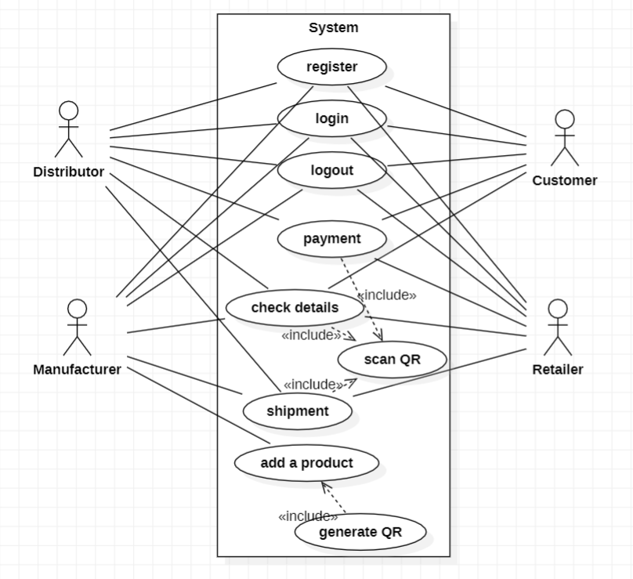
Class Diagram
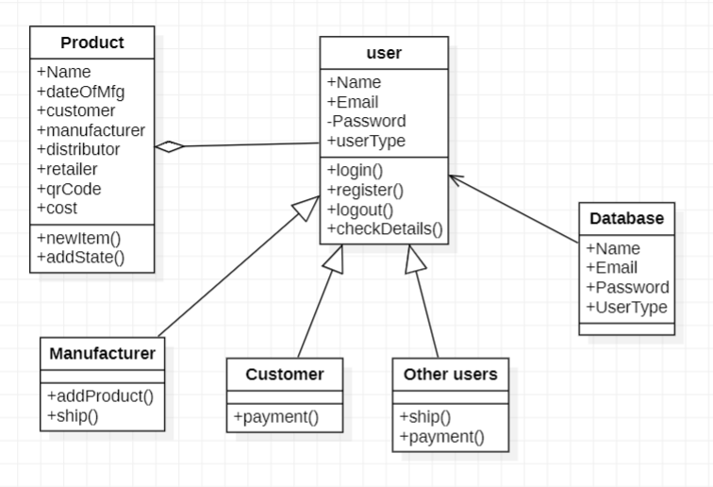
Sequence Diagram: Manufacturer
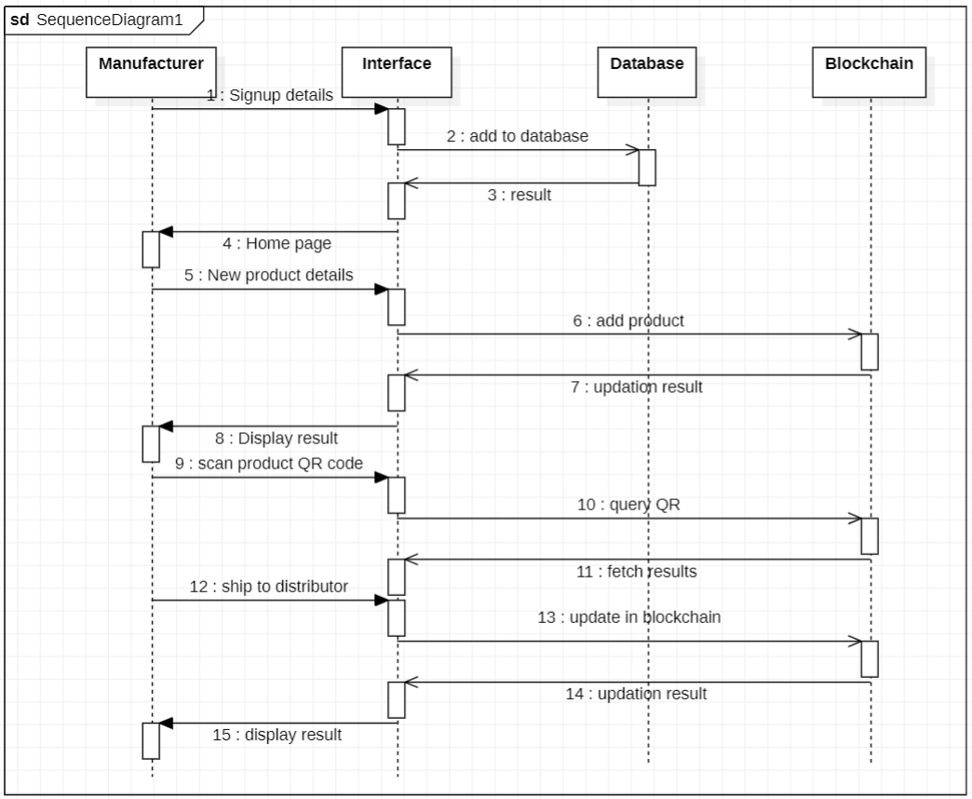
Sequence Diagram: Customer
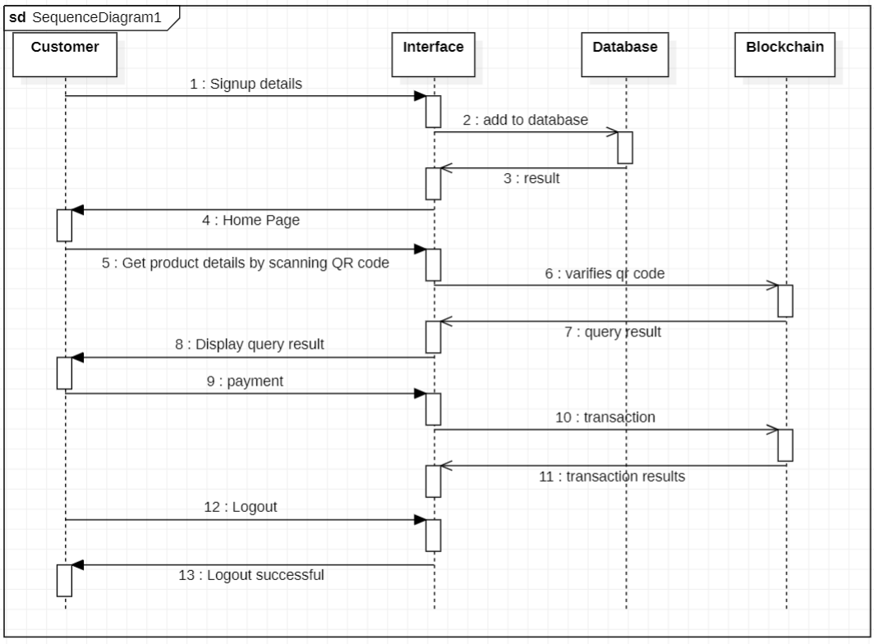
Sequence Diagram: Distributor/Retailer
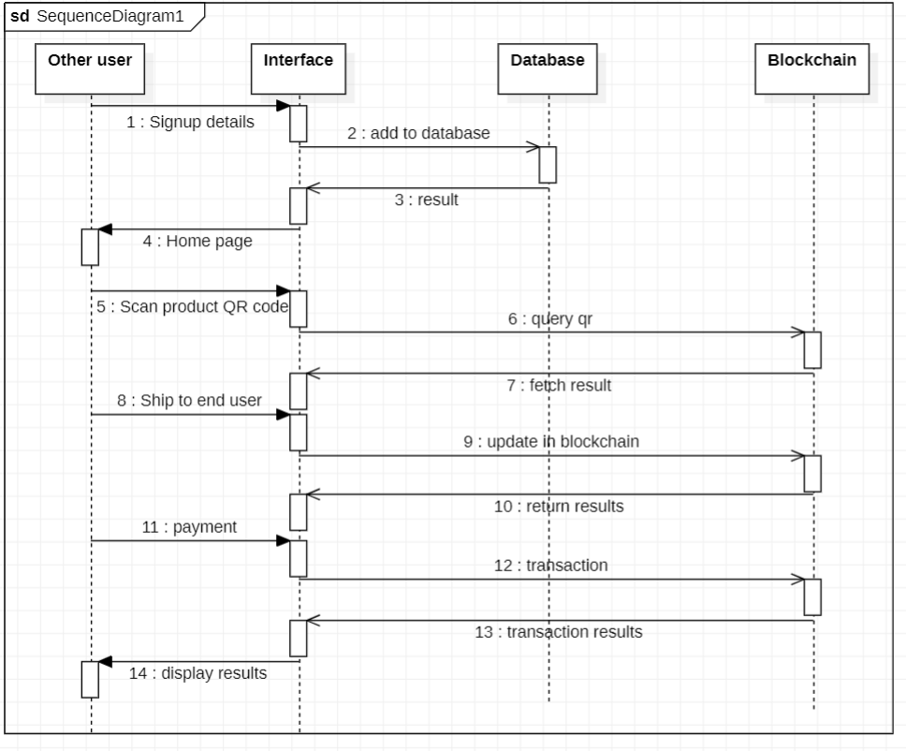
Activity Diagram
