DAY9 SESSION ASSIGNMENTS
1.Draw a Use Case Diagram for an online Library Management System

LOGIN

STOCK VERIFICATION

ITEM RENEWAL

MAKE RESERVATION

CANCEL RESERVATION

LEND ITEM
LIBRARIAN
USER

RETURN OF ITEM

MAINTANANCE

LOGOUT
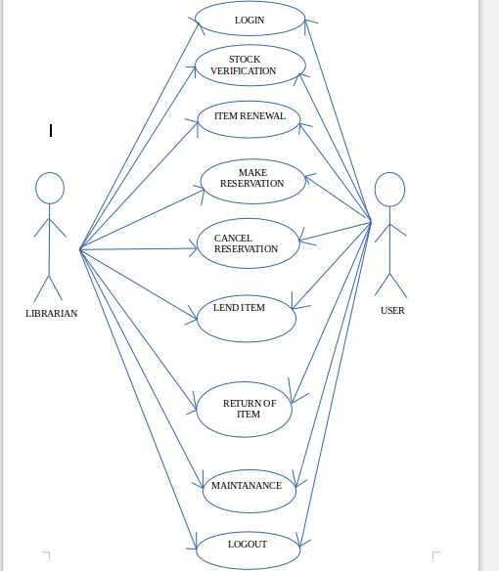

SCREENSHOT OF USECASE DIAGARAM

2.List down the best practices from Agile/Scrum methodology

Best practices from agile/Scrum methodology:

- Product Backlog (PBL),which is ordered list of features based on priorities maintained by product owner.
- Sprint Backlog(SBL),owned by developemnt team and created during Sprint planning
- Planning poker to estimate tasks during sprint planning
- Daily scrums or daily standup meetings to point out current issues
- Burn down to monitor sprint progress
- Sprint reviewmeeting to present completed work
- Sprint retrospective to learn from previous sprint
- Release Planning to release product increments
- User stories are written
- 6 hours per a day is a realistic planning input. Total sprint hour capacity can be calculated as: (number of team members) * (number of sprint days) * 6 hours
- The project velocity is measured
- When a bug is found tests are created
- Acceptance tests are run often and the score is published
- All code must pass all unit test before it can be released

3.Collaboration
a.How does collaboration help agile development?
b.What if the team is distributed and can you achieve the same productivity?
c.What would you do to achieve the productivity for a distributed team?

Collaboration simply means to work jointly rather than independently to accomplish a task.
Two of the four values in the agile manifesto highlight the emphasis Agile methodologies place on strong collaboration. "Individuals and interactions over processes and tools" reminds us of the importance of strong and respectful communication. "Customer collaboration over contract negotiation“reminds us that it's more important for a development team to allow for some flexibility to please a customer, seeking a collaborative solution to issues that might arise during product development, rather than to stick to a rigid contract.

a.)Through collaboration,customer satisfaction can be ensured as they evaluate the product at each level.Modifications can be incorporated at each level.
Collaboration has the following advantages:
- Satisfy the customer through early and continuous delivery
- Welcome changing requirements
- Business people and developers work together daily
- The best way to convey information is face-to-face
- The team regularly tunes and adjust its behavior

b.)Achieving the best results with agile requires a well-connected team. If the team is distributed the productivity tends to decrease

The issues in distributed development are:

- Strategic: Difficult leveraging available resources, best practices are often deemed proprietary, are time consuming and difficult to maintain.
- Project and process management:Difficulty synchronizing work between distributed sites.
- Communication:Lack of effective communication mechanisms.
- Cultural: Conflicting behaviors, processes,and technologies.
- Technical: Incompatible data formats,schemas, and standards.
- Security: Ensuring electronic transmissionconfidentiality and privacy.

c.)Following are the methods to achieve productivity in a distributed agile team:

- OPTIMIZE TEAM SIZE AND TEAM MIX:Finding the right mix of talent at every location is critical when the team is distributed.Effective distributed Agile development is about minimizing the impact of distribution.
- DISTRIBUTE WORK EVENLY:Make sure all team members understand their role and have fairly equal workloads. In a distributed team, if the workload is uneven, you may risk the overall project delivery schedule if you ignore the imbalance. Uneven workloads can also cause bottlenecks
- SET UP PAIR PROGRAMMING:Pair programming, where two team members sit side by side and work on the same code, is a challenge for distributed teams
- ENFORCE AND RE-ENFORCE AGILE PRACTICES:Agile approaches rely on a set of mutually supporting practices. When one practice doesn’t make sense for one team, the practice should be either abandoned or replaced. With distributed teams, enforcing and reinforcing a practice takes time and effort
- USE ONLINE TOOLS FOR AGILE ARTIFACTS:take advantage of Agile process artifacts (white boards, sticky notes, and so on) by moving them from their physical environment to an online tool.
- UNDERSTAND TIME DIFFERENCES
- UNDERSTAND CULTURAL DIFFERENCES
- ADAPT COMMUNICATION FOR REMOTE TEAMS
- ARRANGE FACE-TO-FACE INTERACTIONS
- PLAN FREQUENT DEMOS AND RETROSPECTIVES

4.What is Sprint Zero in Agile?Describe the activities that are done in Sprint Zero.
- Sprint Zero is also called as Iteration Zero.
- Iteration 0 should include a plan for the team to establish testing approaches at the unit, functional, system acceptance,and user acceptance levels.
- The main activities involved are:
            - Vision:Product Champion has prepared vision statements for the project and release.The team understands and agrees to the vision, drivers, and expected outcomes fo the release.
            - Product backlog:Features have been prioritized and estimated.High level architectural milestones have been specified
            - Story estimation:Stories have been decomposed and right sized. Validation criteria for stories are understood. Stories have been estimated for first few iterations work.
            - Iteration Backlog
            - Team Readiness:Creation of the team as per the resourcing plan. You do not need the entire team on day 1 of sprint 0. But you have to make the team ready with the training, tools, systems configured for them for coming sprint.
- People hiring
- Team ramp up
- R&R from each role
- Each developer and tester will also make their system ready with all the required software
- Training:Training will make team ready for the development/testing. These trainings are critical to project success. I would also recommend that these trainings should be recorded for the future use. Recorded sessions will be utilized during the ramp up period for the new associates.
- Domain
- Technical
- Architecture
- Development Framework and Process
- Testing Framework and Process
- Tools

