DAY6 SESSION ASSIGNMENTS (Theory)

1. How do you evaluate the performance of a project in agile?

It is somehow necessary to review or evaluate the performance of any task athat are performed,in order to analyze for what purpose it is actually written for.In agile the projects are more generative rather than prescriptive.The entire general approach reduces the complexity compared to prescrptive approach.Agile project team provides metrics for processes, project deliveries,etc.
Agile project metrics Key measures are:

-Velocity:Its is the rate at which a team can produce a working software.It is the number of storypoints that can be delivered in time

-Hit Rate:It is the percentage of work allocated to a Timebox
that was actually completed.

-Work Remaining on Tasks:It is the task of estimating the work
remaining on each active Task by the team on each day.

-Project Cost:It is the measure of quality and finish of the project.It uses 3 values.They are,
1.CPI(Cost Performance Index)
2.SPI(Schedule Performance Index)
3.EBV(Earned Buisness Value)

*The value of EBV is considered to be cruicial,if the the focus of agile projects is on business value rather than conformance to requirements.

CPI
*CPI > 1 is an indication that cost incured for the project is less than what expected .
*CPI<1 is an indication that the cost has exceeded the expected value.

Cost Performance Index (CPI) = (Baseline Cost per Story
Point)/(Actual Cost per Story Point).
ie, CPI = EV/TAC
= TPC(BC/SP)/TAC
= TPC/TAC(BC/SP)
= (BC/SP)/(TAC/TPC)
= (BC/SP)/(AC/SP)
SPI
*SPI > 1 is an indication that the project has finished earlier than expected.
*SPI < 1 is an indication that the project has finished late than expedcted.

Schedule Performance Index (SPI) = (Actual Velocity/Baseline
Velocity).
ie,SPI = EV/PV
= TPC(BC/SP)/(nBV(BC/SP))
= TPC/n)/BV
= AV/BV

Some other techniques in are:
1.Sprint reportcard
2.End of Sprint Diagnostics
3.Project reportcard
4.Product owner report card
5.Project Peer Review
6.Annual “agile performance review”

2. Compare traditional monitoring & control with agile monitoring & control
with respect to metrics generation

*Monitoring and controlling is one of the phases in Project management.

Agile monitoring and control
*Agile project planning points towards what to do
*The job of the Agile Project Manager is to guide the team to successful delivery despite the challenges the world throws at the project.
*Velocity is more. It takes less time to produce a working software as it is used in sprints.
*Hit rate depends on the completion of each sprint.
*Colocation is necessary for the effective delivery.
*Agile monitoring comes in a variety of forms:
#Frequent delivery
#Colocation
#Daily Team Meeting
#Timebox Review Meeting
*Frequent delivery allows the project finished at any time. Finishing could be for any number of reasons:
- the competition just shipped
- the company needs the cash
- the user/customer needs the functions
- that was when it was promised

Traditional monitoring and control
*Traditional Monitoring and control activity is concerned about observing and measuring actual performance against the plan.
*Velocity is less . It takes more time to produce a working software.
*Delivery takes time.
*It doesnot focus on earned business value
*Hit rate depends on the overall completion of the delivery
*Colocation is not necessary in this method.

3.With a total project budget of $ 175,000, and having
completed one out of four Iterations, we have this product backlog and these actuals:
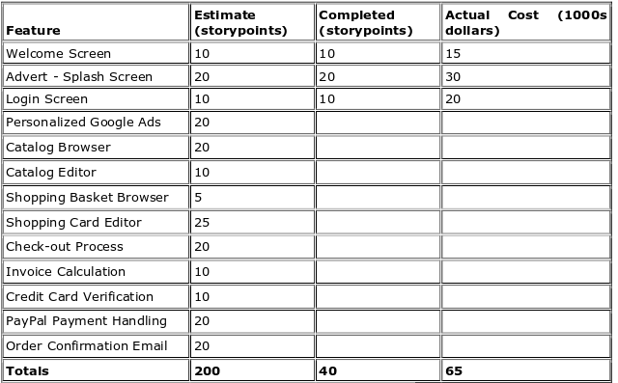

in our example, after Iteration 1 we should be at 25% complete)

Expected percentage of completion during first sprint=25
ie,Expected cost=25%(Total Project cost)
=(25/100)*1,75000
=43750

Percentage of work completed after first iteration=(40/200)*100=20

Since only 20% of the total work has been completed
Therefore,
earned value=(20/100)*175000=35000

