DAY8 SESSION ASSIGNMENTS

1.When to use (Rapid Application Development) RAD model
When not to use (Rapid Application Development) RAD model

RAD IS USED WHEN

*System that can be modularized can be built using
RAD
*RAD is used whenever the working model is to be delivered within a short span of time.
*Apart from waterfall type of model , RAD can be used in situations were detailed documentation is not required.
*RAD is a object oriented model and thereby RAD adds on reusability of code.So in such environments RAD can be used
*RAD suits best in a changing environment.ie,Whenever the buisness or requirement or state changes abruptly,RAD modelling is opted.
*Rather than continues step by step sequential execution,concurrent or parallel execution helps in enhancing the speed and efficiency of delivery of working model.So RAD can be chosen for higher performance rate.
*Should be chosen only if resources with high business knowledge are available

RAD IS NOT USED WHEN

*RAD cannot be opted whenever a technically strong team is not available.
*Modularization should be followed in RAD.The systems that doesnt follow modularisation cannot be implemented using RAD
*Whenever resources with high knowledge are not available,then RAD cannot be chosen.
*Inapplicable to cheaper projects as cost of modelling
and automated code generation is very high.
*Requires highly skilled developers/designers.So only in such a cse RAD can be implemented.

2.Define an ER diagram of a software Organization with all the relationship model that was discussed in the classroom

ADDRESS

C_ID
NAME
E-MAIL
ITEM_CODE
VALUE

CUSTOMER
ITEM/PRODUCT
ORDER

PRODUCES
HOLDS
LIST OF
DEPENDS ON
HAS MANY

COMPANY

CATEGORY
DEPENDENT
ORDERED_ITEMS

ORDERED DATE
DEP_ADDR
DEP_ID
OD_ITEM_CODE

DEP_NAME
ITEM_CODE

NO.OF TIMES ORDERED

3.Describe the Entity Relationships for the following diagram

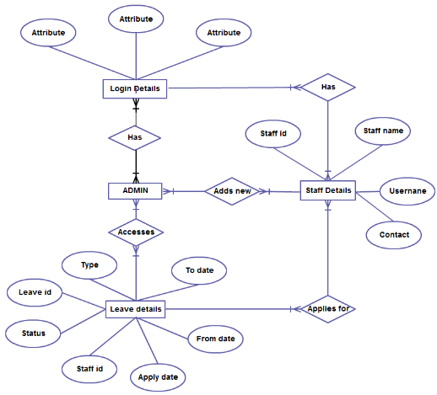

*Here in this ER diagram the user and the admin is involved.ie,Admin and the user or the staff are the main real world objects
*The first step is to login.ie,both the user and admin needs to login to this system
*Admin needs to login because then only he can provide with necessary updations during user processings and all.
*Login details is the gateway through which both admin and staff logs in.
*Multiple staffs can be logged in,but for one staff he/she can login only once.
*Staff entity has got the attributes staff id,staff name,username,contact.
*Only after the admin approves one staff,then only he can get access to use this particular system.
*Once the staff get logged in,he can use that system for various facilities it provides.Here the staff can apply for leave.
*Leave details also acts an entity.Once the staff applied for leave,admin take care of all other manupulations upon every user action.
*Admin is responsible for each users every actions.

