PYTHON LEARNING PLATFORM

A Project Report Submitted by

LAKSHMI VENKATA PADMAVATHI VISWANADHAM
ENROLLMENT NO : 925000122005
PATHURI SINDHURA
ENROLLMENT NO : 92500116009

in partial fulfillment for the award of the degree of

Bachelor of Technology
In
Computer Engineering-AI, ML & DS (P.B.L.)



Faculty of Engineering & Technology
Marwadi University, Rajkot
2025-26

Faculty of Engineering & Technology
Marwadi University
Department of Computer Science & Engineering – AI, ML & DS (P.B.L.)
2025-26

CERTIFICATE

This is to certify that the project entitled Python Learning Hub - A GUI-Based Python Learning Platform has been carried out by Lakshmi Venkata Padmavathi Viswanadham having Enrollment number 925000122005 under my guidance in partial fulfillment of the degree of Bachelor of Technology in Computer Engineering – AI, ML & DS (P.B.L.) of Marwadi University, Rajkot during the academic year 2025-26.

Date: ____________________

Internal Guide Head of the Department
Prof. Mukhtar Sama Dr. Nilesh Kumar Jadav
Professor Head & Associate Professor

Faculty of Engineering & Technology
Marwadi University
Department of Computer Science & Engineering – AI, ML & DS (P.B.L.)
2025-26

CERTIFICATE

This is to certify that the project entitled Python Learning Hub - A GUI-Based Python Learning Platform has been carried out by Pathuri Sindhura having Enrollment number 925000116009 under my guidance in partial fulfillment of the degree of Bachelor of Technology in Computer Engineering – AI, ML & DS (P.B.L.) of Marwadi University, Rajkot during the academic year 2025-26.

Date: ____________________

Internal Guide Head of the Department
Prof. Mukhtar Sama Dr. Nilesh Kumar Jadav
Professor Head & Associate Professor

STUDENT DECLARATION
We, Lakshmi Venkata Padmavathi Viswanadham Enrollment Number: 925000122005 and Pathuri Sindhura Enrollment Number: 92500116009, hereby declare that this project report titled "Python Learning Hub - A GUI-Based Python Learning Platform" is our own original work, carried out jointly by us, prepared under the guidance of Prof. Mukhtar Sama as part of the Programming with Python (01AP0303) course at Marwadi University.
We understand every diagram, program module, test case, and output included in this submission, and we are able to explain and, if required, modify or execute any part of the code during the viva voce examination. Wherever ideas, code fragments, libraries, APIs, or learning material from external sources (including AI-assisted tools) have been used, they have been acknowledged in the References section of this report.
Student Signature: _______________________ Date: _______________

ACKNOWLEDGEMENT
We would like to express our sincere and heartfelt gratitude to our faculty guide, Prof. Mukhtar Sama for his continuous guidance, valuable feedback, patience, and encouragement throughout every stage of this project. His timely suggestions and constructive criticism helped us understand our mistakes early and steadily improve the quality of our work, and without his support this project would not have taken its final shape.
We are equally thankful to Dr. Nilesh Kumar Jadav, Head of the Department, and to the Department of Computer Science & Engineering – AI, ML & DS, Marwadi University, for providing us with the resources, infrastructure, and a healthy learning environment that made the successful completion of this project possible. We would also like to thank the Faculty of Engineering & Technology, Marwadi University, for including the Programming with Python (01AP0303) course as part of our curriculum, which gave us the opportunity to apply our classroom learning to a real, working application.
This project was truly a joint effort from start to finish. Lakshmi Venkata Padmavathi Viswanadham and Pathuri Sindhura worked together at every stage -- from planning the module structure and designing the database, to writing and testing the code, debugging errors, and preparing this report. We spent long hours discussing design decisions, dividing tasks between ourselves, and helping each other whenever either of us got stuck, and we believe this teamwork is what allowed the project to come together as a complete, working platform rather than a collection of separate pieces.
We would also like to thank our friends and classmates for their encouragement and for the useful discussions that helped us think through some of the trickier parts of the implementation. Finally, we acknowledge the official Python documentation, the standard library references, and the publicly available tutorials and resources that supported our understanding of the concepts implemented in this project, all of which are listed in the References section.
.

ABSTRACT
This project presents the design and implementation of “Python Learning Hub”, a desktop-based, GUI-driven Python learning platform built entirely using Python’s standard Tkinter toolkit. The platform addresses a common difficulty faced by beginner programmers: scattered, inconsistent learning material that mixes theory, runnable examples, and self-assessment poorly. Python Learning Hub instead organises learning into seven structured modules -- Python Fundamentals, Control Flow and Functions, Data Structures, File and Exception Handling, Object-Oriented Programming, Database Connectivity, and API/Automation/Reporting -- covering a combined 89 topics, each with detailed theory, key points, a runnable code example, a linked video search, an auto-graded quiz, and a hands-on mini-application.
The system is built with a layered architecture separating the presentation layer (Tkinter screens), application logic (navigation and content registry), and a persistent data layer implemented with SQLite, storing user accounts (with salted PBKDF2 password hashing), topic-level progress, quiz scores, and issued certificates. Learners register and log in, work through modules at their own pace, attempt quizzes that are automatically graded and stored, and unlock auto-generated completion certificates (rendered as PNG images) once a module’s topics are completed and its quiz is passed above a 70% threshold. A live Progress Dashboard visualises overall and per-module completion using data drawn directly from the database.
The platform was tested using functional test cases covering normal, boundary, and invalid-input scenarios across authentication, progress tracking, quiz scoring, and certificate issuance, with all cases passing as documented in Section 7. The result is a complete, extensible, and genuinely useful learning tool that demonstrates practical application of every core Python concept it teaches — variables and control flow, functions, data structures, file handling, exception handling, object-oriented design, database connectivity, and REST API consumption — within a single cohesive application.

INDEX

Description | Page No:
Certificate | ii
Student Declaration | iii
Acknowledgement | iv
Abstract | v
List of Figures | viii
List of Tables | viii
1. Introduction | 1
1.1 Target Learner Profile | 1
1.2 Motivation | 1
2. Problem Statement and Objectives | 2
2.1 Problem Statement | 2
2.2 Objectives | 2
3. Requirement Analysis | 3
3.1 Functional Requirements | 3
3.2 Non-Functional Requirements | 3
3.3 Software and Hardware Requirements | 4
3.4 Input-Process-Output (IPO) Analysis | 4
4. Proposed Design | 5
4.1 Project Workflow Flowchart | 5
4.2 System Architecture / Block Diagram | 6
4.3 Input-Process-Output Diagram | 6
4.4 Module Hierarchy / Structure Chart | 7
4.5 Database Schema (ER Diagram) | 8
4.6 Class Diagram | 8
4.7 User Interface Wireframes | 9
4.8 Use Case Diagram | 10
5. Tools and Concepts Used | 11
6. Implementation | 12
6.1 Project File Overview | 12
6.2 Password Security | 12
6.3 Parameterised Database Queries | 13
6.4 Quiz Auto-Grading | 13
6.5 Object-Oriented Design | 13
6.6 Certificate Generation | 14
6.7 Execution Instructions | 14
6.8 Admin Dashboard | 15
7. Testing and Debugging | 16
8. Results and Discussion | 18
9. Conclusion and Future Scope | 20
References | 21
Appendix A: Submission Folder Structure | 22
Appendix B: Faculty Remarks Action-Taken Table | 22

LIST OF FIGURES
Figure No. | Figure Description | Page No
Figure 1 | Project Workflow Flowchart | 5
Figure 2 | System Architecture / Block Diagram | 6
Figure 3 | Input-Process-Output Diagram | 6
Figure 4 | Module Hierarchy / Structure Chart | 7
Figure 5 | Database Schema (Entity-Relationship Diagram) | 8
Figure 6 | Class Diagram — Module 5 Bank Account Simulator | 8
Figure 7 | User Interface Wireframes (Login and Dashboard) | 9
Figure 8 | Use Case Diagram | 10

LIST OF TABLES
Table No. | Table Description | Page No
Table 1 | Software and Hardware Requirements | 4
Table 2 | Test Case Results | 16
Table 3 | Objective Achievement Summary | 18
Table 4 | Submission Folder Structure | 22
Table 5 | Faculty Remarks Action-Taken Table | 22

1. INTRODUCTION
Learning a programming language such as Python is often made harder than it needs to be by scattered resources: video lectures on one platform, code examples on a blog, and quizzes on a third website, with no single place that tracks what has actually been learned. Beginners frequently lose track of their own progress, skip foundational topics, or attempt advanced material without the prerequisite basics being solidified through practice and self-assessment.
This project, “Python Learning Hub”, was undertaken as the Python Learning Platform Project for the Programming with Python (01AP0303) course. It is a self-contained desktop application, built using Python’s built-in Tkinter GUI toolkit and SQLite database engine, that brings structured theory, runnable code, video references, quizzes, hands-on mini-applications, progress tracking, and certification into a single, coherent learning journey covering all seven prescribed Python modules.

1.1 Target Learner Profile
The platform is designed for a beginner-to-intermediate learner — typically a first- or second-year engineering student — who already has basic computer literacy but is new to Python and to structured programming concepts such as control flow, data structures, object-oriented programming, and database connectivity. The learner is assumed to have access to a desktop or laptop computer capable of running Python 3.8 or later, but not necessarily prior programming experience.

1.2 Motivation
The motivation for this project came directly from a common learning gap: most free tutorials teach isolated snippets without reinforcing them through immediate practice, quizzes, or a visible sense of progress. By combining theory, practice, self-assessment, and gamified certification (unlocked only after demonstrating competence) into one application, learners stay motivated and can objectively see how much of the syllabus they have mastered.

2. PROBLEM STATEMENT AND OBJECTIVES

2.1 Problem Statement
Beginner Python learners lack a single, structured, self-contained application that combines detailed topic-wise theory, runnable code examples, auto-graded quizzes, practical mini-applications, and visible progress tracking — forcing them to piece together their learning from disconnected sources with no reliable way to measure or prove their own progress.

2.2 Objectives
- To design and implement a GUI-based learning platform covering all seven core areas of Python: fundamentals, control flow and functions, data structures, file and exception handling, object-oriented programming, database connectivity, and API/automation/reporting.
- To provide, for every topic, structured theory, key points, a runnable code example, and a linked video reference, so that each concept is reinforced from multiple angles.
- To implement an auto-graded quiz system per module that records every attempt and reports the learner’s best score, with a clear pass threshold (70%).
- To track topic-level and module-level progress persistently in a database, and to visualise this progress through a dedicated Progress Dashboard.
- To reward verified learning with auto-generated digital certificates (per module and for full-course completion), issued only once both topic completion and quiz-passing conditions are objectively met.
- To provide a role-based Admin Dashboard so course instructors can monitor enrollment, completion, and certification metrics across all students at a glance.

3. REQUIREMENT ANALYSIS

3.1 Functional Requirements
- The system shall allow a new user to register with a unique username, a valid email address, and a password (minimum 6 characters).
- The system shall allow a registered user to log in using their username or email and password, verified against a securely hashed password.
- The system shall display seven learning modules, each containing multiple topics with theory, key points, a code example, and a video-search link.
- The system shall allow the user to mark a topic as complete, persisting this status to the database.
- The system shall provide an auto-graded, multiple-choice quiz for each module and store every attempt's score.
- The system shall provide one interactive, working mini-application per module, directly demonstrating that module's concepts.
- The system shall display a Progress Dashboard showing overall completion percentage, per-module completion, and quiz score history.
- The system shall generate and issue a certificate (as a PNG image) once a module's topics are fully completed and its quiz is passed above the 70% threshold, and a final certificate once all seven modules are completed.
- The system shall route Admin-role users to a dedicated Admin Dashboard showing enrollment, average completion, and certificate statistics across all students, while Student-role users are routed to the standard learner dashboard.

3.2 Non-Functional Requirements
- Usability: the interface shall use a consistent visual theme (colour palette, fonts, spacing) across every screen.
- Reliability: all user progress, scores, and certificates shall persist across application restarts via a local SQLite database.
- Security: passwords shall never be stored in plain text; they shall be hashed using a salted PBKDF2 algorithm (100,000 iterations).
- Portability: the core application shall run on any platform with Python 3.8+ and Tkinter installed, without requiring a network connection (except for the optional Module 7 API mini-app).
- Maintainability: the codebase shall be modular — separated into presentation (ui/), content (modules/), data (database.py), and utility (utils/) layers — so new modules or screens can be added independently.

3.3 Software and Hardware Requirements
Category | Requirement
Operating System | Windows 10/11, macOS, or Linux
Programming Language | Python 3.8 or later
GUI Toolkit | Tkinter (Python standard library)
Database | SQLite 3 (via Python's built-in sqlite3 module)
Optional Libraries | requests, Pillow, pandas, matplotlib (see requirements.txt)
IDE | Visual Studio Code (or any Python-capable IDE)
Hardware | Any PC/laptop with 4 GB RAM or more; no special hardware required

3.4 Input-Process-Output (IPO) Analysis
The overall Input-Process-Output relationship of the system is summarised below and illustrated in Figure 3 (Section 4).
- Input: login/registration details, topic navigation actions, quiz answer selections, mark-complete actions, and mini-application interactions (e.g., deposit/withdraw amounts, calculator entries).
- Process: credential validation and password hashing, topic-completion tracking, quiz auto-grading and percentage computation, certificate-eligibility checks, and certificate image generation.
- Output: the dashboard with live progress percentages, rendered topic content, quiz results with a pass/fail remark, updated progress bars, and generated certificate files.

4. PROPOSED DESIGN
This section presents the workflow, architecture, data, and interface design of Python Learning Hub through eight diagrams, each redrawn specifically for this project to match the implemented code exactly.

4.1 Project Workflow Flowchart
Figure 1 illustrates the complete user journey through the application, from launch to logout, including the registration/login branch and the certificate-issuance decision point.
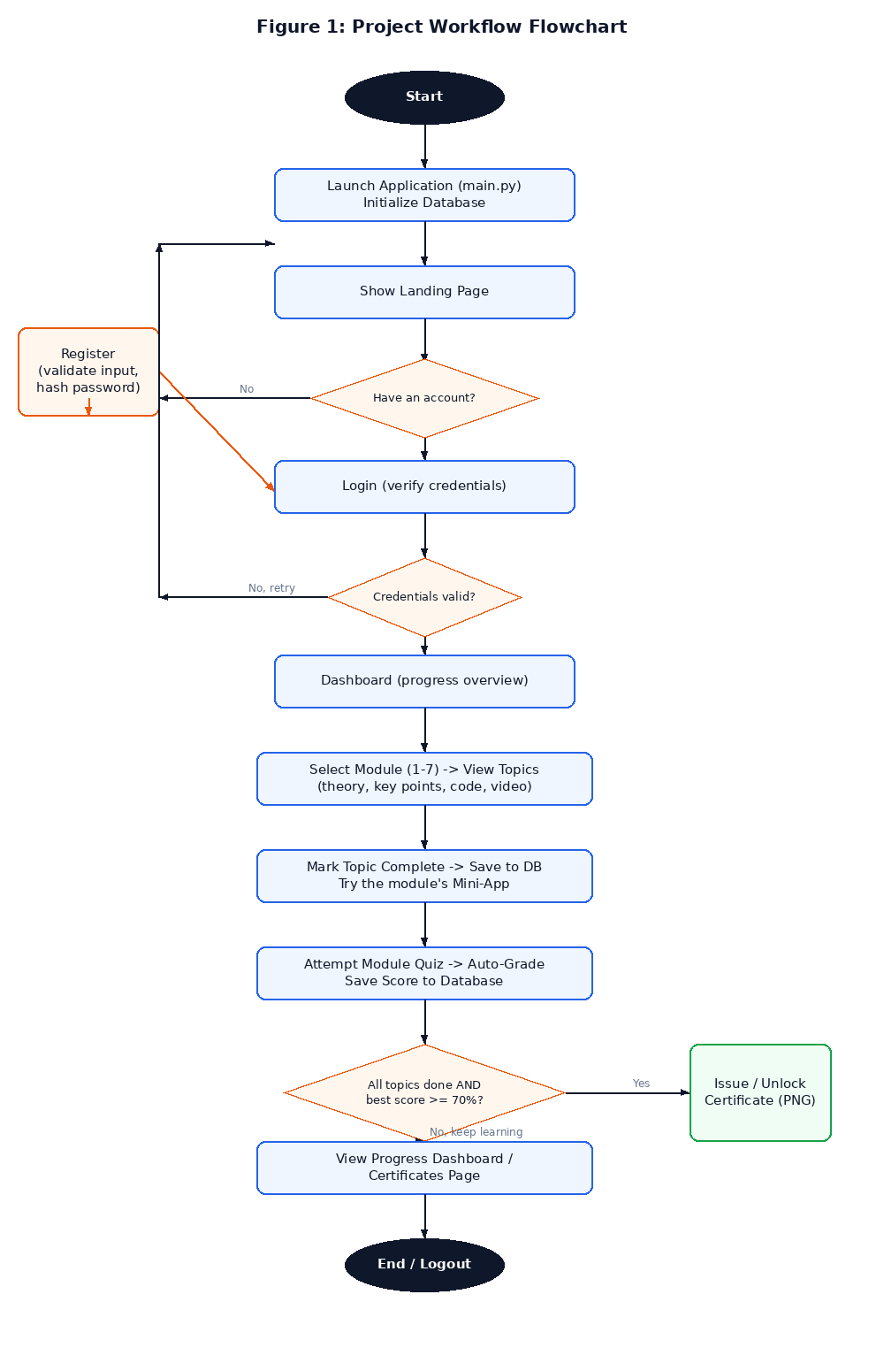
Figure 1: Project Workflow Flowchart

4.2 System Architecture / Block Diagram
Figure 2 shows the four-layer architecture used throughout the project: a Tkinter presentation layer, an application logic layer (navigation and shared utilities), a content layer holding all module data, and a persistent SQLite data layer, with two external touch-points (a public REST API and generated certificate files).
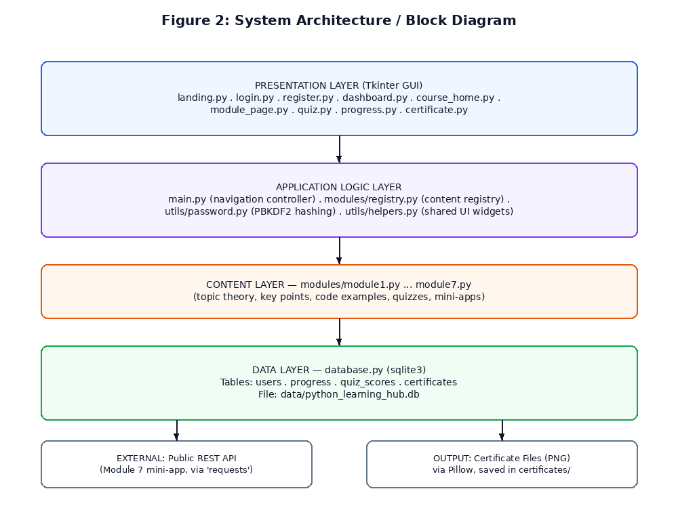
Figure 2: System Architecture / Block Diagram

4.3 Input-Process-Output Diagram
Figure 3 summarises the IPO analysis from Section 3.4 in diagram form.
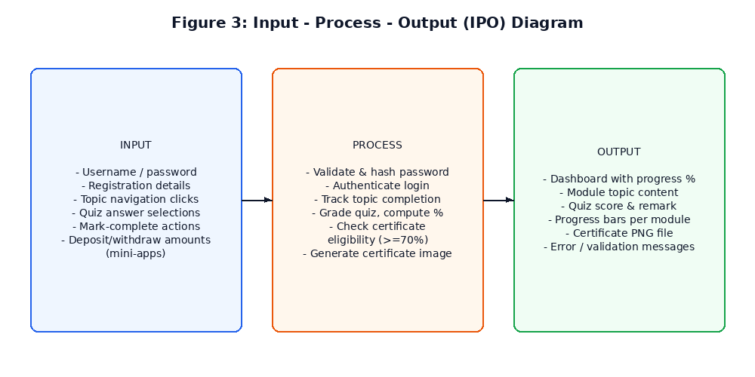
Figure 3: Input-Process-Output Diagram

4.4 Module Hierarchy / Structure Chart
Figure 4 shows how the codebase is actually organised on disk: main.py at the top coordinates config.py, database.py, and three packages (ui/, modules/, utils/), each containing the specific files described in Section 6.
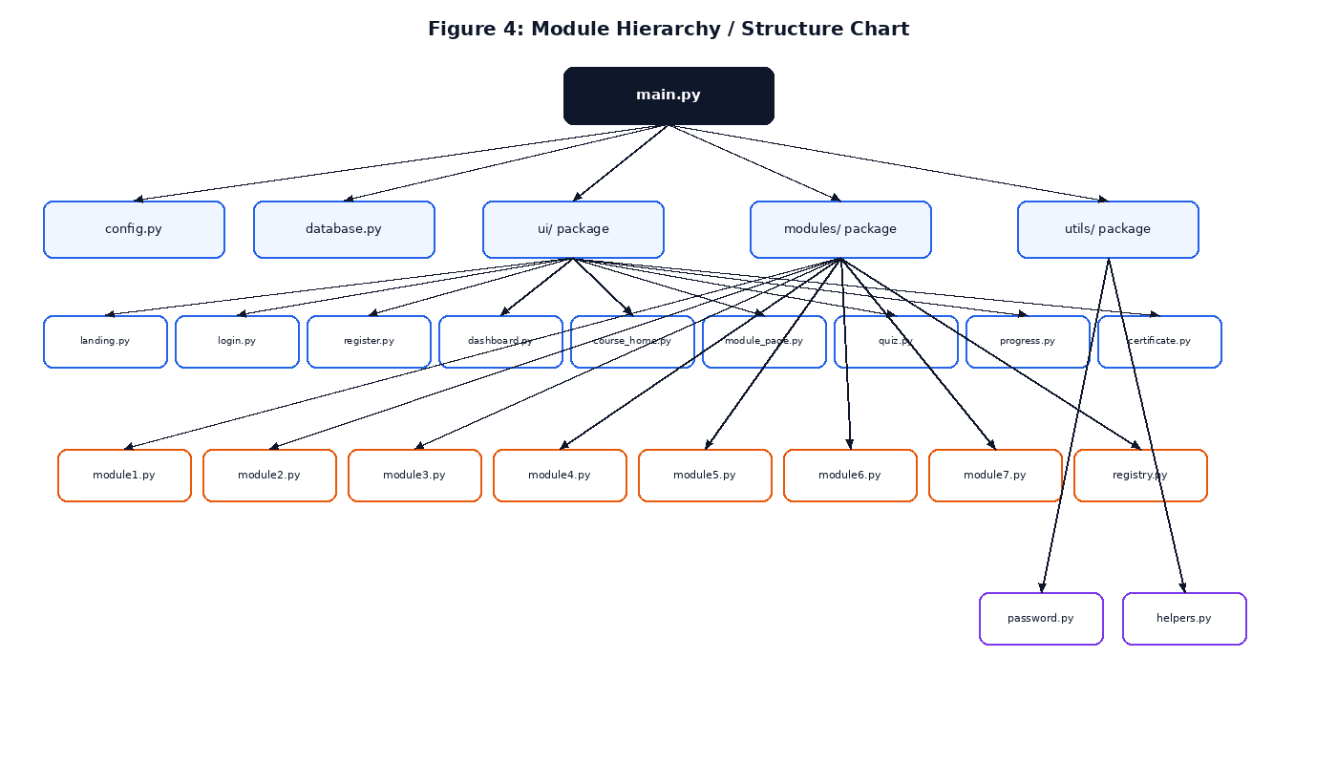
Figure 4: Module Hierarchy / Structure Chart

4.5 Database Schema (Entity-Relationship Diagram)
Figure 5 shows the four SQLite tables used by the application — users, progress, quiz_scores, and certificates — and their one-to-many relationships, all keyed off the users table's primary key.
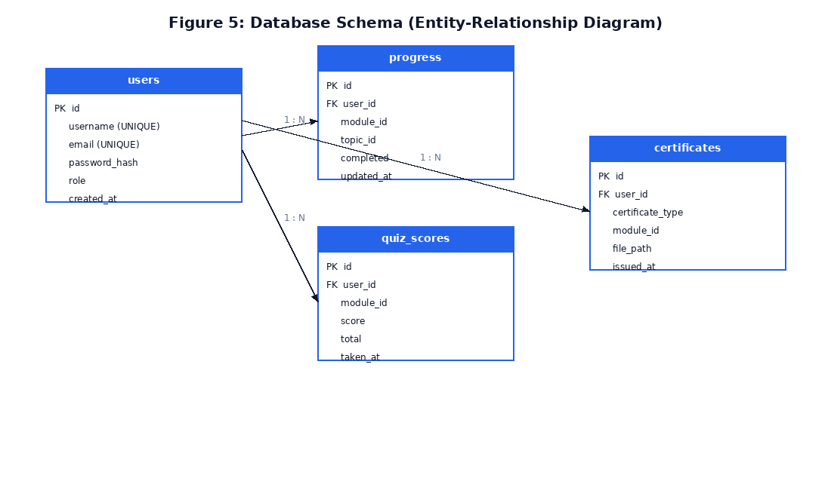
Figure 5: Database Schema (Entity-Relationship Diagram)

4.6 Class Diagram
Object-oriented programming is central to Module 5 (Object-Oriented Programming) of the platform. Figure 6 shows the BankAccount and SavingsAccount classes used in that module's mini-application, demonstrating encapsulation (the protected _balance attribute), inheritance (SavingsAccount extends BankAccount), and polymorphism (the overridden deposit() method).
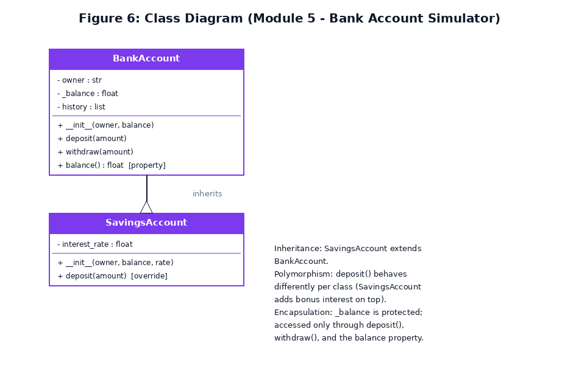
Figure 6: Class Diagram — Module 5 Bank Account Simulator

4.7 User Interface Wireframes
Figure 7 shows simplified wireframes of two representative screens: the Login screen and the post-login Dashboard, both matching the actual Tkinter layout implemented in ui/login.py and ui/dashboard.py.
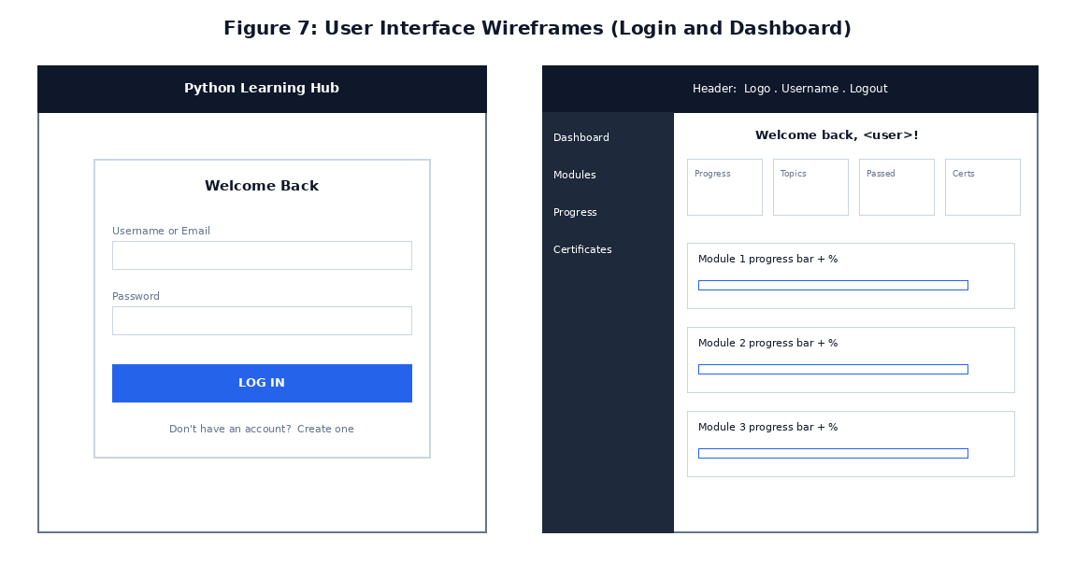
Figure 7: User Interface Wireframes (Login and Dashboard)

4.8 Use Case Diagram
Figure 8 shows the primary actor (the Student/Learner) and the ten main actions available to them across the platform.
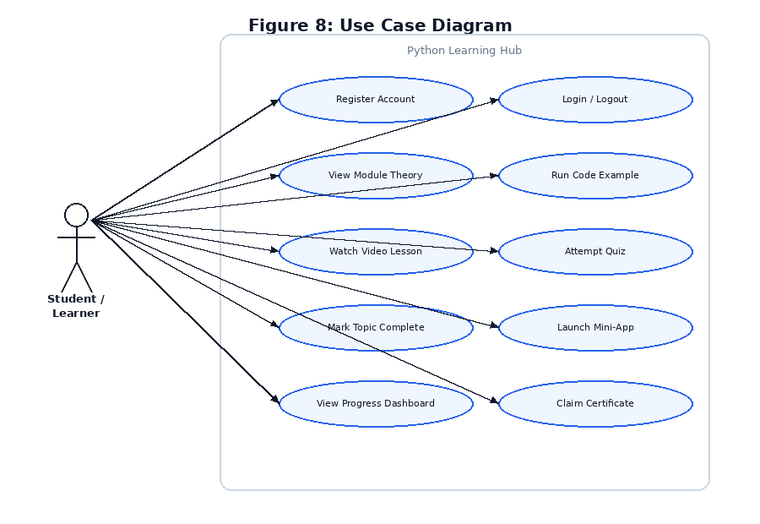
Figure 8: Use Case Diagram

5. TOOLS AND CONCEPTS USED

5.1 Development Environment
- Language: Python 3.12
- IDE: Visual Studio Code
- GUI Toolkit: Tkinter (standard library)
- Database: SQLite 3 (standard library sqlite3 module)
- Image generation: Pillow (PIL) — for certificate rendering
- Networking: requests — for the Module 7 live API mini-application

5.2 Core Python Concepts Demonstrated
Every core concept taught by the platform is also used to build the platform itself — the application is, in effect, a working example of its own syllabus:
- Variables, data types, type conversion, and operators — throughout every module's logic.
- Control flow (if/elif/else, for, while, break, continue) — in quiz grading, navigation, and mini-app logic.
- Functions, parameters, return values, lambda, and recursion — used extensively in utils/helpers.py and the content registry.
- Data structures (lists, dictionaries, sets, tuples) — module content is stored as nested dictionaries and lists; the Contact Book mini-app uses a list of dictionaries.
- File handling and exception handling — the Notes App mini-app performs real file I/O wrapped in try/except; database operations are guarded against errors.
- Object-oriented programming — the BankAccount/SavingsAccount class hierarchy (Section 4.6) demonstrates encapsulation, inheritance, and polymorphism.
- Database connectivity — database.py uses parameterised SQL queries exclusively (see Section 6.3) against a persistent SQLite database.
- APIs and JSON — the Module 7 mini-app performs a real GET request to a public REST API and parses the JSON response, with full error handling.

6. IMPLEMENTATION
The complete source code is submitted separately as editable .py files (see the Submission Folder Structure in Appendix A). This section explains the purpose of each major file and highlights representative code listings; long files are not reproduced here in full, per the report formatting guideline.

6.1 Project File Overview
File / Package | Purpose
main.py | Application entry point; wires all screens together via navigation functions.
config.py | Central configuration: window size, colour theme, fonts, and constants.
database.py | SQLite connection, schema creation, and all data-access functions.
utils/password.py | Salted PBKDF2 password hashing and verification.
utils/helpers.py | Shared UI widget builders (buttons, cards, progress bars) used across every screen.
modules/module1.py ... module7.py | Topic content (theory, key points, code, quiz) and one mini-app per module.
modules/registry.py | Central registry exposing ALL_MODULES and get_module() to the rest of the app.
ui/landing.py, login.py, register.py | Pre-authentication screens.
ui/dashboard.py | Shared sidebar/header shell used by every post-login screen, plus the dashboard home view.
ui/admin.py | Admin-only dashboard: enrollment, completion and certificate statistics across all students (read-only).
ui/course_home.py, module_page.py, quiz.py | Module listing, topic viewer, and quiz screens.
ui/progress.py, certificate.py | Progress Dashboard and certificate eligibility/generation/display.

6.2 Password Security (utils/password.py)
Rather than storing or comparing plain-text passwords, the platform uses PBKDF2-HMAC-SHA256 with a random 16-byte salt per user and 100,000 iterations, matching the guideline's requirement that passwords “shall never be stored as plain text”:
def hash_password(password: str) -> str:
salt = os.urandom(16)
derived = hashlib.pbkdf2_hmac(
"sha256", password.encode("utf-8"), salt, 100_000
)
return salt.hex() + "$" + derived.hex()
def verify_password(password: str, stored_hash: str) -> bool:
salt_hex, hash_hex = stored_hash.split("$")
salt = bytes.fromhex(salt_hex)
derived = hashlib.pbkdf2_hmac(
"sha256", password.encode("utf-8"), salt, 100_000
)
return derived.hex() == hash_hex

6.3 Parameterised Database Queries (database.py)
Every SQL statement in the project uses '?' placeholders instead of string concatenation, eliminating SQL-injection risk. The following function records a topic as complete, using SQLite's UPSERT syntax to insert or update in one statement:
def mark_topic_complete(user_id, module_id, topic_id):
conn = get_connection()
conn.execute(
"""INSERT INTO progress(user_id, module_id, topic_id, completed, updated_at)
VALUES (?, ?, ?, 1, ?)
ON CONFLICT(user_id, module_id, topic_id)
DO UPDATE SET completed=1, updated_at=excluded.updated_at""",
(user_id, module_id, topic_id, now_iso())
)
conn.commit()
conn.close()

6.4 Quiz Auto-Grading (ui/quiz.py)
Each quiz question is a dictionary with an options list and an answer_index. Submission compares every selected answer against the correct index, computes a percentage, and persists the attempt:
score = sum(
1 for i, q in enumerate(quiz)
if selected_answers[i] == q["answer_index"]
)
total = len(quiz)
pct = percent(score, total)
save_quiz_score(user["id"], module_id, score, total)

6.5 Object-Oriented Design (modules/module5.py)
The Module 5 mini-application implements a small class hierarchy that mirrors Figure 6, demonstrating inheritance and polymorphism directly in working code:
class BankAccount:
def __init__(self, owner, balance=0):
self.owner = owner
self._balance = balance # protected attribute
def deposit(self, amount):
if amount <= 0:
raise ValueError("Deposit amount must be positive.")
self._balance += amount
class SavingsAccount(BankAccount): # inheritance
def __init__(self, owner, balance=0, interest_rate=0.02):
super().__init__(owner, balance)
self.interest_rate = interest_rate
def deposit(self, amount): # polymorphism (override)
super().deposit(amount)
self._balance += amount * self.interest_rate

6.6 Certificate Generation (ui/certificate.py)
Once a module's eligibility conditions are met (all topics completed and best quiz score at or above 70%), a certificate image is rendered using Pillow and recorded in the certificates table:
def is_module_eligible(user_id, module_id):
module = get_module(module_id)
completed = get_completed_topic_ids(user_id, module_id)
all_topics_done = len(completed) >= len(module["topics"])
best = get_best_quiz_score(user_id, module_id)
quiz_passed = bool(
best and best[1] and percent(best[0], best[1]) >= PASS_THRESHOLD
)
return all_topics_done and quiz_passed

6.7 Execution Instructions (README summary)
- Required Python version: 3.8 or later (tested on 3.12).
- Required libraries for the core app: none beyond the standard library (Tkinter, sqlite3, hashlib).
- Optional libraries (Module 7 mini-app and code examples): requests, pandas, matplotlib — install via: pip install -r requirements.txt
- Certificate generation requires Pillow: pip install pillow
- To run the application: open the project's root folder in VS Code (or any terminal), and run: python main.py
- Demo accounts pre-loaded on first run: admin / Admin@123 and student / Student@123.

6.8 Admin Dashboard (ui/admin.py)
On login, users with the Admin role (rather than the default Student role) are routed to a separate, read-only Admin Dashboard instead of the standard learner dashboard. The screen summarises four course-wide statistics — enrolled students, certificates issued, final certificates earned, and average course completion — and lists every registered student with their join date, completion percentage, modules passed, and certificate count.
For each student, the modules-passed count reuses the same pass-threshold logic as certificate eligibility (Section 6.6), applied across every module:
modules_passed = sum(
1 for mid, (score, total, _) in best_scores.items()
if mid != 0 and total and (score / total * 100) >= cfg.PASS_THRESHOLD
)

7. TESTING AND DEBUGGING
The application was tested using a combination of manual GUI walkthroughs and direct backend function tests (bypassing the GUI to test database and logic functions in isolation). Table 2 below documents the five mandatory test cases, all executed against the actual project code, covering normal, boundary, and invalid-input scenarios.
Test ID | Feature | Input / Condition | Expected Result | Actual Result | Status
TC-01 | Registration validation (normal case) | Valid username, valid email, matching passwords ≥ 6 characters | Account created; success message shown; redirected to login | Account created successfully; redirected to login | Pass
TC-02 | Registration validation (boundary case) | Password exactly 6 characters long (minimum allowed) | Account created — boundary value accepted | Account created successfully | Pass
TC-03 | Login (invalid input) | Correct username, incorrect password | “Incorrect password. Please try again.” shown; login denied | Error message displayed exactly as expected; access denied | Pass
TC-04 | Database / quiz scoring (integrated) | Submit a 10-question quiz with 9 correct answers, then a second attempt with 7 correct | Best score recorded as 9/10 (90%); second, lower attempt does not overwrite it | get_best_quiz_score() returned (9, 10, ...) after both attempts | Pass
TC-05 | Certificate issuance (integrated output) | All 10 Module 1 topics marked complete + quiz score 9/10 (≥70%) | Module 1 eligible=True; certificate PNG generated and recorded in database | Certificate file generated (44,953 bytes) and row inserted in certificates table | Pass

7.1 Additional Edge Cases Verified
- Duplicate certificate claim: attempting to issue a certificate a second time correctly returns 'already_issued' without creating a duplicate row.
- Final certificate eligibility correctly evaluates to False when only 1 of 7 modules is complete, and True only once every module individually satisfies the eligibility check.
- Empty/blank registration fields are rejected with “Please fill in all fields.” before any database query is attempted.
- An invalid email format (missing '@' or domain) is rejected before account creation.

7.2 Debugging Notes
During development, an early version of the certificate generator produced a broken glyph in place of an emoji character, because the default Pillow font does not support emoji glyphs. This was identified by visually inspecting a generated certificate image and corrected by removing the unsupported character from the image-rendering path while keeping it in the on-screen Tkinter labels (which do support emoji rendering via the operating system's font stack).

8. RESULTS AND DISCUSSION
The completed Python Learning Hub platform successfully implements all seven planned modules, covering a combined 89 topics, 70 auto-graded quiz questions (10 per module), and seven distinct working mini-applications. All functional requirements listed in Section 3.1 were implemented and verified through the test cases in Section 7.

8.1 Screenshot Evidence
[STUDENT ACTION REQUIRED: Insert numbered, captioned screenshots here before final submission, showing at minimum: (1) the Landing/Welcome page, (2) the Login screen, (3) a Module topic page showing theory and code, (4) a Quiz in progress and its result, (5) the Progress Dashboard, (6) the Certificates page with an unlocked certificate, and (7) an example of error/invalid-input handling, e.g., a wrong-password message. Each screenshot must have a figure number and a specific caption, e.g., ‘Figure 9: Module 3 quiz result showing 9/10 (90%) — Passed.’ Run the application with python main.py to capture these.]

8.2 Objective Achievement
Objective (from Section 2.2) | Status
GUI platform covering all seven Python areas | Achieved — all 7 modules implemented
Theory, code example, and video link per topic | Achieved — all 89 topics include all three
Auto-graded quiz per module with best-score tracking | Achieved — verified in TC-04
Persistent topic/module progress tracking | Achieved — SQLite progress table, verified in TC-04/TC-05
Auto-generated certificates on verified completion | Achieved — verified in TC-05
Role-based Admin Dashboard for course-wide monitoring | Achieved — Admin-role login routes to the dashboard; verified manually

8.3 Limitations
- The Module 7 mini-application (Live Joke Fetcher) requires an active internet connection and the optional 'requests' library; it degrades gracefully with a clear message when either is unavailable, but is not usable fully offline.
- The platform is a single-user desktop application per machine; it does not currently support a shared, multi-device account system over a network.
- Content for all modules is fixed in code/JSON at build time; there is no in-app content editor for instructors to add new topics without editing the module files directly.

9. CONCLUSION AND FUTURE SCOPE

9.1 Conclusion
This project successfully designed and implemented a complete, GUI-based Python Learning Platform that unifies structured theory, runnable examples, auto-graded assessment, hands-on mini-applications, persistent progress tracking, and verified digital certification within a single Tkinter desktop application. Every core Python concept covered by the syllabus — from basic syntax through object-oriented programming, file handling, database connectivity, and REST APIs — is not only taught by the platform but actively used to build it, reinforcing the learning objectives of the Programming with Python course.

9.2 Learning Achieved
Building this project reinforced practical, hands-on understanding of: structuring a multi-file Python application with clear separation of concerns; secure password handling; writing safe, parameterised SQL queries; designing a normalised relational schema; applying object-oriented principles (encapsulation, inheritance, polymorphism) to a real feature; and consuming a REST API with proper error handling.

9.3 Future Scope
- Add an in-app content management screen so instructors can add or edit topics, quizzes, and mini-apps without editing Python files directly.
- Migrate the data layer from SQLite to a client-server database (e.g., MySQL or PostgreSQL) to support multi-device, multi-user access.
- Add a leaderboard and peer-comparison view to the Progress Dashboard for gamified motivation.
- Package the application as a standalone executable (e.g., via PyInstaller) for distribution without requiring a separate Python installation.
- Extend the reporting capability of Module 7 into a built-in PDF/CSV export of a learner's full progress and certificates.

REFERENCES
[1] Python Software Foundation. Python 3 Documentation. https://docs.python.org/3/
[2]Python Software Foundation. tkinter — Python interface to Tcl/Tk. https://docs.python.org/3/library/tkinter.html
[3] Python Software Foundation. sqlite3 — DB-API 2.0 interface for SQLite databases. https://docs.python.org/3/library/sqlite3.html
[4] Python Software Foundation. hashlib — Secure hashes and message digests. https://docs.python.org/3/library/hashlib.html
[5] Pillow (PIL Fork) Documentation. https://pillow.readthedocs.io/
[6] Requests: HTTP for Humans. https://requests.readthedocs.io/
[7] Official Joke API (public REST API used in the Module 7 mini-application). https://official-joke-api.appspot.com/
[8] Marwadi University, Department of CSE AI ML DS. Project Report Preparation Guideline — Python Learning Platform Project and End Semester Capstone Project, Course Code 01AP0303.
[9] AI-assisted development: Anthropic Claude was used for brainstorming the application architecture, generating boilerplate UI code, and drafting this report structure; all generated code was reviewed, tested, and verified by the student as required by Section 17 of the guideline.

APPENDIX A: SUBMISSION FOLDER STRUCTURE
The complete project follows the folder structure below, matching the department's required submission format:
Folder | Contents
01 Report | This document — editable DOCX and final PDF
02 Source Code | main.py, config.py, database.py, and the ui/, modules/, utils/ packages
03 Data | data/python_learning_hub.db (SQLite database, generated on first run)
04 Diagrams | Original diagram-generation script and exported PNG figures (Figures 1-8)
05 Screenshots | Numbered, captioned screenshots (to be added — see Section 8.1)
06 Testing | Test-case sheet (Table 2) and any additional logs
07 Presentation | Final PPT/PPTX (to be prepared separately)
08 Learning Evidence | References listed above; AI-assistance acknowledgement
09 Review Records | Review 1 report, Review 2 report, and faculty action-taken sheet

APPENDIX B: FACULTY REMARKS ACTION-TAKEN TABLE
[To be completed after Review 1 — record every faculty remark and the corresponding correction made before Review 2.]
Sr No | Review 1 Faculty Remark | Correction Made | Page / Module | Status
1 |  |  |  | Pending
2 |  |  |  | Pending
3 |  |  |  | Pending

