CI/CD Pipelines
A Practical Guide to Continuous Integration & Continuous Delivery

1. Introduction
Modern software teams release changes far more often than they did a decade ago — sometimes dozens of times a day. This pace is only possible because of CI/CD, a set of practices that automate the path code takes from a developer's laptop to a live production environment. CI/CD removes manual, error-prone steps from that journey and replaces them with a repeatable, automated pipeline.
CI/CD stands for Continuous Integration and Continuous Delivery (or Continuous Deployment). While the two halves of the acronym are closely related, they solve different problems: CI focuses on merging and validating code changes frequently, while CD focuses on getting validated changes safely into the hands of users.

2. Continuous Integration (CI)
Continuous Integration is the practice of merging all developers' working copies to a shared mainline several times a day. Every merge automatically triggers a build and a suite of automated tests, so integration problems are caught within minutes rather than discovered weeks later during a painful “integration phase.”
- Developers commit small, frequent changes instead of large, risky ones.
- Every commit triggers an automated build and test run.
- Failures are reported immediately, so they can be fixed while the context is still fresh.
- The mainline branch is always kept in a working, deployable state.

3. Continuous Delivery vs. Continuous Deployment
Once code has passed CI, Continuous Delivery and Continuous Deployment decide what happens next. Both automatically prepare a release-ready build after every successful pipeline run — the difference is what triggers the final push to production.

Continuous Delivery
Every change that passes the pipeline is automatically prepared for release, but a human still clicks the button to deploy to production. This keeps a manual approval gate for business or compliance reasons.

Continuous Deployment
Every change that passes the pipeline is automatically released to production with no human intervention at all. This requires very high confidence in the automated test suite, since there is no manual safety net.
Rule of thumb: Continuous Integration is about the code always being mergeable. Continuous Delivery is about the code always being releasable. Continuous Deployment is about the code always being released.

4. The CI/CD Pipeline — Flowchart
The diagram below shows a typical end-to-end pipeline, from a developer's commit all the way through to production monitoring, including the feedback loop that brings issues discovered in production back into the next round of development.
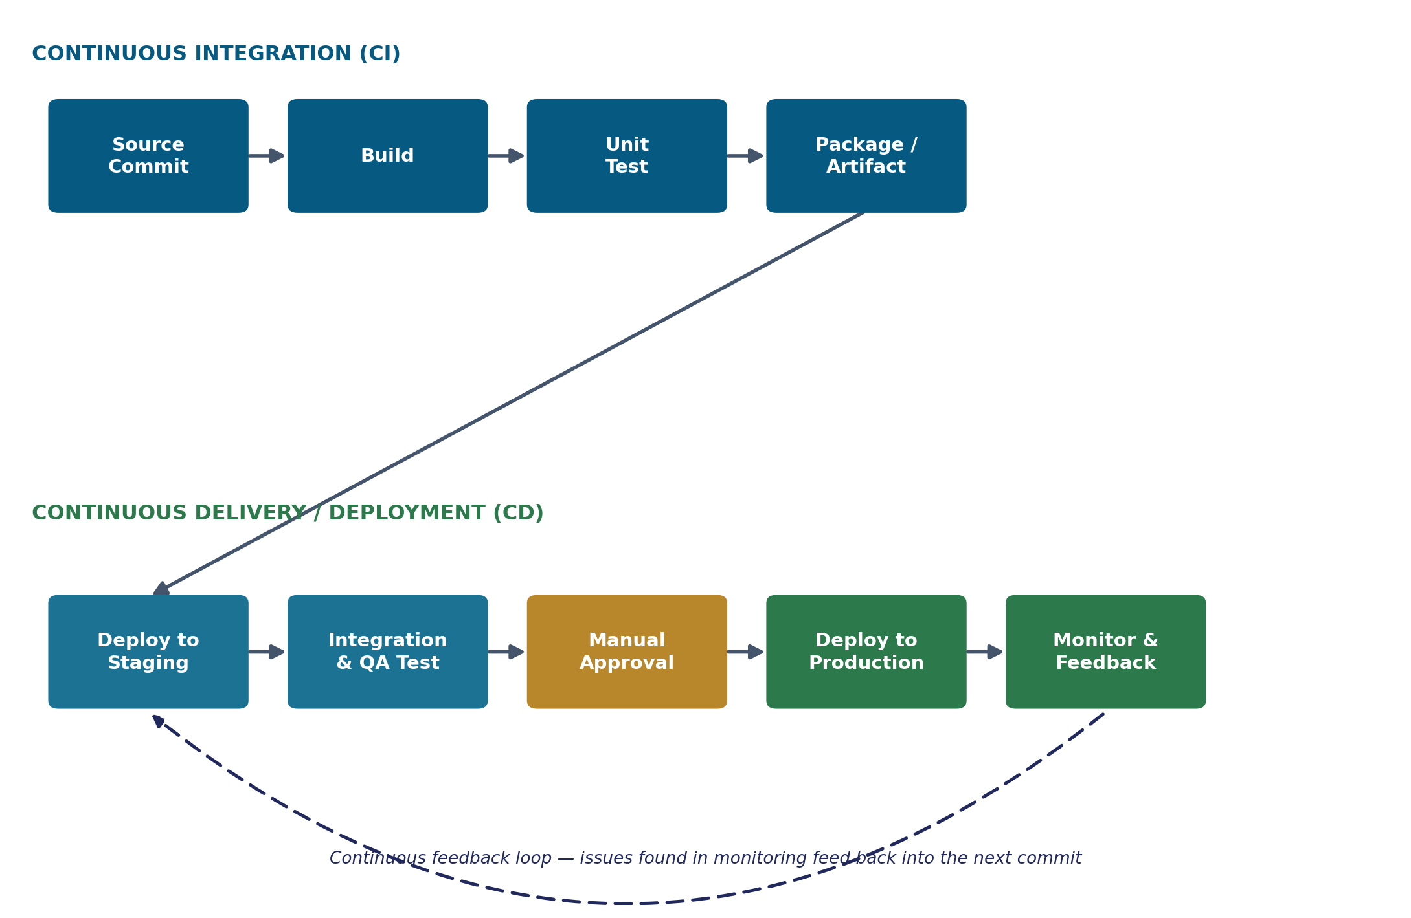

5. Pipeline Stages Explained
Each box in the flowchart corresponds to an automated stage in the pipeline. The table below breaks down what happens at each stage and the tools commonly used to implement it.
Stage | What Happens | Typical Tools
1. Source Control | A developer commits and pushes code changes to a shared repository, triggering the pipeline automatically. | Git, GitHub, GitLab, Bitbucket
2. Build | The source code is compiled, dependencies are resolved, and the application is packaged into a runnable form. | Maven, Gradle, npm, Webpack
3. Automated Testing | Unit, integration, and static-analysis tests run automatically to catch bugs and regressions early. | JUnit, Jest, Selenium, SonarQube
4. Package / Artifact | A versioned, deployable artifact (binary, container image, etc.) is created and stored in a registry. | Docker, JFrog Artifactory, Nexus
5. Deploy to Staging | The artifact is automatically deployed to a staging environment that mirrors production. | Kubernetes, Ansible, Terraform
6. QA / Integration Test | Further automated or manual checks confirm the release behaves correctly with real dependencies. | Postman, Cypress, TestRail
7. Approval Gate | For Continuous Delivery, a human reviewer signs off before the release goes live (skipped in full Continuous Deployment). | Jira, ServiceNow, manual sign-off
8. Deploy to Production | The approved build is released to end users, often using rolling, blue-green, or canary strategies. | Spinnaker, ArgoCD, AWS CodeDeploy
9. Monitor & Feedback | Logs, metrics, and alerts track the release in production; issues feed back into the next development cycle. | Prometheus, Grafana, Datadog

6. Benefits of CI/CD
- Faster releases — changes reach users in hours instead of weeks.
- Early bug detection — automated tests catch issues right after they are introduced.
- Reduced manual effort — repetitive build, test, and deploy steps are automated.
- Higher release confidence — every change follows the same tested, repeatable process.
- Easier rollback — small, frequent releases are simpler to diagnose and revert than large ones.
- Better collaboration — shared pipelines and visibility keep dev, QA, and ops aligned.

7. Popular CI/CD Tools
Most CI/CD toolchains combine several specialized tools rather than one single product. A common stack is shown below.
Category | Popular Tools
CI/CD Platforms | Jenkins, GitHub Actions, GitLab CI/CD, CircleCI, Travis CI
Containerization | Docker, Podman
Orchestration | Kubernetes, Docker Swarm
Infrastructure as Code | Terraform, Ansible, Pulumi
Artifact Repositories | JFrog Artifactory, Nexus Repository, Docker Hub
Monitoring & Logging | Prometheus, Grafana, Datadog, ELK Stack

8. Best Practices
- Keep the pipeline fast — aim for feedback within minutes, not hours.
- Fix a broken build immediately; a red pipeline blocks everyone.
- Write automated tests before relying on Continuous Deployment.
- Use feature flags to decouple deployment from release.
- Treat pipeline configuration as code, version-controlled alongside the application.
- Monitor production closely and feed incidents back into the backlog.

9. Conclusion
CI/CD turns software delivery from a risky, manual event into a routine, automated process. Continuous Integration keeps code always mergeable by testing every change as it lands; Continuous Delivery and Deployment keep that tested code always releasable — or automatically released — to production. Together, they let teams ship smaller changes more often, catch problems sooner, and build the confidence to move fast without breaking things.

