For our cloud-native retail banking training, these topics fit naturally into one end-to-end story:
Developer
│
▼
Azure DevOps / Git
│
▼
CI Pipeline
│
├── Build
├── Test
├── Scan
└── Push Image → ACR
│
▼
GitOps Repo
│
▼
Argo CD
│
┌──────┴──────┐
▼ ▼
AKS ARO
│ │
└──────┬──────┘
▼
Production App
│
┌──────────┼──────────┐
▼ ▼ ▼
Monitoring Security Scaling
I'll explain each topic using a retail banking application as the running example.

1. Rancher Concepts

5

What is Rancher?
Rancher is a Kubernetes management platform.
Kubernetes itself manages containers and workloads, but when an organization has many Kubernetes clusters, managing them individually becomes difficult.
Rancher provides a centralized management layer.
For example, a bank might have:
Rancher
│
┌────────────┼────────────┐
▼ ▼ ▼
AKS Cluster ARO Cluster On-Prem Cluster
│ │ │
Banking App Banking App Legacy Banking
Instead of administrators logging into every cluster separately, Rancher provides centralized visibility and management.

Rancher can help with
- Cluster management
- Kubernetes provisioning
- User authentication
- RBAC
- Monitoring
- Policy management
- Application deployment
- Multi-cluster management

2. Rancher Architecture
A simplified architecture is:
Users
│
▼
Rancher Server
│
┌───────────┼───────────┐
▼ ▼ ▼
Cluster A Cluster B Cluster C
│ │ │
AKS ARO On-Prem
The Rancher management server provides the central UI/API.

Example
Suppose the bank has:
- Development AKS
- QA AKS
- Production ARO
Rancher can provide:
Rancher
├── dev-aks
├── qa-aks
└── production-aro
The administrator can inspect:
- Nodes
- Pods
- Deployments
- Services
- Namespaces
- Applications
- Cluster health
from a centralized platform.

3. Multi-Cluster Management
This is one of Rancher's major use cases.
Imagine:
Development
│
▼
AKS-DEV

Testing
│
▼
AKS-QA

Production
│
▼
ARO-PROD
Without centralized management:
kubectl → cluster 1
kubectl → cluster 2
oc → cluster 3
With Rancher:
Rancher
│
┌───────────┼───────────┐
▼ ▼ ▼
DEV QA PROD
AKS AKS ARO

Real-world example
A bank may have:
Cluster Purpose
----------- ----------------
AKS-DEV Developer testing
AKS-UAT Business validation
ARO-PROD Production
An operations team can monitor all three environments centrally.

4. Cluster Provisioning
Cluster provisioning means creating and configuring a Kubernetes cluster.
Rancher can help organizations provision or import clusters depending on the infrastructure and Rancher setup.
Typical cluster provisioning involves:
Infrastructure
↓
VMs / Cloud Resources
↓
Kubernetes Control Plane
↓
Worker Nodes
↓
Networking
↓
Storage
↓
Cluster Ready

Example
For a production banking environment:
3 Control Plane Nodes
+
6 Worker Nodes
+
Load Balancer
+
Persistent Storage
+
Network Policies
After provisioning:
kubectl get nodes
might show:
NAME STATUS
node-01 Ready
node-02 Ready
node-03 Ready
...

5. Cluster Monitoring
Rancher can provide visibility into cluster resources and workloads.
Important metrics include:

Node
- CPU
- Memory
- Disk
- Network

Kubernetes
- Pod status
- Deployment status
- Replica availability
- Restarts

Application
- Request rate
- Error rate
- Response time
For your banking application:
customer-service
account-service
frontend
Kafka
PostgreSQL
you might monitor:
CPU: 45%
Memory: 62%
Pod restarts: 0
HTTP errors: 0.4%
Response time: 180 ms

6. User & Access Management
This is extremely important in banking.
You don't want every user to have administrator privileges.
For example:
Bank DevOps Team
│
├── Cluster Admin
│
├── Developer
│
└── Read Only

Example
Developer:
Can:
✓ View pods
✓ View logs
✓ Deploy to DEV

Cannot:
✗ Delete production namespace
✗ Modify cluster configuration
✗ Create cluster
Operations:
Can:
✓ Restart workloads
✓ Scale deployments
✓ View logs

Cannot:
✗ Change organizational security policy
This follows the principle of least privilege.

7. Policy Management
Policies define what users and workloads are allowed to do.
For example:
Production Namespace
│
├── No privileged containers
├── Resource limits required
├── Approved registries only
├── Network restrictions
└── Required labels
A banking organization might enforce:
Containers must only pull images from the organization's approved ACR.
Therefore:
docker.io/random-image
↓
BLOCKED

solo01akslab.azurecr.io/customer-service
↓
ALLOWED

8. GitOps
GitOps means using Git as the source of truth for infrastructure and deployment configuration.
Traditional deployment:
Developer
↓
kubectl apply
↓
Kubernetes
GitOps:
Developer
↓
Git
↓
Argo CD
↓
Kubernetes
For your banking application, Git might contain:
k8s/
├── namespace.yaml
├── customer-service.yaml
├── account-service.yaml
├── frontend.yaml
├── postgres.yaml
└── ingress.yaml
The desired state is stored in Git.

9. GitOps Principles
The main principles are:

1. Declarative
Describe what you want, rather than manually describing every operation.
Example:
replicas: 3
means:
I want three instances.

2. Version controlled
Every deployment configuration is stored in Git.
commit 101
↓
version 1.0

commit 102
↓
version 1.1

commit 103
↓
version 1.2

3. Automated
Changes in Git can trigger deployment.
Git commit
↓
Argo CD detects change
↓
Kubernetes updated

4. Auditable
You can determine:
Who changed it?
When?
What changed?
Why?
This is particularly valuable in regulated environments such as banking.

10. Argo CD Architecture
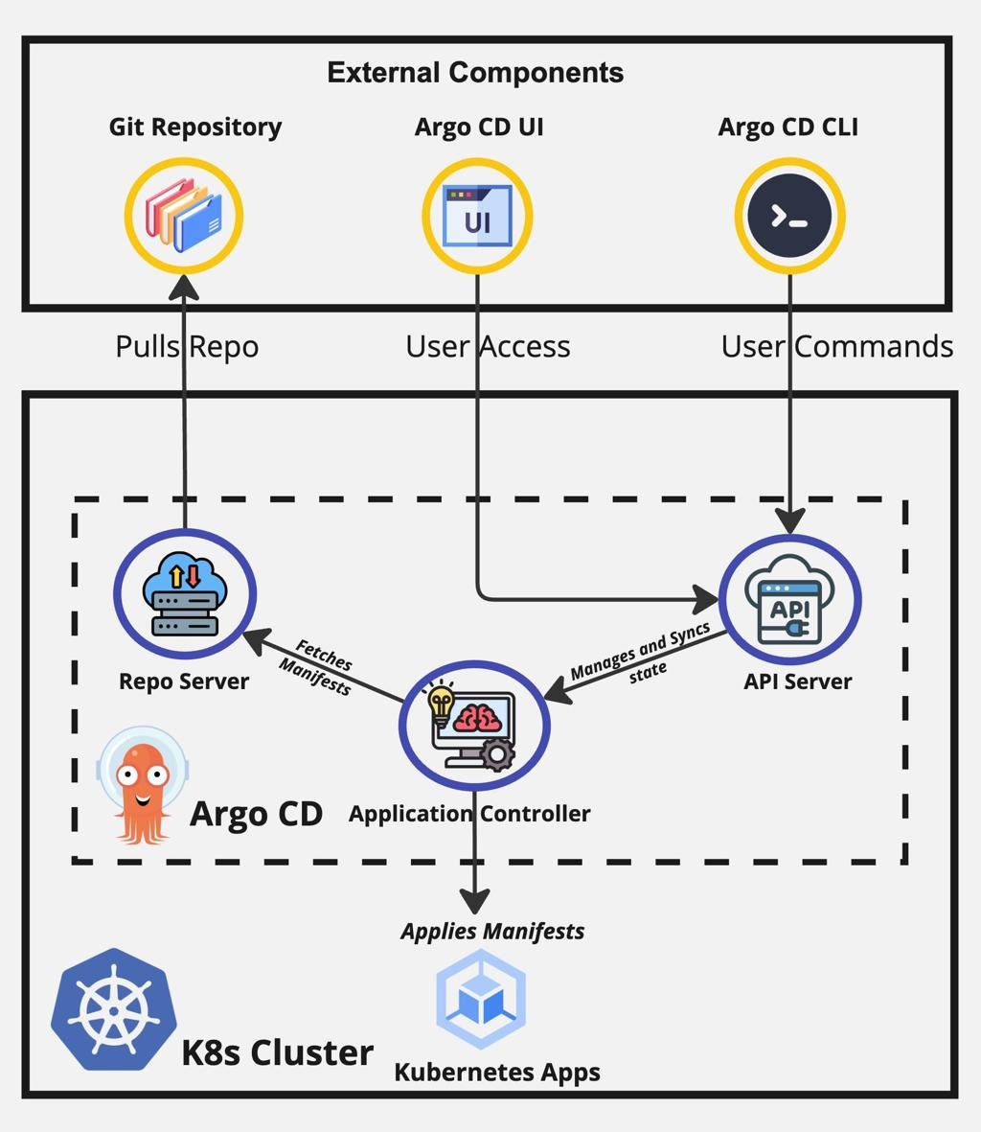
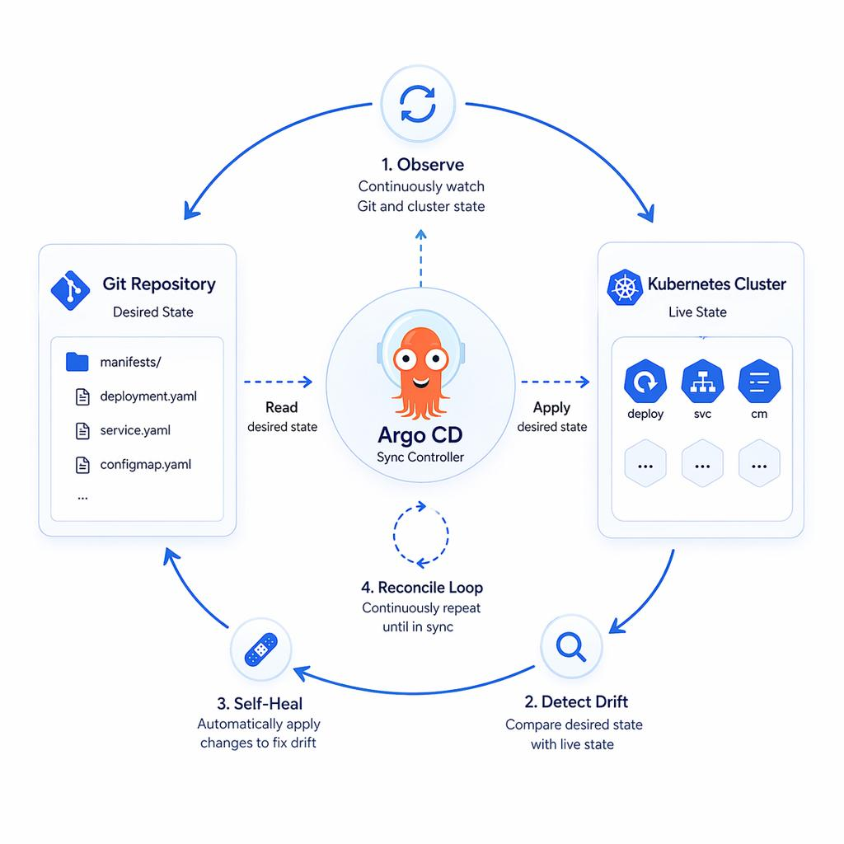
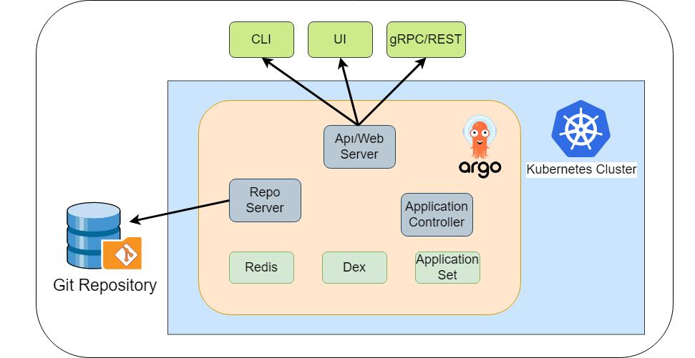
5
Argo CD is a GitOps continuous delivery tool for Kubernetes.
Architecture:
Git Repository
│
│
▼
Argo CD
│
Application Controller
│
▼
Kubernetes
│
▼
Pods
Argo CD continuously compares:
Desired State
│
│ Git
▼
Argo CD
│
│ compare
▼
Actual State
│
▼
Kubernetes
If they differ:
Desired: 3 replicas
Actual: 2 replicas
Argo CD detects the difference.
This is called drift.

11. Continuous Deployment
Continuous Deployment means changes can automatically move toward an environment after passing required checks.
Example:
Developer commits code
↓
Azure DevOps Pipeline
↓
Compile
↓
Unit Tests
↓
Security Scan
↓
Docker Build
↓
Push Image to ACR
↓
Update Git deployment manifest
↓
Argo CD
↓
AKS
Suppose:
customer-service:v1.2
becomes:
customer-service:v1.3
The Git manifest changes:
image: solo01akslab.azurecr.io/customer-service:v1.3
Argo CD detects it and deploys v1.3.

12. Rollback Strategy
Suppose v1.3 introduces a transaction-processing problem.
GitOps makes rollback straightforward.
Git history:
v1.1
↓
v1.2
↓
v1.3 ← problem
Rollback:
v1.3
↓
restore Git configuration
↓
v1.2
↓
Argo CD
↓
Kubernetes
For example:
customer-service:v1.3
is replaced with:
customer-service:v1.2
Then Argo CD reconciles the cluster.

Important banking consideration
Application rollback and database rollback are not automatically the same thing.
For example:
Application v1.3
Database schema v15
You must ensure the database migration strategy is compatible with rollback.
This is why production teams commonly use backward-compatible database migrations.

13. DevOps
DevOps is a combination of:
Development
+
Operations
+
Automation
+
Collaboration
Traditional:
Developer → Operations → Deployment
DevOps:
Develop
↓
Build
↓
Test
↓
Secure
↓
Deploy
↓
Monitor
↓
Feedback
↺
For your banking application:
Code
↓
Customer Service
↓
Automated Test
↓
Docker
↓
ACR
↓
AKS/ARO
↓
Prometheus/Grafana

14. Azure DevOps Pipelines
Azure DevOps Pipelines can automate CI/CD.
A simplified pipeline:
Azure DevOps
│
┌──────────┴──────────┐
▼ ▼
CI CD
│ │
Build/Test Deployment
│ │
Docker Build Kubernetes
│ │
Push ACR AKS
Example stages:
Stage 1: Build
Stage 2: Test
Stage 3: Security Scan
Stage 4: Docker Build
Stage 5: Push ACR
Stage 6: Deploy
Stage 7: Smoke Test
A pipeline might build:
customer-service
account-service
frontend
and push:
ACR
├── customer-service:build-125
├── account-service:build-125
└── frontend:build-125

15. OpenShift Pipelines — Tekton
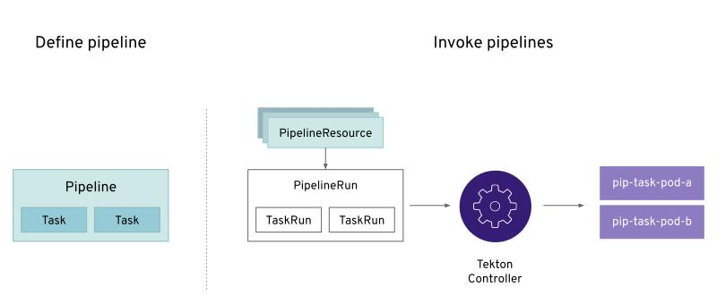
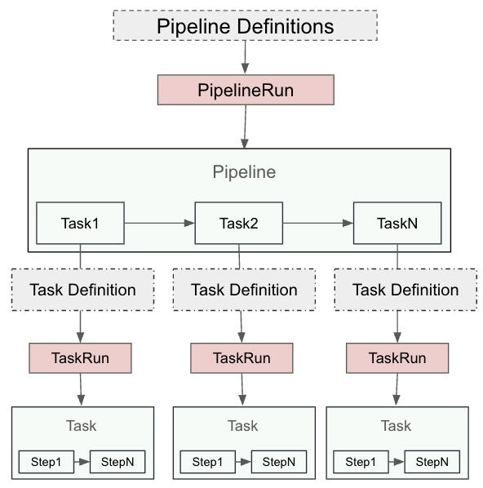
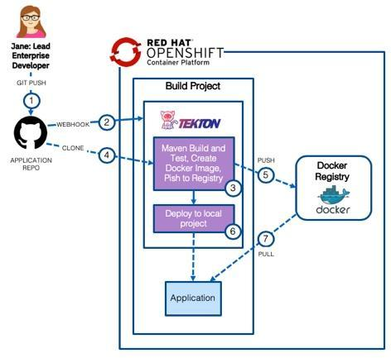
5
Tekton is a Kubernetes-native CI/CD framework.
Instead of a traditional external CI server, pipeline components run as Kubernetes resources.
Conceptually:
Pipeline
│
├── Task: Clone Git
│
├── Task: Build
│
├── Task: Test
│
├── Task: Build Image
│
└── Task: Push Image
Example:
Git
↓
Tekton
↓
Maven Build
↓
Tests
↓
Buildah
↓
ACR
In OpenShift:
OpenShift
│
└── Tekton
│
├── Pipeline
├── Tasks
└── PipelineRuns

16. Blue-Green Deployment
Blue-green deployment maintains two production environments.
Load Balancer
│
┌─────┴─────┐
▼ ▼
BLUE GREEN
v1.0 v1.1
Suppose BLUE is currently serving customers:
BLUE → 100% traffic
GREEN → 0%
Deploy v1.1 to GREEN.
Test:
GREEN
├── Health check
├── API test
├── Database test
└── Smoke test
Then switch traffic:
BLUE → 0%
GREEN → 100%
If a problem occurs:
GREEN → 0%
BLUE → 100%

Advantage
Fast traffic switching.

Consideration
You need capacity for two environments.

17. Canary Deployment
Canary deployment sends only a small percentage of traffic to the new version.
Example:
v1.0 → 95%
v1.1 → 5%
Monitor:
Error rate
Latency
CPU
Business transactions
If everything is healthy:
v1.0 → 75%
v1.1 → 25%
Then:
v1.0 → 50%
v1.1 → 50%
Eventually:
v1.0 → 0%
v1.1 → 100%

Banking example
Suppose the bank has:
1,000,000 daily API requests
Instead of sending the new account-service version to everyone:
50,000 requests → v2
950,000 requests → v1
The operations team observes the new version before increasing traffic.

18. Production Readiness
Before deploying to production, ask:
Is the application operationally ready?
A production-readiness checklist includes:

Application
✓ Health endpoints
✓ Error handling
✓ Logging
✓ Configuration externalized
✓ Timeouts
✓ Retry strategy

Kubernetes
✓ Resource requests
✓ Resource limits
✓ Readiness probe
✓ Liveness probe
✓ Pod disruption strategy
✓ Replica count

Security
✓ Authentication
✓ Authorization
✓ Secrets management
✓ TLS
✓ RBAC
✓ Image scanning

Observability
✓ Metrics
✓ Logs
✓ Alerts
✓ Dashboards

19. Scalability Review
Ask:
Can the system handle increasing traffic?
Suppose account-service currently has:
replicas: 2
Traffic increases.
You might scale to:
replicas: 5
Kubernetes:
Service
│
┌────────┼────────┐
▼ ▼ ▼
Pod Pod Pod
│ │ │
└────────┼────────┘
...

Horizontal scaling
Add more pods.
2 pods → 5 pods → 10 pods

Vertical scaling
Give an individual pod more resources.
CPU:
500m → 1 CPU

Memory:
512Mi → 1Gi
For stateless services, horizontal scaling is commonly useful because requests can be distributed across replicas.

20. Security Review
For a banking application, security review should cover multiple layers.
Internet
↓
Ingress
↓
Authentication
↓
Authorization
↓
API
↓
Database

Identity
Use:
- Microsoft Entra ID
- OAuth 2.0
- JWT
- RBAC

Secrets
Don't put:
DB_PASSWORD=banking123
directly into Git.
Instead:
Azure Key Vault
↓
Secret integration
↓
Application

Container security
Check:
Base image vulnerabilities
Known CVEs
Running as non-root
Image provenance
Registry access

21. Performance Tuning
Performance tuning means identifying and reducing bottlenecks.
For your banking system:
Frontend
↓
Account Service
↓
PostgreSQL
Suppose:
API response = 2.5 seconds
Find where the time is spent.
Frontend 100 ms
Account API 200 ms
Database 2,100 ms
The database is the likely bottleneck.
Possible improvements:
- Database indexes
- Query optimization
- Connection pool tuning
- Caching
- Pagination
- Async processing
- Kafka for event-driven operations where appropriate

Kubernetes performance
Also inspect:
CPU throttling
Memory usage
OOMKilled
Pod restarts
Network latency
Prometheus and Grafana become very useful here.

22. Disaster Recovery
Disaster Recovery means preparing for major failures.
Imagine the production cluster becomes unavailable.
A banking application needs a recovery strategy.
Important concepts:

RTO
Recovery Time Objective
How quickly must the service be restored?
Example:
RTO = 30 minutes

RPO
Recovery Point Objective
How much data loss is acceptable?
Example:
RPO = 5 minutes
That means the organization designs backups/replication so that, in a disaster, it aims to recover with no more than approximately five minutes of data loss.

Example architecture
Production
│
AKS
│
┌───────┴───────┐
│ │
Database Application
│
▼
Backups
│
▼
DR Region
For databases, you need a specific backup and restore/replication strategy rather than assuming Kubernetes replication protects persistent data.

23. Cost Optimization
Cloud cost optimization means getting the required reliability and performance without unnecessary resource consumption.

Example
Suppose:
Development
10 pods × 2 CPU
but average utilization is only:
8%
That may indicate over-provisioning.
Possible approaches:
- Right-size CPU/memory
- Scale development environments down outside working hours
- Use autoscaling
- Remove unused resources
- Optimize storage
- Review load balancer usage
- Review log retention
- Review monitoring retention
- Use appropriate VM sizes

Important trade-off
Cost optimization should not simply mean:
Use the smallest possible VM.
Instead:
Cost
↕
Performance
↕
Availability
↕
Security
The goal is to find an appropriate balance for the workload and its requirements.

Putting Everything Together
For your Retail Banking Cloud-Native application, you can turn all these topics into one realistic enterprise architecture:
Developer
│
▼
Git Repo
│
▼
Azure DevOps Pipeline
│
┌──────────────┼──────────────┐
▼ ▼ ▼
Build Test Security
│
▼
Docker Image
│
▼
ACR
│
▼
GitOps Repository
│
▼
Argo CD
│
┌─────┴─────┐
▼ ▼
AKS ARO
│ │
└─────┬─────┘
▼
Banking Application
│
┌────────┼─────────┐
▼ ▼ ▼
Customer Account Frontend
Service Service
│ │
└────┬───┘
▼
PostgreSQL
│
▼
Kafka
│
▼
Event Processing
And around the entire platform:
┌───────────────────────┐
│ Rancher │
│ Multi-Cluster Mgmt │
└───────────┬───────────┘
│
┌──────────────────┼──────────────────┐
▼ ▼ ▼
Security Monitoring Policy
│ │ │
RBAC/Entra Prometheus/Grafana Governance
Then the production deployment strategy can be:
Deployment
│
┌──────────┴──────────┐
▼ ▼
Blue-Green Canary
│ │
└──────────┬──────────┘
▼
Production
│
┌────────────┼────────────┐
▼ ▼ ▼
Scalability Performance Security
│ │ │
└────────────┼────────────┘
▼
DR + Backup
│
▼
Cost Optimization

Suggested training flow
For your participants, I would teach these in this order rather than following the raw list:
Day 1 — Enterprise Kubernetes Management
- Rancher concepts
- Rancher architecture
- Multi-cluster management
- Cluster provisioning
- Cluster monitoring
- User/access management
- Policy management
Day 2 — GitOps
8. GitOps principles
9. Argo CD architecture
10. Continuous Deployment
11. Rollback strategy
Day 3 — CI/CD
12. DevOps
13. Azure DevOps Pipelines
14. OpenShift Pipelines/Tekton
Day 4 — Advanced Deployment
15. Blue-Green
16. Canary
Day 5 — Production Readiness
17. Scalability review
18. Security review
19. Performance tuning
20. Disaster Recovery
21. Cost optimization
That progression gives participants a coherent story: manage clusters → automate deployment → progressively release software → validate production readiness → operate it reliably and economically.

