DSA0601 Data Handling and Visualization
Name: Lakshna Sree T S
Regno: 192524059
SET 13 — GEOGRAPHIC DATA ANALYSIS
Dataset
City | Population | Avg. Temperature | Elevation
City A | 500000 | 75 | 1000
City B | 700000 | 68 | 800
City C | 600000 | 80 | 1200

Note: The dataset has no latitude or longitude, so sample coordinates were assumed to draw the map: City A (20°N, 75°E), City B (24°N, 79°E) and City C (16°N, 80°E). No base map is drawn; each city is a labelled point on a latitude–longitude grid.
PROGRAM 1 — Map Chart of City Locations
library(ggplot2)

# Dataset (coordinates are sample values)
cities <- data.frame(
City = c("City A", "City B", "City C"),
Population = c(500000, 700000, 600000),
Longitude = c(75, 79, 80),
Latitude = c(20, 24, 16)
)

# Map chart: bubble size = population
ggplot(cities, aes(x = Longitude, y = Latitude)) +
geom_point(aes(size = Population), shape = 21,
fill = "gray60", colour = "black", stroke = 1) +
geom_text(aes(label = City), vjust = -2) +
scale_size(range = c(6, 10)) +
xlim(73, 82) + ylim(14, 26) +
theme_bw() +
labs(title = "Geographic Distribution of Cities",
x = "Longitude", y = "Latitude", size = "Population")

Output: Map chart showing the location of each city, labelled, with bubble size showing population.
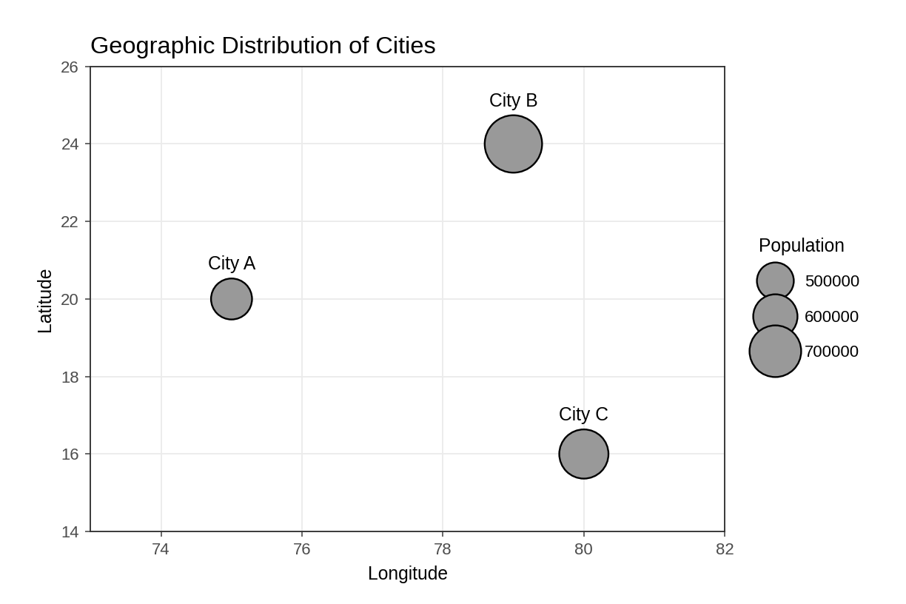
Observation: City B (24°N, 79°E) is the northernmost and has the largest bubble (700,000), City C (600,000) is in the south-east and City A (500,000) is in the west. The labels, axes and the population legend identify each element of the map.
PROGRAM 2 — Scatter Plot of Average Temperature vs Population
# Dataset
city <- c("City A", "City B", "City C")
population <- c(500000, 700000, 600000)
temperature <- c(75, 68, 80)

# Scatter Plot
plot(temperature, population,
pch = 19,
xlab = "Average Temperature",
ylab = "Population",
main = "Average Temperature vs Population",
ylim = c(480000, 730000))
text(temperature, population, labels = city, pos = 3)
abline(lm(population ~ temperature), lty = 2)

# Correlation
cor(temperature, population)

Output: Scatter plot showing the relationship between average temperature and population.
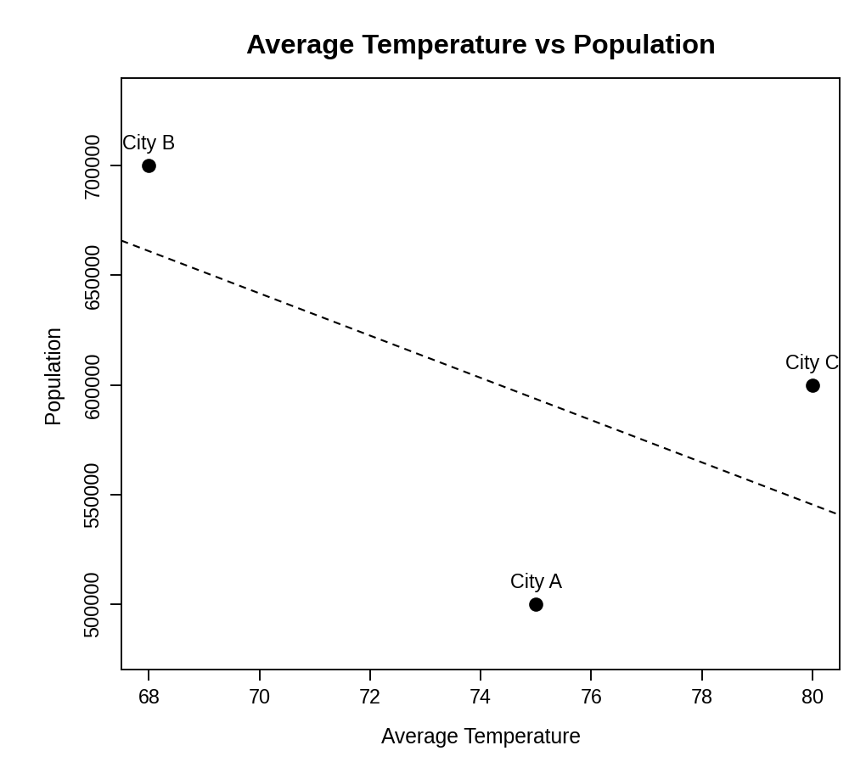
> cor(temperature, population)
[1] -0.5806513

Insight: The trend line slopes downward and the correlation is about -0.58, a moderate negative relationship. City B, the coolest city (68), has the largest population (700,000), while City A (75) has the smallest. The pattern is not perfectly regular, because City C is the hottest (80) yet has more people than City A. With only three cities this is only an indication, not proof.
PROGRAM 3 — Table of Geographic Data
# Dataset
geo_table <- data.frame(
"City" = c("City A", "City B", "City C"),
"Population" = c(500000, 700000, 600000),
"Avg. Temperature" = c(75, 68, 80),
"Elevation" = c(1000, 800, 1200),
check.names = FALSE
)

# Display the table
print(geo_table)

Output: Table showing the geographic data of each city.
> print(geo_table)
City Population Avg. Temperature Elevation
1 City A 500000 75 1000
2 City B 700000 68 800
3 City C 600000 80 1200

Observation: The table lists the population, average temperature and elevation of every city. City C is the hottest and highest (1200), while City B is the coolest and lowest (800).
PROGRAM 4 — Tableau Dashboard for Geographic Data
Dashboard steps:
- Open Tableau and connect to the data (Connect > Text file / Microsoft Excel) containing the three city records (with latitude and longitude columns added).
- Sheet 1: Map: double-click Latitude and Longitude to create the map, drag City to Label and Population to Size, and set the mark type to Circle.
- Sheet 2: Scatter plot: drag Avg. Temperature to Columns and Population to Rows, drag City to Label, and add a Trend Line from the Analytics pane.
- Sheet 3: Table: drag City, Population, Avg. Temperature and Elevation to the Text shelf (Show Me > Text Table).
- Create a new dashboard (Dashboard > New Dashboard) and drag the sheets onto the canvas.
- Add the filters: City (and Elevation as a range filter). For each filter choose Show Filter and set Apply to Worksheets > All Using This Data Source.
- Select each chart and enable Use as Filter, so that clicking a mark updates the other views and the table.

Output: An interactive Tableau dashboard showing the city map, the temperature–population scatter plot and the data table, with a City filter.
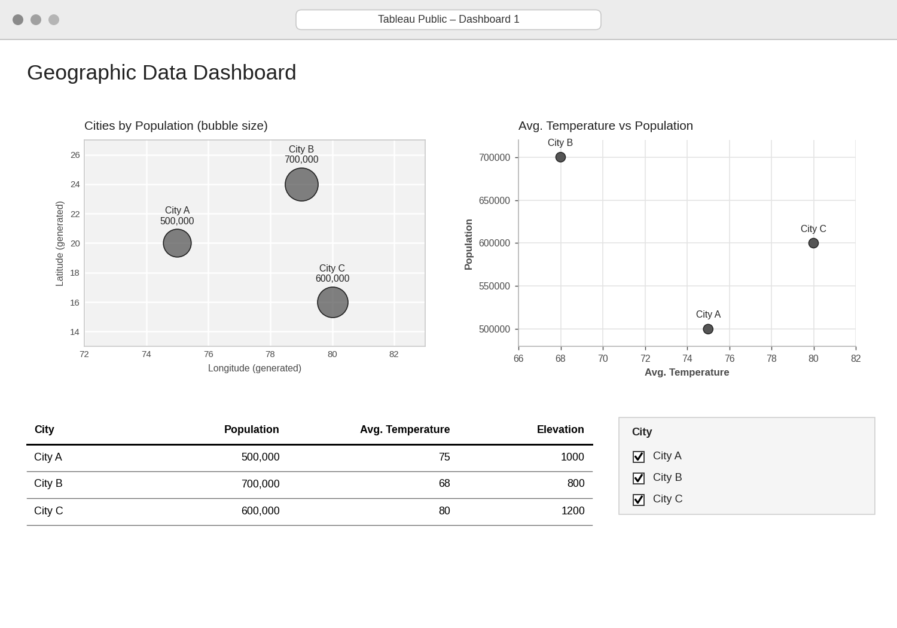
Observation: Selecting a city in the filter (or clicking its bubble on the map) highlights the same city in the scatter plot and the table, so the location, climate, population and elevation can be explored together.
PROCEDURE
- Create the city, population, temperature, elevation and coordinate data in R.
- Draw the map chart with ggplot2 using longitude and latitude, bubble size for population and city labels.
- Use plot() to create the temperature–population scatter plot, add labels and a trend line, and calculate the correlation with cor().
- Create a data.frame() with the geographic data and display it as a table.
- Connect the data in Tableau and build the map, scatter plot and table as three sheets.
- Combine the sheets into a dashboard and add a City filter for interactive exploration.
RESULT
The geographic data was successfully visualized using a map chart, a scatter plot and a data table. A moderate negative relationship (r ≈ -0.58) was found between average temperature and population, and an interactive Tableau dashboard combining all three views was designed.
KEY FUNCTIONS / TOOLS USED
- ggplot() / geom_point() – Draws the map chart (ggplot2 package).
- geom_text() – Labels each city on the map.
- plot() / text() – Create and label the scatter plot.
- abline() / lm() – Add a linear trend line.
- cor() – Calculates the correlation coefficient.
- data.frame() – Creates the data table.
- Tableau Sheets – One worksheet for each chart or table.
- Tableau Dashboard – Combines the sheets with filters for interactive exploration.

