DSA0601 Data Handling and Visualization
Name: Lakshna Sree T S
Regno: 192524059
SET 14 — SURVEY RESULTS
Dataset
Respondent | Question 1 | Question 2 | Question 3
1 | A | B | C
2 | B | A | D
3 | C | A | B

PROGRAM 1 — Stacked Bar Chart for Question 1
# Dataset
q1 <- c("A", "B", "C")
levels <- c("A", "B", "C", "D")
# Count the answers to Question 1
q1_counts <- table(factor(q1, levels = levels))
# Stacked Bar Chart
barplot(as.matrix(q1_counts),
names.arg = "Question 1",
xlab = "Question",
ylab = "Number of Respondents",
main = "Distribution of Answers: Question 1",
col = gray.colors(4),
legend.text = levels,
args.legend = list(title = "Answer"),
xlim = c(0, 2.2),
ylim = c(0, 4))

Output: Stacked bar chart showing how the respondents answered Question 1.
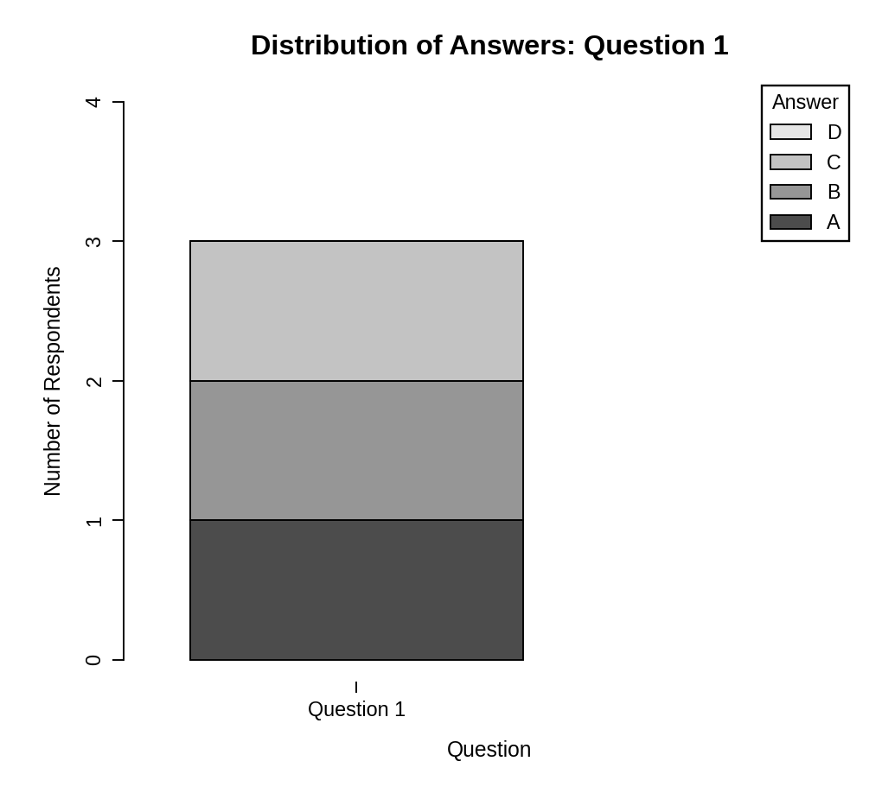
Observation: The bar is split into equal parts for answers A, B and C (one respondent each). Answer D was not chosen, so the three respondents gave three different answers to Question 1.
PROGRAM 2 — Radar Chart of Overall Response Pattern
library(fmsb)

# Dataset
survey <- data.frame(Q1 = c("A", "B", "C"),
Q2 = c("B", "A", "A"),
Q3 = c("C", "D", "B"))
levels <- c("A", "B", "C", "D")

# Count each answer for every question (rows = questions)
counts <- t(sapply(survey, function(x) table(factor(x, levels = levels))))

# radarchart() needs the maximum and minimum rows first
radar_data <- as.data.frame(rbind(rep(2, 4), rep(0, 4), counts))
rownames(radar_data) <- c("max", "min",
"Question 1", "Question 2", "Question 3")

# Radar Chart
radarchart(radar_data, axistype = 1, seg = 4,
caxislabels = c(0, 0.5, 1, 1.5, 2),
plty = 1:3, pcol = "black", plwd = 2,
cglcol = "gray50",
title = "Overall Response Pattern (Radar Chart)")
legend("topleft", legend = rownames(radar_data)[3:5],
lty = 1:3, bty = "n")

Output: Radar chart showing how often each answer (A to D) was chosen in each question.
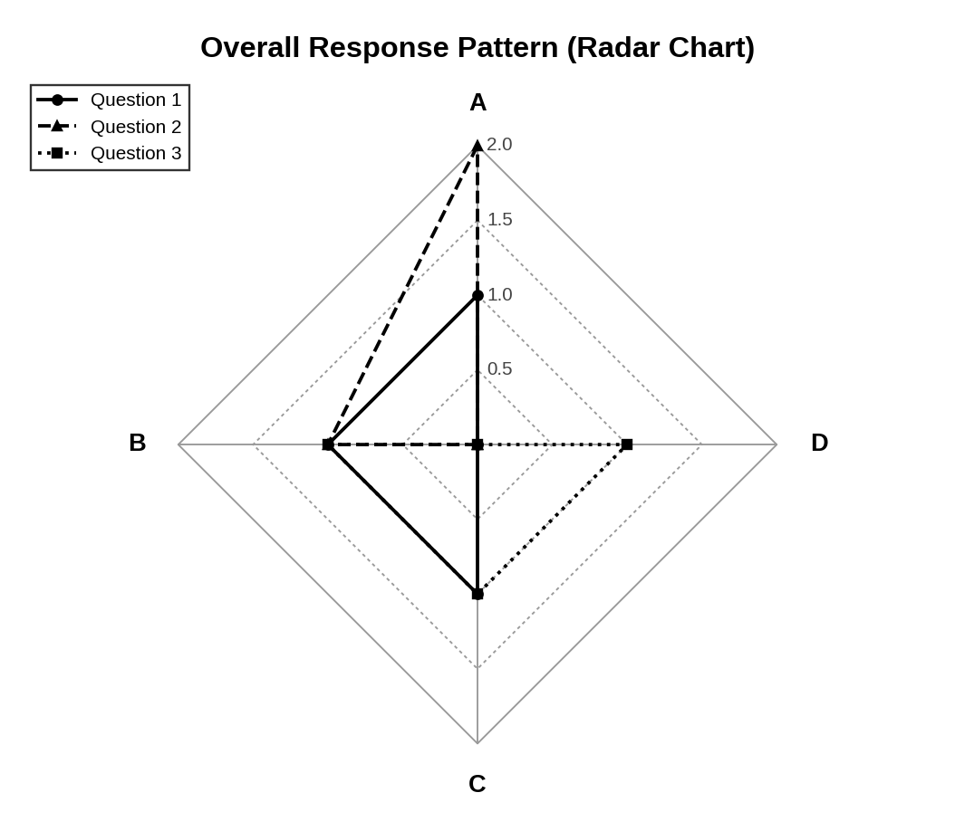
Observation: Question 2 reaches furthest towards A (chosen twice), Question 1 is spread equally over A, B and C, and Question 3 is spread over B, C and D. Only Question 3 uses option D. The different line types separate the three questions.
PROGRAM 3 — Table of Survey Responses
# Dataset
survey_table <- data.frame(
"Respondent" = c(1, 2, 3),
"Question 1" = c("A", "B", "C"),
"Question 2" = c("B", "A", "A"),
"Question 3" = c("C", "D", "B"),
check.names = FALSE
)
# Display the table
print(survey_table)

Output: Table showing the answers given by each respondent.
> print(survey_table)
Respondent Question 1 Question 2 Question 3
1 1 A B C
2 2 B A D
3 3 C A B

Observation: The table shows the answer of every respondent to all three questions. Respondent 2 and Respondent 3 gave the same answer (A) to Question 2.
PROGRAM 4 — Tableau Dashboard for Survey Responses
Dashboard steps:
- Open Tableau and connect to the data (Connect > Text file / Microsoft Excel) containing the survey responses (Respondent, Question 1, Question 2, Question 3).
- Sheet 1: Stacked bar chart: select the Question 1 field, drag it to Color and to Columns (as a Count), and drag Number of Records to Rows to stack the answers.
- Sheet 2: Radar chart: Tableau has no built-in radar chart, so insert the radar chart created in R as an image (Dashboard > Image), or build it with a polar-coordinate path calculation.
- Sheet 3: Table: drag Respondent to Rows and the three question fields to Text (Show Me > Text Table).
- Create a new dashboard (Dashboard > New Dashboard) and drag the sheets onto the canvas.
- Add the filters: Respondent. For each filter choose Show Filter and set Apply to Worksheets > All Using This Data Source.
- Select each chart and enable Use as Filter, so that clicking a mark updates the other views and the table.

Output: An interactive Tableau dashboard combining the stacked bar chart, the radar chart and the response table, with a Respondent filter.
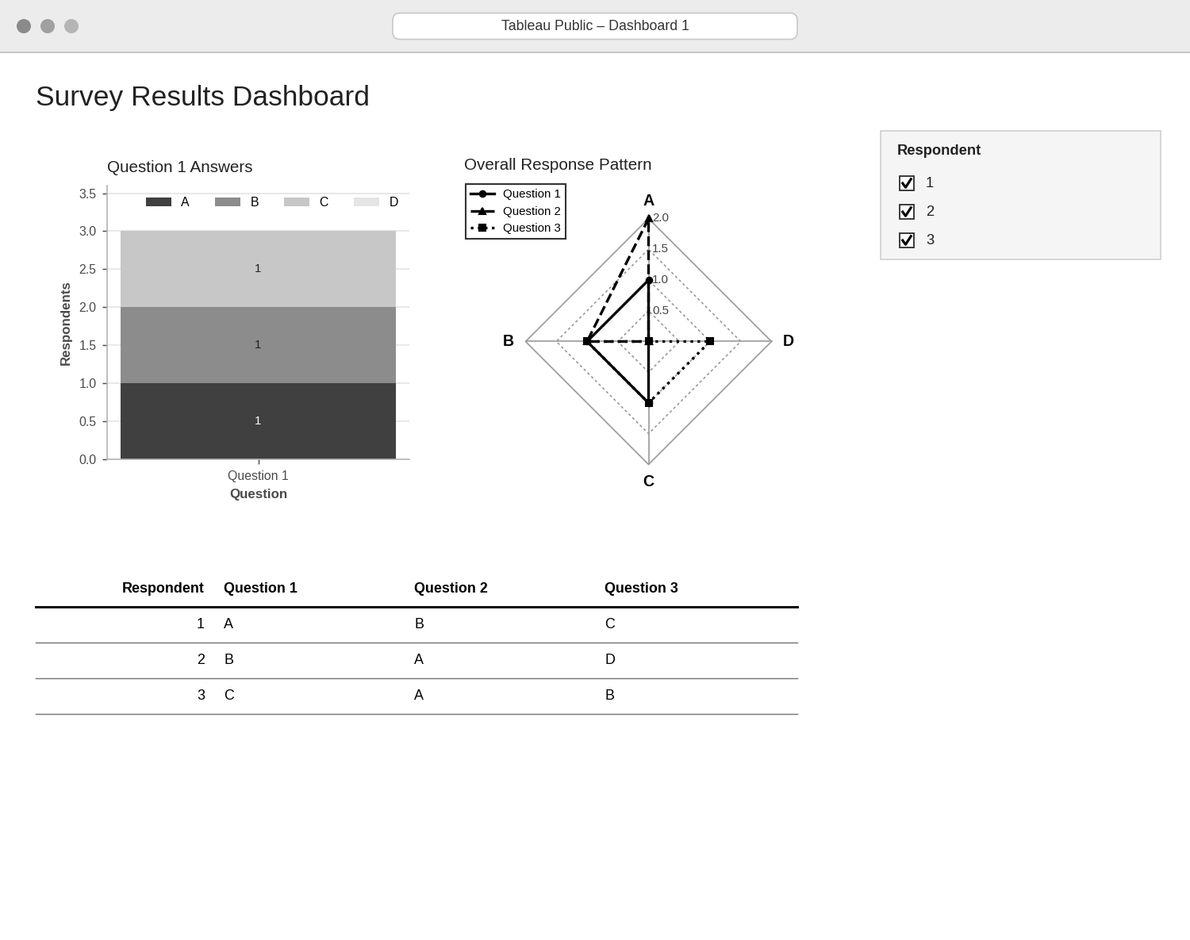
Observation: Filtering by respondent shows only that respondent’s answers in the stacked bar and in the table, so individual response patterns can be compared with the overall pattern.
PROCEDURE
- Create the respondent and Question 1, 2 and 3 answers in R.
- Count the answers to Question 1 with table() and draw the stacked bar chart with barplot().
- Count the answers for every question and draw the radar chart with the fmsb package.
- Create a data.frame() with the survey responses and display it as a table.
- Connect the data in Tableau and build the stacked bar chart, radar image and table as sheets.
- Combine the sheets into a dashboard and add a Respondent filter.
RESULT
The survey results were successfully visualized using a stacked bar chart, a radar chart and a data table. An interactive Tableau dashboard combining all three was designed.
KEY FUNCTIONS / TOOLS USED
- table() / factor() – Count how many times each answer was chosen.
- barplot() – Creates the stacked bar chart.
- radarchart() – Creates the radar chart (fmsb package).
- data.frame() – Creates the response table.
- Tableau Sheets – One worksheet for each chart or table.
- Tableau Dashboard – Combines the sheets with filters for interactive exploration.

