DSA0601 Data Handling and Visualization
Name: Lakshna Sree T S
Regno: 192524059
SET 15 — PRODUCT SALES ANALYSIS
Dataset
Product ID | Product Name | January Sales | February Sales | March Sales
1 | Product A | 2000 | 2200 | 2400
2 | Product B | 1500 | 1800 | 1600
3 | Product C | 1200 | 1400 | 1100

PROGRAM 1 — Grouped Bar Chart of Q1 Sales
# Dataset (rows = months, columns = products)
product <- c("Product A", "Product B", "Product C")
sales <- matrix(c(2000, 1500, 1200, # January
2200, 1800, 1400, # February
2400, 1600, 1100), # March
nrow = 3, byrow = TRUE)
rownames(sales) <- c("January", "February", "March")
# Grouped Bar Chart
barplot(sales,
beside = TRUE,
names.arg = product,
xlab = "Product",
ylab = "Sales ($)",
main = "Q1 Sales by Product",
col = gray.colors(3),
ylim = c(0, 3000),
legend.text = rownames(sales))

Output: Grouped bar chart comparing the Q1 sales of each product.
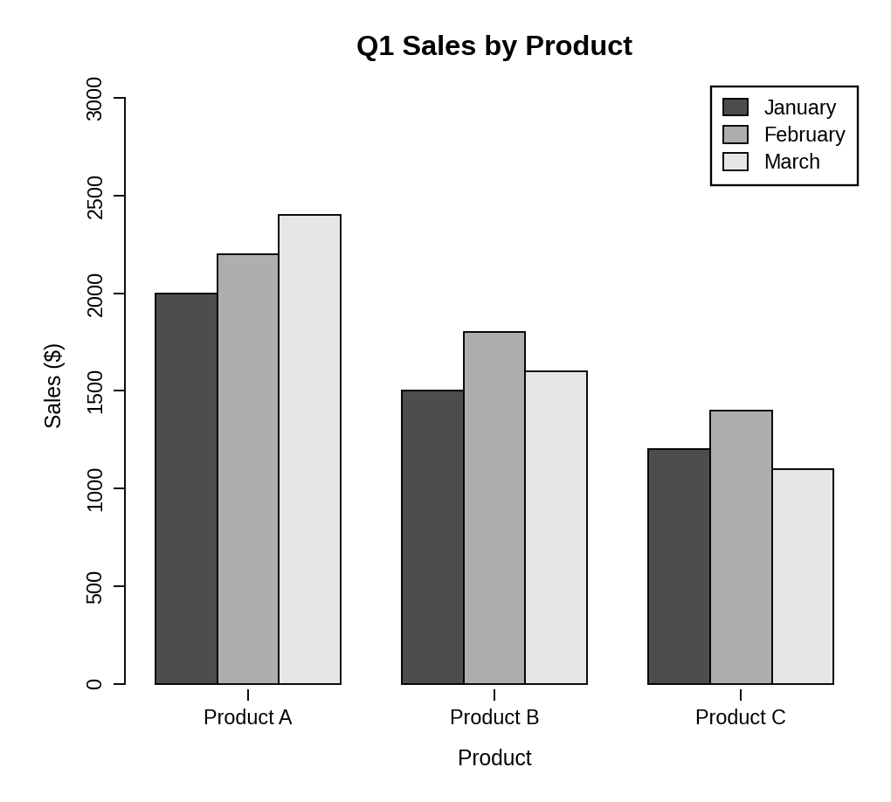
Observation: Product A has the highest sales in every month and grows steadily from 2000 to 2400. Product B and Product C both peak in February and fall in March.
PROGRAM 2 — Stacked Area Chart of Overall Sales Trend
library(ggplot2)

# Dataset
sales_data <- data.frame(
month = factor(rep(c("January", "February", "March"), times = 3),
levels = c("January", "February", "March")),
product = rep(c("Product A", "Product B", "Product C"), each = 3),
sales = c(2000, 2200, 2400, # Product A
1500, 1800, 1600, # Product B
1200, 1400, 1100) # Product C
)

# Stacked Area Chart
ggplot(sales_data, aes(x = month, y = sales, fill = product,
group = product)) +
geom_area() +
scale_fill_grey() +
theme_bw() +
labs(title = "Overall Sales Trend",
x = "Month", y = "Total Sales ($)", fill = "Product")

Output: Stacked area chart representing the overall sales trend of all products.
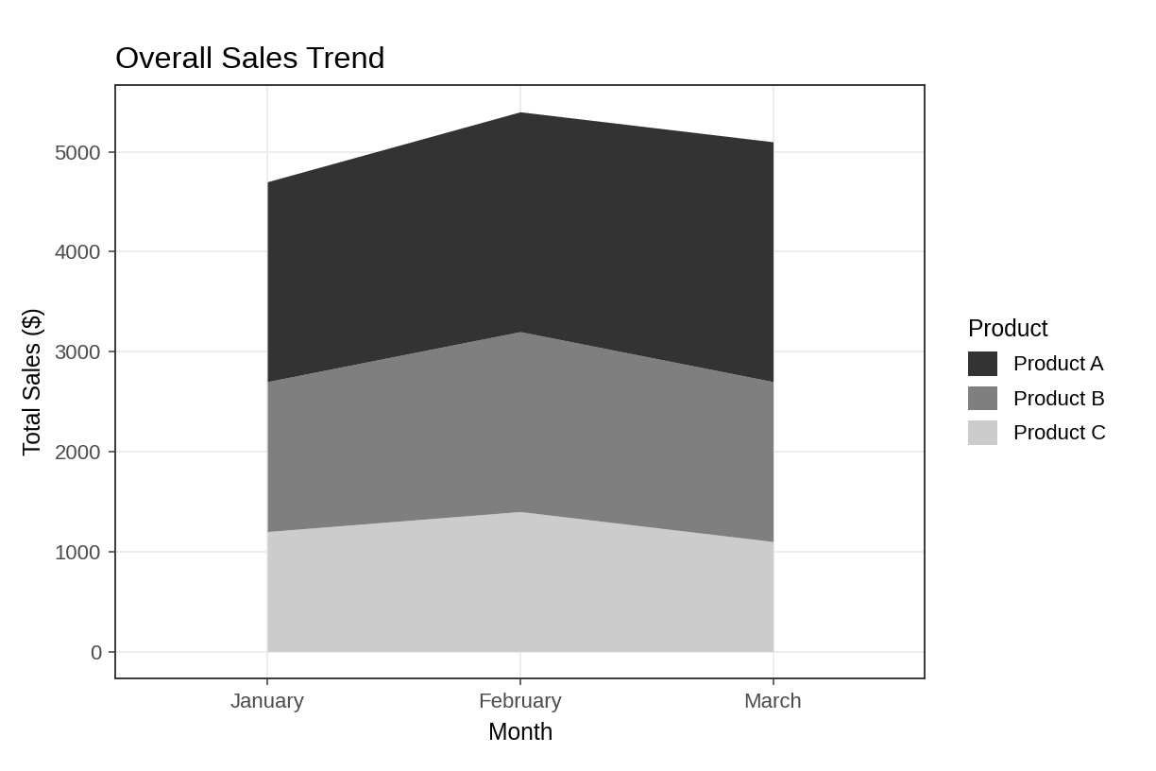
Observation: Total sales rise from 4700 in January to 5400 in February and then fall to 5100 in March. Product A forms the biggest part of the total in every month.
PROGRAM 3 — Table of Monthly Sales Data
# Dataset
sales_table <- data.frame(
"Product ID" = c(1, 2, 3),
"Product Name" = c("Product A", "Product B", "Product C"),
"January Sales" = c(2000, 1500, 1200),
"February Sales" = c(2200, 1800, 1400),
"March Sales" = c(2400, 1600, 1100),
check.names = FALSE
)
# Display the table
print(sales_table)

Output: Table showing the monthly sales of each product.
> print(sales_table)
Product ID Product Name January Sales February Sales March Sales
1 1 Product A 2000 2200 2400
2 2 Product B 1500 1800 1600
3 3 Product C 1200 1400 1100

Observation: The table lists the exact sales of every product for each month. Product A sold 6600 in total, Product B 4900 and Product C 3700 over the quarter.
PROGRAM 4 — Tableau Dashboard for Sales Data
Dashboard steps:
- Open Tableau and connect to the data (Connect > Text file / Microsoft Excel) containing the monthly product sales.
- Sheet 1: Grouped bar chart: use Pivot to turn the three month columns into one Month field, drag Product Name to Columns, Month to Color and Sales to Rows (Show Me > Side-by-side bars).
- Sheet 2: Stacked area chart: drag Month to Columns, Sales to Rows, change the mark type to Area and drag Product Name to Color.
- Sheet 3: Table: drag Product ID, Product Name and the three sales columns to the Text shelf.
- Create a new dashboard (Dashboard > New Dashboard) and drag the sheets onto the canvas.
- Add the filters: Product Name and Month. For each filter choose Show Filter and set Apply to Worksheets > All Using This Data Source.
- Select each chart and enable Use as Filter, so that clicking a mark updates the other views and the table.

Output: An interactive Tableau dashboard combining the grouped bar chart, the stacked area chart and the sales table, with Product and Month filters.
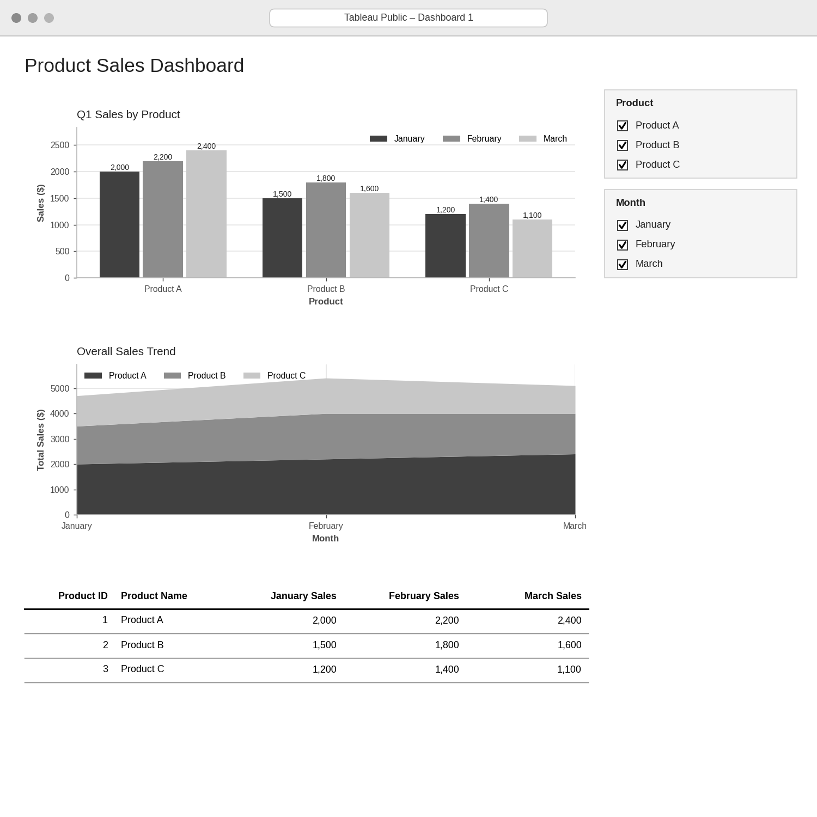
Observation: Selecting or clearing products and months updates the grouped bars, the area chart and the table at the same time, which makes it easy to compare the sales of individual products.
PROCEDURE
- Create the product and monthly sales data in R.
- Build a month-by-product matrix and use barplot() with beside = TRUE for the grouped bar chart.
- Create a long-format data frame and draw the stacked area chart with ggplot2 and geom_area().
- Create a data.frame() with the monthly sales and display it as a table.
- Connect the data in Tableau, pivot the month columns and build the three sheets.
- Combine the sheets into a dashboard and add Product and Month filters.
RESULT
The product sales data was successfully visualized using a grouped bar chart, a stacked area chart and a data table. An interactive Tableau dashboard combining all three views was designed.
KEY FUNCTIONS / TOOLS USED
- matrix() – Builds the month-by-product sales data.
- barplot(beside = TRUE) – Creates the grouped bar chart.
- ggplot() / geom_area() – Creates the stacked area chart (ggplot2 package).
- data.frame() – Creates the sales table.
- Pivot – Reshapes the monthly columns in Tableau.
- Tableau Sheets – One worksheet for each chart or table.
- Tableau Dashboard – Combines the sheets with filters for interactive exploration.

