LAB EXPERIMENT RECORD
Field | Details
Course Code / Course Name | DSA0601 / Data Handling and Visualization
Experiment | Data Visualization using R
Name | Lakshna Sree T S
Register Number | 192524059
Date | 29 September 2026
SET 1: MONTHLY SALES DATA
Aim
To visualize monthly sales data using a line chart, bar chart and scatter plot, and to build an interactive dashboard combining the line and bar charts using R and Shiny.
Dataset: Monthly Sales
Month | Sales ($)
January | 15000
February | 18000
March | 22000
April | 20000
May | 23000
Procedure
1. Create the month and sales vectors containing the monthly sales data.
2. Use plot() with type = "o" and axis() to draw the labelled line chart.
3. Use barplot() with names.arg to compare sales across months.
4. Create an advertising budget vector, draw the scatter plot with plot() and add a regression line using lm() and abline().
5. Load the shiny package and create the UI with fluidPage() and the server function.
6. Run the app with shinyApp() and use the month and colour selectors to explore both charts together.
Key R Functions Used
Function | Purpose
plot() / axis() / grid() | Draw line and scatter plots, add month labels and grid lines.
barplot() | Creates bar charts.
lm() / abline() / cor() | Fit and draw the trend line; measure correlation.
fluidPage() / selectInput() | Build the Shiny layout and selection controls.
reactive() / renderPlot() | Filter data and redraw plots dynamically.
shinyApp() | Runs the Shiny application.
PROGRAM 1: Line Chart of Monthly Sales
Create a line chart to visualize the monthly sales. Label the axes and title the chart appropriately.
# Dataset
month <- c("January", "February", "March", "April", "May")
sales <- c(15000, 18000, 22000, 20000, 23000)
# Line Chart
plot(1:5, sales,
type = "o",
pch = 19,
lwd = 2,
col = "blue",
xaxt = "n",
xlab = "Month",
ylab = "Sales ($)",
main = "Monthly Sales Trend")
axis(1, at = 1:5, labels = month)
grid()
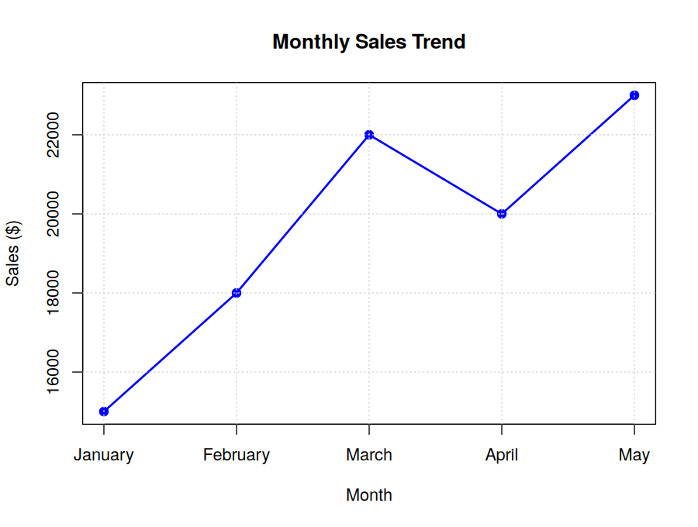
Output 1: Monthly Sales Trend (Line Chart)
Observation: Sales rise from $15,000 in January to $22,000 in March, dip to $20,000 in April, and reach the highest value of $23,000 in May. The overall trend is upward.
PROGRAM 2: Bar Chart of Monthly Sales
Generate a bar chart to display the top-selling months for the year. Label the chart elements.
# Dataset
month <- c("January", "February", "March", "April", "May")
sales <- c(15000, 18000, 22000, 20000, 23000)
# Bar Chart
barplot(sales,
names.arg = month,
col = "skyblue",
ylim = c(0, 25000),
xlab = "Month",
ylab = "Sales ($)",
main = "Monthly Sales")
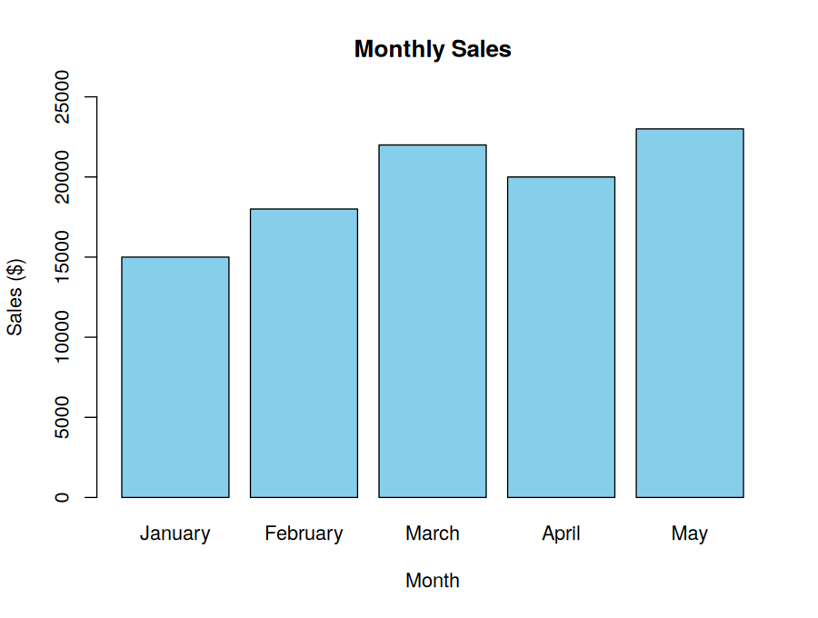
Output 2: Monthly Sales (Bar Chart)
Observation: May is the top-selling month ($23,000), followed by March ($22,000). January has the lowest sales ($15,000). Total sales are $98,000, an average of $19,600 per month.
PROGRAM 3: Scatter Plot of Advertising Budget vs Monthly Sales
Develop a scatter plot to explore the relationship between advertising budget and monthly sales. Explain the insights drawn from the scatter plot.
# Dataset
sales <- c(15000, 18000, 22000, 20000, 23000)
advertising <- c(5000, 6000, 7000, 8000, 9000)
# Scatter Plot
plot(advertising, sales,
pch = 19,
col = "red",
cex = 1.4,
xlab = "Advertising Budget ($)",
ylab = "Monthly Sales ($)",
main = "Advertising Budget vs Monthly Sales")
# Trend line and correlation
model <- lm(sales ~ advertising)
abline(model, col = "blue", lwd = 2)
cor(advertising, sales) # 0.887
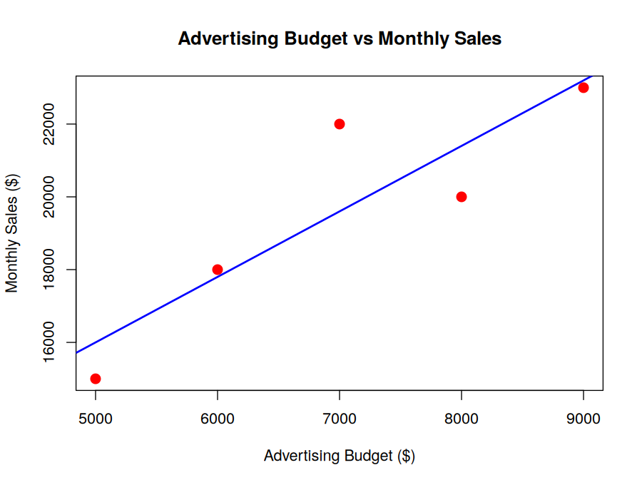
Output 3: Advertising Budget vs Monthly Sales (Scatter Plot)
Insight: There is a strong positive relationship between advertising budget and sales (r = 0.89). The trend line (Sales ≈ 7000 + 1.8 × Budget, R² = 0.79) indicates that every extra $1,000 spent on advertising is associated with about $1,800 more in sales. April ($8,000 budget, $20,000 sales) falls below the line, so the relationship is strong but not perfect.
Note: The given dataset has no advertising values, so the budget values 5000–9000 were assumed. With five points this shows association, not cause and effect.
PROGRAM 4: Interactive Sales Dashboard
Build an interactive dashboard combining the line chart and bar chart to allow users to explore sales data interactively.
library(shiny)
# Dataset
sales_data <- data.frame(
Month = factor(c("January", "February", "March", "April", "May"),
levels = c("January", "February", "March", "April", "May")),
Sales = c(15000, 18000, 22000, 20000, 23000)
)
ui <- fluidPage(
titlePanel("Monthly Sales Dashboard"),
sidebarLayout(
sidebarPanel(width = 3,
selectInput("months", "Select Months:",
choices = levels(sales_data$Month),
selected = levels(sales_data$Month),
multiple = TRUE),
selectInput("color", "Chart Colour:",
choices = c("blue", "darkgreen", "purple", "red")),
hr(),
strong("Summary"),
verbatimTextOutput("summary")
),
mainPanel(width = 9,
fluidRow(
column(6, plotOutput("linePlot", height = "350px")),
column(6, plotOutput("barPlot", height = "350px"))
)
)
)
)
server <- function(input, output) {
filtered <- reactive({
sales_data[sales_data$Month %in% input$months, ]
})
output$linePlot <- renderPlot({
d <- filtered()
req(nrow(d) > 0)
plot(seq_len(nrow(d)), d$Sales, type = "o", pch = 16, lwd = 2,
col = input$color, xaxt = "n",
xlab = "Month", ylab = "Sales ($)", main = "Monthly Sales Trend")
axis(1, at = seq_len(nrow(d)), labels = as.character(d$Month))
grid()
}, width = 420, height = 340)
output$barPlot <- renderPlot({
d <- filtered()
req(nrow(d) > 0)
barplot(d$Sales, names.arg = as.character(d$Month), col = input$color,
xlab = "Month", ylab = "Sales ($)", main = "Monthly Sales")
}, width = 420, height = 340)
output$summary <- renderText({
d <- filtered()
req(nrow(d) > 0)
paste0("Total : $", format(sum(d$Sales), big.mark = ","), "\n",
"Average: $", format(round(mean(d$Sales)), big.mark = ","), "\n",
"Highest: ", d$Month[which.max(d$Sales)])
})
}
shinyApp(ui = ui, server = server)
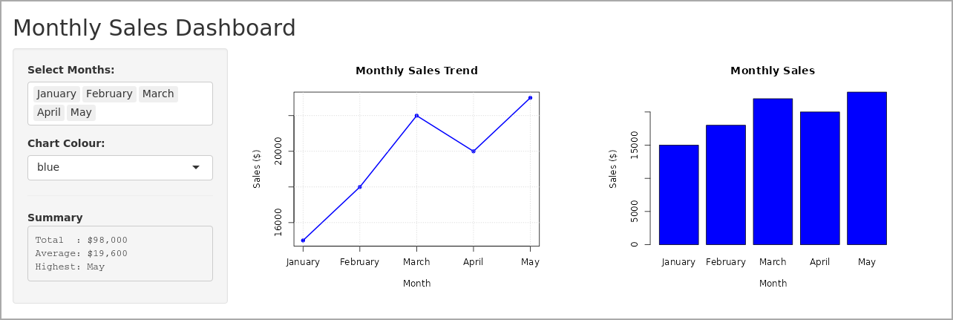
Output 4: Interactive Monthly Sales Dashboard (R Shiny)
Observation: Both charts are shown together. Selecting months updates the line chart, the bar chart and the summary (total, average, highest month) at the same time, and the colour selector restyles both charts. With all months selected, total sales are $98,000 and May is the highest month.
Result
The monthly sales data was successfully visualized using a line chart, bar chart and scatter plot in R, and an interactive Shiny dashboard combining the line and bar charts was created and executed.

