LAB EXPERIMENT RECORD
Field | Details
Course Code / Course Name | DSA0601 / Data Handling and Visualization
Experiment | Data Visualization using R
Name | Lakshna Sree T S
Register Number | 192524059
Date | 29 September 2026
SET 3: EMPLOYEE PERFORMANCE EVALUATION
Aim
To analyse employee performance data using a line chart, bar chart and scatter plot, and to build an interactive dashboard combining the line and bar charts.
Dataset: Employee Performance
Employee ID | Department | Years of Service | Performance Score
1 | Sales | 5 | 85
2 | HR | 3 | 92
3 | Marketing | 7 | 78
4 | Sales | 4 | 90
5 | HR | 2 | 76
Procedure
1. Create vectors for employee ID, department, years of service and performance score.
2. Sort the data by years of service with order() and use plot() and legend() to draw the performance trend line chart.
3. Use table() and barplot() to display employees by department.
4. Use plot() and cor() to analyse years of service versus performance score.
5. Create a Shiny interface with department and minimum-score filters using fluidPage(), selectInput() and numericInput().
6. Use renderPlot() and renderTable() to update the charts, and run the dashboard with shinyApp().
Key R Functions Used
Function | Purpose
plot() / legend() | Creates line and scatter plots with a legend.
order() | Sorts employees by years of service.
table() / barplot() | Counts and plots employees by department.
cor() / lm() | Measures correlation and fits a trend line.
selectInput() / numericInput() | Provide dashboard filters.
renderPlot() / renderTable() | Update charts and table dynamically.
shinyApp() | Runs the Shiny application.
PROGRAM 1: Line Chart of Employee Performance
Create a line chart to visualize the performance trend of employees over time. Include a legend and labels.
# Dataset
employee_id <- c(1, 2, 3, 4, 5)
years <- c(5, 3, 7, 4, 2)
performance <- c(85, 92, 78, 90, 76)
# Sort by years of service so the line follows time order
o <- order(years)
# Line Chart
plot(years[o], performance[o],
type = "o", pch = 19, lwd = 2, col = "blue",
ylim = c(74, 95),
xlab = "Years of Service",
ylab = "Performance Score",
main = "Employee Performance Trend")
text(years[o], performance[o], labels = paste0("E", employee_id[o]),
pos = 3, cex = 0.8)
legend("topright", legend = "Performance Score",
col = "blue", pch = 19, lty = 1, lwd = 2)
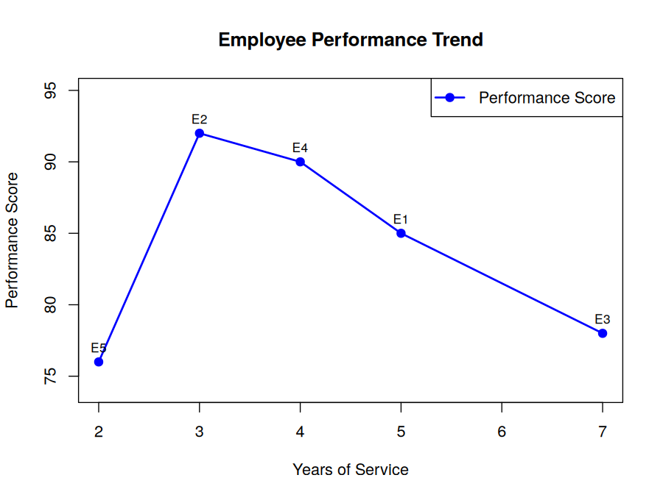
Output 1: Employee Performance Trend (Line Chart)
Observation: Performance rises from 76 (2 years, E5) to a peak of 92 (3 years, E2), then declines steadily to 78 at 7 years (E3). Employees with 3–4 years of service perform best.
PROGRAM 2: Bar Chart of Employees by Department
Generate a bar chart showing the distribution of employees across different departments. Label the chart elements.
# Dataset
department <- c("Sales", "HR", "Marketing", "Sales", "HR")
# Count employees in each department
department_count <- table(department)
# Bar Chart
barplot(department_count,
col = "orange",
ylim = c(0, 2.5),
xlab = "Department",
ylab = "Number of Employees",
main = "Employees by Department")
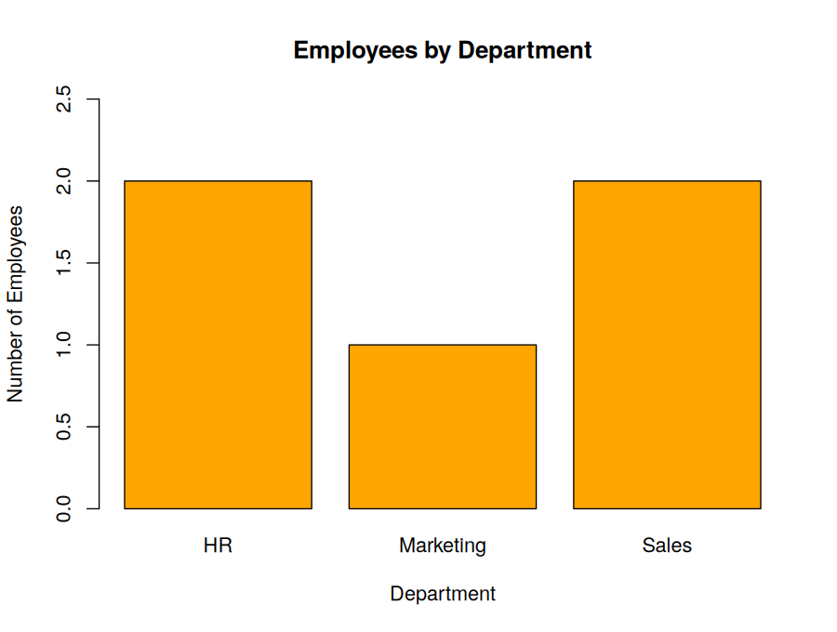
Output 2: Employees by Department (Bar Chart)
Observation: HR and Sales have two employees each, while Marketing has one. Average performance is highest in Sales (87.5), then HR (84) and Marketing (78).
PROGRAM 3: Scatter Plot of Years of Service vs Performance
Build a scatter plot to analyze the correlation between years of service and performance scores. Explain any insights.
# Dataset
years <- c(5, 3, 7, 4, 2)
performance <- c(85, 92, 78, 90, 76)
# Scatter Plot
plot(years, performance,
pch = 19,
col = "red",
cex = 1.4,
xlab = "Years of Service",
ylab = "Performance Score",
main = "Years of Service vs Performance Score")
abline(lm(performance ~ years), col = "gray40", lty = 2)
# Correlation
cor(years, performance) # -0.17
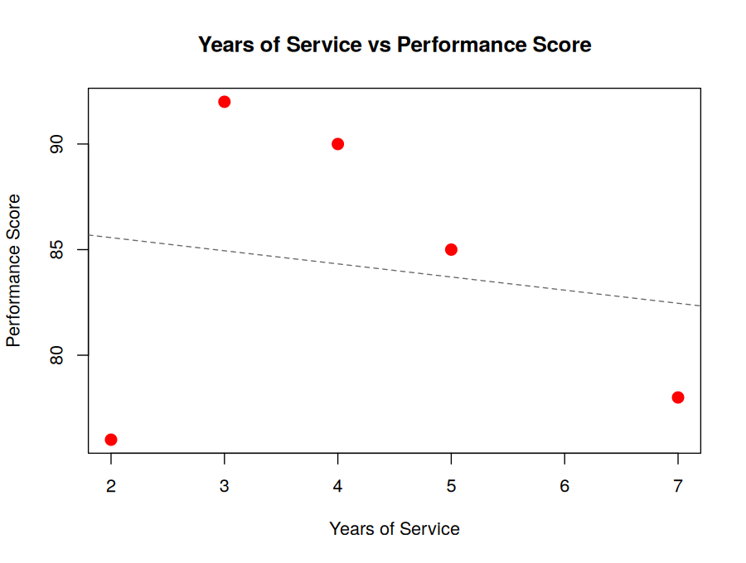
Output 3: Years of Service vs Performance Score (Scatter Plot)
Insight: The correlation is −0.17, so there is no strong linear relationship between years of service and performance. The highest scores (92 and 90) come from employees with 3–4 years, while both the newest (2 years, 76) and the most experienced employee (7 years, 78) score lowest. Experience alone does not predict performance here.
PROGRAM 4: Interactive Employee Performance Dashboard
Develop a Tableau dashboard with the line chart and bar chart for interactive exploration.
library(shiny)
# Dataset
emp <- data.frame(
EmployeeID = 1:5,
Department = c("Sales", "HR", "Marketing", "Sales", "HR"),
Years = c(5, 3, 7, 4, 2),
Performance = c(85, 92, 78, 90, 76)
)
dept_cols <- c(HR = "red", Marketing = "darkgreen", Sales = "blue")
ui <- fluidPage(
titlePanel("Employee Performance Dashboard"),
sidebarLayout(
sidebarPanel(width = 3,
selectInput("dept", "Filter by Department:",
choices = names(dept_cols),
selected = names(dept_cols),
multiple = TRUE),
numericInput("score", "Minimum Performance Score:",
value = 70, min = 70, max = 95, step = 1)
),
mainPanel(width = 9,
fluidRow(
column(6, plotOutput("linePlot", height = "350px")),
column(6, plotOutput("barPlot", height = "350px"))
),
h4("Filtered Employee Records"),
tableOutput("table")
)
)
)
server <- function(input, output) {
filtered <- reactive({
emp[emp$Department %in% input$dept & emp$Performance >= input$score, ]
})
output$linePlot <- renderPlot({
d <- filtered()
req(nrow(d) > 0)
plot(d$EmployeeID, d$Performance, type = "o", pch = 19, col = "gray40",
xlim = c(1, 5), ylim = c(70, 95), xaxt = "n",
xlab = "Employee ID", ylab = "Performance Score",
main = "Employee Performance Trend")
points(d$EmployeeID, d$Performance, pch = 19, cex = 1.6,
col = dept_cols[d$Department])
axis(1, at = 1:5)
legend("topright", legend = names(dept_cols), col = dept_cols,
pch = 19, title = "Department", cex = 0.85)
}, width = 420, height = 340)
output$barPlot <- renderPlot({
d <- filtered()
req(nrow(d) > 0)
counts <- table(factor(d$Department, levels = names(dept_cols)))
barplot(counts, col = dept_cols, ylim = c(0, 3),
xlab = "Department", ylab = "Number of Employees",
main = "Employees by Department")
}, width = 420, height = 340)
output$table <- renderTable(filtered(), digits = 0)
}
shinyApp(ui = ui, server = server)
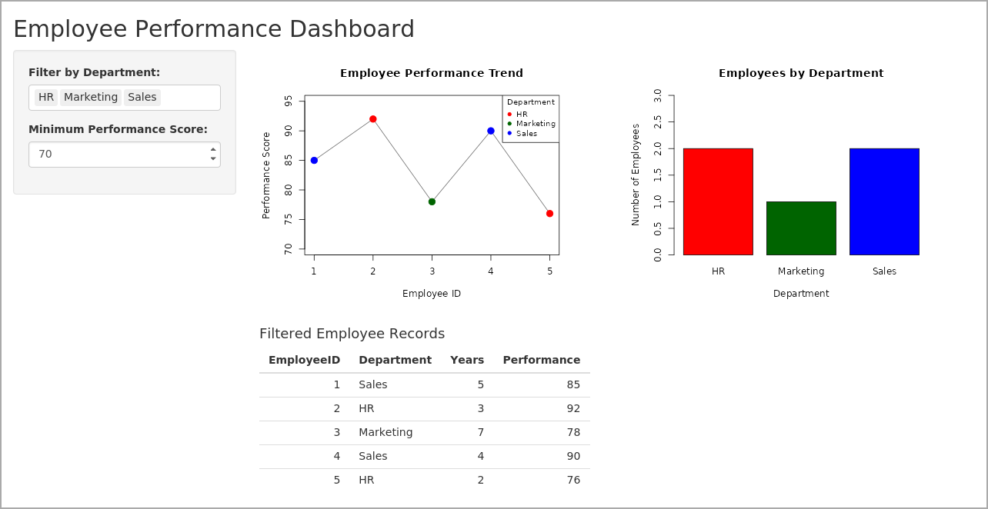
Output 4: Interactive Employee Performance Dashboard (R Shiny)
Observation: The dashboard shows the performance line chart (points coloured by department, with a legend) and the department bar chart together with a table of records. Choosing departments or raising the minimum score updates all views — for example, a minimum score of 85 leaves only Employees 1, 2 and 4.
Note: The question specifies Tableau; since this record uses R, the equivalent dashboard was built with Shiny. In Tableau: import the dataset, create a line chart sheet (Employee ID vs Performance Score) and a bar chart sheet (Department vs COUNT of Employee ID), place both on a dashboard, and add a Department filter applied to both sheets.
Result
The employee performance data was successfully visualized using a line chart, bar chart and scatter plot, and an interactive dashboard combining the line and bar charts was created.

