DSA0601 Data Handling and Visualization
Name: Lakshna Sree T S
Regno: 192524059
SET 16 — CUSTOMER DEMOGRAPHICS ANALYSIS
Dataset
Customer ID | Age | Gender | Income (in $)
1 | 28 | Female | 50000
2 | 35 | Male | 60000
3 | 42 | Female | 75000

PROGRAM 1 — Bar Chart of Customer Ages
# Dataset
customer <- c("Customer 1", "Customer 2", "Customer 3")
age <- c(28, 35, 42)
# Bar Chart
barplot(age,
names.arg = customer,
xlab = "Customer",
ylab = "Age (years)",
main = "Distribution of Customer Ages",
ylim = c(0, 50))

Output: Bar chart showing the age of each customer.
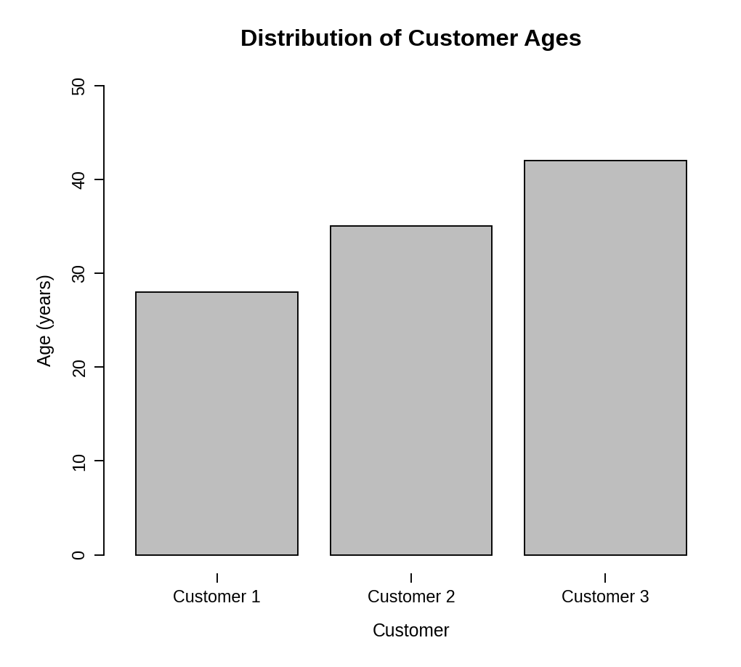
Observation: The customers are aged 28, 35 and 42. Customer 3 is the oldest and Customer 1 the youngest, with the ages about 7 years apart.
PROGRAM 2 — Pie Chart of Customers by Gender
# Dataset
gender <- c("Female", "Male", "Female")
gender_count <- table(gender)
percent <- round(100 * gender_count / sum(gender_count), 1)
# Pie Chart
pie(gender_count,
labels = paste0(names(gender_count), " (", percent, "%)"),
main = "Customers by Gender",
col = c("gray85", "gray45"))

Output: Pie chart showing the distribution of customers by gender.
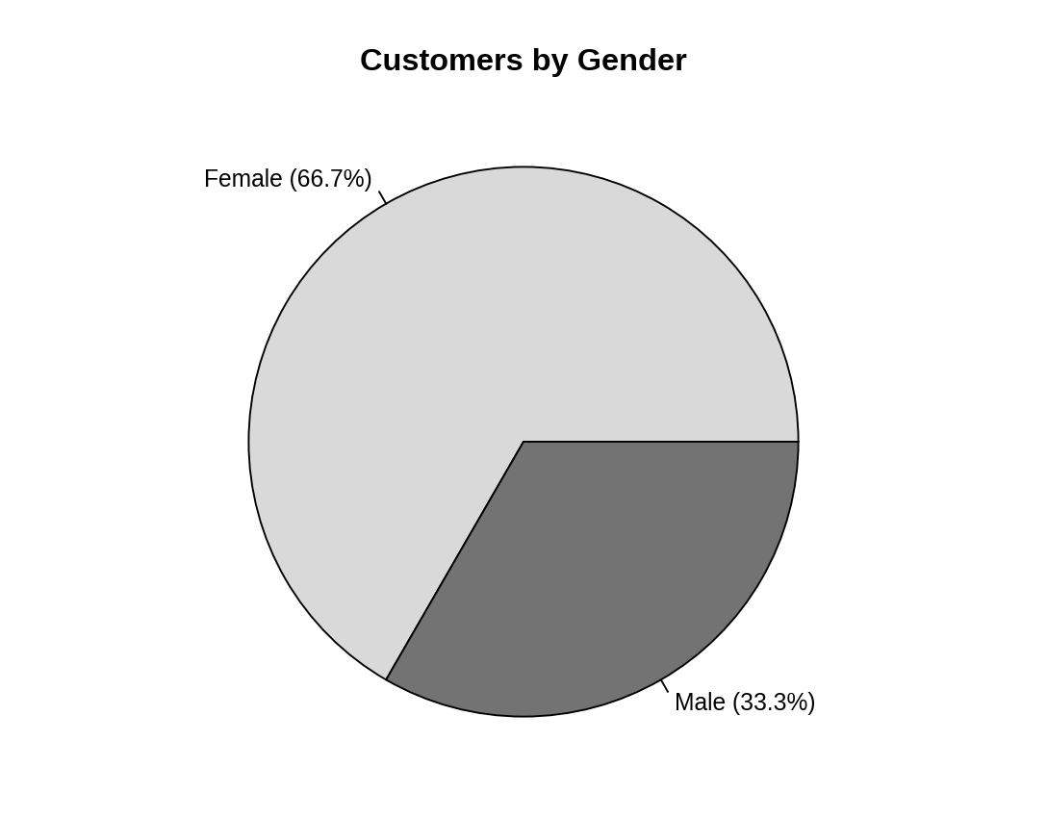
Observation: Two of the three customers (66.7%) are female and one (33.3%) is male, so female customers form the majority.
PROGRAM 3 — Table of Customer Demographics
# Dataset
customers <- data.frame(
"Customer ID" = c(1, 2, 3),
"Age" = c(28, 35, 42),
"Gender" = c("Female", "Male", "Female"),
"Income (in $)" = c(50000, 60000, 75000),
check.names = FALSE
)
# Display the table
print(customers)

Output: Table showing the demographic information of each customer.
> print(customers)
Customer ID Age Gender Income (in $)
1 1 28 Female 50000
2 2 35 Male 60000
3 3 42 Female 75000

Observation: The table gives the age, gender and income of every customer. Income increases with age: $50,000 at 28, $60,000 at 35 and $75,000 at 42.
PROGRAM 4 — Tableau Dashboard for Customer Demographics
Dashboard steps:
- Open Tableau and connect to the data (Connect > Text file / Microsoft Excel) containing the customer demographics.
- Sheet 1: Bar chart: drag Customer ID to Columns and Age to Rows (Show Me > Bar chart) and show the Age values as labels.
- Sheet 2: Pie chart: drag Gender to Color, Number of Records to Angle, and set the mark type to Pie; show the percentage of total as the label.
- Sheet 3: Table: drag Customer ID, Age, Gender and Income to the Text shelf.
- Create a new dashboard (Dashboard > New Dashboard) and drag the sheets onto the canvas.
- Add the filters: Gender (single value list) and Age (range slider). For each filter choose Show Filter and set Apply to Worksheets > All Using This Data Source.
- Select each chart and enable Use as Filter, so that clicking a mark updates the other views and the table.

Output: An interactive Tableau dashboard combining the age bar chart, the gender pie chart and the demographics table, with Gender and Age filters.
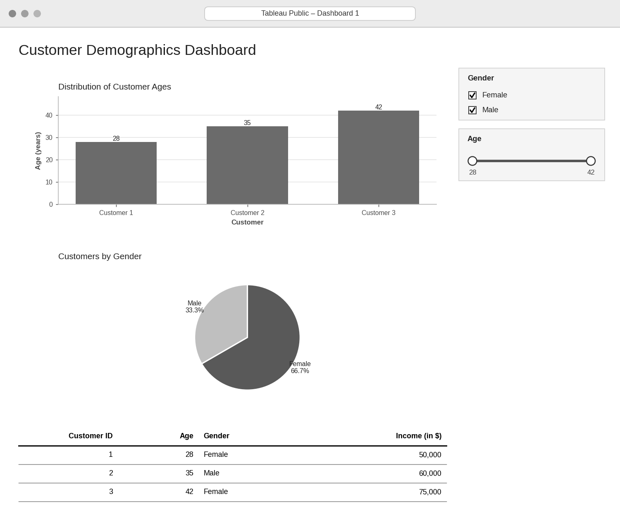
Observation: Choosing a gender or an age range updates the bar chart, the pie chart and the table together, so the demographic groups can be explored interactively.
PROCEDURE
- Create the customer ID, age, gender and income data in R.
- Use barplot() to draw the bar chart of customer ages with labelled axes and a title.
- Count the genders with table() and draw the pie chart with pie().
- Create a data.frame() with the demographic information and display it as a table.
- Connect the data in Tableau and build the bar chart, pie chart and table as three sheets.
- Combine the sheets into a dashboard and add Gender and Age filters.
RESULT
The customer demographic data was successfully visualized using a bar chart, a pie chart and a data table. An interactive Tableau dashboard combining all three was designed.
KEY FUNCTIONS / TOOLS USED
- barplot() – Creates the bar chart.
- table() – Counts customers in each gender group.
- pie() – Creates the pie chart.
- data.frame() – Creates the demographic table.
- Tableau Sheets – One worksheet for each chart or table.
- Tableau Dashboard – Combines the sheets with filters for interactive exploration.

