DSA0601 Data Handling and Visualization
Name: Lakshna Sree T S
Regno: 192524059
SET 17 — EMPLOYEE PERFORMANCE ANALYSIS
Dataset
Employee ID | Department | Years of Service | Performance Score
1 | Sales | 5 | 85
2 | HR | 3 | 92
3 | Marketing | 7 | 78

Note: The dataset has no date column, so the performance trend is shown against Years of Service, with the employees arranged from the shortest to the longest service.
PROGRAM 1 — Line Chart of Performance Trend
# Dataset
years <- c(5, 3, 7)
score <- c(85, 92, 78)
# Arrange by years of service
ord <- order(years)
# Line Chart
plot(years[ord], score[ord],
type = "o",
xaxt = "n",
xlab = "Years of Service",
ylab = "Performance Score",
main = "Employee Performance Trend",
ylim = c(70, 100))
axis(1, at = years[ord])

Output: Line chart showing performance score against years of service.
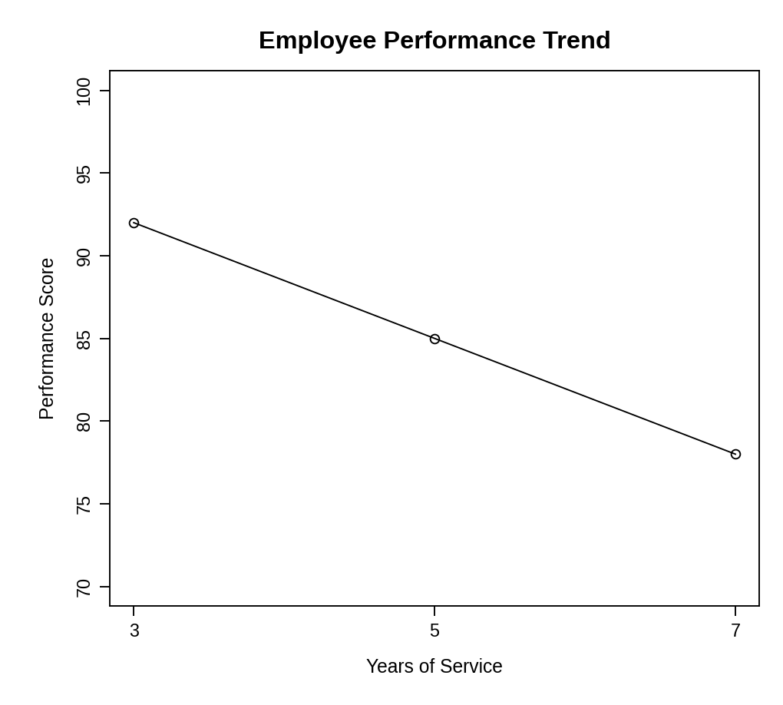
Observation: The performance score falls as years of service increase: 92 at 3 years, 85 at 5 years and 78 at 7 years. With only three employees this is a pattern in the sample, not a general rule.
PROGRAM 2 — Bar Chart of Employees by Department
# Dataset
department <- c("Sales", "HR", "Marketing")
# Count employees in each department
dept_count <- table(department)
# Bar Chart
barplot(dept_count,
xlab = "Department",
ylab = "Number of Employees",
main = "Employees by Department",
ylim = c(0, 2))

Output: Bar chart displaying the number of employees in each department.
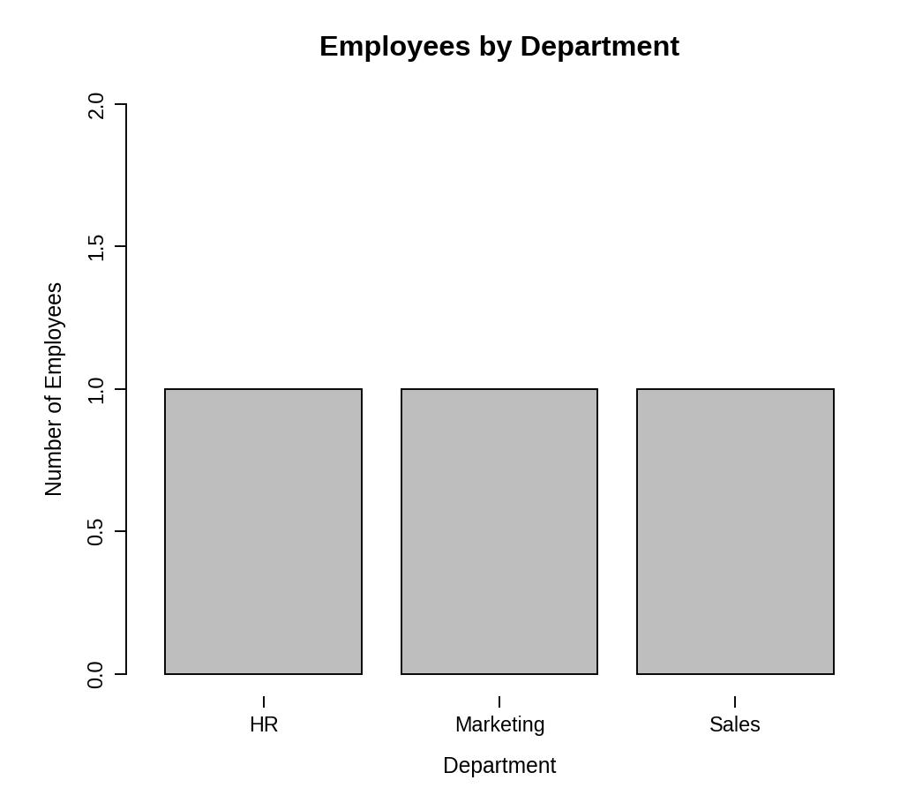
Observation: HR, Marketing and Sales have exactly one employee each, so the employees are evenly distributed across the departments.
PROGRAM 3 — Table of Employee Performance Data
# Dataset
employees <- data.frame(
"Employee ID" = c(1, 2, 3),
"Department" = c("Sales", "HR", "Marketing"),
"Years of Service" = c(5, 3, 7),
"Performance Score" = c(85, 92, 78),
check.names = FALSE
)
# Display the table
print(employees)

Output: Table showing the performance data of each employee.
> print(employees)
Employee ID Department Years of Service Performance Score
1 1 Sales 5 85
2 2 HR 3 92
3 3 Marketing 7 78

Observation: The HR employee has the highest performance score (92) and the Marketing employee the lowest (78).
PROGRAM 4 — Tableau Dashboard for Employee Performance
Dashboard steps:
- Open Tableau and connect to the data (Connect > Text file / Microsoft Excel) containing the employee performance data.
- Sheet 1: Line chart: drag Years of Service to Columns (as a continuous dimension) and Performance Score to Rows, and set the mark type to Line.
- Sheet 2: Bar chart: drag Department to Columns and Number of Records to Rows (Show Me > Bar chart).
- Sheet 3: Table: drag Employee ID, Department, Years of Service and Performance Score to the Text shelf.
- Create a new dashboard (Dashboard > New Dashboard) and drag the sheets onto the canvas.
- Add the filters: Department and Years of Service. For each filter choose Show Filter and set Apply to Worksheets > All Using This Data Source.
- Select each chart and enable Use as Filter, so that clicking a mark updates the other views and the table.

Output: An interactive Tableau dashboard combining the line chart, the bar chart and the performance table, with a Department filter.
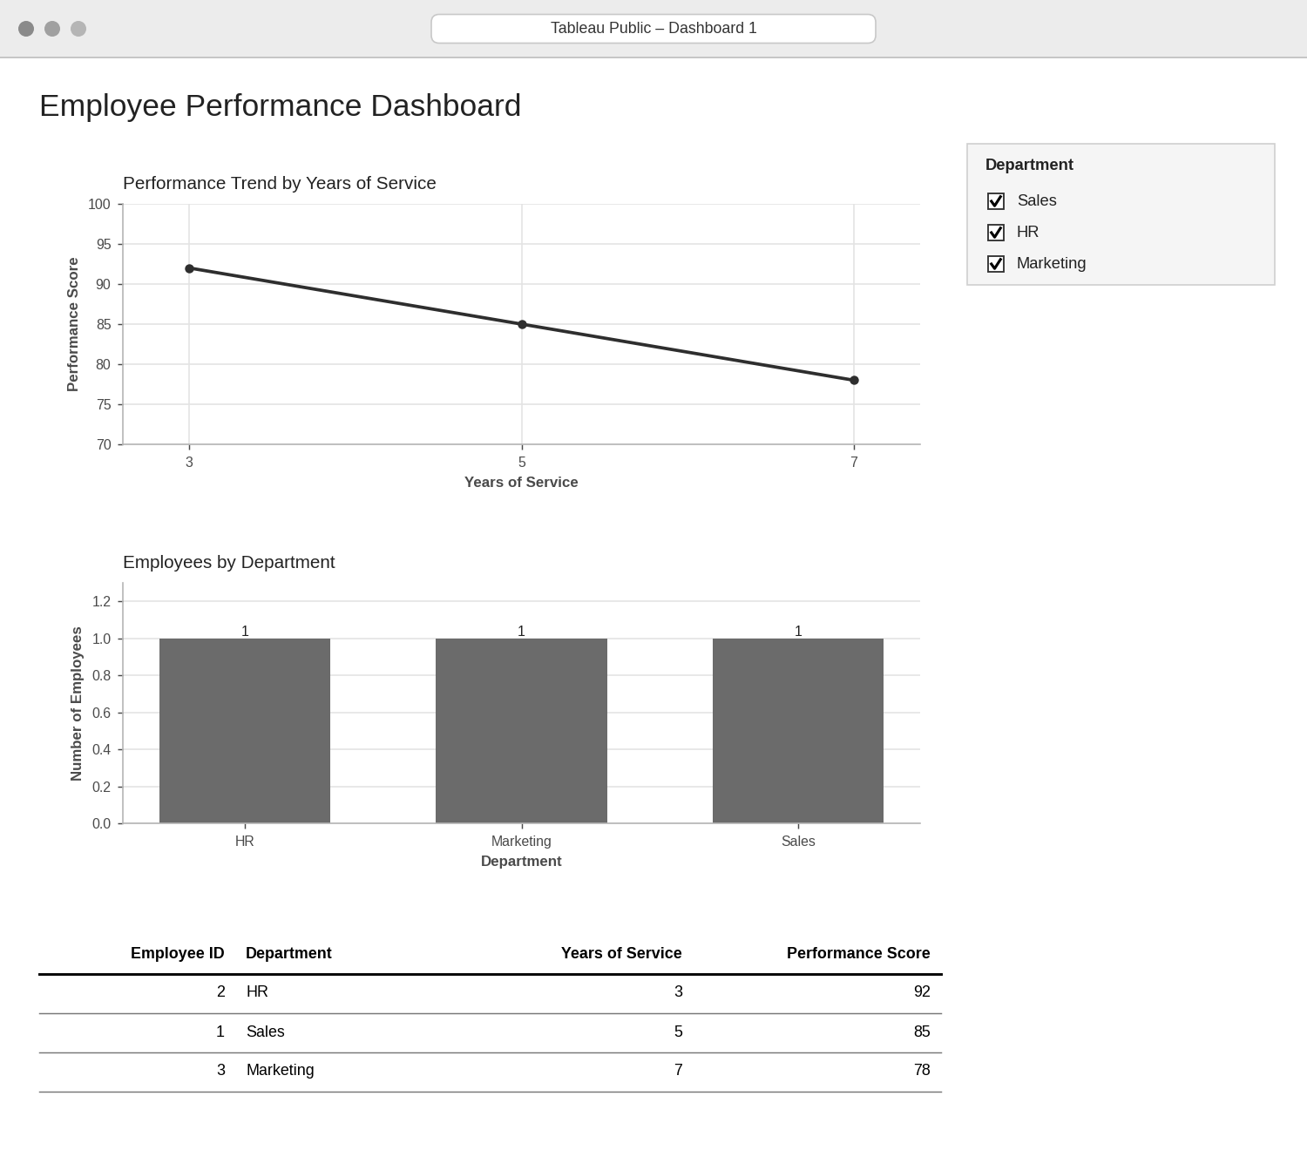
Observation: Selecting a department filters the line chart, the bar chart and the table together, so the performance of each department can be explored interactively.
PROCEDURE
- Create the employee ID, department, years of service and performance score data in R.
- Sort the employees by years of service with order() and draw the line chart with plot().
- Count employees per department with table() and draw the bar chart with barplot().
- Create a data.frame() with the performance data and display it as a table.
- Connect the data in Tableau and build the line chart, bar chart and table as three sheets.
- Combine the sheets into a dashboard and add a Department filter.
RESULT
The employee performance data was successfully visualized using a line chart, a bar chart and a data table. An interactive Tableau dashboard combining all three was designed.
KEY FUNCTIONS / TOOLS USED
- order() – Arranges employees by years of service.
- plot() – Creates the line chart.
- table() – Counts employees per department.
- barplot() – Creates the bar chart.
- data.frame() – Creates the performance table.
- Tableau Sheets – One worksheet for each chart or table.
- Tableau Dashboard – Combines the sheets with filters for interactive exploration.

