DSA0601 Data Handling and Visualization
Name: Lakshna Sree T S
Regno: 192524059
SET 18 — PRODUCT INVENTORY MANAGEMENT
Dataset
Product ID | Product Name | Quantity Available | Price (in $)
1 | Product A | 250 | 20
2 | Product B | 175 | 15
3 | Product C | 300 | 18

Note: The dataset has no product categories, so sample values were assumed for Program 2 (Electronics / Home / Office): Product A 120/80/50, Product B 70/60/45 and Product C 150/90/60. Each product’s categories add up to its available quantity.
PROGRAM 1 — Bar Chart of Product Quantity
# Dataset
product <- c("Product A", "Product B", "Product C")
quantity <- c(250, 175, 300)
# Bar Chart
barplot(quantity,
names.arg = product,
xlab = "Product Name",
ylab = "Quantity Available",
main = "Product Inventory")

Output: Bar chart displaying the quantity available for each product.
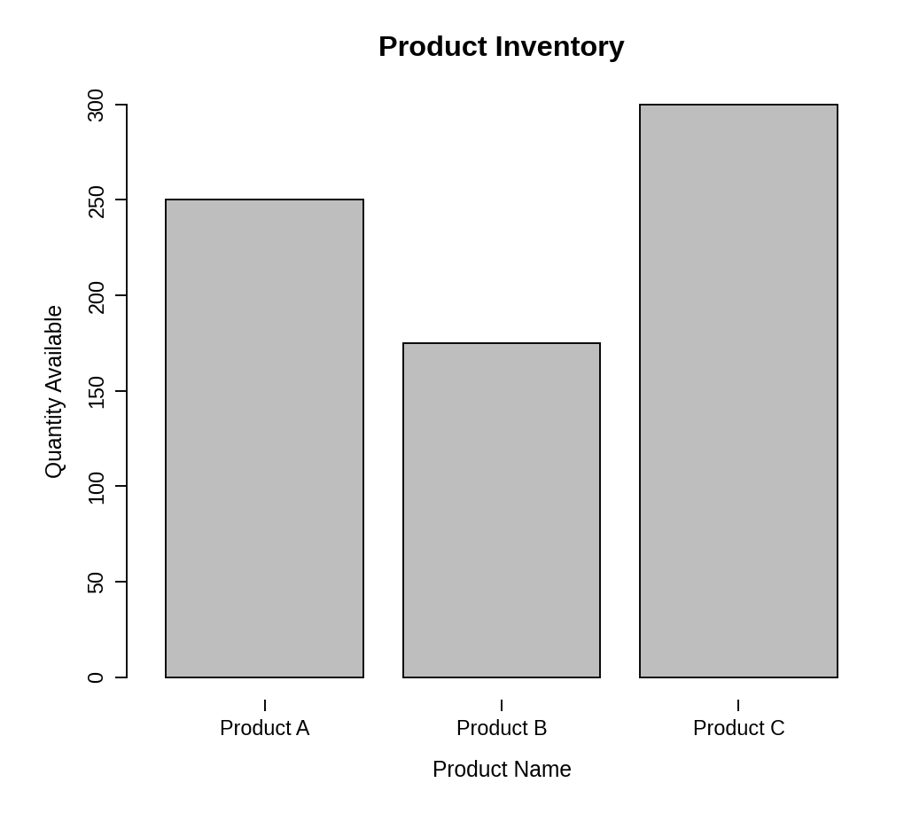
Observation: Product C has the highest stock (300 units) and Product B the lowest (175 units), so Product B is the one most likely to need restocking.
PROGRAM 2 — Stacked Bar Chart by Product Category
# Dataset (rows = categories, columns = products)
product <- c("Product A", "Product B", "Product C")
qty <- matrix(c(120, 70, 150, # Electronics
80, 60, 90, # Home
50, 45, 60), # Office
nrow = 3, byrow = TRUE)
rownames(qty) <- c("Electronics", "Home", "Office")
# Stacked Bar Chart
barplot(qty,
names.arg = product,
xlab = "Product Name",
ylab = "Quantity Available",
main = "Inventory by Product Category",
col = gray.colors(3),
ylim = c(0, 350),
legend.text = rownames(qty))

Output: Stacked bar chart showing the quantity of each product within the categories.
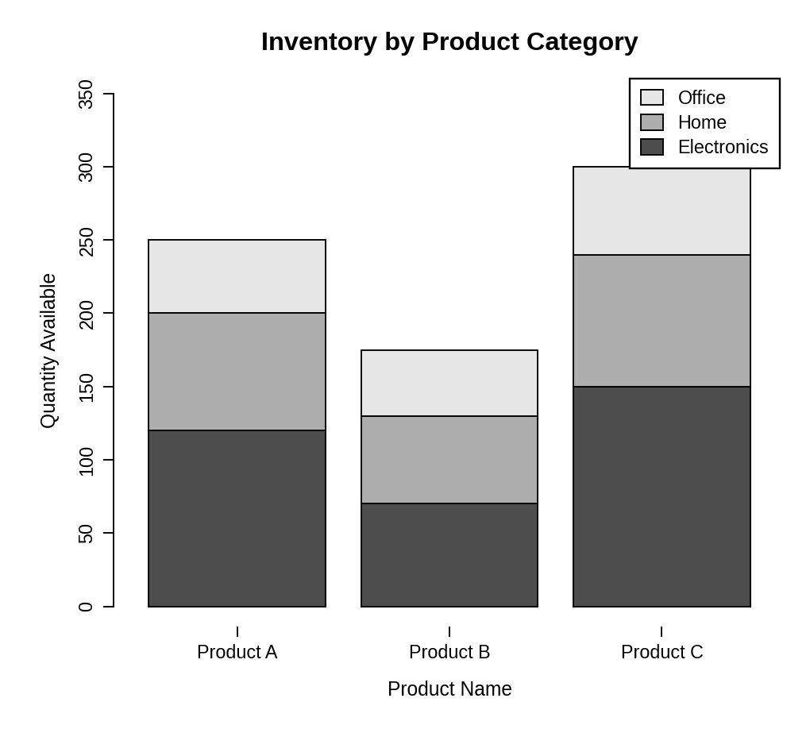
Observation: Each bar is split into Electronics, Home and Office stock and its total height matches the quantity in Program 1. Electronics contributes the largest share for all three products.
PROGRAM 3 — Table of Inventory Data
# Dataset
inventory <- data.frame(
"Product ID" = c(1, 2, 3),
"Product Name" = c("Product A", "Product B", "Product C"),
"Quantity Available" = c(250, 175, 300),
"Price (in $)" = c(20, 15, 18),
check.names = FALSE
)
# Display the table
print(inventory)

Output: Table showing the inventory data of each product.
> print(inventory)
Product ID Product Name Quantity Available Price (in $)
1 1 Product A 250 20
2 2 Product B 175 15
3 3 Product C 300 18

Observation: The table lists the stock and price of every product. Product A has the highest price ($20) and Product B the lowest ($15). The total stock is 725 units.
PROGRAM 4 — Tableau Dashboard for Inventory Data
Dashboard steps:
- Open Tableau and connect to the data (Connect > Text file / Microsoft Excel) containing the inventory data (with a Product Category column added).
- Sheet 1: Bar chart: drag Product Name to Columns and Quantity Available to Rows, and show the values as labels.
- Sheet 2: Stacked bar chart: drag Product Name to Columns, Quantity to Rows and Product Category to Color.
- Sheet 3: Table: drag Product ID, Product Name, Quantity Available and Price to the Text shelf.
- Create a new dashboard (Dashboard > New Dashboard) and drag the sheets onto the canvas.
- Add the filters: Product Category and Product Name. For each filter choose Show Filter and set Apply to Worksheets > All Using This Data Source.
- Select each chart and enable Use as Filter, so that clicking a mark updates the other views and the table.

Output: An interactive Tableau dashboard combining the bar chart, the stacked bar chart and the inventory table, with Category and Product filters.
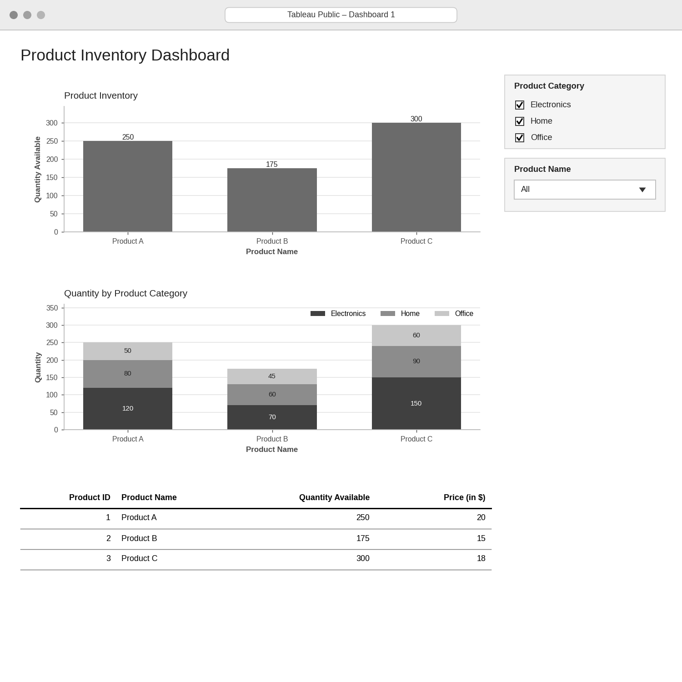
Observation: Choosing a category or a product updates the bar chart, the stacked bar chart and the table together, which helps to compare the stock levels interactively.
PROCEDURE
- Create the product, quantity, price and category data in R.
- Use barplot() to draw the bar chart of quantity for each product.
- Create a category-by-product matrix and use barplot() to draw the stacked bar chart with a legend.
- Create a data.frame() with the inventory data and display it as a table.
- Connect the data in Tableau and build the bar chart, stacked bar chart and table as three sheets.
- Combine the sheets into a dashboard and add Category and Product filters.
RESULT
The inventory data was successfully visualized using a bar chart, a stacked bar chart and a data table. An interactive Tableau dashboard combining all three was designed.
KEY FUNCTIONS / TOOLS USED
- barplot() – Creates bar charts and stacked bar charts.
- matrix() – Builds the category-by-product data.
- gray.colors() – Provides the black-and-white shades for the stacked segments.
- data.frame() – Creates the inventory table.
- Tableau Sheets – One worksheet for each chart or table.
- Tableau Dashboard – Combines the sheets with filters for interactive exploration.

