SET 10 — SURVEY RESPONSES ANALYSIS
Dataset
Survey ID | Question 1 | Question 2 | Question 3
1 | A | B | C
2 | B | A | D
3 | C | A | B
PROGRAM 1 — Grouped Bar Chart for Question 1
# Dataset
q1 <- c("A", "B", "C")
options <- c("A", "B", "C", "D")
# Rows = surveys, columns = answer options (1 if chosen)
q1_matrix <- sapply(options, function(o) as.numeric(q1 == o))
rownames(q1_matrix) <- c("Survey 1", "Survey 2", "Survey 3")
# Grouped Bar Chart
barplot(q1_matrix,
beside = TRUE,
xlab = "Answer Option (Question 1)",
ylab = "Number of Responses",
main = "Distribution of Answers: Question 1",
col = gray.colors(3),
legend.text = rownames(q1_matrix),
ylim = c(0, 1.5))

Output: Grouped bar chart showing which answer each survey chose for Question 1.
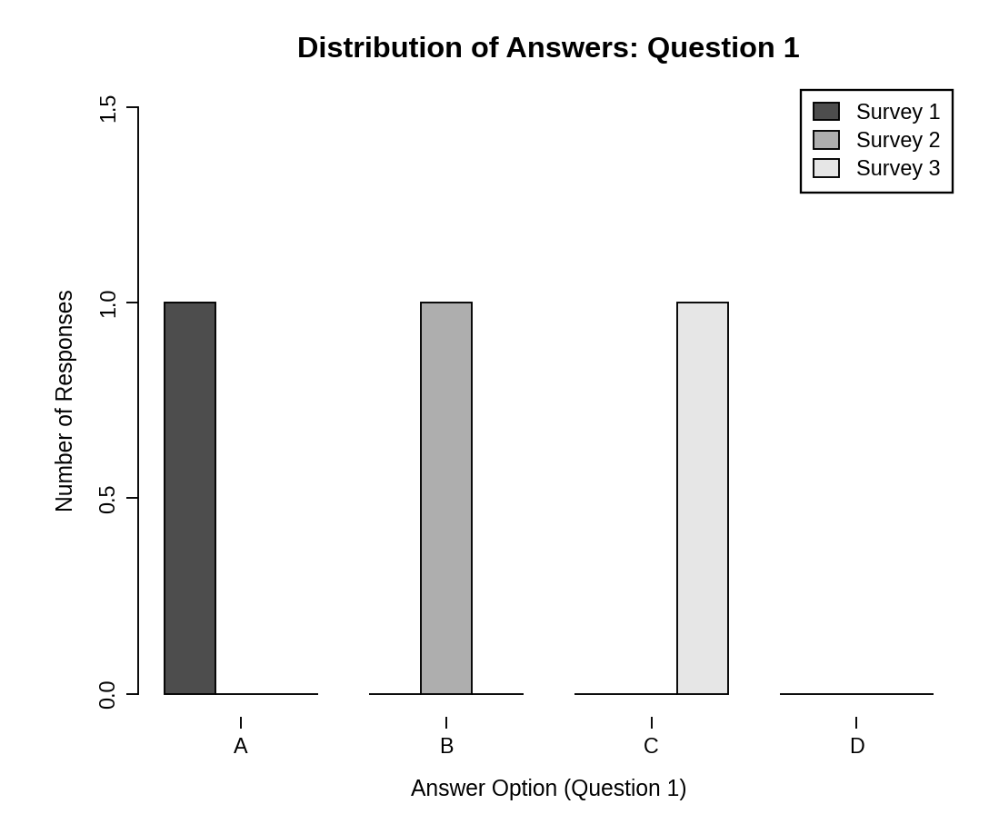
Observation: Options A, B and C were each chosen by exactly one survey (Survey 1, 2 and 3 respectively) and option D was not chosen, so the answers to Question 1 are evenly split.
PROGRAM 2 — Stacked Bar Chart for All Questions
# Dataset
survey <- data.frame(
Q1 = c("A", "B", "C"),
Q2 = c("B", "A", "A"),
Q3 = c("C", "D", "B")
)
# Count answers for each question (rows = answers, columns = questions)
levels <- c("A", "B", "C", "D")
counts <- sapply(survey, function(x) table(factor(x, levels = levels)))
colnames(counts) <- c("Question 1", "Question 2", "Question 3")
# Stacked Bar Chart
barplot(counts,
xlab = "Question",
ylab = "Number of Responses",
main = "Overall Distribution of Responses",
col = gray.colors(4),
legend.text = rownames(counts),
args.legend = list(title = "Answer"),
ylim = c(0, 5))

Output: Stacked bar chart showing the distribution of answers for all three questions.
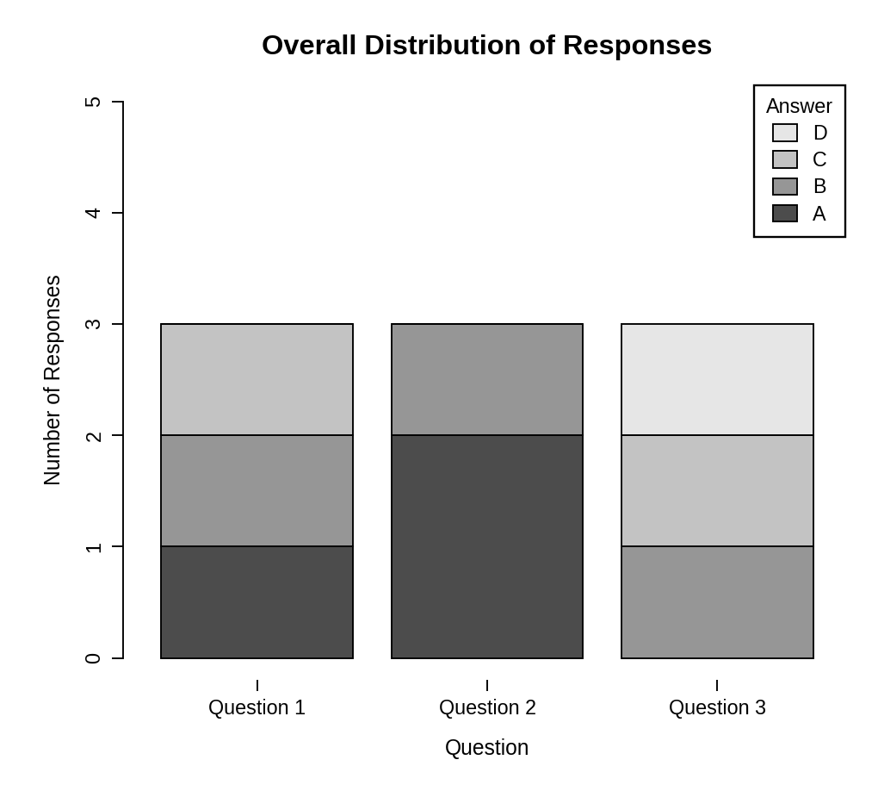
Observation: Every bar totals 3 responses. Option A was the most common answer to Question 2 (2 of 3), while Questions 1 and 3 had a different answer from each respondent. Option D appears only once, in Question 3.
PROGRAM 3 — Table of Survey Responses
# Dataset
survey_table <- data.frame(
"Survey ID" = c(1, 2, 3),
"Question 1" = c("A", "B", "C"),
"Question 2" = c("B", "A", "A"),
"Question 3" = c("C", "D", "B"),
check.names = FALSE
)
# Display the table
print(survey_table)

Output: Table showing the answers given by each survey.
> print(survey_table)
Survey ID Question 1 Question 2 Question 3
1 1 A B C
2 2 B A D
3 3 C A B

Observation: The table shows the answer given by each survey to every question, which can be compared with the counts in the charts.
PROGRAM 4 — Interactive Survey Dashboard using Shiny
library(shiny)

# Dataset
survey <- data.frame(
id = c(1, 2, 3),
Q1 = c("A", "B", "C"),
Q2 = c("B", "A", "A"),
Q3 = c("C", "D", "B")
)
levels <- c("A", "B", "C", "D")

# User Interface
ui <- fluidPage(
titlePanel("Survey Responses Dashboard"),
sidebarLayout(
sidebarPanel(
checkboxGroupInput("ids", "Select Surveys:",
choices = survey$id,
selected = survey$id)
),
mainPanel(
plotOutput("groupPlot", height = "300px"),
plotOutput("stackPlot", height = "300px"),
tableOutput("surveyTable")
)
)
)

# Server
server <- function(input, output) {
filtered <- reactive({ subset(survey, id %in% input$ids) })

output$groupPlot <- renderPlot({
d <- filtered(); req(nrow(d) > 0)
m <- sapply(levels, function(o) as.numeric(d$Q1 == o))
m <- matrix(m, nrow = nrow(d))
barplot(m, beside = TRUE, names.arg = levels,
xlab = "Answer Option (Question 1)",
ylab = "Number of Responses",
main = "Distribution of Answers: Question 1",
col = gray.colors(nrow(d)), ylim = c(0, 1.5))
})

output$stackPlot <- renderPlot({
d <- filtered(); req(nrow(d) > 0)
counts <- sapply(d[, c("Q1", "Q2", "Q3")],
function(x) table(factor(x, levels = levels)))
barplot(counts, xlab = "Question", ylab = "Number of Responses",
main = "Overall Distribution of Responses",
col = gray.colors(4), legend.text = levels,
ylim = c(0, 5))
})

output$surveyTable <- renderTable({
d <- filtered()
names(d) <- c("Survey ID", "Question 1", "Question 2", "Question 3")
d
}, digits = 0)
}

# Run Application
shinyApp(ui = ui, server = server)

Output: An interactive dashboard with a "Select Surveys" option. Both charts and the table update with the selection.
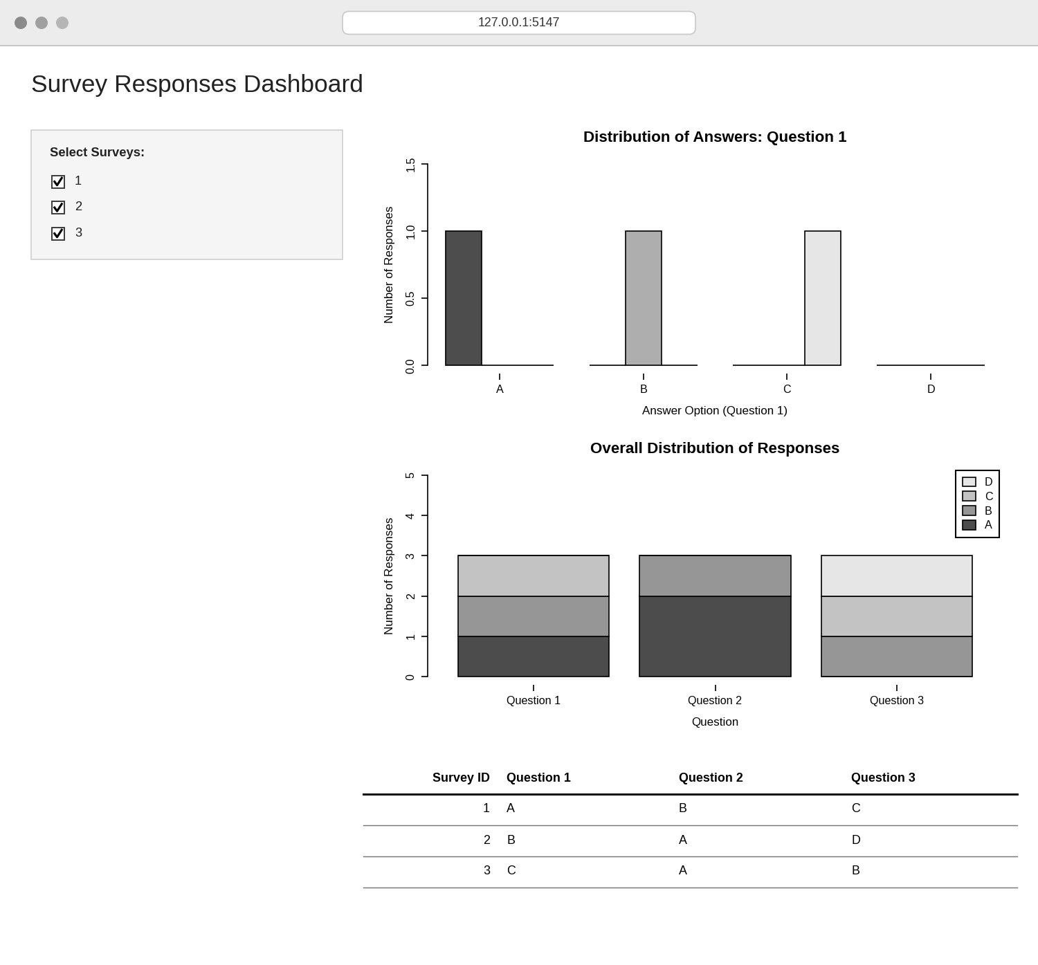
Observation: The dashboard combines the grouped bar chart, stacked bar chart and response table. Selecting or clearing surveys in the sidebar updates all three views together.
PROCEDURE
- Create the survey ID and the Question 1, Question 2 and Question 3 answers in R.
- Build a survey-by-option matrix for Question 1 and use barplot() with beside = TRUE for the grouped bar chart.
- Count the answers to each question with table() and use barplot() to draw the stacked bar chart.
- Create a data.frame() with the survey responses and display it as a table.
- Load the Shiny package, then create the UI and server components for the dashboard.
- Run the Shiny application and select surveys to update the charts and table.
RESULT
The survey response data was successfully visualized using a grouped bar chart, a stacked bar chart and a data table. An interactive Shiny dashboard combining all three was also created.
KEY R FUNCTIONS USED
- sapply() – Builds the answer-count matrices.
- table() / factor() – Count how many times each answer was chosen.
- barplot(beside = TRUE) – Creates the grouped bar chart.
- barplot() – Creates the stacked bar chart.
- data.frame() – Creates the response table.
- checkboxGroupInput() – Provides the survey selection control.
- reactive() – Filters the data when the selection changes.
- renderPlot() / renderTable() – Generate plots and tables dynamically in Shiny.
- shinyApp() – Runs the interactive Shiny application.

