SET 11 — PRODUCT CATEGORY ANALYSIS
Dataset
Category | Sales (in $)
Electronics | 50000
Clothing | 35000
Appliances | 40000

Note: The dataset has only one sales value per category and no conversion stages. The funnel chart therefore ranks the categories from highest to lowest sales, with the bar width showing each category's sales.
PROGRAM 1 — Funnel Chart of Category Sales
# Dataset
category <- c("Electronics", "Clothing", "Appliances")
sales <- c(50000, 35000, 40000)
# Order the stages from highest to lowest sales
ord <- order(sales, decreasing = TRUE)
category <- category[ord]
sales <- sales[ord]
# Funnel Chart (centred horizontal bars)
plot(NULL, xlim = c(-30000, 30000), ylim = c(0.5, 3.5),
axes = FALSE, xlab = "", ylab = "",
main = "Sales Funnel by Product Category")
cols <- c("gray55", "gray75", "gray92")
for (i in 1:3) {
y <- 4 - i
rect(-sales[i] / 2, y - 0.4, sales[i] / 2, y + 0.4, col = cols[i])
text(0, y, paste0(category[i], "\n$", format(sales[i], big.mark = ",")),
font = 2)
}

Output: Funnel chart ranking the product categories by sales.
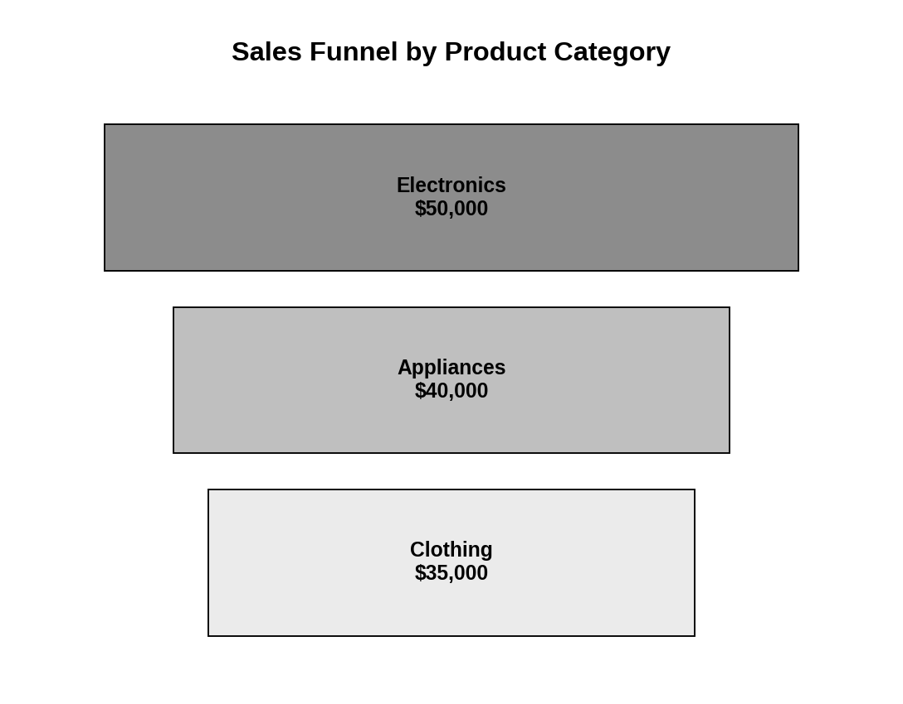
Observation: Electronics is the widest stage ($50,000), followed by Appliances ($40,000) and Clothing ($35,000). The funnel narrows from the highest to the lowest selling category.
PROGRAM 2 — Table of Category Sales
# Dataset
sales_table <- data.frame(
"Category" = c("Electronics", "Clothing", "Appliances"),
"Sales (in $)" = c(50000, 35000, 40000),
check.names = FALSE
)
# Display the table
print(sales_table)

Output: Table showing the sales of each product category.
> print(sales_table)
Category Sales (in $)
1 Electronics 50000
2 Clothing 35000
3 Appliances 40000

Observation: The table lists the sales of each category. Total sales are $125,000.
PROGRAM 3 — Interactive Product Category Dashboard using Shiny
library(shiny)

# Dataset
sales_data <- data.frame(
category = c("Electronics", "Clothing", "Appliances"),
sales = c(50000, 35000, 40000)
)
cols <- c(Electronics = "gray55", Clothing = "gray92",
Appliances = "gray75")

# User Interface
ui <- fluidPage(
titlePanel("Product Category Dashboard"),
sidebarLayout(
sidebarPanel(
checkboxGroupInput("cats", "Select Categories:",
choices = sales_data$category,
selected = sales_data$category)
),
mainPanel(
plotOutput("piePlot", height = "300px"),
plotOutput("funnelPlot", height = "300px"),
tableOutput("salesTable")
)
)
)

# Server
server <- function(input, output) {
filtered <- reactive({
d <- subset(sales_data, category %in% input$cats)
d[order(d$sales, decreasing = TRUE), ]
})

output$piePlot <- renderPlot({
d <- filtered(); req(nrow(d) > 0)
pct <- round(100 * d$sales / sum(d$sales), 1)
pie(d$sales, labels = paste0(d$category, " (", pct, "%)"),
col = cols[d$category], main = "Sales Distribution by Category")
})

output$funnelPlot <- renderPlot({
d <- filtered(); req(nrow(d) > 0)
n <- nrow(d)
plot(NULL, xlim = c(-30000, 30000), ylim = c(0.5, n + 0.5),
axes = FALSE, xlab = "", ylab = "",
main = "Sales Funnel by Product Category")
for (i in 1:n) {
y <- n + 1 - i
rect(-d$sales[i] / 2, y - 0.4, d$sales[i] / 2, y + 0.4,
col = cols[d$category[i]])
text(0, y, paste0(d$category[i], ": $",
format(d$sales[i], big.mark = ",")), font = 2)
}
})

output$salesTable <- renderTable({
d <- filtered()
names(d) <- c("Category", "Sales (in $)")
d
}, digits = 0)
}

# Run Application
shinyApp(ui = ui, server = server)

Output: An interactive dashboard with a "Select Categories" option. The pie chart, funnel chart and table update with the selection.
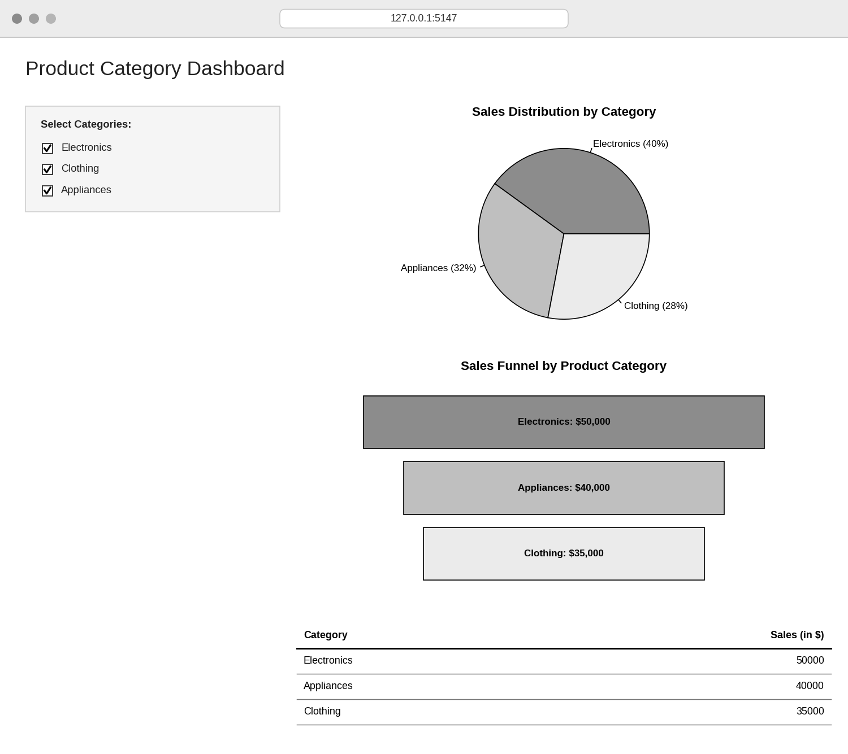
Observation: The dashboard combines the pie chart, funnel chart and sales table. Selecting or clearing categories in the sidebar updates all three views together.
PROGRAM 4 — Pie Chart of Sales Distribution
# Dataset
category <- c("Electronics", "Clothing", "Appliances")
sales <- c(50000, 35000, 40000)
# Percentage labels
percent <- round(100 * sales / sum(sales), 1)
# Pie Chart
pie(sales,
labels = paste0(category, " (", percent, "%)"),
main = "Sales Distribution by Category",
col = c("gray55", "gray92", "gray75"))

Output: Pie chart showing the share of sales for each product category.
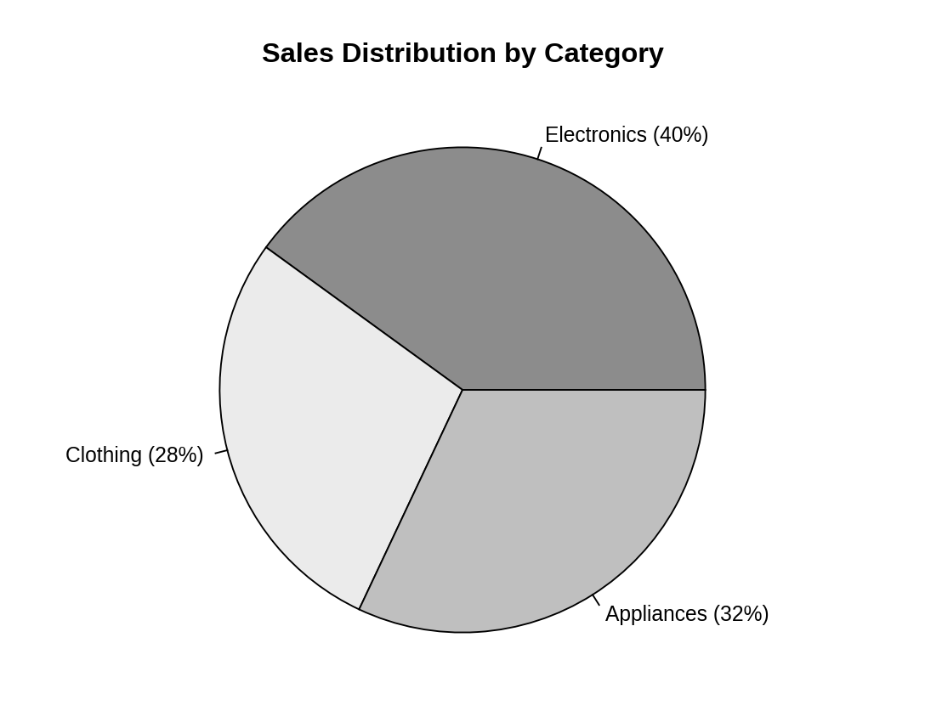
Observation: Electronics contributes 40% of total sales, Appliances 32% and Clothing 28%, so no single category dominates.
PROCEDURE
- Create the category and sales vectors in R.
- Order the categories by sales and draw centred bars with plot(), rect() and text() to build the funnel chart.
- Create a data.frame() with the category sales and display it as a table.
- Use pie() with percentage labels to draw the pie chart.
- Load the Shiny package, then create the UI and server components for the dashboard.
- Run the Shiny application and select categories to update the pie chart, funnel chart and table.
RESULT
The product category sales data was successfully visualized using a funnel chart, a pie chart and a data table. An interactive Shiny dashboard combining all three was also created.
KEY R FUNCTIONS USED
- order() – Ranks categories from highest to lowest sales.
- plot(NULL, ...) – Creates an empty plotting area for the funnel.
- rect() / text() – Draw and label the funnel stages.
- pie() – Creates the pie chart.
- data.frame() – Creates the sales table.
- checkboxGroupInput() – Provides the category selection control.
- reactive() – Filters the data when the selection changes.
- renderPlot() / renderTable() – Generate plots and tables dynamically in Shiny.
- shinyApp() – Runs the interactive Shiny application.

