SET 12 — WEBSITE TRAFFIC ANALYSIS
Dataset
Date | Page Views | Click-through Rate (%)
2023-01-01 | 1500 | 2.3
2023-01-02 | 1600 | 2.7
2023-01-03 | 1400 | 2
PROGRAM 1 — Line Chart of Daily Page Views
# Dataset
date <- as.Date(c("2023-01-01", "2023-01-02", "2023-01-03"))
page_views <- c(1500, 1600, 1400)
# Line Chart
plot(date, page_views,
type = "o",
xlab = "Date",
ylab = "Page Views",
main = "Daily Page Views")

Output: Line chart showing the trend in daily page views.
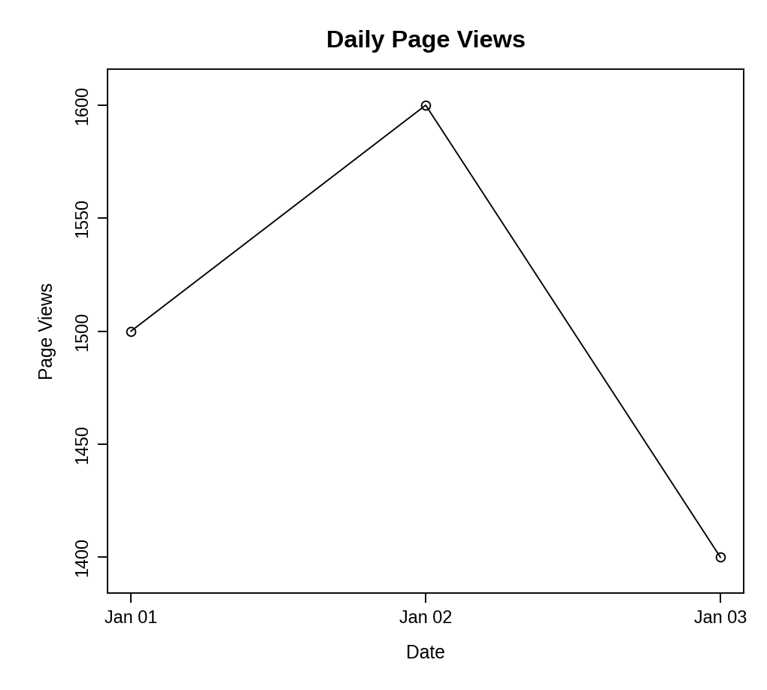
Observation: Page views increase from 1500 to 1600 on 2 January and then drop to 1400 on 3 January, the lowest value in the period.
PROGRAM 2 — Bar Chart of Top N Days by Click-through Rate
# Dataset
date <- c("2023-01-01", "2023-01-02", "2023-01-03")
ctr <- c(2.3, 2.7, 2.0)
# Select the top N days
N <- 2
top <- order(ctr, decreasing = TRUE)[1:N]
# Bar Chart
barplot(ctr[top],
names.arg = date[top],
xlab = "Date",
ylab = "Click-through Rate (%)",
main = paste("Top", N, "Days by Click-through Rate"))

Output: Bar chart displaying the top two days according to click-through rate.
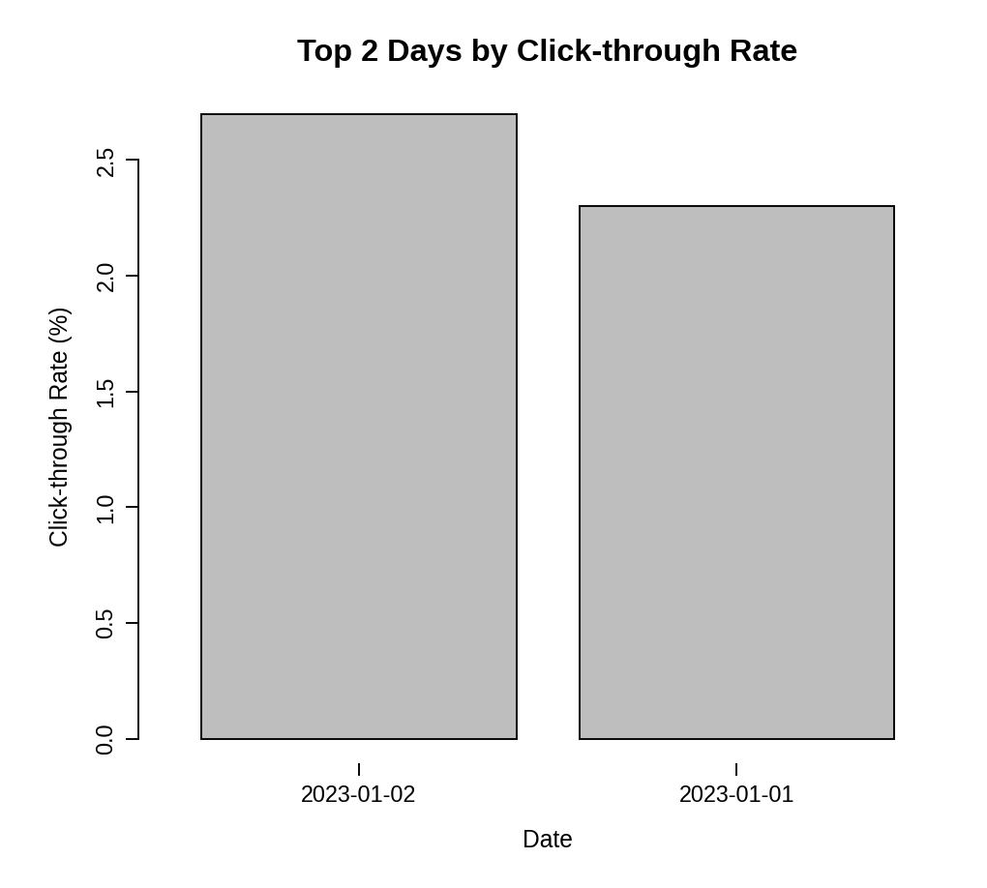
Observation: The two best days are 2 January (2.7%) and 1 January (2.3%). 3 January has the lowest click-through rate (2.0%) and is left out of the top 2.
PROGRAM 3 — Table of Website Traffic Data
# Dataset
traffic <- data.frame(
"Date" = c("2023-01-01", "2023-01-02", "2023-01-03"),
"Page Views" = c(1500, 1600, 1400),
"Click-through Rate (%)" = c(2.3, 2.7, 2.0),
check.names = FALSE
)
# Display the table
print(traffic)

Output: Table showing the website traffic data for each day.
> print(traffic)
Date Page Views Click-through Rate (%)
1 2023-01-01 1500 2.3
2 2023-01-02 1600 2.7
3 2023-01-03 1400 2.0

Observation: The table gives the page views and click-through rate for each day. 2 January has both the most page views and the highest click-through rate, and 3 January has the lowest of both.
PROGRAM 4 — Interactive Website Traffic Dashboard using Shiny
library(shiny)

# Dataset
date <- as.Date(c("2023-01-01", "2023-01-02", "2023-01-03"))
page_views <- c(1500, 1600, 1400)
ctr <- c(2.3, 2.7, 2.0)

# User Interface
ui <- fluidPage(
titlePanel("Website Traffic Dashboard"),
sidebarLayout(
sidebarPanel(
sliderInput("n", "Top N days (by CTR):",
min = 1, max = 3, value = 2, step = 1)
),
mainPanel(
plotOutput("linePlot", height = "300px"),
plotOutput("barPlot", height = "300px"),
tableOutput("trafficTable")
)
)
)

# Server
server <- function(input, output) {
output$linePlot <- renderPlot({
plot(date, page_views, type = "o", xlab = "Date",
ylab = "Page Views", main = "Daily Page Views")
})

output$barPlot <- renderPlot({
top <- order(ctr, decreasing = TRUE)[1:input$n]
barplot(ctr[top], names.arg = format(date[top]),
xlab = "Date", ylab = "Click-through Rate (%)",
main = paste("Top", input$n, "Days by Click-through Rate"))
})

output$trafficTable <- renderTable({
data.frame("Date" = format(date),
"Page Views" = as.integer(page_views),
"Click-through Rate (%)" = ctr,
check.names = FALSE)
}, digits = 1)
}

# Run Application
shinyApp(ui = ui, server = server)

Output: An interactive dashboard with a "Top N days" slider. The bar chart updates with the slider value.
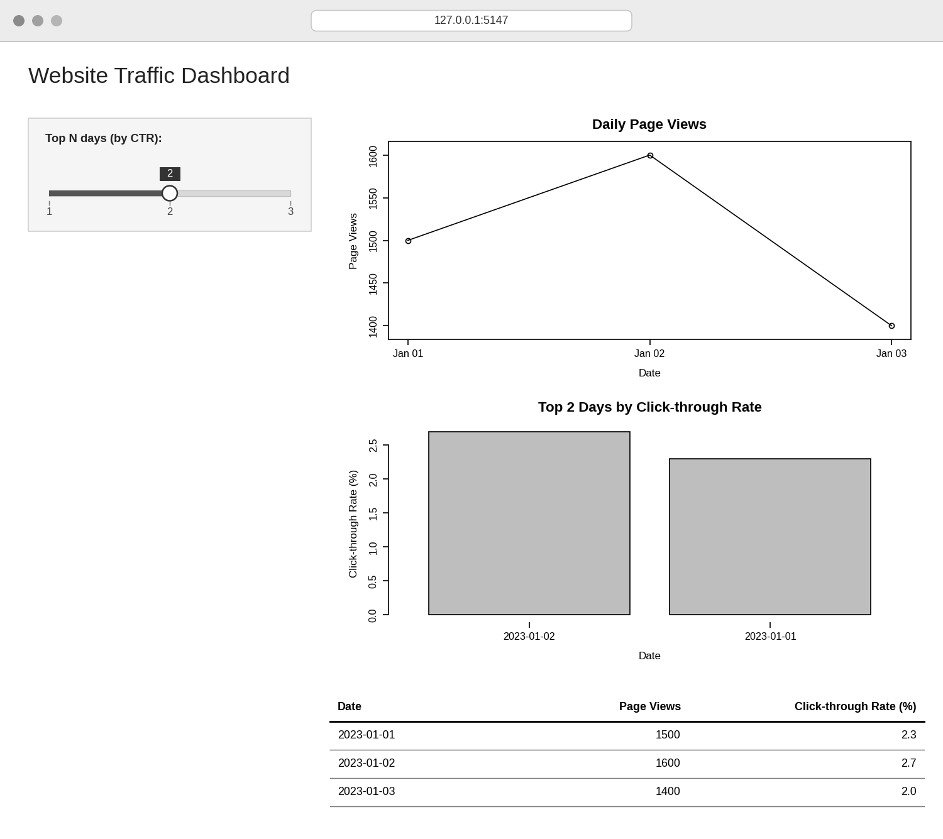
Observation: The dashboard shows the page-view trend, the top-N click-through chart and the traffic table together. Moving the slider changes N, so the bar chart shows the top 1, 2 or 3 days.
PROCEDURE
- Create the date, page-view and click-through-rate vectors in R.
- Use plot() with type = "o" to create the line chart of daily page views.
- Use order() to find the top N click-through rates and barplot() to display them.
- Create a data.frame() with the traffic data and display it as a table.
- Load the Shiny package, then create the UI and server components for the dashboard.
- Run the Shiny application and change the slider to explore the top N days.
RESULT
The website traffic data was successfully visualized using a line chart, a bar chart of the top N click-through days and a data table. An interactive Shiny dashboard combining all three was also created.
KEY R FUNCTIONS USED
- as.Date() – Converts text into date values.
- plot() – Creates the line chart.
- order() – Ranks the days by click-through rate.
- barplot() – Creates the bar chart.
- data.frame() – Creates the traffic table.
- sliderInput() – Provides the control for choosing N in Shiny.
- renderPlot() / renderTable() – Generate plots and tables dynamically in Shiny.
- shinyApp() – Runs the interactive Shiny application.

