DSA0601 Data Handling and Visualization
Name: Lakshna Sree T S
Regno: 192524059
Date: 01 October 2026
SET 4 — PRODUCT INVENTORY MANAGEMENT
Dataset
Product ID | Product Name | Quantity Available
1 | Product A | 250
2 | Product B | 175
3 | Product C | 300
4 | Product D | 200
5 | Product E | 220

Note: The assignment table contains only Product ID, Product Name and Quantity Available. Programs 2 and 3 also need product categories and prices, so these sample values were assumed. Categories (Electronics / Home / Office): A 120/80/50, B 70/60/45, C 150/90/60, D 90/70/40, E 100/70/50 (each row adds up to the available quantity). Prices ($): A 20, B 25, C 15, D 22, E 18.
PROGRAM 1 — Bar Chart of Product Quantity
# Dataset
product <- c("Product A", "Product B", "Product C", "Product D", "Product E")
quantity <- c(250, 175, 300, 200, 220)
# Bar Chart
barplot(quantity,
names.arg = product,
xlab = "Product Name",
ylab = "Quantity Available",
main = "Product Inventory")

Output: Bar chart displaying the quantity available for each product.
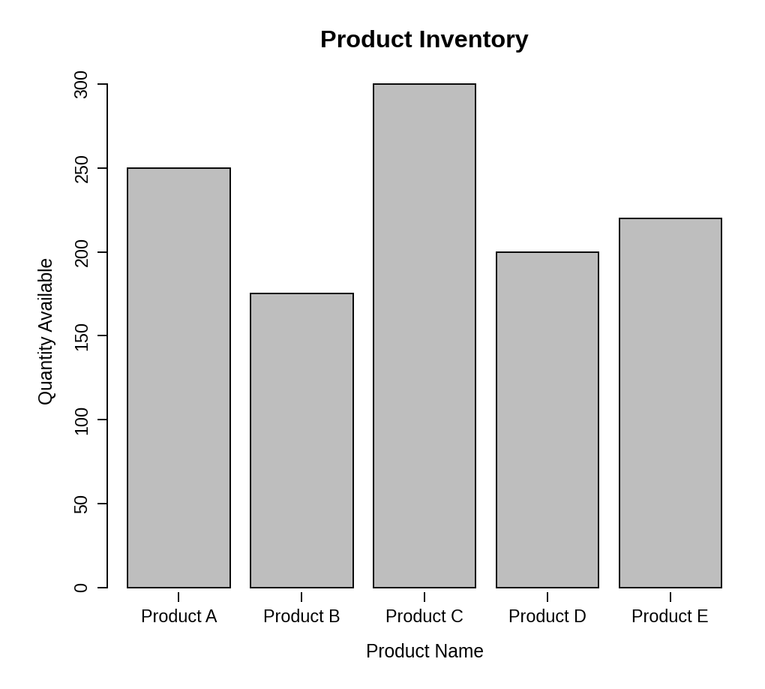
Observation: Product C has the highest stock (300 units) and Product B has the lowest (175 units). The bar chart makes it easy to see which products may need to be restocked.
PROGRAM 2 — Stacked Bar Chart by Product Category
# Dataset (rows = categories, columns = products)
product <- c("Product A", "Product B", "Product C", "Product D", "Product E")
qty <- matrix(c(120, 70, 150, 90, 100, # Electronics
80, 60, 90, 70, 70, # Home
50, 45, 60, 40, 50), # Office
nrow = 3, byrow = TRUE)
rownames(qty) <- c("Electronics", "Home", "Office")
# Stacked Bar Chart
barplot(qty,
names.arg = product,
xlab = "Product Name",
ylab = "Quantity Available",
main = "Inventory by Product Category",
col = gray.colors(3),
ylim = c(0, 350),
legend.text = rownames(qty))

Output: Stacked bar chart showing the quantity of each product within the categories.
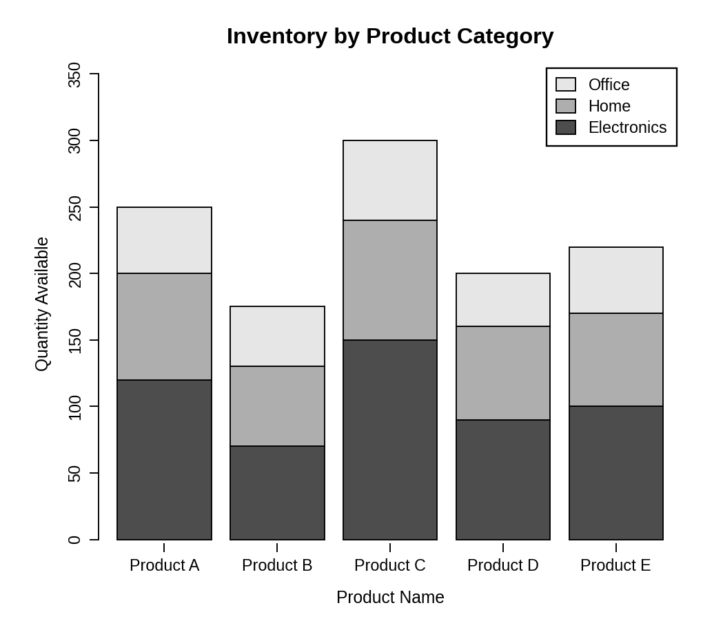
Observation: Each bar is split into Electronics, Home and Office stock. Electronics contributes the largest share for every product, and the total height of each bar matches the quantity in Program 1.
PROGRAM 3 — Scatter Plot of Price vs Quantity Available
# Dataset
price <- c(20, 25, 15, 22, 18)
quantity <- c(250, 175, 300, 200, 220)
# Scatter Plot
plot(price, quantity,
main = "Product Price vs Quantity Available",
xlab = "Price ($)",
ylab = "Quantity Available",
pch = 19)
# Trend line
abline(lm(quantity ~ price), lty = 2)
# Correlation
cor(price, quantity)

Output: Scatter plot showing the relationship between product price and quantity available.
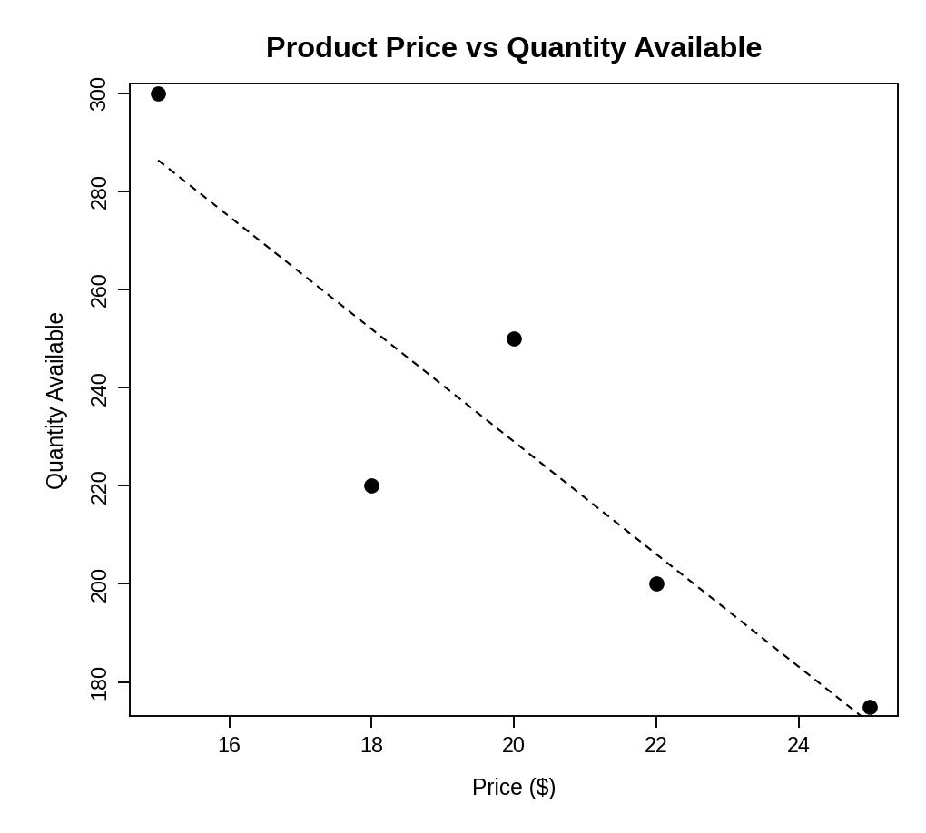
> cor(price, quantity)
[1] -0.9044815

Insight: The points slope downward: as the price rises from $15 to $25, the quantity available falls from 300 to 175 units. The correlation coefficient is about -0.90, a strong negative relationship. Cheaper products (such as Product C) are stocked in larger quantities, while costlier products (such as Product B) are stocked less. With only five products this is an indication, not proof, of a general trend.
PROGRAM 4 — Interactive Inventory Dashboard using Shiny
library(shiny)

# Dataset
product <- c("Product A", "Product B", "Product C", "Product D", "Product E")
quantity <- c(250, 175, 300, 200, 220)
qty <- matrix(c(120, 70, 150, 90, 100,
80, 60, 90, 70, 70,
50, 45, 60, 40, 50),
nrow = 3, byrow = TRUE)
rownames(qty) <- c("Electronics", "Home", "Office")

# User Interface
ui <- fluidPage(
titlePanel("Product Inventory Dashboard"),
sidebarLayout(
sidebarPanel(
checkboxGroupInput("charts", "Select Chart(s):",
choices = c("Bar Chart", "Stacked Bar Chart"),
selected = c("Bar Chart", "Stacked Bar Chart"))
),
mainPanel(
conditionalPanel("input.charts.indexOf('Bar Chart') > -1",
plotOutput("barPlot", height = "300px")),
conditionalPanel("input.charts.indexOf('Stacked Bar Chart') > -1",
plotOutput("stackPlot", height = "300px"))
)
)
)

# Server
server <- function(input, output) {
output$barPlot <- renderPlot({
barplot(quantity, names.arg = product,
xlab = "Product Name", ylab = "Quantity Available",
main = "Product Inventory")
})
output$stackPlot <- renderPlot({
barplot(qty, names.arg = product,
xlab = "Product Name", ylab = "Quantity Available",
main = "Inventory by Product Category",
col = gray.colors(3), ylim = c(0, 350),
legend.text = rownames(qty))
})
}

# Run Application
shinyApp(ui = ui, server = server)

Output: An interactive dashboard with a "Select Chart(s)" option. Ticking or un-ticking a box shows or hides the bar chart and the stacked bar chart.
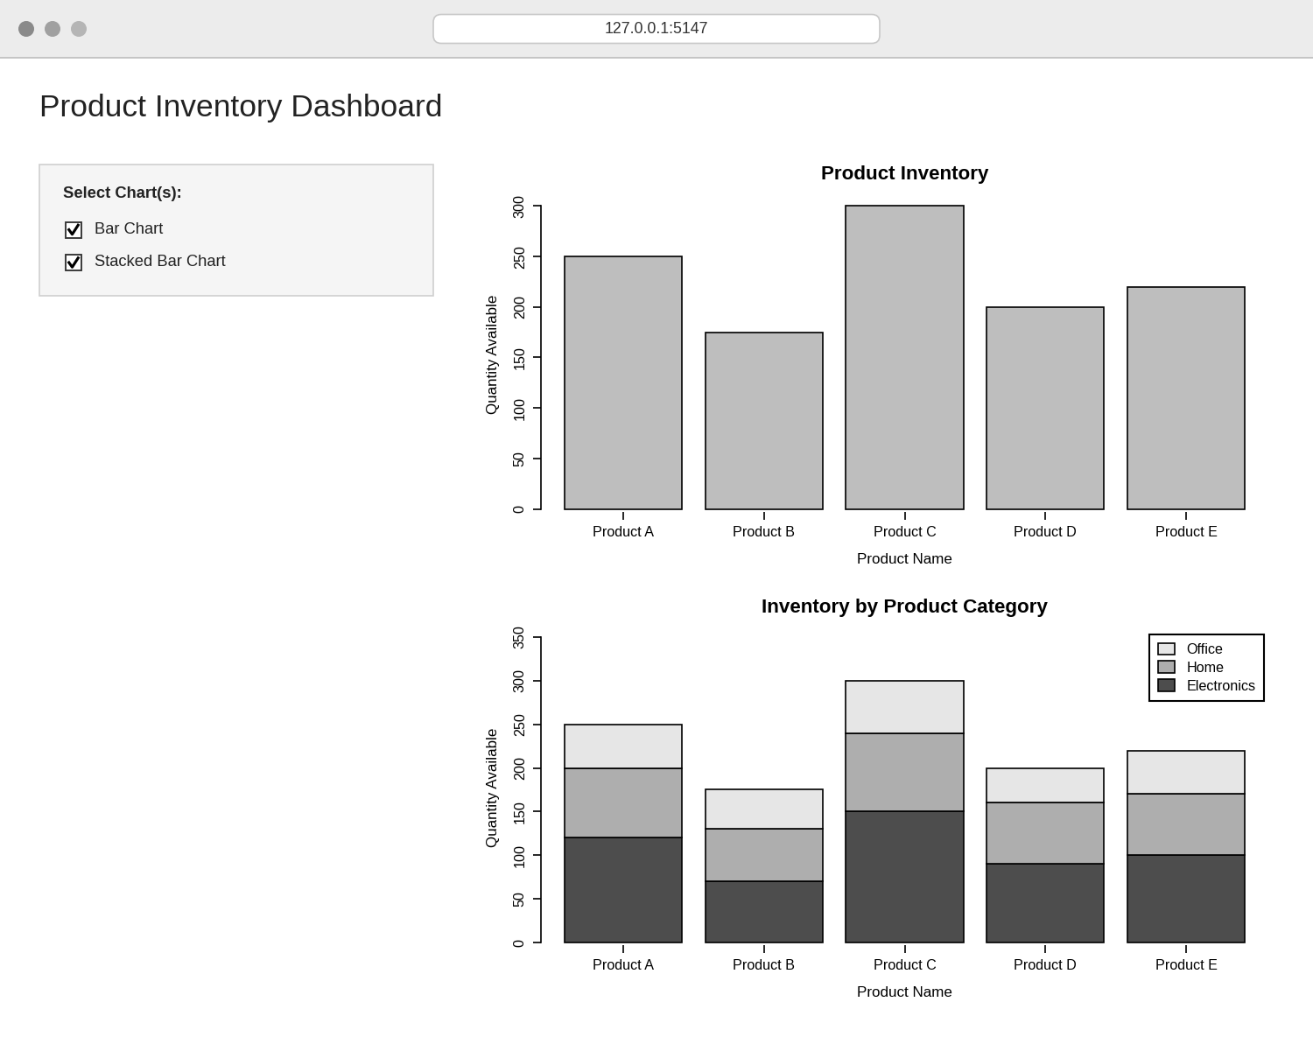
Observation: The dashboard has check boxes in the sidebar. The user can show or hide the bar chart and the stacked bar chart to explore the inventory data interactively.
PROCEDURE
- Create the product, quantity, category and price data in R.
- Use barplot() to draw the bar chart of quantity for each product.
- Create a category-by-product matrix and use barplot() to draw the stacked bar chart with a legend.
- Create price and quantity vectors of equal length, use plot() for the scatter plot, and use cor() to measure the relationship.
- Load the Shiny package, then create the UI and server components for the dashboard.
- Run the Shiny application and use the check boxes to show or hide the charts.
RESULT
The product inventory data was successfully visualized using a bar chart, a stacked bar chart and a scatter plot. The scatter plot showed a strong negative relationship between price and quantity available. An interactive Shiny dashboard combining the bar chart and stacked bar chart was also created.
KEY R FUNCTIONS USED
- barplot() – Creates bar charts and stacked bar charts.
- matrix() – Builds the category-by-product data for stacking.
- plot() – Creates the scatter plot.
- abline() / lm() – Adds a linear trend line to the scatter plot.
- cor() – Calculates the correlation between price and quantity.
- checkboxGroupInput() – Provides the chart selection control.
- conditionalPanel() – Shows or hides a chart based on the selection.
- renderPlot() – Generates plots dynamically in Shiny.
- shinyApp() – Runs the interactive Shiny application.

