SET 5 — WEBSITE ANALYTICS
Dataset
Date | Page Views | Click-through Rate (%)
2023-01-01 | 1500 | 2.3
2023-01-02 | 1600 | 2.7
2023-01-03 | 1400 | 2
2023-01-04 | 1650 | 2.4
2023-01-05 | 1800 | 2.6

Note: The assignment table does not include likes, shares and comments. For Program 3, these sample values were assumed (Jan 1 to Jan 5). Likes: 320, 350, 300, 380, 410; Shares: 80, 95, 70, 100, 120; Comments: 45, 55, 40, 60, 70.
PROGRAM 1 — Line Chart of Daily Page Views
# Dataset
date <- as.Date(c("2023-01-01", "2023-01-02", "2023-01-03",
"2023-01-04", "2023-01-05"))
page_views <- c(1500, 1600, 1400, 1650, 1800)
# Line Chart
plot(date, page_views,
type = "o",
xlab = "Date",
ylab = "Page Views",
main = "Daily Page Views")

Output: Line chart showing the trend in daily page views.
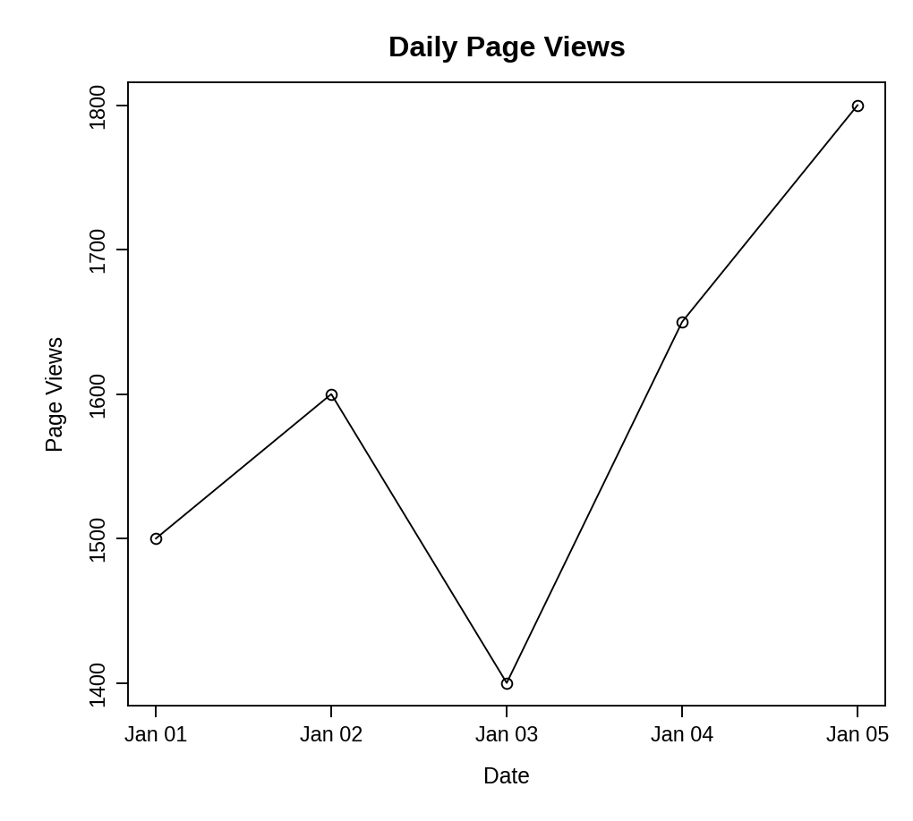
Observation: Page views rise from 1500 to 1600, drop to 1400 on 3 January, and then climb steadily to 1650 and finally 1800 on 5 January. Overall the trend is upward.
PROGRAM 2 — Bar Chart of Top N Days by Click-through Rate
# Dataset
date <- c("2023-01-01", "2023-01-02", "2023-01-03",
"2023-01-04", "2023-01-05")
ctr <- c(2.3, 2.7, 2.0, 2.4, 2.6)
# Select the top N days
N <- 3
top <- order(ctr, decreasing = TRUE)[1:N]
# Bar Chart
barplot(ctr[top],
names.arg = date[top],
xlab = "Date",
ylab = "Click-through Rate (%)",
main = paste("Top", N, "Days by Click-through Rate"))

Output: Bar chart displaying the top three days according to click-through rate.
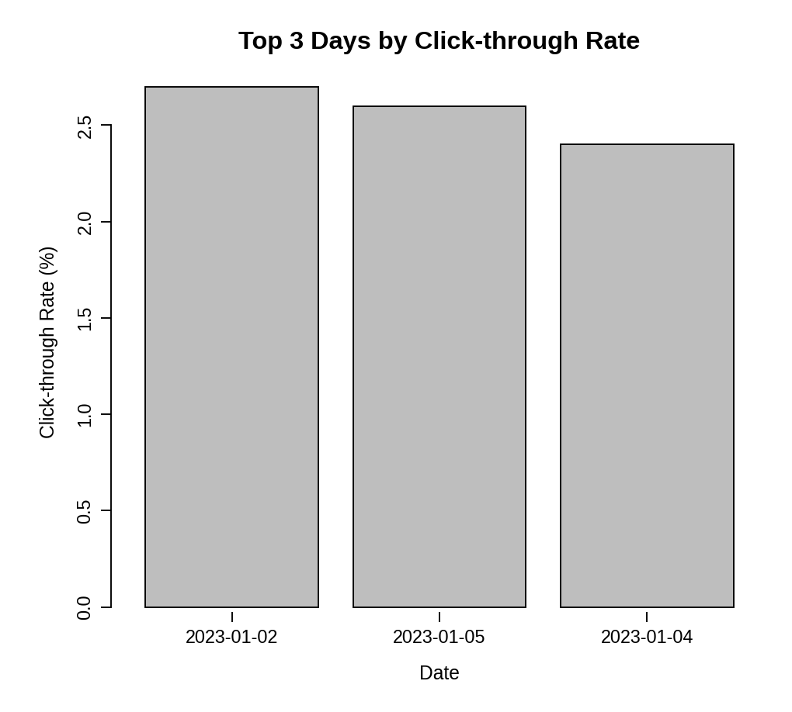
Observation: The three best days are 2 January (2.7%), 5 January (2.6%) and 4 January (2.4%). 3 January had the lowest click-through rate (2.0%) and is not in the top 3.
PROGRAM 3 — Stacked Area Chart of User Interactions
library(ggplot2)

# Dataset (sample interaction values)
interactions <- data.frame(
date = rep(as.Date(c("2023-01-01", "2023-01-02", "2023-01-03",
"2023-01-04", "2023-01-05")), times = 3),
type = factor(rep(c("Likes", "Shares", "Comments"), each = 5),
levels = c("Likes", "Shares", "Comments")),
count = c(320, 350, 300, 380, 410, # Likes
80, 95, 70, 100, 120, # Shares
45, 55, 40, 60, 70) # Comments
)

# Stacked Area Chart
ggplot(interactions, aes(x = date, y = count, fill = type)) +
geom_area() +
scale_fill_grey() +
theme_bw() +
labs(title = "Distribution of User Interactions",
x = "Date", y = "Number of Interactions", fill = "Interaction")

Output: Stacked area chart showing the distribution of likes, shares and comments.
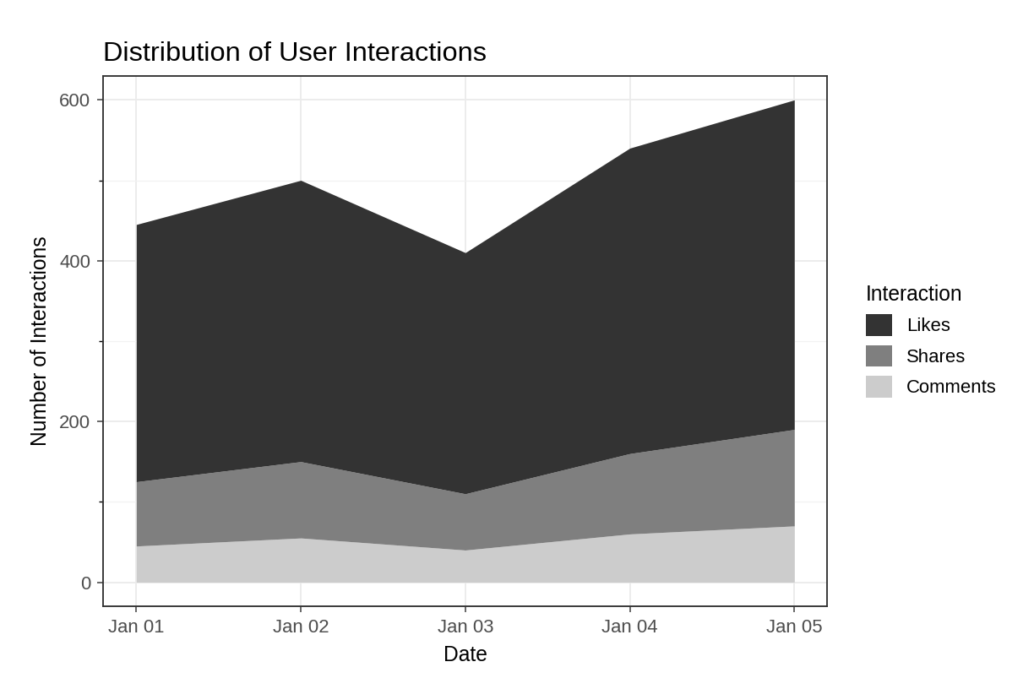
Observation: Likes make up the largest share of interactions every day, followed by shares and comments. Total interactions dip on 3 January and reach their peak on 5 January, matching the page-view trend.
PROGRAM 4 — Interactive Website Traffic Dashboard using Shiny
library(shiny)

# Dataset
date <- as.Date(c("2023-01-01", "2023-01-02", "2023-01-03",
"2023-01-04", "2023-01-05"))
page_views <- c(1500, 1600, 1400, 1650, 1800)
ctr <- c(2.3, 2.7, 2.0, 2.4, 2.6)

# User Interface
ui <- fluidPage(
titlePanel("Website Traffic Dashboard"),
sidebarLayout(
sidebarPanel(
sliderInput("n", "Top N days (by CTR):",
min = 1, max = 5, value = 3, step = 1)
),
mainPanel(
plotOutput("linePlot", height = "300px"),
plotOutput("barPlot", height = "300px")
)
)
)

# Server
server <- function(input, output) {
output$linePlot <- renderPlot({
plot(date, page_views, type = "o", xlab = "Date",
ylab = "Page Views", main = "Daily Page Views")
})
output$barPlot <- renderPlot({
top <- order(ctr, decreasing = TRUE)[1:input$n]
barplot(ctr[top], names.arg = format(date[top]),
xlab = "Date", ylab = "Click-through Rate (%)",
main = paste("Top", input$n, "Days by Click-through Rate"))
})
}

# Run Application
shinyApp(ui = ui, server = server)

Output: An interactive dashboard with a "Top N days" slider. The line chart stays fixed while the bar chart updates with the slider value.
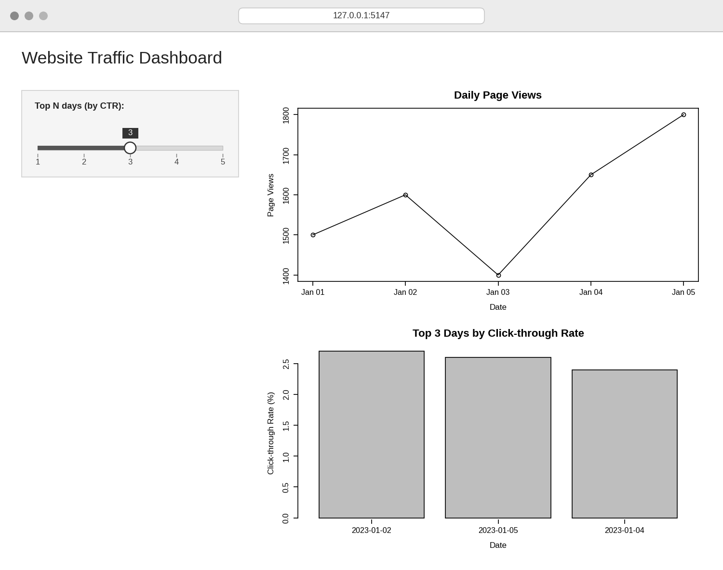
Observation: The dashboard shows the page-view trend and the click-through-rate chart together. Moving the slider changes N, so the bar chart updates to show the top 1 to 5 days.
PROCEDURE
- Create the date, page-view and click-through-rate vectors in R.
- Use plot() with type = "o" to create the line chart of daily page views.
- Use order() to find the top N click-through rates and barplot() to display them.
- Create a data frame of likes, shares and comments, and use ggplot2 with geom_area() to draw the stacked area chart.
- Load the Shiny package, then create the UI and server components for the dashboard.
- Run the Shiny application and change the slider to explore the top N days.
RESULT
The website traffic data was successfully visualized using a line chart, a bar chart of the top N click-through days, and a stacked area chart of user interactions. An interactive Shiny dashboard combining the line chart and bar chart was also created.
KEY R FUNCTIONS USED
- as.Date() – Converts text into date values.
- plot() – Creates the line chart.
- order() – Ranks the days by click-through rate.
- barplot() – Creates the bar chart.
- ggplot() / geom_area() – Creates the stacked area chart (ggplot2 package).
- sliderInput() – Provides the control for choosing N in Shiny.
- renderPlot() – Generates plots dynamically in Shiny.
- shinyApp() – Runs the interactive Shiny application.

