SET 6 — PRODUCT SALES ANALYSIS
Dataset
Product ID | Product Name | January Sales | February Sales | March Sales
1 | Product A | 2000 | 2200 | 2400
2 | Product B | 1500 | 1800 | 1600
3 | Product C | 1200 | 1400 | 1100

PROGRAM 1 — Grouped Bar Chart of Q1 Sales
# Dataset (rows = months, columns = products)
product <- c("Product A", "Product B", "Product C")
sales <- matrix(c(2000, 1500, 1200, # January
2200, 1800, 1400, # February
2400, 1600, 1100), # March
nrow = 3, byrow = TRUE)
rownames(sales) <- c("January", "February", "March")
# Grouped Bar Chart
barplot(sales,
beside = TRUE,
names.arg = product,
xlab = "Product",
ylab = "Sales ($)",
main = "Q1 Sales by Product",
col = gray.colors(3),
ylim = c(0, 3000),
legend.text = rownames(sales))

Output: Grouped bar chart comparing the Q1 sales of each product.
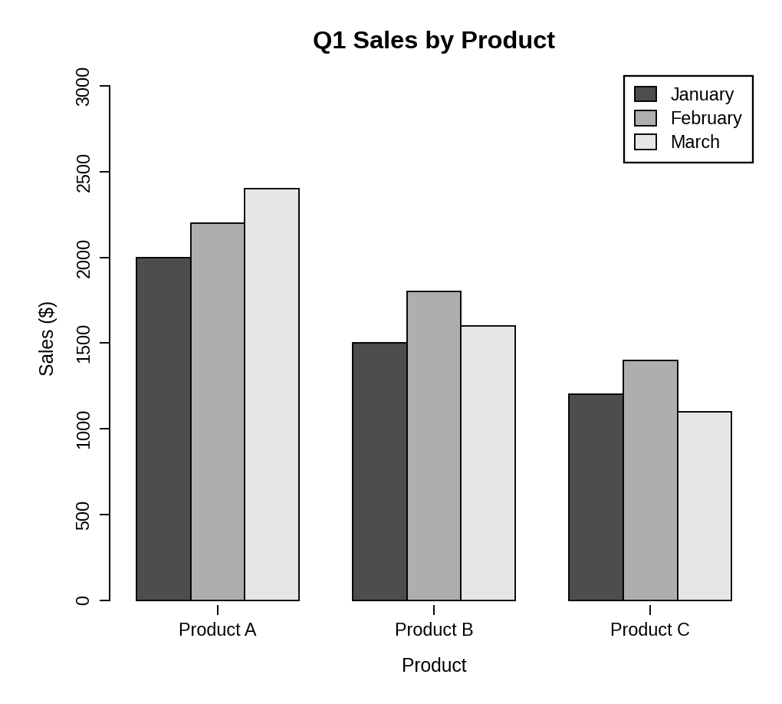
Observation: Product A has the highest sales in every month and grows steadily from 2000 to 2400. Product B peaks in February and falls in March, and Product C peaks in February and drops to its lowest value in March.
PROGRAM 2 — Stacked Area Chart of Overall Sales Trend
library(ggplot2)

# Dataset
sales_data <- data.frame(
month = factor(rep(c("January", "February", "March"), times = 3),
levels = c("January", "February", "March")),
product = rep(c("Product A", "Product B", "Product C"), each = 3),
sales = c(2000, 2200, 2400, # Product A
1500, 1800, 1600, # Product B
1200, 1400, 1100) # Product C
)

# Stacked Area Chart
ggplot(sales_data, aes(x = month, y = sales, fill = product,
group = product)) +
geom_area() +
scale_fill_grey() +
theme_bw() +
labs(title = "Overall Sales Trend",
x = "Month", y = "Total Sales ($)", fill = "Product")

Output: Stacked area chart representing the overall sales trend of all products.
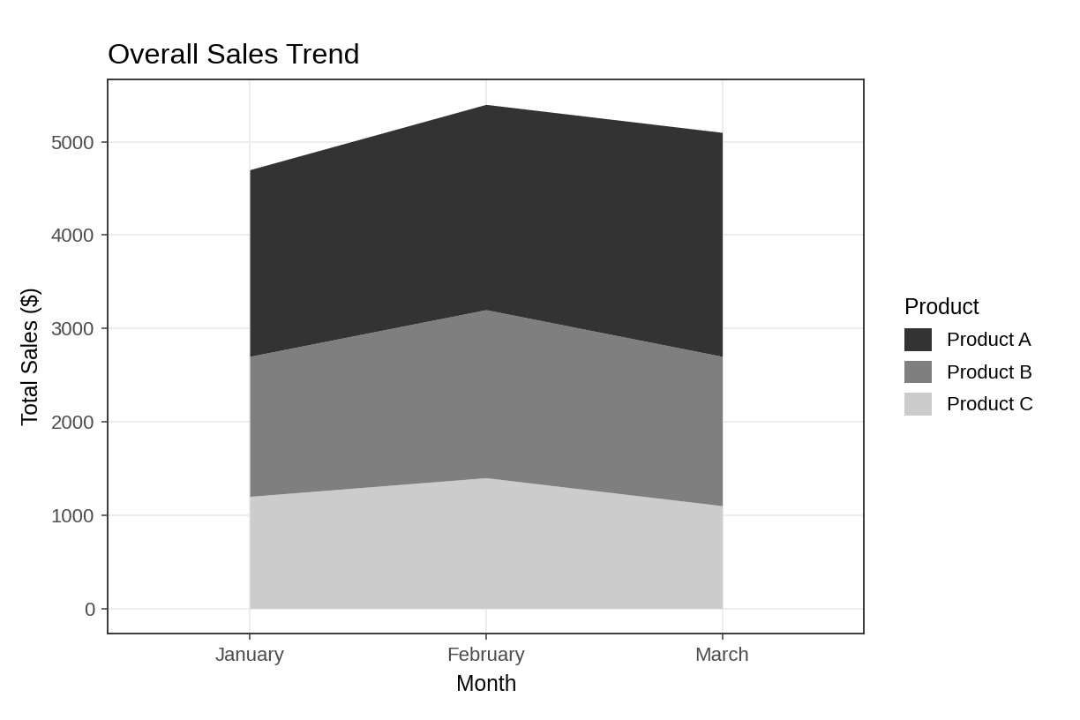
Observation: Total sales rise from 4700 in January to 5400 in February and then fall to 5100 in March. Product A forms the biggest part of the total in every month.
PROGRAM 3 — Table of Monthly Sales Data
# Dataset
sales_table <- data.frame(
"Product ID" = c(1, 2, 3),
"Product Name" = c("Product A", "Product B", "Product C"),
"January Sales" = c(2000, 1500, 1200),
"February Sales" = c(2200, 1800, 1400),
"March Sales" = c(2400, 1600, 1100),
check.names = FALSE
)

# Display the table
print(sales_table)

Output: Table showing the monthly sales of each product.
> print(sales_table)
Product ID Product Name January Sales February Sales March Sales
1 1 Product A 2000 2200 2400
2 2 Product B 1500 1800 1600
3 3 Product C 1200 1400 1100

Observation: The table lists the exact sales value of every product for each month, which complements the charts.
PROGRAM 4 — Interactive Sales Dashboard using Shiny
library(shiny)
library(ggplot2)

# Dataset
sales_data <- data.frame(
product_id = rep(1:3, times = 3),
product = rep(c("Product A", "Product B", "Product C"), times = 3),
month = factor(rep(c("January", "February", "March"), each = 3),
levels = c("January", "February", "March")),
sales = c(2000, 1500, 1200,
2200, 1800, 1400,
2400, 1600, 1100)
)

# User Interface
ui <- fluidPage(
titlePanel("Product Sales Dashboard"),
sidebarLayout(
sidebarPanel(
checkboxGroupInput("products", "Select Products:",
choices = c("Product A", "Product B", "Product C"),
selected = c("Product A", "Product B", "Product C"))
),
mainPanel(
plotOutput("groupPlot", height = "300px"),
plotOutput("areaPlot", height = "300px"),
tableOutput("salesTable")
)
)
)

# Server
server <- function(input, output) {
filtered <- reactive({
subset(sales_data, product %in% input$products)
})

output$groupPlot <- renderPlot({
ggplot(filtered(), aes(x = product, y = sales, fill = month)) +
geom_col(position = "dodge") +
scale_fill_grey() + theme_bw() +
labs(title = "Q1 Sales by Product", x = "Product",
y = "Sales ($)", fill = "Month")
})

output$areaPlot <- renderPlot({
ggplot(filtered(), aes(x = month, y = sales, fill = product,
group = product)) +
geom_area() +
scale_fill_grey() + theme_bw() +
labs(title = "Overall Sales Trend", x = "Month",
y = "Total Sales ($)", fill = "Product")
})

output$salesTable <- renderTable({
wide <- reshape(filtered()[, c("product_id", "product",
"month", "sales")],
idvar = c("product_id", "product"),
timevar = "month", direction = "wide")
names(wide) <- c("Product ID", "Product Name", "January Sales",
"February Sales", "March Sales")
wide
}, digits = 0)
}

# Run Application
shinyApp(ui = ui, server = server)

Output: An interactive dashboard with a "Select Products" option. The grouped bar chart, stacked area chart and table all update when products are selected or cleared.
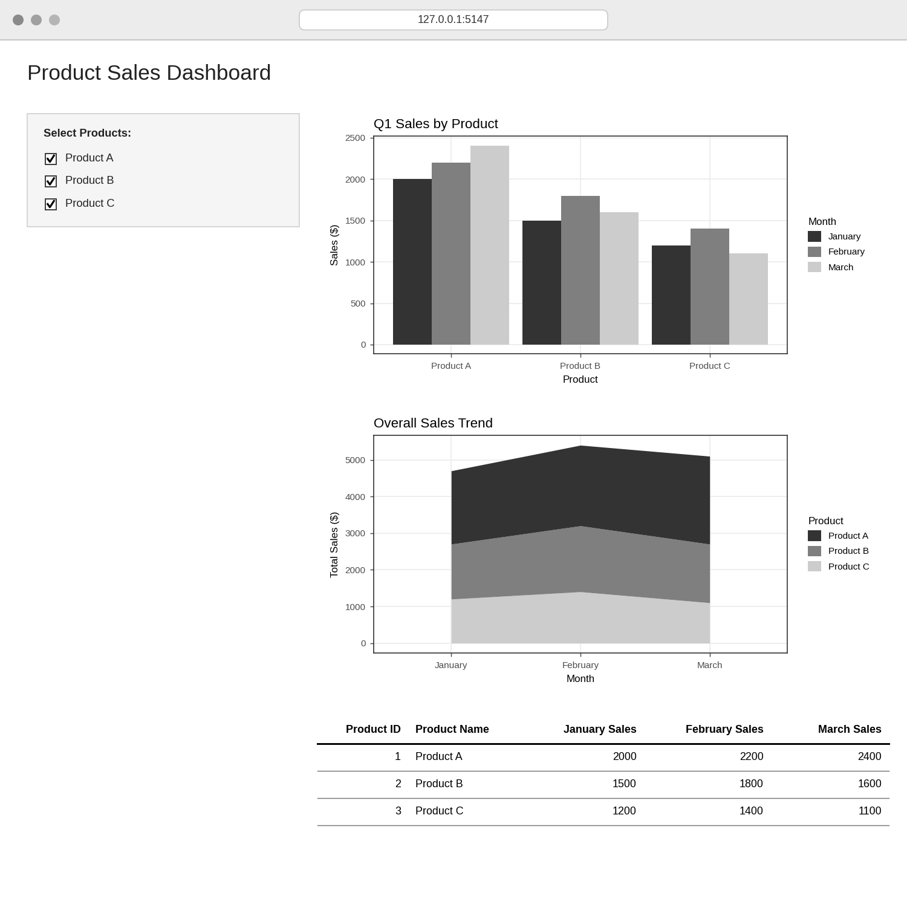
Observation: The dashboard combines the grouped bar chart, stacked area chart and sales table. Selecting or clearing products in the sidebar updates all three views at the same time.
PROCEDURE
- Create the product and monthly sales data in R.
- Build a month-by-product matrix and use barplot() with beside = TRUE to create the grouped bar chart.
- Create a long-format data frame and use ggplot2 with geom_area() to draw the stacked area chart.
- Create a data.frame() with the monthly sales of each product and display it as a table.
- Load the Shiny and ggplot2 packages, then create the UI and server components for the dashboard.
- Run the Shiny application and select products to update the charts and table.
RESULT
The monthly product sales data was successfully visualized using a grouped bar chart, a stacked area chart and a data table. An interactive Shiny dashboard combining all three was also created.
KEY R FUNCTIONS USED
- matrix() – Builds the month-by-product sales data.
- barplot(beside = TRUE) – Creates the grouped bar chart.
- ggplot() / geom_area() – Creates the stacked area chart (ggplot2 package).
- data.frame() – Creates the sales table.
- checkboxGroupInput() – Provides the product selection control.
- reactive() – Filters the data when the selection changes.
- renderPlot() / renderTable() – Generate plots and tables dynamically in Shiny.
- shinyApp() – Runs the interactive Shiny application.

