DSA0601 Data Handling and Visualization
Name: Lakshna Sree T S
Regno: 192524059
SET 22 — TIME SERIES ANALYSIS
Dataset
Month | Sales (in $)
January | 15000
February | 18000
March | 22000
April | 20000
May | 23000

Note: The dataset has no advertising budget, product split or year. Sample values were assumed: advertising budget $5000, $6000, $7000, $8000, $9000 (Program 2); sales by product A $42,000, B $31,000, C $25,000, which add up to the total of $98,000 (Program 3); and the series starts in January 2025.
PROGRAM 1 — Time Series Line Chart of Monthly Sales
# Dataset
month <- c("January", "February", "March", "April", "May")
sales <- c(15000, 18000, 22000, 20000, 23000)
# Convert to a time series object
sales_ts <- ts(sales, start = c(2025, 1), frequency = 12)
# Time Series Line Chart
plot(sales_ts,
type = "o",
xaxt = "n",
xlab = "Month",
ylab = "Sales ($)",
main = "Monthly Sales Trend")
axis(1, at = time(sales_ts), labels = month)

Output: Time series line chart showing the trend in monthly sales.
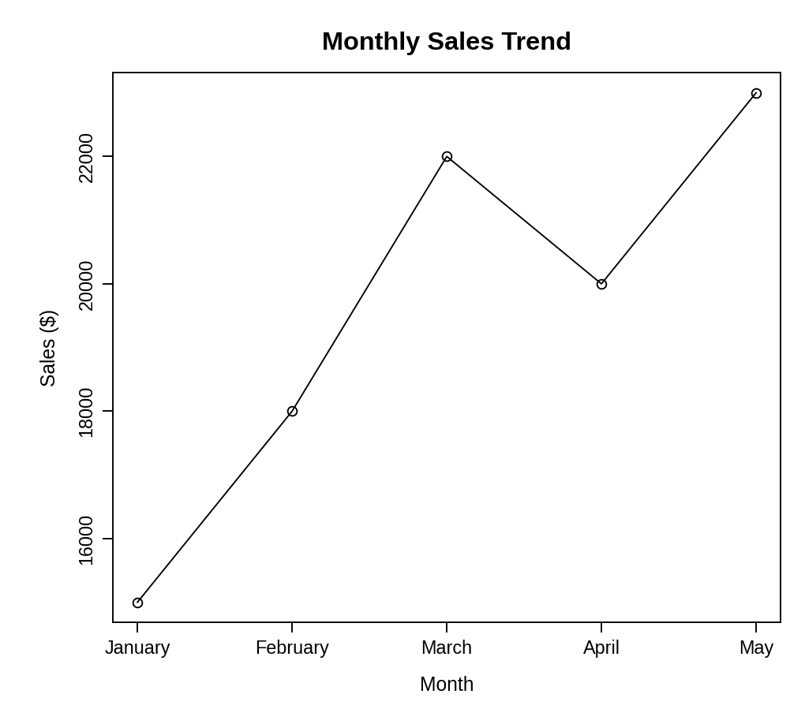
Observation: Sales rise from $15,000 in January to $22,000 in March, dip to $20,000 in April and reach the highest value of $23,000 in May. The overall trend is upward.
PROGRAM 2 — Scatter Plot of Advertising Budget vs Monthly Sales
# Dataset (advertising budget is a sample value)
advertising <- c(5000, 6000, 7000, 8000, 9000)
sales <- c(15000, 18000, 22000, 20000, 23000)
# Scatter Plot
plot(advertising, sales,
pch = 19,
xlab = "Advertising Budget ($)",
ylab = "Monthly Sales ($)",
main = "Advertising Budget vs Monthly Sales")
abline(lm(sales ~ advertising), lty = 2)
# Correlation
cor(advertising, sales)

Output: Scatter plot showing the relationship between advertising budget and monthly sales.
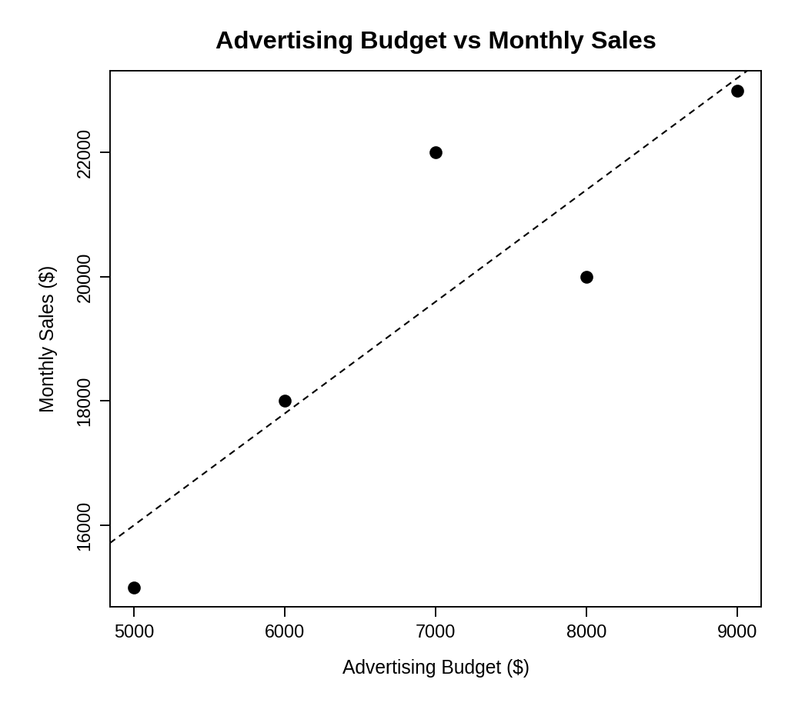
> cor(advertising, sales)
[1] 0.8867964

Insight: The points follow the upward trend line and the correlation is about 0.89, a strong positive relationship: months with a larger advertising budget generally had higher sales. April is below the line (budget $8000, sales $20,000), so advertising is not the only factor. With five months this shows association, not proof of cause.
PROGRAM 3 — Tableau Dashboard: Sales Trend and Product Distribution
Dashboard steps:
- Open Tableau and connect to the monthly sales data and the product-wise sales data (sample values).
- Line chart: drag Month to Columns (sorted January to May) and SUM(Sales) to Rows, and set the mark type to Line with markers.
- Pie chart: drag Product to Color, SUM(Sales) to Angle, set the mark type to Pie and show the percentage of total as the label.
- Add a Month filter (Show Filter) and set it to Apply to Worksheets > All Using This Data Source.
- Create a new dashboard, drag the line chart and the pie chart onto it and place the filter on the right.
- Select each chart and enable Use as Filter for interactive exploration.

Output: An interactive Tableau dashboard with the sales trend line chart and the product-wise sales pie chart.
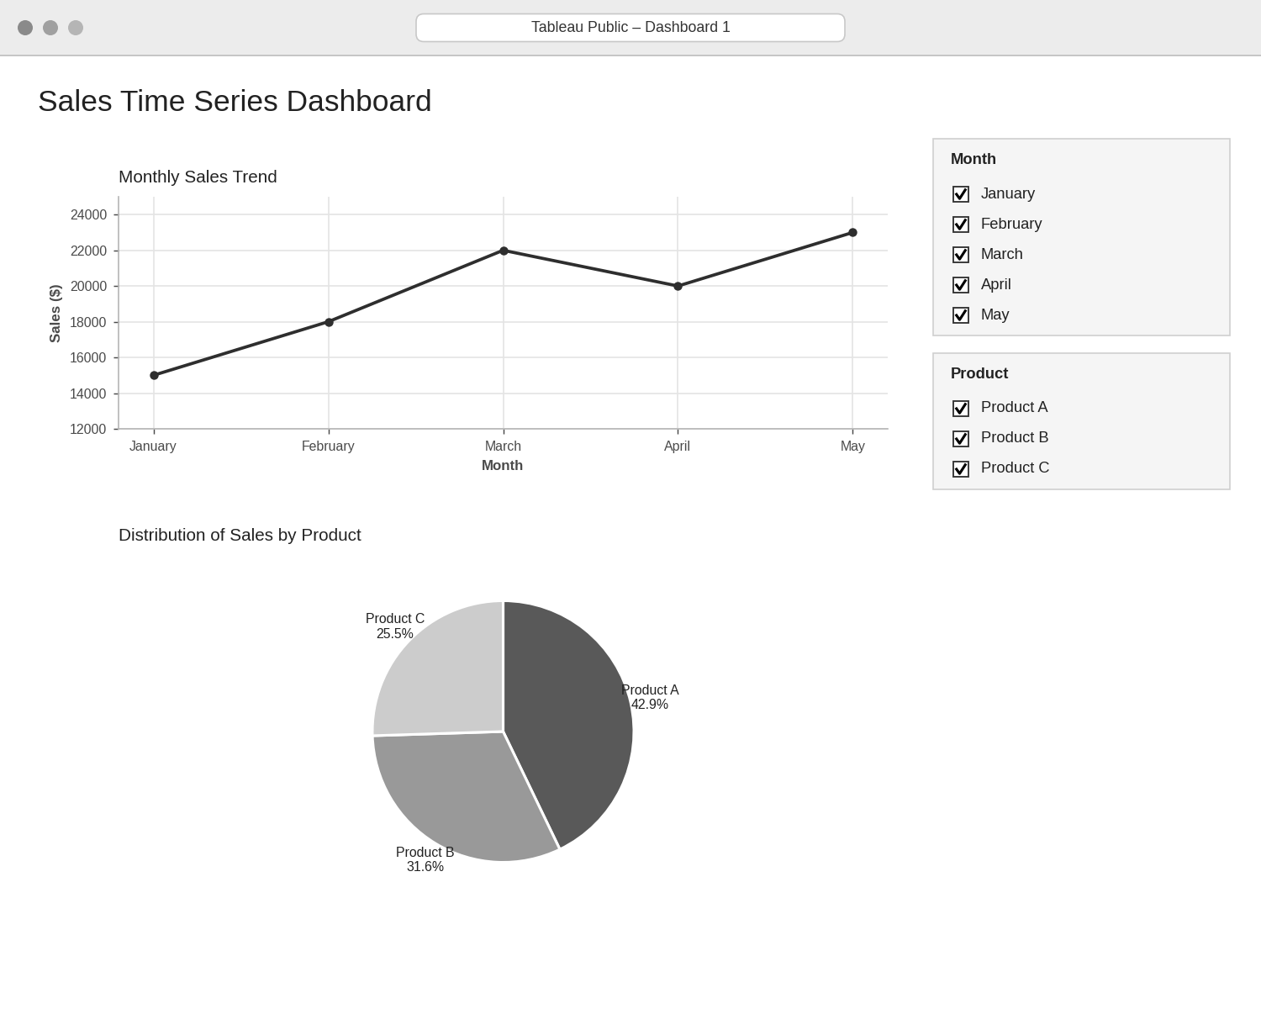
Observation: The line chart shows the rising monthly trend while the pie chart shows the share of each product: Product A 42.9%, Product B 31.6% and Product C 25.5% of the $98,000 total. Selecting months or products updates both views.
PROGRAM 4 — Autocorrelation Plot of Monthly Sales
# Dataset
sales <- c(15000, 18000, 22000, 20000, 23000)
# Autocorrelation plot (up to lag 4)
acf(sales, lag.max = 4,
main = "Series sales")
# Autocorrelation values
acf(sales, lag.max = 4, plot = FALSE)

Output: Autocorrelation plot of the monthly sales series.
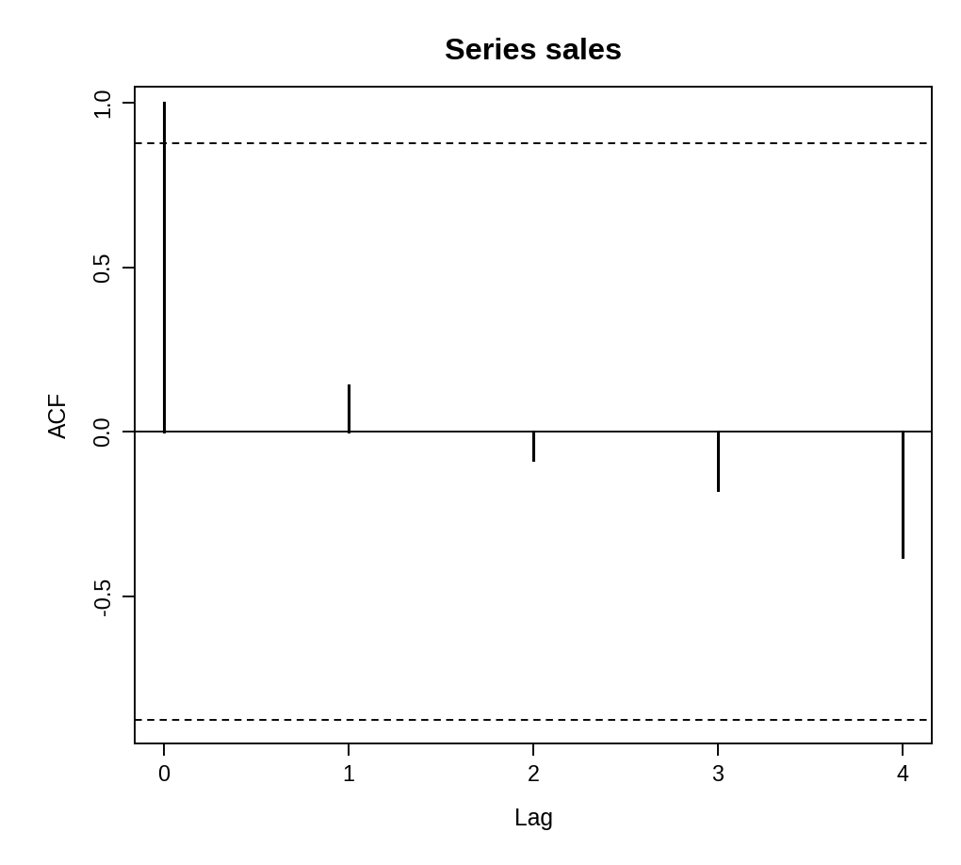
> acf(sales, lag.max = 4, plot = FALSE)

Autocorrelations of series ‘sales’, by lag

0 1 2 3 4
1.000 0.142 -0.085 -0.177 -0.380

Interpretation: The autocorrelation is 0.14 at lag 1 and becomes negative at lags 2 to 4 (-0.09, -0.18, -0.38). All values lie inside the dashed 95% confidence limits (about ±0.88), so there is no significant autocorrelation and no seasonal pattern can be identified. With only five monthly values, seasonality cannot be judged anyway: at least two full years (24 months) of data are needed to see a 12-month cycle.
PROCEDURE
- Create the month and sales data and convert the sales to a time series with ts().
- Draw the time series line chart with plot() and label the months with axis().
- Create the advertising budget vector, draw the scatter plot with a trend line and calculate the correlation with cor().
- In Tableau, build the sales trend line chart and the product-sales pie chart and combine them in a dashboard with a Month filter.
- Use acf() to draw the autocorrelation plot and print the autocorrelation values.
- Interpret the trend, the relationship with advertising and the autocorrelation.
RESULT
The monthly sales data was successfully analysed using a time series line chart, a scatter plot, an autocorrelation plot and an interactive Tableau dashboard. Sales show an upward trend with a strong positive relationship (r ≈ 0.89) to advertising, and no seasonality could be detected from only five months.
KEY FUNCTIONS / TOOLS USED
- ts() – Creates a time series object.
- plot() / axis() – Draw the line chart with month labels.
- abline() / lm() / cor() – Add the trend line and calculate the correlation.
- acf() – Calculates and plots the autocorrelation.
- Tableau Sheets – One worksheet for each chart or table.
- Tableau Dashboard – Combines the sheets with filters for interactive exploration.

