DSA0601 Data Handling and Visualization
Name: Lakshna Sree T S
Regno: 192524059
SET 23 — EMPLOYEE PERFORMANCE ANALYSIS
Dataset
Employee ID | Department | Years of Service | Performance Score
1 | Sales | 5 | 85
2 | HR | 3 | 92
3 | Marketing | 7 | 78
4 | Sales | 4 | 90
5 | HR | 2 | 76

Note: The dataset has no date column, so "performance over time" is shown against Years of Service, with the employees arranged from the shortest to the longest service.
PROGRAM 1 — Bar Chart of Employees by Department
# Dataset
department <- c("Sales", "HR", "Marketing", "Sales", "HR")
# Count employees in each department
dept_count <- table(department)
# Bar Chart
barplot(dept_count,
xlab = "Department",
ylab = "Number of Employees",
main = "Employees by Department",
ylim = c(0, 2))

Output: Bar chart displaying the number of employees in each department.
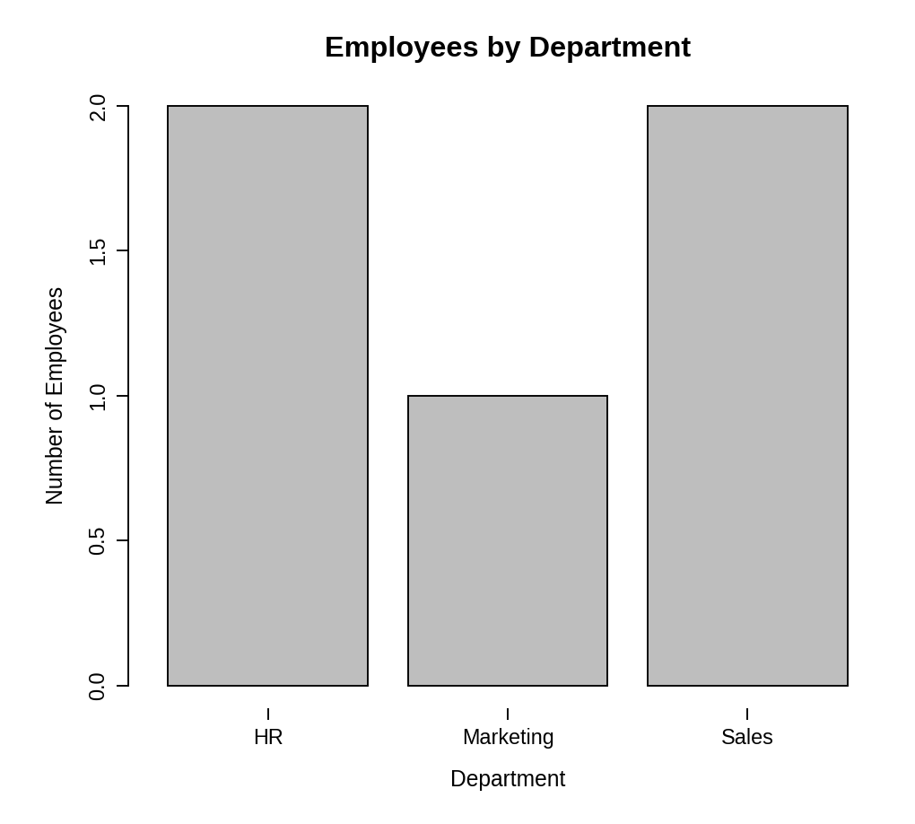
Observation: HR and Sales have two employees each, while Marketing has one employee.
PROGRAM 2 — Line Chart of Performance Trend
# Dataset
years <- c(5, 3, 7, 4, 2)
score <- c(85, 92, 78, 90, 76)
# Arrange by years of service
ord <- order(years)
# Line Chart
plot(years[ord], score[ord],
type = "o",
xaxt = "n",
xlab = "Years of Service",
ylab = "Performance Score",
main = "Employee Performance Trend")
axis(1, at = years[ord])

Output: Line chart showing performance score against years of service.
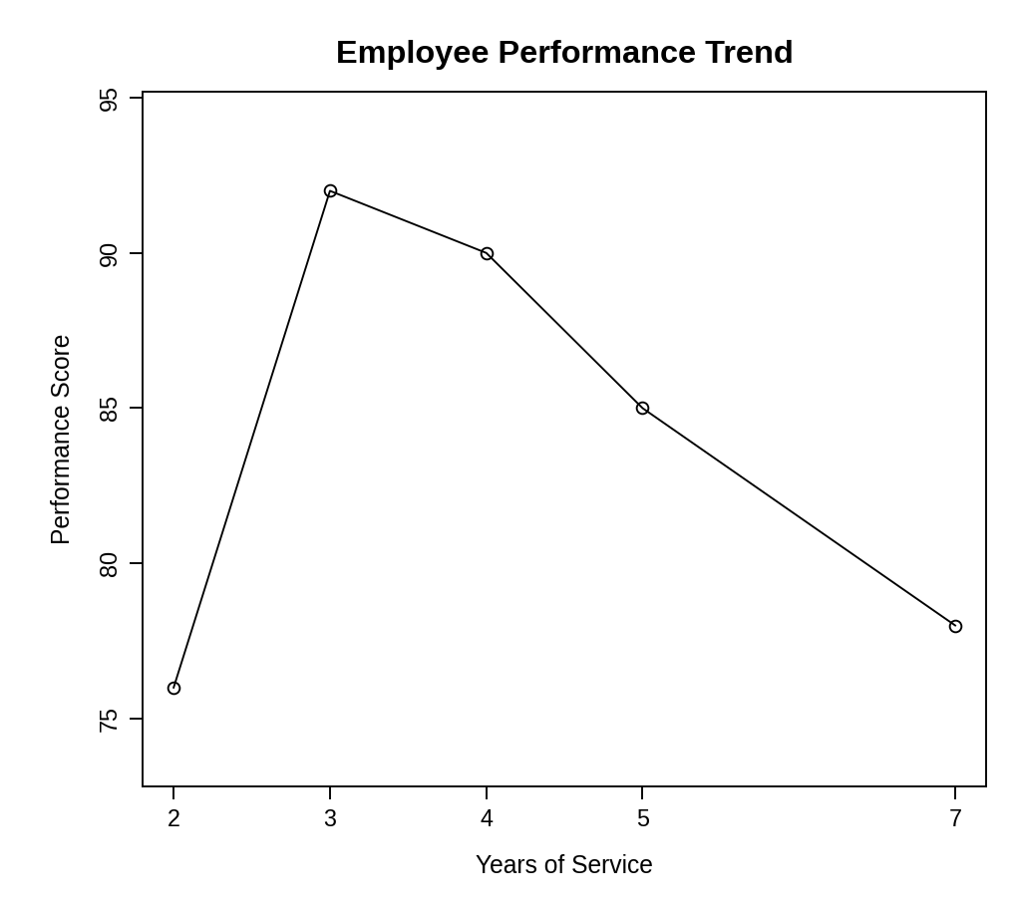
Observation: The score jumps from 76 (2 years) to 92 (3 years), then falls steadily to 90, 85 and 78 at 4, 5 and 7 years. The employees with the shortest and longest service do not have the highest scores; the best results are at 3 to 4 years of service.
PROGRAM 3 — Tableau Dashboard for Department Distribution and Performance
Dashboard steps:
- Open Tableau and connect to the employee performance data.
- Bar chart: drag Department to Columns and Number of Records to Rows (Show Me > Bar chart).
- Scatter plot: drag Years of Service to Columns and Performance Score to Rows, turn off Aggregate Measures (Analysis menu), drag Employee ID to Label and add a Trend Line from the Analytics pane.
- Show the Department filter (Apply to Worksheets > All Using This Data Source) and a Years of Service range filter.
- Create a new dashboard, drag both sheets onto it and place the filters on the right.
- Enable Use as Filter on the bar chart so that clicking a department filters the scatter plot.

Output: An interactive Tableau dashboard with the department bar chart and the years-of-service vs performance scatter plot.
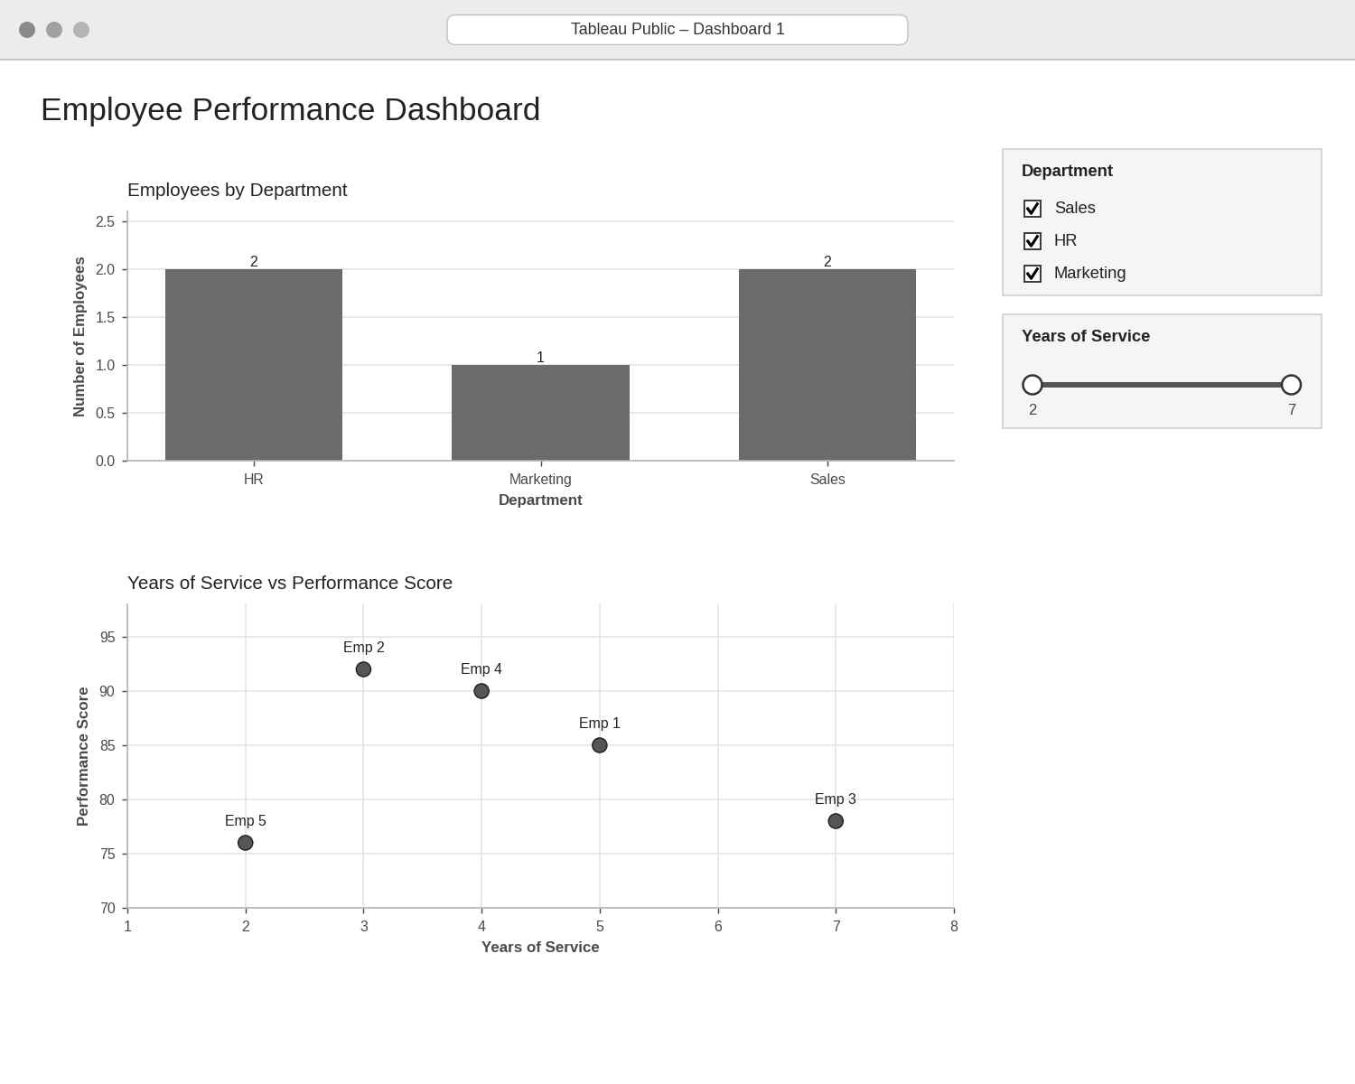
Observation: Clicking a department bar shows only that department’s employees in the scatter plot. The scatter plot shows no clear straight-line relationship between years of service and performance (correlation about -0.17), so experience alone does not explain the score.
PROGRAM 4 — Table of Employee Performance Data
# Dataset
employees <- data.frame(
"Employee ID" = c(1, 2, 3, 4, 5),
"Department" = c("Sales", "HR", "Marketing", "Sales", "HR"),
"Years of Service" = c(5, 3, 7, 4, 2),
"Performance Score" = c(85, 92, 78, 90, 76),
check.names = FALSE
)
# Display the table
print(employees)

Output: Table showing the performance data of each employee.
> print(employees)
Employee ID Department Years of Service Performance Score
1 1 Sales 5 85
2 2 HR 3 92
3 3 Marketing 7 78
4 4 Sales 4 90
5 5 HR 2 76

Observation: The HR employee with 3 years of service has the highest score (92), while the HR employee with 2 years has the lowest (76). The average performance score is 84.2.
PROCEDURE
- Create the employee ID, department, years of service and performance score data in R.
- Count employees per department with table() and draw the bar chart with barplot().
- Sort the employees by years of service with order() and draw the line chart with plot().
- In Tableau, build the department bar chart and the scatter plot and combine them in a dashboard with filters.
- Create a data.frame() with the performance data and display it as a table.
- Interpret the department distribution and the performance pattern.
RESULT
The employee performance data was successfully analysed using a bar chart, a line chart, a data table and an interactive Tableau dashboard. Performance does not rise steadily with years of service.
KEY FUNCTIONS / TOOLS USED
- table() – Counts employees per department.
- barplot() – Creates the bar chart.
- order() – Arranges employees by years of service.
- plot() / axis() – Create the line chart.
- data.frame() – Creates the performance table.
- Tableau Sheets – One worksheet for each chart or table.
- Tableau Dashboard – Combines the sheets with filters for interactive exploration.

