DSA0601 Data Handling and Visualization
Name: Lakshna Sree T S
Regno: 192524059
SET 24 — PRODUCT INVENTORY MANAGEMENT
Dataset
Product ID | Product Name | Quantity Available
1 | Product A | 250
2 | Product B | 175
3 | Product C | 300
4 | Product D | 200
5 | Product E | 220

Note: The dataset has no categories or prices. Sample values were assumed. Categories (Electronics / Home / Office): A 120/80/50, B 70/60/45, C 150/90/60, D 90/70/40, E 100/70/50 (each row adds up to the available quantity). Prices ($): A 20, B 25, C 15, D 22, E 18.
PROGRAM 1 — Bar Chart of Product Quantity
# Dataset
product <- c("Product A", "Product B", "Product C", "Product D", "Product E")
quantity <- c(250, 175, 300, 200, 220)
# Bar Chart
barplot(quantity,
names.arg = product,
xlab = "Product Name",
ylab = "Quantity Available",
main = "Product Inventory")

Output: Bar chart displaying the quantity available for each product.
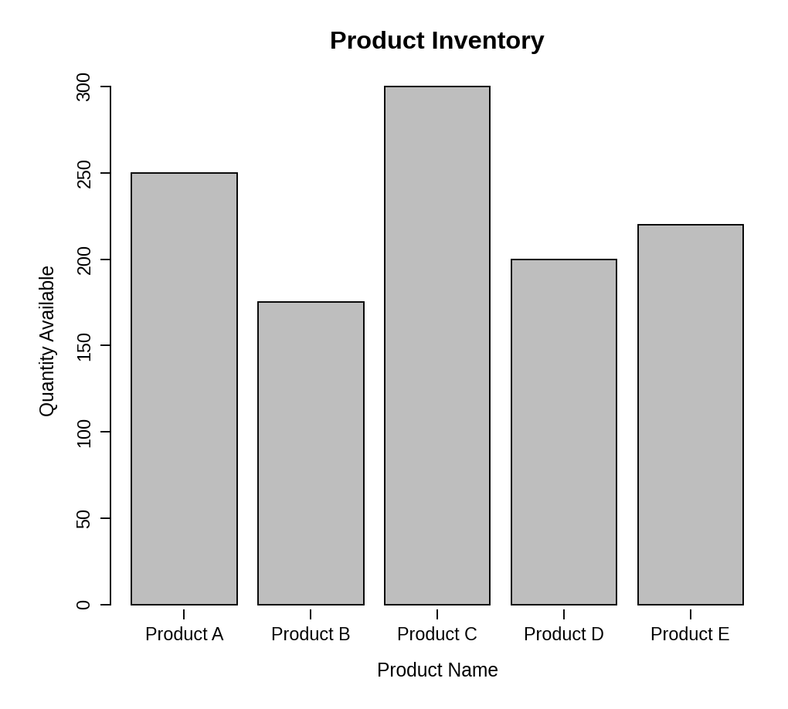
Observation: Product C has the highest stock (300 units) and Product B the lowest (175 units). The other products hold between 200 and 250 units.
PROGRAM 2 — Stacked Bar Chart by Product Category
# Dataset (rows = categories, columns = products)
product <- c("Product A", "Product B", "Product C", "Product D", "Product E")
qty <- matrix(c(120, 70, 150, 90, 100, # Electronics
80, 60, 90, 70, 70, # Home
50, 45, 60, 40, 50), # Office
nrow = 3, byrow = TRUE)
rownames(qty) <- c("Electronics", "Home", "Office")
# Stacked Bar Chart
barplot(qty,
names.arg = product,
xlab = "Product Name",
ylab = "Quantity Available",
main = "Inventory by Product Category",
col = gray.colors(3),
ylim = c(0, 350),
legend.text = rownames(qty))

Output: Stacked bar chart showing the quantity of each product within the categories.
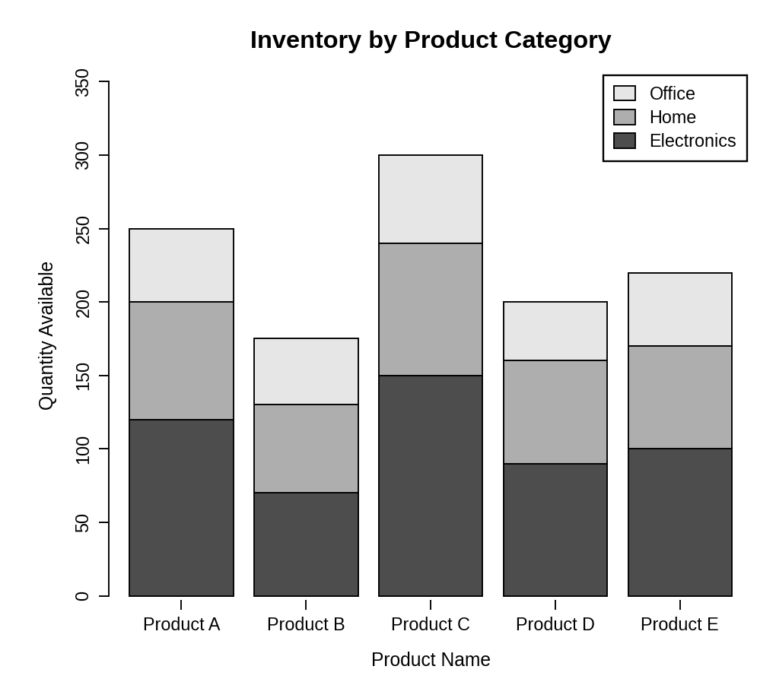
Observation: Each bar is split into Electronics, Home and Office stock, and the total height of each bar matches the quantity in Program 1. Electronics is the largest category for every product.
PROGRAM 3 — Tableau Dashboard for Inventory Data
Dashboard steps:
- Open Tableau and connect to the inventory data (with a Product Category column added).
- Bar chart: drag Product Name to Columns and Quantity Available to Rows, and show the values as labels.
- Stacked bar chart: drag Product Name to Columns, Quantity to Rows and Product Category to Color.
- Show the Product Category and Product Name filters (Apply to Worksheets > All Using This Data Source).
- Create a new dashboard, drag both sheets onto it and place the filters on the right.
- Enable Use as Filter on both charts for interactive exploration.

Output: An interactive Tableau dashboard combining the bar chart and the stacked bar chart, with Category and Product filters.
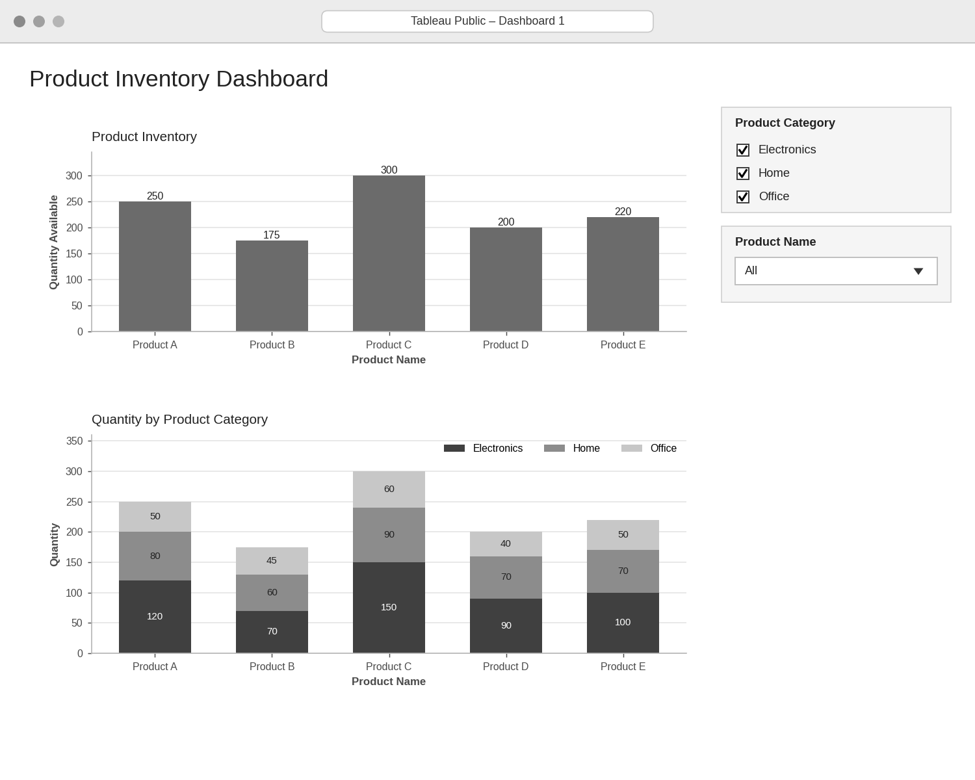
Observation: Choosing a category or product updates both charts, so the stock of each category can be compared product by product.
PROGRAM 4 — Scatter Plot of Price vs Quantity Available
# Dataset (prices are sample values)
price <- c(20, 25, 15, 22, 18)
quantity <- c(250, 175, 300, 200, 220)
# Scatter Plot
plot(price, quantity,
pch = 19,
xlab = "Price ($)",
ylab = "Quantity Available",
main = "Product Price vs Quantity Available")
abline(lm(quantity ~ price), lty = 2)
# Correlation
cor(price, quantity)

Output: Scatter plot showing the relationship between product price and quantity available.
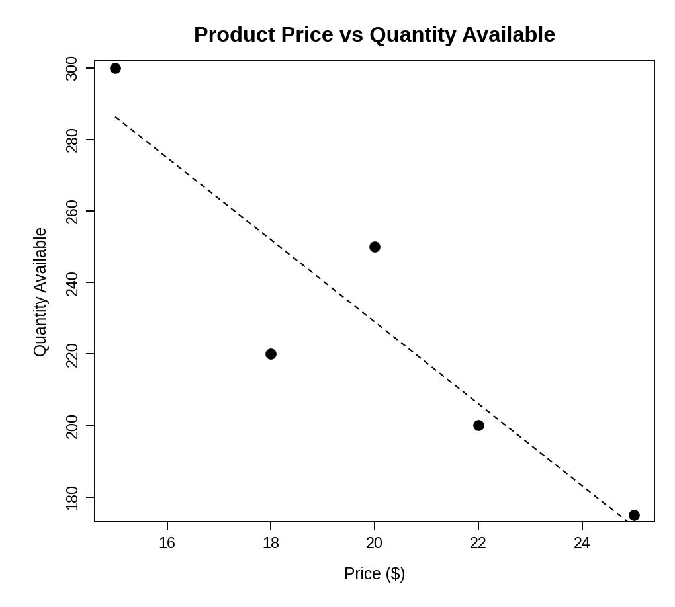
> cor(price, quantity)
[1] -0.9044815

Insight: The points slope downward and the correlation is about -0.90, a strong negative relationship. Cheaper products (such as Product C at $15) are stocked in larger quantities, while costlier products (such as Product B at $25) are stocked in smaller quantities. With only five products this is an indication of a pattern, not proof.
PROCEDURE
- Create the product, quantity, category and price data in R.
- Use barplot() to draw the bar chart of quantity for each product.
- Create a category-by-product matrix and use barplot() to draw the stacked bar chart with a legend.
- In Tableau, build the bar chart and the stacked bar chart and combine them in a dashboard with filters.
- Create price and quantity vectors, draw the scatter plot with plot() and measure the relationship with cor().
- Interpret the stock levels and the price–quantity relationship.
RESULT
The inventory data was successfully visualized using a bar chart, a stacked bar chart, a scatter plot and an interactive Tableau dashboard. A strong negative relationship (r ≈ -0.90) was found between price and quantity available.
KEY FUNCTIONS / TOOLS USED
- barplot() – Creates bar charts and stacked bar charts.
- matrix() – Builds the category-by-product data.
- plot() / abline() / lm() – Create the scatter plot with a trend line.
- cor() – Calculates the correlation.
- Tableau Sheets – One worksheet for each chart or table.
- Tableau Dashboard – Combines the sheets with filters for interactive exploration.

