DSA0601 • DATA HANDLING AND VISUALIZATION
LAB EXPERIMENT RECORD
Set 10: Survey Responses Analysis
Department | AIML
Course Code / Course Name | DSA0601 / Data Handling and Visualization
Experiment | Data Visualization using R
Name | Lakshna Sree T S
Register Number | 192524059
Aim
To visualize survey response data using a grouped bar chart, stacked bar chart, and data table, and to build an interactive dashboard using R and Shiny.
Dataset: Survey Responses
Survey ID | Question 1 | Question 2 | Question 3
1 | A | B | C
2 | B | A | D
3 | C | A | B
PROGRAM 1: Grouped Bar Chart for Question 1
Create a grouped bar chart to visualize the distribution of answers for Question 1. Label the chart elements.
# Dataset
q1 <- c("A", "B", "C")
options <- c("A", "B", "C", "D")

# Rows = surveys, columns = answer options (1 if chosen)
q1_matrix <- sapply(options, function(o) as.numeric(q1 == o))
rownames(q1_matrix) <- c("Survey 1", "Survey 2", "Survey 3")

# Grouped Bar Chart
barplot(q1_matrix,
beside = TRUE,
xlab = "Answer Option (Question 1)",
ylab = "Number of Responses",
main = "Distribution of Answers: Question 1",
col = c("steelblue", "orange", "darkgreen"),
legend.text = rownames(q1_matrix),
ylim = c(0, 1.5))

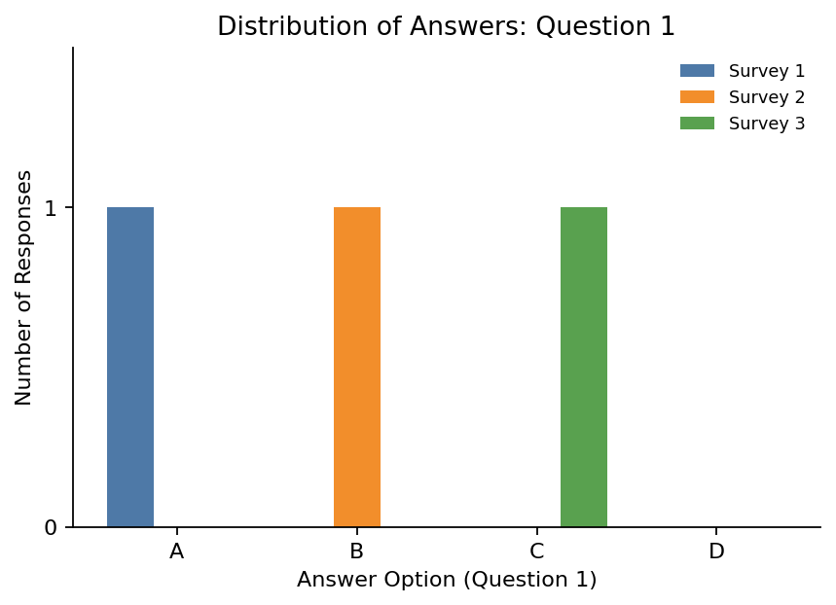
Output 1: Grouped Bar Chart of Question 1 Answers
Observation: Options A, B and C were each chosen by exactly one survey (Survey 1, 2 and 3 respectively) and option D was not chosen, so the answers to Question 1 are evenly split.
PROGRAM 2: Stacked Bar Chart for All Questions
Generate a stacked bar chart to represent the overall distribution of responses for all three questions.
# Dataset
survey <- data.frame(
Q1 = c("A", "B", "C"),
Q2 = c("B", "A", "A"),
Q3 = c("C", "D", "B")
)

# Count answers for each question (rows = answers, columns = questions)
levels <- c("A", "B", "C", "D")
counts <- sapply(survey, function(x) table(factor(x, levels = levels)))
colnames(counts) <- c("Question 1", "Question 2", "Question 3")

# Stacked Bar Chart
barplot(counts,
xlab = "Question",
ylab = "Number of Responses",
main = "Overall Distribution of Responses",
col = c("steelblue", "orange", "darkgreen", "firebrick"),
legend.text = rownames(counts),
args.legend = list(title = "Answer"),
ylim = c(0, 4.2))

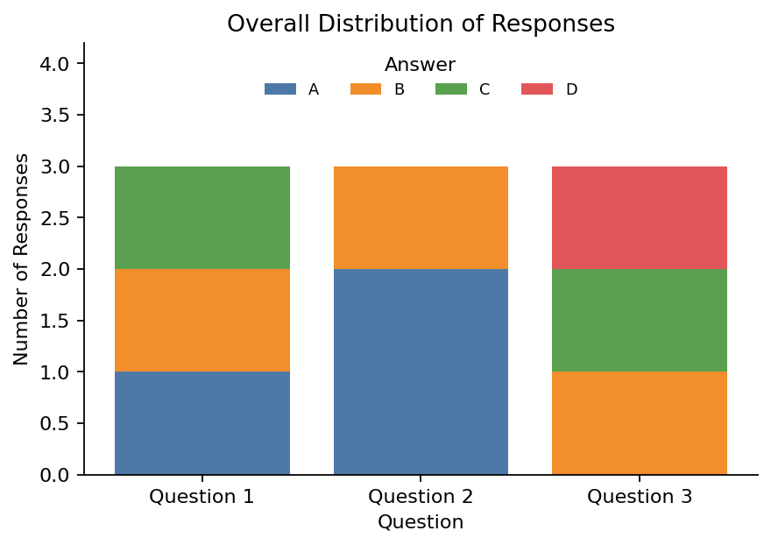
Output 2: Stacked Bar Chart of All Responses
Observation: Every bar totals 3 responses. Option A was the most common answer to Question 2 (2 of 3), while Questions 1 and 3 had a different answer from each respondent. Option D appears only once, in Question 3.
PROGRAM 3: Table of Survey Responses
Build a table to show the survey response data for each survey. Label the table elements.
# Dataset
survey_table <- data.frame(
"Survey ID" = c(1, 2, 3),
"Question 1" = c("A", "B", "C"),
"Question 2" = c("B", "A", "A"),
"Question 3" = c("C", "D", "B"),
check.names = FALSE
)

# Display the table
print(survey_table)

Observation: The table shows the answer given by each survey to every question, which can be compared with the counts in the charts.
Output 3: Survey Responses Table
Survey ID | Question 1 | Question 2 | Question 3
1 | A | B | C
2 | B | A | D
3 | C | A | B
PROGRAM 4: Interactive Survey Dashboard
Develop an interactive dashboard combining the grouped bar chart, stacked bar chart and table using the Shiny package.
library(shiny)

survey <- data.frame(
id = c(1, 2, 3),
Q1 = c("A", "B", "C"),
Q2 = c("B", "A", "A"),
Q3 = c("C", "D", "B")
)
levels <- c("A", "B", "C", "D")

ui <- fluidPage(
titlePanel("Survey Responses Dashboard"),
sidebarLayout(
sidebarPanel(
checkboxGroupInput("ids", "Select Surveys:",
choices = survey$id,
selected = survey$id)
),
mainPanel(
plotOutput("groupPlot"),
plotOutput("stackPlot"),
tableOutput("surveyTable")
)
)
)

server <- function(input, output) {
filtered <- reactive({ subset(survey, id %in% input$ids) })

output$groupPlot <- renderPlot({
d <- filtered(); req(nrow(d) > 0)
m <- sapply(levels, function(o) as.numeric(d$Q1 == o))
m <- matrix(m, nrow = nrow(d))
barplot(m, beside = TRUE, names.arg = levels,
xlab = "Answer Option (Question 1)", ylab = "Number of Responses",
main = "Distribution of Answers: Question 1",
col = rainbow(nrow(d)), ylim = c(0, 1.5))
})

output$stackPlot <- renderPlot({
d <- filtered(); req(nrow(d) > 0)
counts <- sapply(d[, c("Q1", "Q2", "Q3")],
function(x) table(factor(x, levels = levels)))
barplot(counts, xlab = "Question", ylab = "Number of Responses",
main = "Overall Distribution of Responses",
col = c("steelblue", "orange", "darkgreen", "firebrick"),
legend.text = levels)
})

output$surveyTable <- renderTable({
d <- filtered()
names(d) <- c("Survey ID", "Question 1", "Question 2", "Question 3")
d
})
}

shinyApp(ui = ui, server = server)

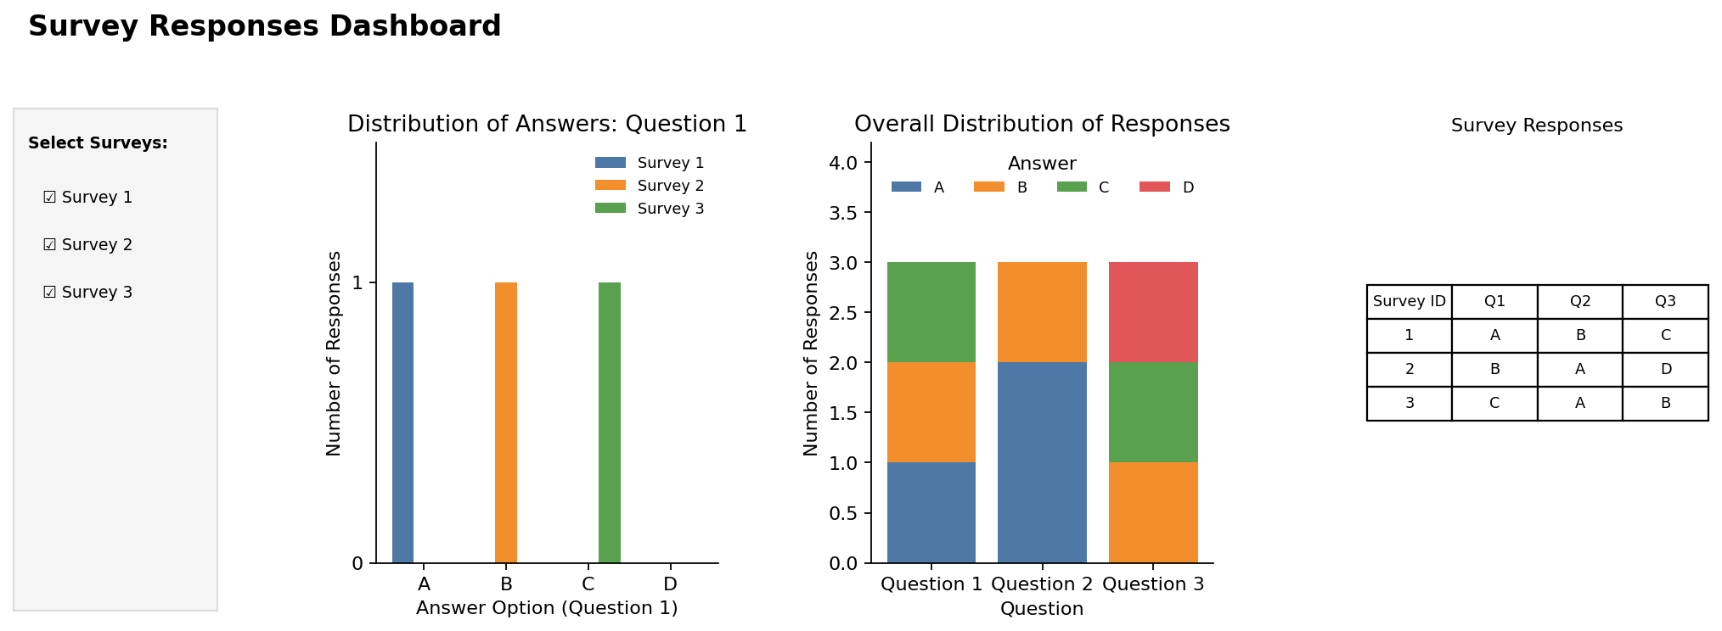
Output 4: Interactive Survey Responses Dashboard
Observation: The dashboard combines the grouped bar chart, stacked bar chart and response table. Selecting or clearing surveys in the sidebar updates all three views together.
Procedure
1. Create the survey ID and the Question 1, Question 2 and Question 3 answers in R.
2. Build a survey-by-option matrix for Question 1 and use barplot() with beside = TRUE for the grouped bar chart.
3. Count the answers to each question with table() and use barplot() to draw the stacked bar chart.
4. Create a data.frame() with the survey responses and display it as a table.
5. Install and load the Shiny package, then create the UI and server components for the dashboard.
6. Run the Shiny application and select surveys to update the charts and table.
Result
The survey response data was successfully visualized using a grouped bar chart, a stacked bar chart and a data table. An interactive Shiny dashboard combining all three was also created.
Key R Functions Used
Function | Purpose
sapply() | Builds the answer-count matrices.
table() / factor() | Count how many times each answer was chosen.
barplot(beside = TRUE) | Creates the grouped bar chart.
barplot() | Creates the stacked bar chart.
data.frame() | Creates the response table.
checkboxGroupInput() | Provides the survey selection control.
reactive() | Filters the data when the selection changes.
renderPlot() / renderTable() | Generate plots and tables dynamically in Shiny.
shinyApp() | Runs the interactive Shiny application.

