DSA0601 • DATA HANDLING AND VISUALIZATION
LAB EXPERIMENT RECORD
Set 11: Product Category Analysis
Department | AIML
Course Code / Course Name | DSA0601 / Data Handling and Visualization
Experiment | Data Visualization using R
Name | Lakshna Sree T S
Register Number | 192524059
Aim
To analyze product category sales using a funnel chart, table, and pie chart, and to build an interactive dashboard using R and Shiny.
Dataset: Product Categories
Category | Sales (in $)
Electronics | 50000
Clothing | 35000
Appliances | 40000
Note: The dataset has only one sales value per category and no conversion stages. The funnel chart therefore ranks the categories from highest to lowest sales, with the bar width showing each category's sales.
PROGRAM 1: Funnel Chart of Category Sales
Generate a funnel chart to analyze the sales conversion process for each product category. Label the stages and title the chart.
# Dataset
category <- c("Electronics", "Clothing", "Appliances")
sales <- c(50000, 35000, 40000)

# Order the stages from highest to lowest sales
ord <- order(sales, decreasing = TRUE)
category <- category[ord]
sales <- sales[ord]

# Funnel Chart (centred horizontal bars)
plot(NULL, xlim = c(-30000, 30000), ylim = c(0.5, 3.5),
axes = FALSE, xlab = "", ylab = "",
main = "Sales Funnel by Product Category")
cols <- c("steelblue", "orange", "darkgreen")
for (i in 1:3) {
y <- 4 - i
rect(-sales[i] / 2, y - 0.4, sales[i] / 2, y + 0.4, col = cols[i])
text(0, y, paste0(category[i], "\n$", format(sales[i], big.mark = ",")),
col = "white", font = 2)
}

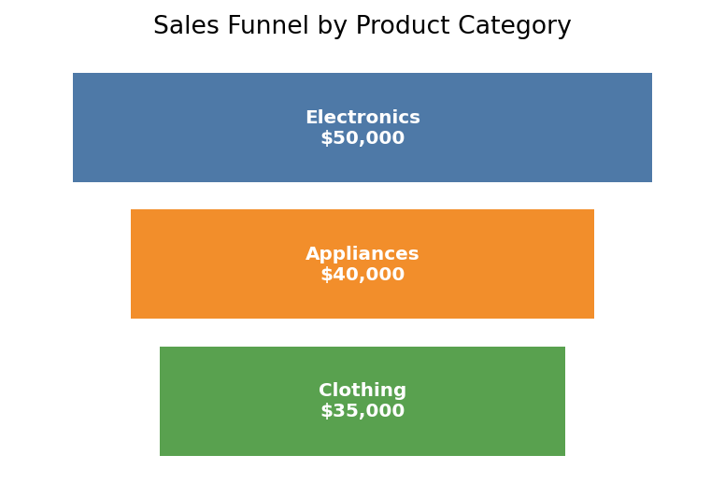
Output 1: Sales Funnel by Product Category
Observation: Electronics is the widest stage ($50,000), followed by Appliances ($40,000) and Clothing ($35,000). The funnel narrows from the highest to the lowest selling category.
PROGRAM 2: Table of Category Sales
Build a table to display the sales data for each product category. Label the table elements.
# Dataset
sales_table <- data.frame(
"Category" = c("Electronics", "Clothing", "Appliances"),
"Sales (in $)" = c(50000, 35000, 40000),
check.names = FALSE
)

# Display the table
print(sales_table)

Observation: The table lists the sales of each category. Total sales are $125,000.
Output 2: Product Category Sales Table
Category | Sales (in $)
Electronics | 50000
Clothing | 35000
Appliances | 40000
PROGRAM 3: Interactive Product Category Dashboard
Develop an interactive dashboard combining the pie chart, funnel chart and table using the Shiny package.
library(shiny)

sales_data <- data.frame(
category = c("Electronics", "Clothing", "Appliances"),
sales = c(50000, 35000, 40000)
)
cols <- c(Electronics = "steelblue", Clothing = "darkgreen", Appliances = "orange")

ui <- fluidPage(
titlePanel("Product Category Dashboard"),
sidebarLayout(
sidebarPanel(
checkboxGroupInput("cats", "Select Categories:",
choices = sales_data$category,
selected = sales_data$category)
),
mainPanel(
plotOutput("piePlot"),
plotOutput("funnelPlot"),
tableOutput("salesTable")
)
)
)

server <- function(input, output) {
filtered <- reactive({
d <- subset(sales_data, category %in% input$cats)
d[order(d$sales, decreasing = TRUE), ]
})

output$piePlot <- renderPlot({
d <- filtered(); req(nrow(d) > 0)
pct <- round(100 * d$sales / sum(d$sales), 1)
pie(d$sales, labels = paste0(d$category, " (", pct, "%)"),
col = cols[d$category], main = "Sales Distribution by Category")
})

output$funnelPlot <- renderPlot({
d <- filtered(); req(nrow(d) > 0)
n <- nrow(d)
plot(NULL, xlim = c(-30000, 30000), ylim = c(0.5, n + 0.5),
axes = FALSE, xlab = "", ylab = "",
main = "Sales Funnel by Product Category")
for (i in 1:n) {
y <- n + 1 - i
rect(-d$sales[i] / 2, y - 0.4, d$sales[i] / 2, y + 0.4, col = cols[d$category[i]])
text(0, y, paste0(d$category[i], ": $", format(d$sales[i], big.mark = ",")),
col = "white", font = 2)
}
})

output$salesTable <- renderTable({
d <- filtered()
names(d) <- c("Category", "Sales (in $)")
d
})
}

shinyApp(ui = ui, server = server)

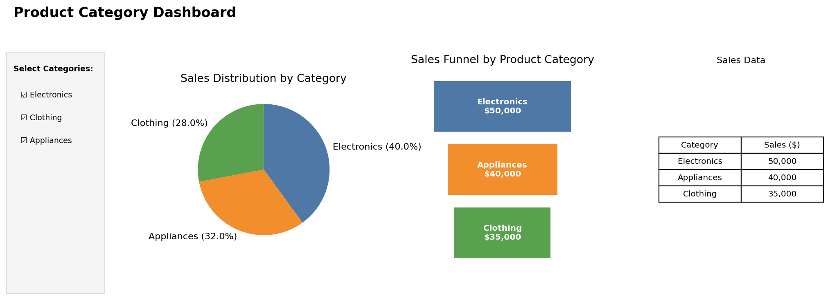
Output 3: Interactive Product Category Dashboard
Observation: The dashboard combines the pie chart, funnel chart and sales table. Selecting or clearing categories in the sidebar updates all three views together.
PROGRAM 4: Pie Chart of Sales Distribution
Create a pie chart to represent the distribution of sales across product categories. Include labels.
# Dataset
category <- c("Electronics", "Clothing", "Appliances")
sales <- c(50000, 35000, 40000)

# Percentage labels
percent <- round(100 * sales / sum(sales), 1)

# Pie Chart
pie(sales,
labels = paste0(category, " (", percent, "%)"),
main = "Sales Distribution by Category",
col = c("steelblue", "darkgreen", "orange"))

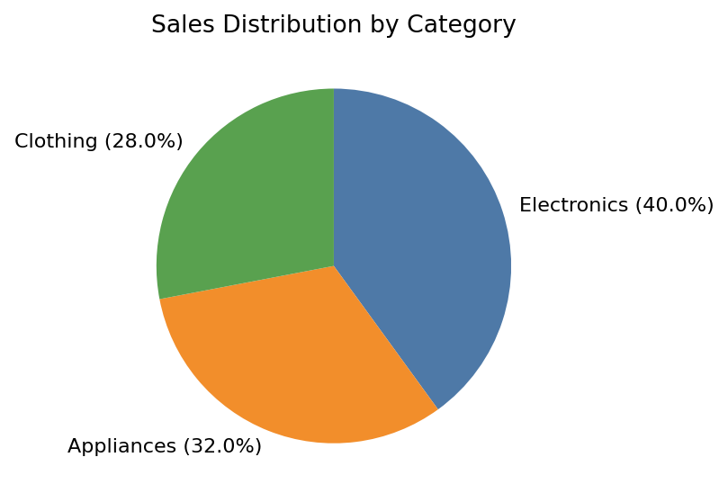
Output 4: Sales Distribution Pie Chart
Observation: Electronics contributes 40% of total sales, Appliances 32% and Clothing 28%, so no single category dominates.
Procedure
1. Create the category and sales vectors in R.
2. Order the categories by sales and draw centred bars with plot(), rect() and text() to build the funnel chart.
3. Create a data.frame() with the category sales and display it as a table.
4. Use pie() with percentage labels to draw the pie chart.
5. Install and load the Shiny package, then create the UI and server components for the dashboard.
6. Run the Shiny application and select categories to update the pie chart, funnel chart and table.
Result
The product category sales data was successfully visualized using a funnel chart, a pie chart and a data table. An interactive Shiny dashboard combining all three was also created.
Key R Functions Used
Function | Purpose
order() | Ranks categories from highest to lowest sales.
plot(NULL, ...) | Creates an empty plotting area for the funnel.
rect() / text() | Draw and label the funnel stages.
pie() | Creates the pie chart.
data.frame() | Creates the sales table.
checkboxGroupInput() | Provides the category selection control.
reactive() | Filters the data when the selection changes.
renderPlot() / renderTable() | Generate plots and tables dynamically in Shiny.
shinyApp() | Runs the interactive Shiny application.

