DSA0601 • DATA HANDLING AND VISUALIZATION
LAB EXPERIMENT RECORD
Set 12: Website Traffic Analysis
Department | AIML
Course Code / Course Name | DSA0601 / Data Handling and Visualization
Experiment | Data Visualization using R
Name | Lakshna Sree T S
Register Number | 192524059
Aim
To visualize website traffic data using a line chart, bar chart, and data table, and to build an interactive dashboard using R and Shiny.
Dataset: Website Traffic
Date | Page Views | Click-through Rate
2023-01-01 | 1500 | 2.3%
2023-01-02 | 1600 | 2.7%
2023-01-03 | 1400 | 2.0%
PROGRAM 1: Line Chart of Daily Page Views
Create a line chart to visualize the trend in daily page views over time. Label the axes and title the chart.
# Dataset
date <- as.Date(c("2023-01-01", "2023-01-02", "2023-01-03"))
page_views <- c(1500, 1600, 1400)

# Line Chart
plot(date, page_views,
type = "o",
xlab = "Date",
ylab = "Page Views",
main = "Daily Page Views",
col = "blue")

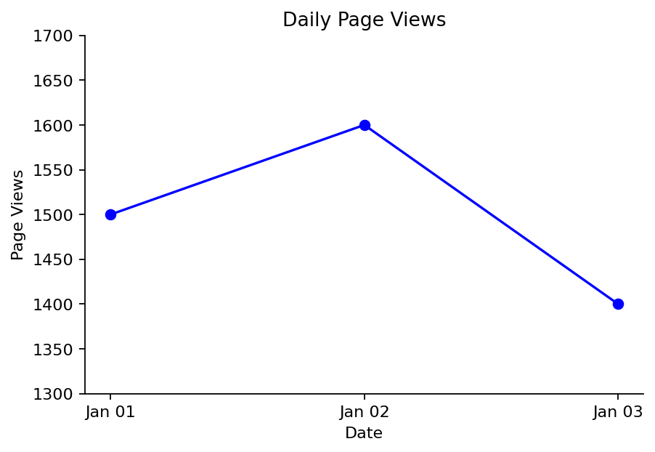
Output 1: Daily Page Views Line Chart
Observation: Page views increase from 1500 to 1600 on 2 January and then drop to 1400 on 3 January, the lowest value in the period.
PROGRAM 2: Bar Chart of Top N Days by Click-through Rate
Generate a bar chart showing the top N days with the highest click-through rates. Label the chart elements.
# Dataset
date <- c("2023-01-01", "2023-01-02", "2023-01-03")
ctr <- c(2.3, 2.7, 2.0)

# Select the top N days
N <- 2
top <- order(ctr, decreasing = TRUE)[1:N]

# Bar Chart
barplot(ctr[top],
names.arg = date[top],
xlab = "Date",
ylab = "Click-through Rate (%)",
main = paste("Top", N, "Days by Click-through Rate"),
col = "darkgreen")

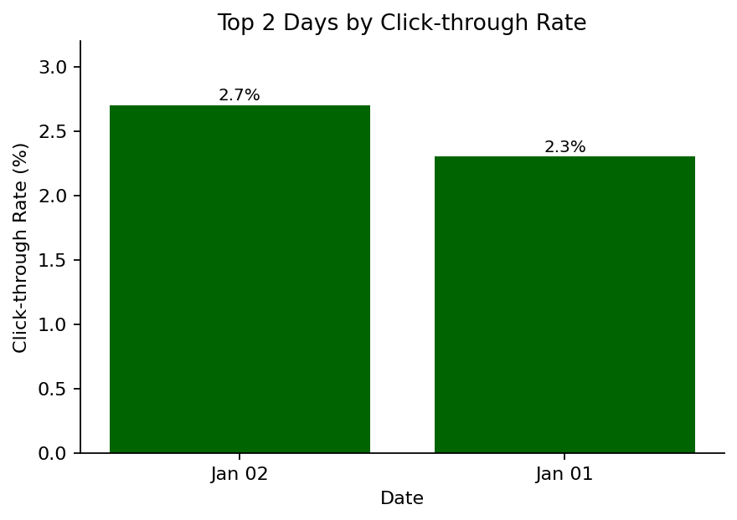
Output 2: Top 2 Days by Click-through Rate
Observation: The two best days are 2 January (2.7%) and 1 January (2.3%). 3 January has the lowest click-through rate (2.0%) and is left out of the top 2.
PROGRAM 3: Table of Website Traffic Data
Build a table to show the website traffic data for each day. Label the table elements.
# Dataset
traffic <- data.frame(
"Date" = c("2023-01-01", "2023-01-02", "2023-01-03"),
"Page Views" = c(1500, 1600, 1400),
"Click-through Rate (%)" = c(2.3, 2.7, 2.0),
check.names = FALSE
)

# Display the table
print(traffic)

Observation: The table gives the page views and click-through rate for each day. 2 January has both the most page views and the highest click-through rate, and 3 January has the lowest of both.
Output 3: Website Traffic Table
Date | Page Views | Click-through Rate (%)
2023-01-01 | 1500 | 2.3
2023-01-02 | 1600 | 2.7
2023-01-03 | 1400 | 2.0
PROGRAM 4: Interactive Website Traffic Dashboard
Develop an interactive dashboard combining the line chart, bar chart and table using the Shiny package.
library(shiny)

date <- as.Date(c("2023-01-01", "2023-01-02", "2023-01-03"))
page_views <- c(1500, 1600, 1400)
ctr <- c(2.3, 2.7, 2.0)

ui <- fluidPage(
titlePanel("Website Traffic Dashboard"),
sidebarLayout(
sidebarPanel(
sliderInput("n", "Top N days (by CTR):",
min = 1, max = 3, value = 2, step = 1)
),
mainPanel(
plotOutput("linePlot"),
plotOutput("barPlot"),
tableOutput("trafficTable")
)
)
)

server <- function(input, output) {
output$linePlot <- renderPlot({
plot(date, page_views, type = "o", xlab = "Date",
ylab = "Page Views", main = "Daily Page Views", col = "blue")
})

output$barPlot <- renderPlot({
top <- order(ctr, decreasing = TRUE)[1:input$n]
barplot(ctr[top], names.arg = format(date[top]),
xlab = "Date", ylab = "Click-through Rate (%)",
main = paste("Top", input$n, "Days by Click-through Rate"),
col = "darkgreen")
})

output$trafficTable <- renderTable({
data.frame("Date" = format(date), "Page Views" = page_views,
"Click-through Rate (%)" = ctr, check.names = FALSE)
})
}

shinyApp(ui = ui, server = server)

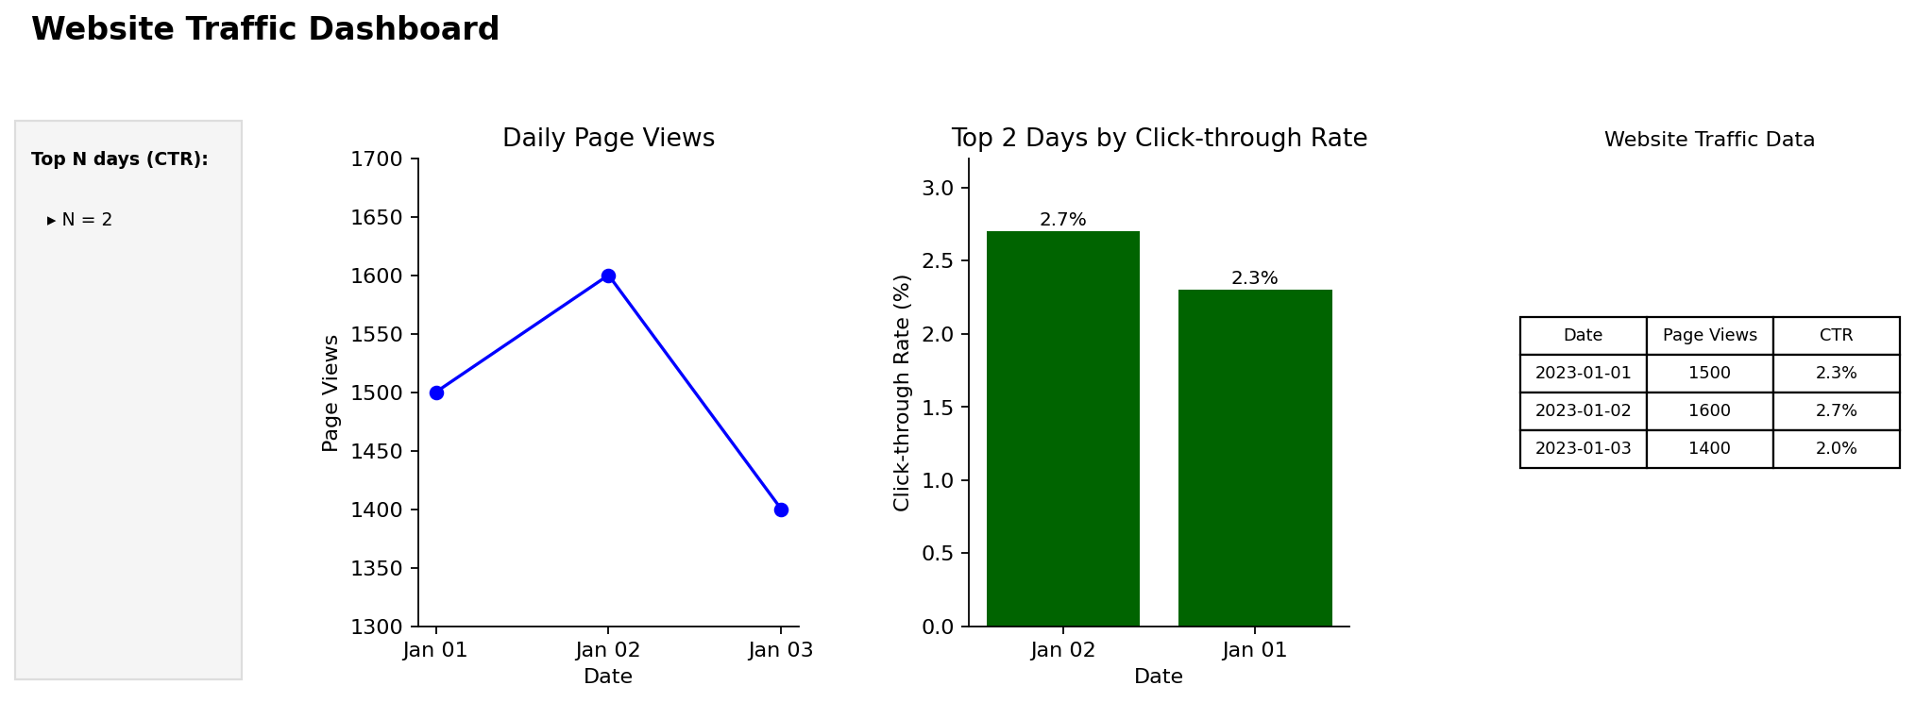
Output 4: Interactive Website Traffic Dashboard
Observation: The dashboard shows the page-view trend, the top-N click-through chart and the traffic table together. Moving the slider changes N, so the bar chart shows the top 1, 2 or 3 days.
Procedure
1. Create the date, page-view and click-through-rate vectors in R.
2. Use plot() with type = "o" to create the line chart of daily page views.
3. Use order() to find the top N click-through rates and barplot() to display them.
4. Create a data.frame() with the traffic data and display it as a table.
5. Install and load the Shiny package, then create the UI and server components for the dashboard.
6. Run the Shiny application and change the slider to explore the top N days.
Result
The website traffic data was successfully visualized using a line chart, a bar chart of the top N click-through days and a data table. An interactive Shiny dashboard combining all three was also created.
Key R Functions Used
Function | Purpose
as.Date() | Converts text into date values.
plot() | Creates the line chart.
order() | Ranks the days by click-through rate.
barplot() | Creates the bar chart.
data.frame() | Creates the traffic table.
sliderInput() | Provides the control for choosing N in Shiny.
renderPlot() / renderTable() | Generate plots and tables dynamically in Shiny.
shinyApp() | Runs the interactive Shiny application.

