SET 7 — CUSTOMER DEMOGRAPHICS ANALYSIS
Dataset
Customer ID | Age | Gender | Income (in $)
1 | 28 | Female | 50000
2 | 35 | Male | 60000
3 | 42 | Female | 75000
PROGRAM 1 — Bar Chart of Customer Ages
# Dataset
customer <- c("Customer 1", "Customer 2", "Customer 3")
age <- c(28, 35, 42)
# Bar Chart
barplot(age,
names.arg = customer,
xlab = "Customer",
ylab = "Age (years)",
main = "Distribution of Customer Ages",
ylim = c(0, 50))

Output: Bar chart showing the age of each customer.
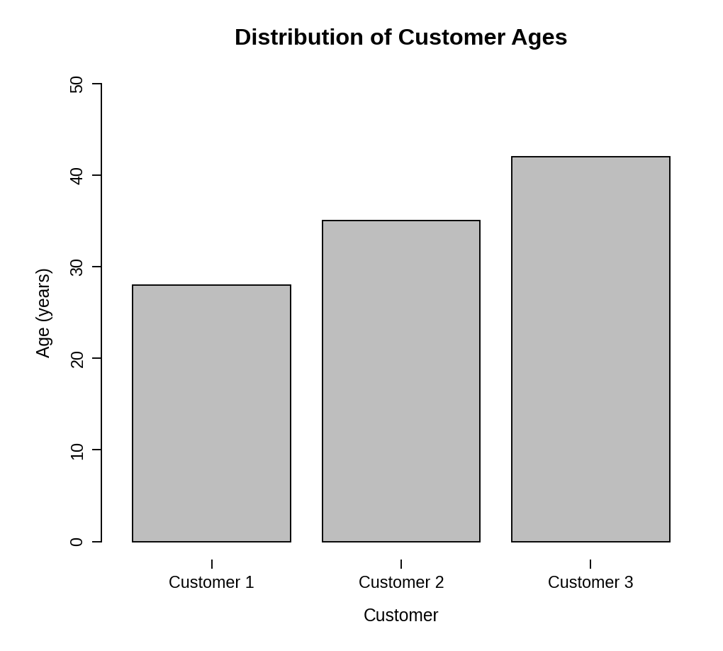
Observation: The customers are aged 28, 35 and 42. Customer 3 is the oldest and Customer 1 the youngest, and the ages are spread evenly about 7 years apart.
PROGRAM 2 — Pie Chart of Customers by Gender
# Dataset
gender <- c("Female", "Male", "Female")
# Count customers by gender
gender_count <- table(gender)
percent <- round(100 * gender_count / sum(gender_count), 1)
# Pie Chart
pie(gender_count,
labels = paste0(names(gender_count), " (", percent, "%)"),
main = "Customers by Gender",
col = c("gray85", "gray45"))

Output: Pie chart showing the distribution of customers by gender.
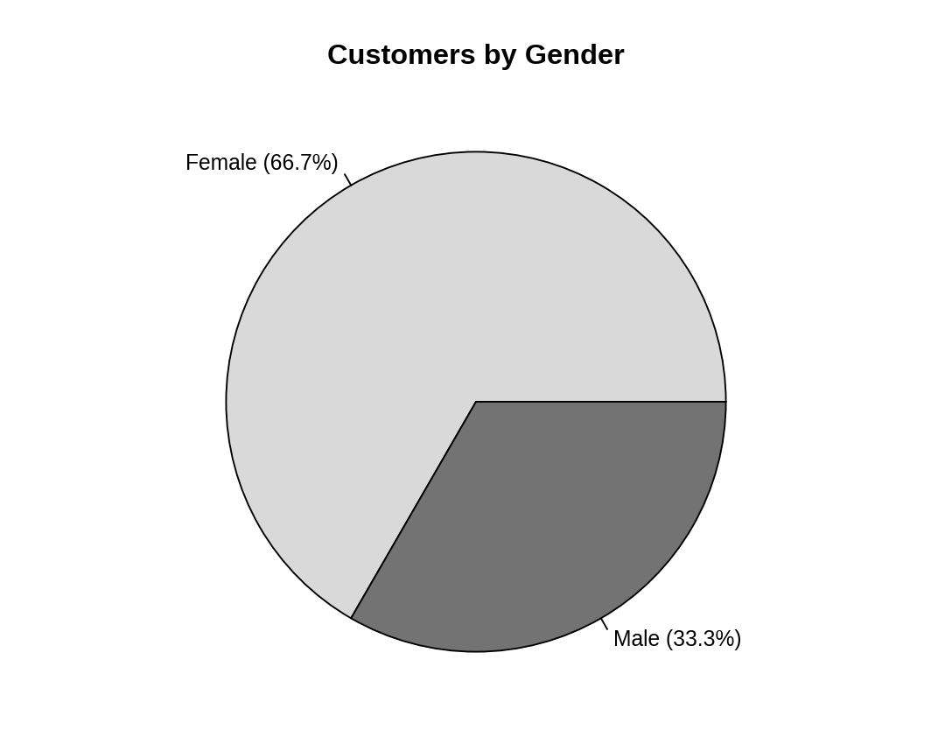
Observation: Two of the three customers (66.7%) are female and one (33.3%) is male, so female customers form the majority.
PROGRAM 3 — Table of Customer Demographics
# Dataset
customers <- data.frame(
"Customer ID" = c(1, 2, 3),
"Age" = c(28, 35, 42),
"Gender" = c("Female", "Male", "Female"),
"Income (in $)" = c(50000, 60000, 75000),
check.names = FALSE
)
# Display the table
print(customers)

Output: Table showing the demographic information of each customer.
> print(customers)
Customer ID Age Gender Income (in $)
1 1 28 Female 50000
2 2 35 Male 60000
3 3 42 Female 75000

Observation: The table gives the age, gender and income of each customer. Income increases with age: $50,000 at age 28, $60,000 at 35 and $75,000 at 42.
PROGRAM 4 — Interactive Customer Demographics Dashboard using Shiny
library(shiny)

# Dataset
customers <- data.frame(
id = c(1, 2, 3),
age = c(28, 35, 42),
gender = c("Female", "Male", "Female"),
income = c(50000, 60000, 75000)
)

# User Interface
ui <- fluidPage(
titlePanel("Customer Demographics Dashboard"),
sidebarLayout(
sidebarPanel(
selectInput("gender", "Select Gender:",
choices = c("All", "Female", "Male"))
),
mainPanel(
plotOutput("agePlot", height = "300px"),
plotOutput("genderPlot", height = "300px"),
tableOutput("custTable")
)
)
)

# Server
server <- function(input, output) {
filtered <- reactive({
if (input$gender == "All") customers
else subset(customers, gender == input$gender)
})

output$agePlot <- renderPlot({
d <- filtered()
barplot(d$age, names.arg = paste("Customer", d$id),
xlab = "Customer", ylab = "Age (years)",
main = "Distribution of Customer Ages")
})

output$genderPlot <- renderPlot({
g <- table(filtered()$gender)
pie(g, labels = names(g), main = "Customers by Gender",
col = c("gray85", "gray45")[seq_along(g)])
})

output$custTable <- renderTable({
d <- filtered()
names(d) <- c("Customer ID", "Age", "Gender", "Income (in $)")
d
}, digits = 0)
}

# Run Application
shinyApp(ui = ui, server = server)

Output: An interactive dashboard with a "Select Gender" box. The age bar chart, gender pie chart and table all update with the selection.
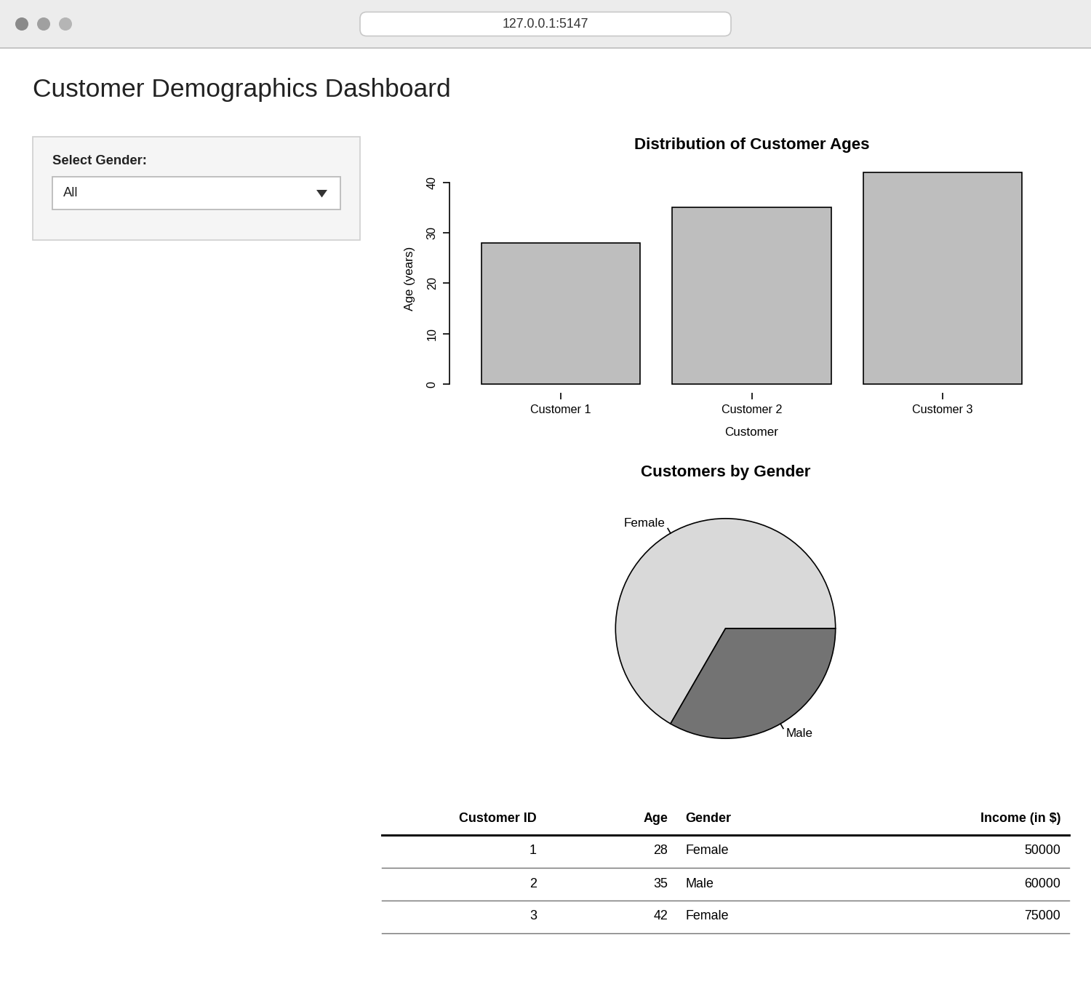
Observation: The dashboard combines the age bar chart, gender pie chart and demographics table. Choosing All, Female or Male in the selection box updates all three views together.
PROCEDURE
- Create the customer ID, age, gender and income data in R.
- Use barplot() to draw the bar chart of customer ages.
- Use table() to count customers by gender and pie() to draw the pie chart with labels.
- Create a data.frame() with the demographic information and display it as a table.
- Load the Shiny package, then create the UI and server components for the dashboard.
- Run the Shiny application and choose a gender to update the charts and table.
RESULT
The customer demographic data was successfully visualized using a bar chart, a pie chart and a data table. An interactive Shiny dashboard combining all three was also created.
KEY R FUNCTIONS USED
- barplot() – Creates the bar chart.
- table() – Counts customers in each gender group.
- pie() – Creates the pie chart.
- data.frame() – Creates the demographic table.
- selectInput() – Provides the gender selection control.
- reactive() – Filters the data when the selection changes.
- renderPlot() / renderTable() – Generate plots and tables dynamically in Shiny.
- shinyApp() – Runs the interactive Shiny application.

