SET 8 — EMPLOYEE PERFORMANCE ANALYSIS
Dataset
Employee ID | Department | Years of Service | Performance Score
1 | Sales | 5 | 85
2 | HR | 3 | 92
3 | Marketing | 7 | 78

Note: The dataset has no date column, so "performance over time" is shown against Years of Service, with the employees arranged from the shortest to the longest service.
PROGRAM 1 — Line Chart of Performance Trend
# Dataset
years <- c(5, 3, 7)
score <- c(85, 92, 78)
# Arrange by years of service
ord <- order(years)
# Line Chart
plot(years[ord], score[ord],
type = "o",
xaxt = "n",
xlab = "Years of Service",
ylab = "Performance Score",
main = "Employee Performance Trend",
ylim = c(70, 100))
axis(1, at = years[ord])

Output: Line chart showing performance score against years of service.
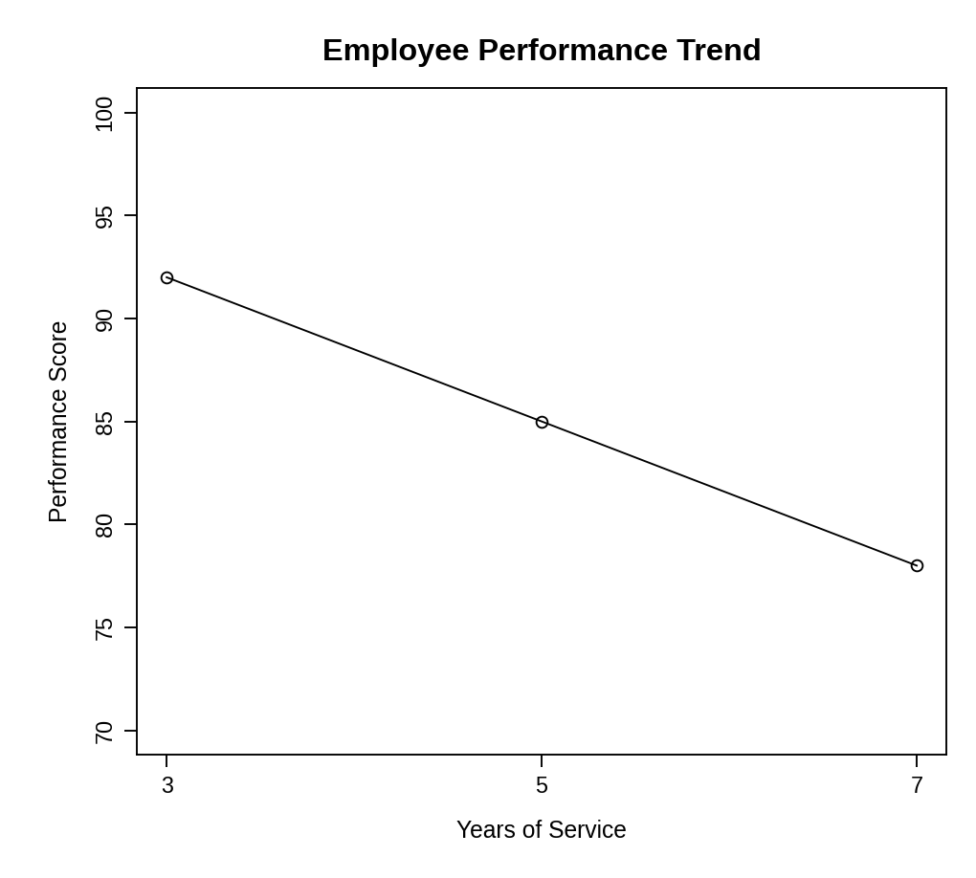
Observation: The performance score falls as years of service increase: 92 at 3 years, 85 at 5 years and 78 at 7 years. With only three employees this is a pattern in the sample, not a general rule.
PROGRAM 2 — Bar Chart of Employees by Department
# Dataset
department <- c("Sales", "HR", "Marketing")
# Count employees in each department
dept_count <- table(department)
# Bar Chart
barplot(dept_count,
xlab = "Department",
ylab = "Number of Employees",
main = "Employees by Department",
ylim = c(0, 2))

Output: Bar chart displaying the number of employees in each department.
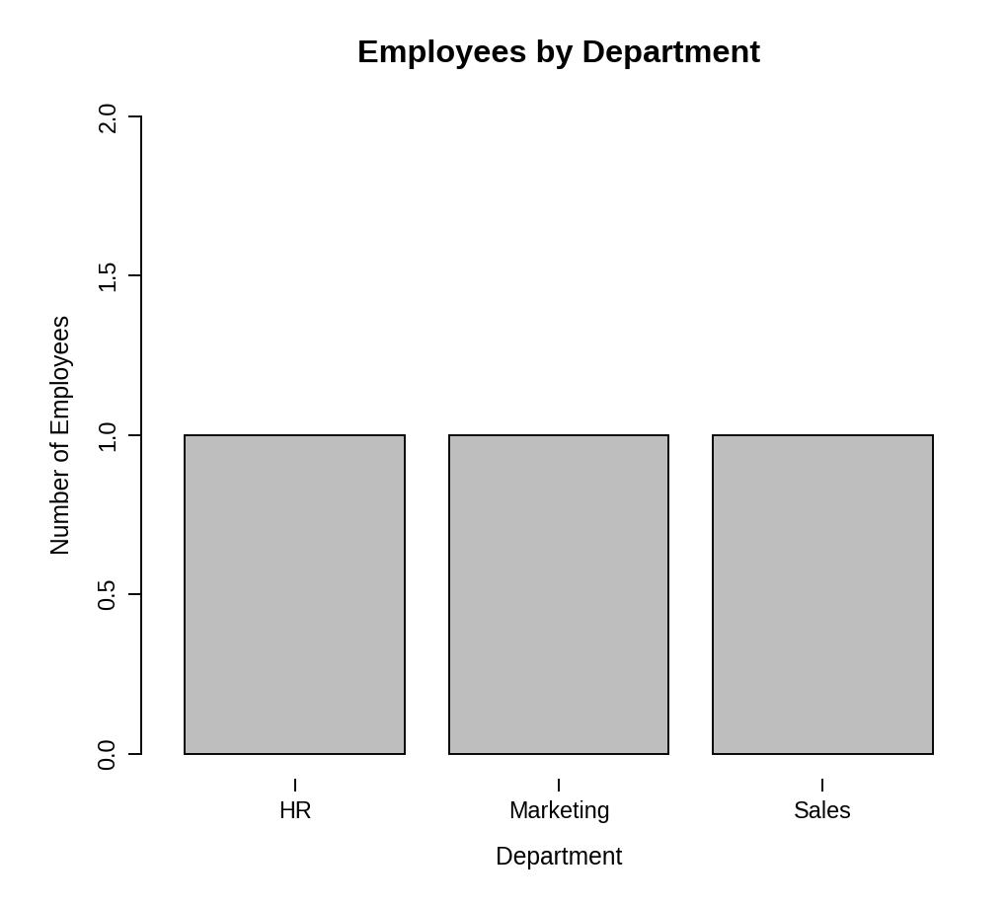
Observation: Each of the three departments (Sales, HR and Marketing) has exactly one employee, so the employees are evenly distributed.
PROGRAM 3 — Table of Employee Performance Data
# Dataset
employees <- data.frame(
"Employee ID" = c(1, 2, 3),
"Department" = c("Sales", "HR", "Marketing"),
"Years of Service" = c(5, 3, 7),
"Performance Score" = c(85, 92, 78),
check.names = FALSE
)
# Display the table
print(employees)

Output: Table showing the performance data of each employee.
> print(employees)
Employee ID Department Years of Service Performance Score
1 1 Sales 5 85
2 2 HR 3 92
3 3 Marketing 7 78

Observation: The table lists the department, years of service and performance score of each employee. The HR employee has the highest score (92) and the Marketing employee the lowest (78).
PROGRAM 4 — Interactive Employee Performance Dashboard using Shiny
library(shiny)

# Dataset
employees <- data.frame(
id = c(1, 2, 3),
department = c("Sales", "HR", "Marketing"),
years = c(5, 3, 7),
score = c(85, 92, 78)
)

# User Interface
ui <- fluidPage(
titlePanel("Employee Performance Dashboard"),
sidebarLayout(
sidebarPanel(
checkboxGroupInput("dept", "Select Department:",
choices = c("Sales", "HR", "Marketing"),
selected = c("Sales", "HR", "Marketing"))
),
mainPanel(
plotOutput("linePlot", height = "300px"),
plotOutput("barPlot", height = "300px"),
tableOutput("empTable")
)
)
)

# Server
server <- function(input, output) {
filtered <- reactive({
d <- subset(employees, department %in% input$dept)
d[order(d$years), ]
})

output$linePlot <- renderPlot({
d <- filtered()
req(nrow(d) > 0)
plot(d$years, d$score, type = "o", xlab = "Years of Service",
ylab = "Performance Score",
main = "Employee Performance Trend", ylim = c(70, 100))
})

output$barPlot <- renderPlot({
d <- filtered()
req(nrow(d) > 0)
barplot(table(d$department), xlab = "Department",
ylab = "Number of Employees",
main = "Employees by Department")
})

output$empTable <- renderTable({
d <- filtered()
names(d) <- c("Employee ID", "Department", "Years of Service",
"Performance Score")
d
}, digits = 0)
}

# Run Application
shinyApp(ui = ui, server = server)

Output: An interactive dashboard with a "Select Department" option. The line chart, bar chart and table update when departments are selected or cleared.
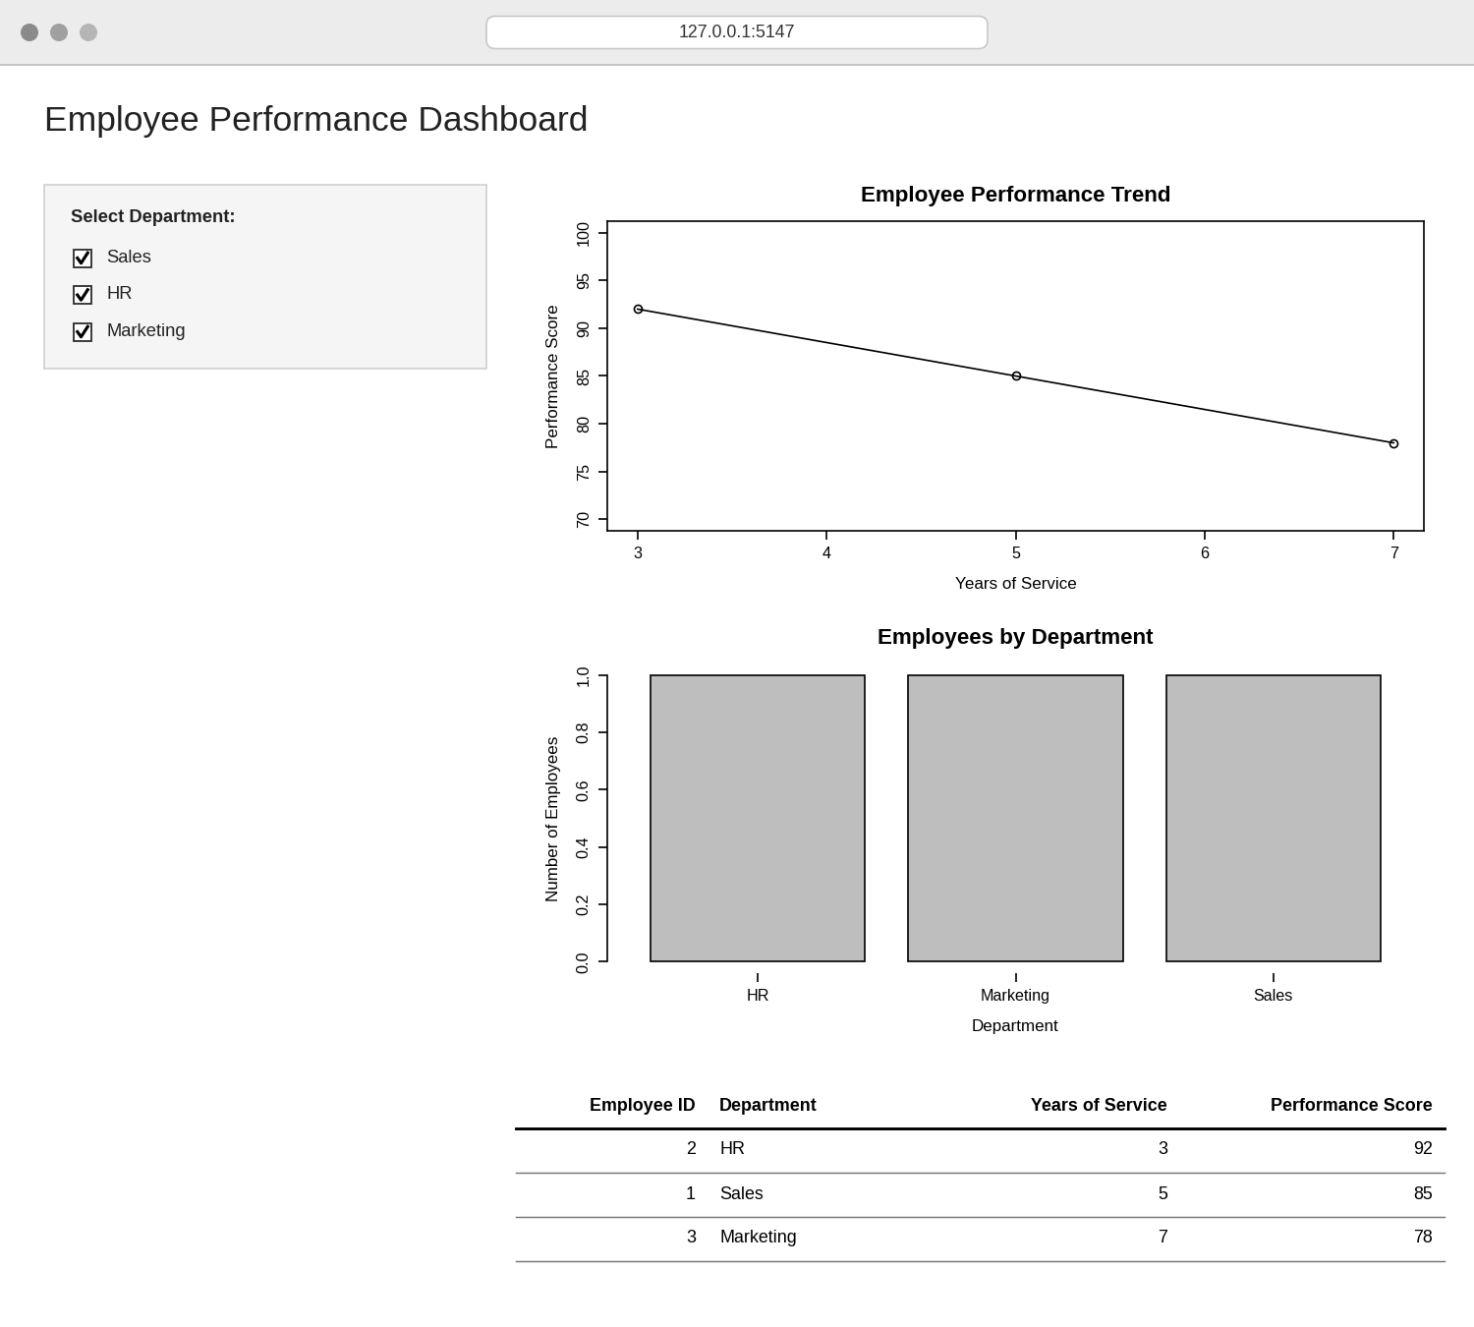
Observation: The dashboard shows the performance trend, department distribution and data table together. Selecting or clearing departments in the sidebar updates all three views at once.
PROCEDURE
- Create the employee ID, department, years of service and performance score data in R.
- Sort the employees by years of service with order() and use plot() with type = "o" for the line chart.
- Use table() to count employees per department and barplot() to draw the bar chart.
- Create a data.frame() with the performance data and display it as a table.
- Load the Shiny package, then create the UI and server components for the dashboard.
- Run the Shiny application and select departments to update the charts and table.
RESULT
The employee performance data was successfully visualized using a line chart, a bar chart and a data table. An interactive Shiny dashboard combining all three was also created.
KEY R FUNCTIONS USED
- order() – Arranges employees by years of service.
- plot() – Creates the line chart.
- table() – Counts employees in each department.
- barplot() – Creates the bar chart.
- data.frame() – Creates the performance table.
- checkboxGroupInput() – Provides the department selection control.
- reactive() – Filters the data when the selection changes.
- renderPlot() / renderTable() – Generate plots and tables dynamically in Shiny.
- shinyApp() – Runs the interactive Shiny application.

