DSA0601 Data Handling and Visualization
Name: Lakshna Sree T S
Regno: 192524059
SET 26 — STUDENT PERFORMANCE ANALYSIS
Dataset: Student_Mini_Data.csv
Student_ID | Gender | Study_Hours | Attendance | Math_Score | Science_Score | Exam_Date
S01 | Male | 2.0 | 78 | 62 | 65 | 2025-01-10
S02 | Female | 3.5 | 90 | 80 | 85 | 2025-01-10
S03 | Male | 1.5 | 70 | 55 | 58 | 2025-02-12
S04 | Female | 4.0 | 95 | 90 | 92 | 2025-02-12
S05 | Male | 2.8 | 85 | 72 | 74 | 2025-03-15
S06 | Female | 3.0 | 92 | 82 | 86 | 2025-03-15

Note: The table above was saved as Student_Mini_Data.csv in the R working directory before running the programs.
PROGRAM 1 — Histogram of Math Score and Boxplot of Science Score by Gender
# Import the dataset
data <- read.csv("Student_Mini_Data.csv")
head(data)

# Histogram of Math_Score
hist(data$Math_Score,
breaks = seq(50, 90, by = 10),
xlab = "Math Score",
ylab = "Frequency",
main = "Histogram of Math Scores")

# Boxplot of Science_Score by Gender
boxplot(Science_Score ~ Gender, data = data,
xlab = "Gender",
ylab = "Science Score",
main = "Science Score by Gender",
col = c("gray85", "gray60"))

Output: Dataset imported with read.csv(), followed by the histogram of Math_Score and the boxplot of Science_Score by gender.
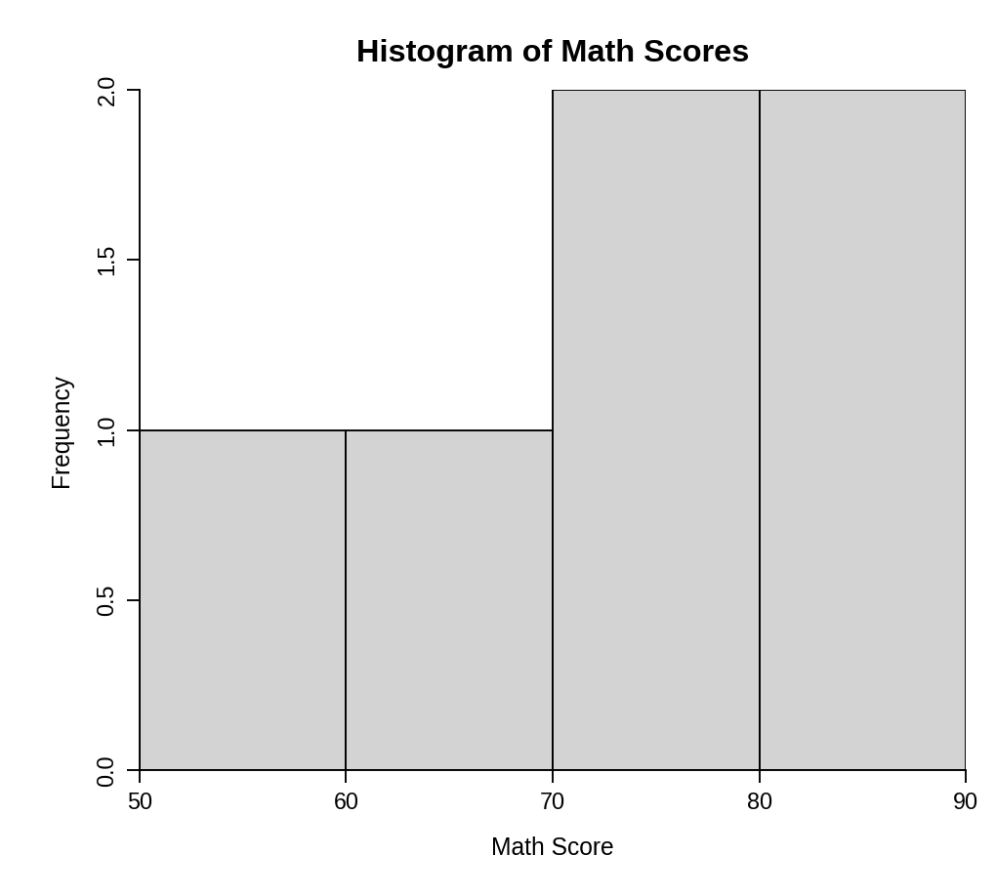
Output 1(a): Histogram of Math Scores
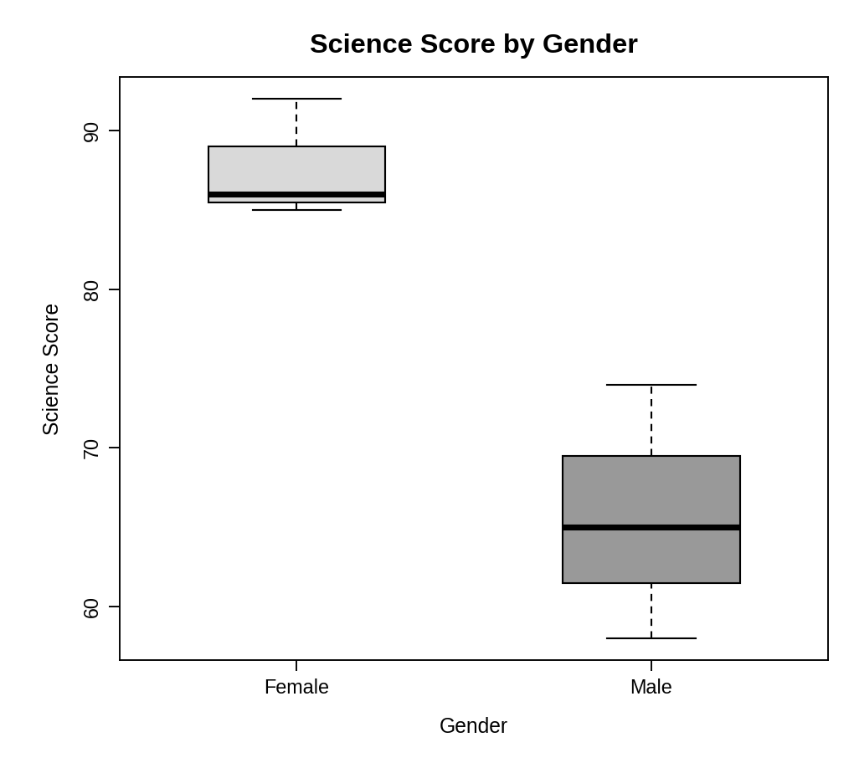
Output 1(b): Boxplot of Science Score by Gender
> head(data)
Student_ID Gender Study_Hours Attendance Math_Score Science_Score Exam_Date
1 S01 Male 2.0 78 62 65 2025-01-10
2 S02 Female 3.5 90 80 85 2025-01-10
3 S03 Male 1.5 70 55 58 2025-02-12
4 S04 Female 4.0 95 90 92 2025-02-12
5 S05 Male 2.8 85 72 74 2025-03-15
6 S06 Female 3.0 92 82 86 2025-03-15

Interpretation: Math scores range from 55 to 90 (mean 73.5). Two students scored in each of the 70–80 and 80–90 ranges and one in each of the lower two ranges, so the scores are spread evenly with no extreme values. In the boxplot, female students have clearly higher science scores (median 86, range 85–92) than male students (median 65, range 58–74), and the two boxes do not overlap. The female scores are also more tightly grouped.
PROGRAM 2 — Scatter Plot of Study Hours vs Math Score by Gender
data <- read.csv("Student_Mini_Data.csv")

# Scatter plot: black = Male, white = Female
plot(data$Study_Hours, data$Math_Score,
pch = 21, cex = 1.6,
bg = ifelse(data$Gender == "Male", "black", "white"),
xlab = "Study Hours",
ylab = "Math Score",
main = "Study Hours vs Math Score")
# Regression line
abline(lm(Math_Score ~ Study_Hours, data = data), lwd = 2)
legend("topleft", legend = c("Male", "Female"),
pch = 21, pt.bg = c("black", "white"), pt.cex = 1.6)

# Correlation and regression coefficients
cor(data$Study_Hours, data$Math_Score)
coef(lm(Math_Score ~ Study_Hours, data = data))

Output: Scatter plot of study hours against math score, with different fill for each gender and a regression line.
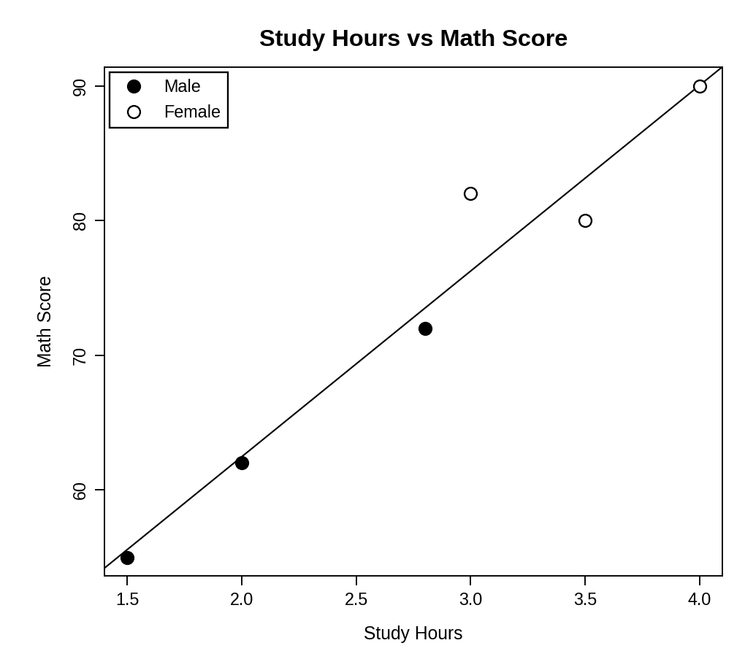
> cor(data$Study_Hours, data$Math_Score)
[1] 0.9731713
> coef(lm(Math_Score ~ Study_Hours, data = data))
(Intercept) Study_Hours
34.88605 13.79070

Relationship: The points lie close to the regression line, the correlation is 0.97 and the line shows that each extra study hour is associated with about 13.8 more math marks. The students who studied the most (all female) scored highest and the students who studied least (all male) scored lowest. Note that gender and study time are linked in this sample, so the effect of study time cannot be separated from gender with six students. (Black and white fills are used instead of colours for the two genders.)
PROGRAM 3 — Monthly Average Math Score with Moving Average
data <- read.csv("Student_Mini_Data.csv")

# Convert Exam_Date to Date format
data$Exam_Date <- as.Date(data$Exam_Date)
data$Month <- format(data$Exam_Date, "%Y-%m")

# Monthly average Math score
monthly <- aggregate(Math_Score ~ Month, data = data, FUN = mean)

# Moving average (window = 2)
monthly$MA <- stats::filter(monthly$Math_Score, rep(1/2, 2), sides = 1)
print(monthly)

# Line chart
plot(monthly$Math_Score, type = "o", xaxt = "n",
ylim = c(70, 77),
xlab = "Month", ylab = "Average Math Score",
main = "Average Math Score per Month")
axis(1, at = 1:3, labels = monthly$Month)
lines(monthly$MA, type = "o", lty = 2)
legend("topleft", legend = c("Monthly average", "Moving average"),
lty = c(1, 2), pch = 1)

Output: Monthly average math score and its moving average on one line chart.
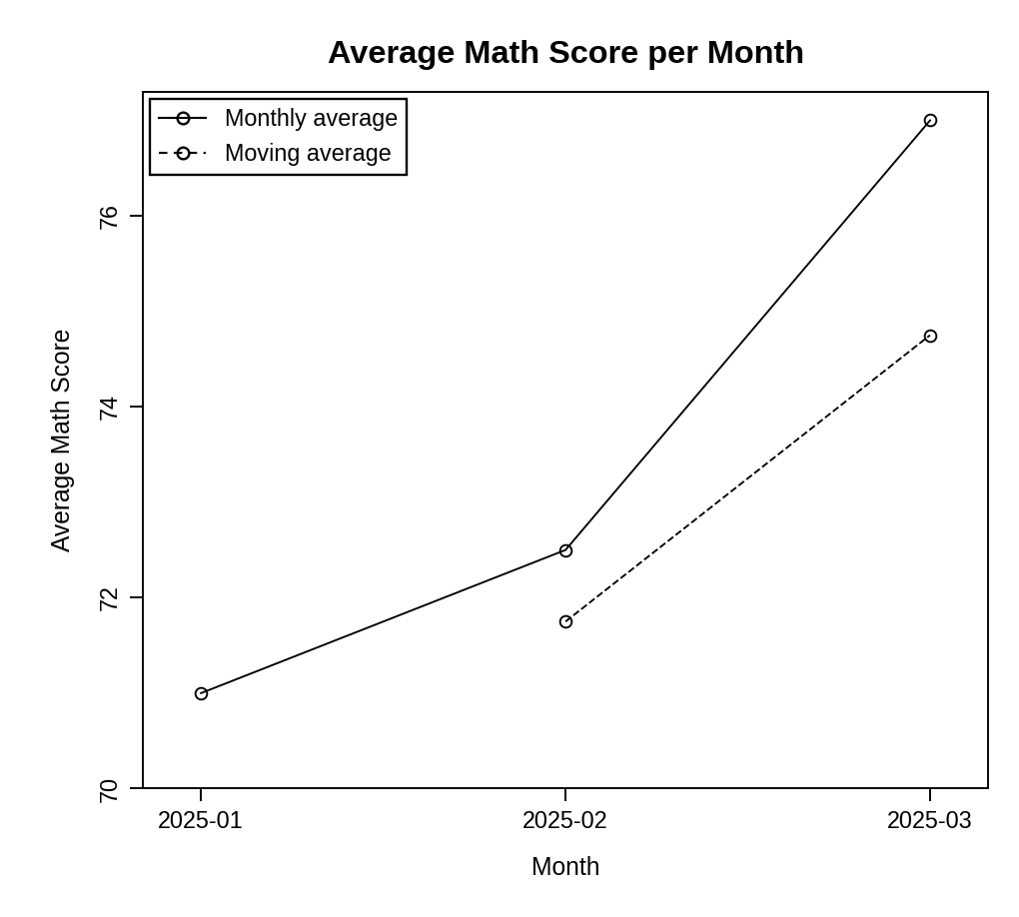
> print(monthly)
Month Math_Score MA
1 2025-01 71.0 NA
2 2025-02 72.5 71.75
3 2025-03 77.0 74.75

Pattern: The monthly average rises from 71.0 (January) to 72.5 (February) and 77.0 (March). The moving average also increases, from 71.75 to 74.75, and smooths the jump in March. The pattern is increasing, so math performance improved over the three exam months.
PROGRAM 4 — Tableau Dashboard for Student Performance
Dashboard steps:
- Open Tableau and import Student_Mini_Data.csv (Connect > Text file).
- Bar chart: drag Gender to Columns and AVG(Math_Score) to Rows, and show the values as labels.
- Line chart: drag Exam_Date to Columns (as a Month or exact date), AVG(Math_Score) to Rows and Gender to Color.
- Right-click Exam_Date and choose Show Filter (Range of Dates), then set it to Apply to Worksheets > All Using This Data Source.
- Create a new dashboard, drag the bar chart and the line chart onto it and place the Exam_Date filter on the right.
- Enable Use as Filter on the bar chart, so that clicking a gender filters the trend line.

Output: An interactive Tableau dashboard with the average math score by gender, the score trend over time and an Exam_Date filter.
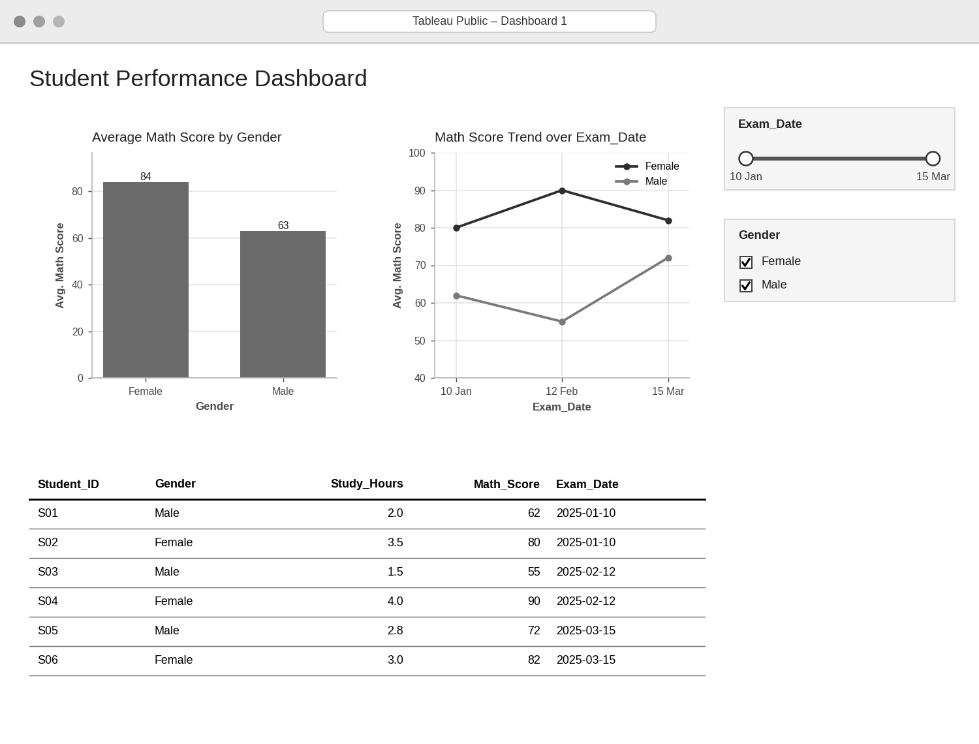
Observation: Female students average 84 in math and male students 63. The female scores are higher at every exam date, and the male scores rise to 72 in March. The Exam_Date filter limits both charts to the chosen exam period.
PROCEDURE
- Save the dataset as Student_Mini_Data.csv and import it with read.csv().
- Draw the histogram of Math_Score with hist() and the boxplot of Science_Score by gender with boxplot().
- Draw the scatter plot with different fills for gender, add the regression line with abline(lm()) and calculate the correlation.
- Convert Exam_Date with as.Date(), find the monthly average with aggregate() and apply moving-average smoothing with stats::filter().
- Import the CSV into Tableau and build the bar chart and the line chart.
- Add the Exam_Date filter and design the interactive dashboard.
RESULT
The student data was successfully analysed using a histogram, a boxplot, a scatter plot with a regression line and a moving-average line chart. Study time and math score are strongly related (r ≈ 0.97), math scores show an increasing trend over the three months, and an interactive Tableau dashboard was designed.
KEY FUNCTIONS / TOOLS USED
- read.csv() – Imports the CSV dataset.
- hist() / boxplot() – Create the histogram and the boxplot.
- abline() / lm() / cor() – Add the regression line and measure the relationship.
- as.Date() / format() – Convert the date and extract the month.
- aggregate() – Calculates the monthly averages.
- stats::filter() – Applies moving-average smoothing.
- Tableau Sheets – One worksheet for each chart or table.
- Tableau Dashboard – Combines the sheets with filters for interactive exploration.

