DSA0601 Data Handling and Visualization
Name: Lakshna Sree T S
Regno: 192524059
SET 27 — PATIENT HEALTH RISK ANALYSIS
Dataset
Patient_ID | Age | BMI | BP | Cholesterol
P1 | 25 | 22 | 120 | 180
P2 | 40 | 28 | 135 | 210
P3 | 55 | 30 | 145 | 240
P4 | 35 | 26 | 130 | 200
P5 | 60 | 32 | 150 | 260

PROGRAM 1 — Scatterplot Matrix of Health Indicators
# Dataset
patients <- data.frame(
Patient_ID = c("P1", "P2", "P3", "P4", "P5"),
Age = c(25, 40, 55, 35, 60),
BMI = c(22, 28, 30, 26, 32),
BP = c(120, 135, 145, 130, 150),
Cholesterol = c(180, 210, 240, 200, 260)
)
# Scatterplot matrix
pairs(patients[, c("Age", "BMI", "BP", "Cholesterol")],
pch = 19,
main = "Scatterplot Matrix of Health Indicators")
# Correlation matrix
round(cor(patients[, 2:5]), 3)

Output: Scatterplot matrix showing the pairwise relationships between Age, BMI, BP and Cholesterol.
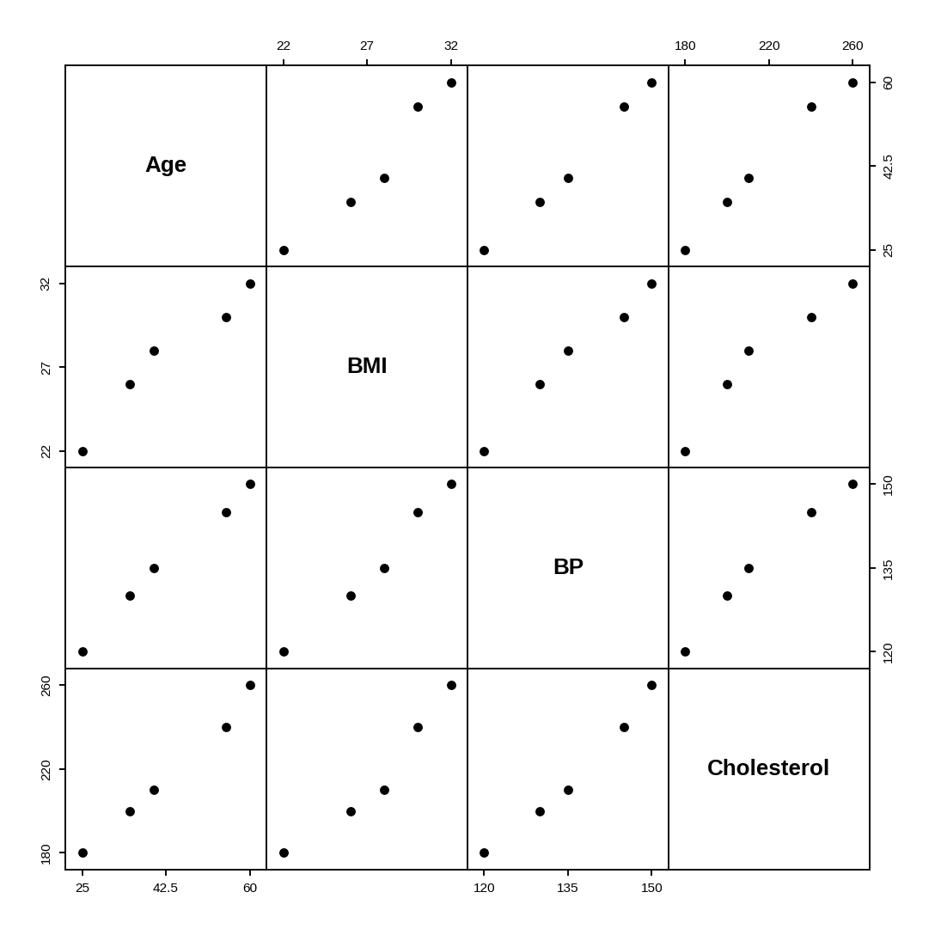
> round(cor(patients[, 2:5]), 3)
Age BMI BP Cholesterol
Age 1.000 0.974 0.996 0.994
BMI 0.974 1.000 0.991 0.969
BP 0.996 0.991 1.000 0.990
Cholesterol 0.994 0.969 0.990 1.000

Interpretation: Every pair of variables forms an almost straight upward line and all correlations are between 0.97 and 1.00, so older patients tend to have higher BMI, blood pressure and cholesterol together. Blood pressure and age have the strongest link (0.996). There are no separate clusters; instead the patients form a continuous series from the low-risk P1 (25 years, BMI 22, BP 120) to the high-risk P5 (60 years, BMI 32, BP 150). Patients P3 and P5, who have the highest values on all four indicators, show the strongest risk pattern.
PROGRAM 2 — Q-Q Plot and ECDF of Cholesterol
cholesterol <- c(180, 210, 240, 200, 260)

# Normal Q-Q plot
qqnorm(cholesterol, main = "Normal Q-Q Plot of Cholesterol")
qqline(cholesterol)

# Empirical cumulative distribution function
plot(ecdf(cholesterol),
xlab = "Cholesterol", ylab = "Fn(x)",
main = "ECDF of Cholesterol")

# Skewness and normality test
mean((cholesterol - mean(cholesterol))^3) /
mean((cholesterol - mean(cholesterol))^2)^1.5
shapiro.test(cholesterol)

Output: Normal Q-Q plot and empirical cumulative distribution function of the cholesterol levels.
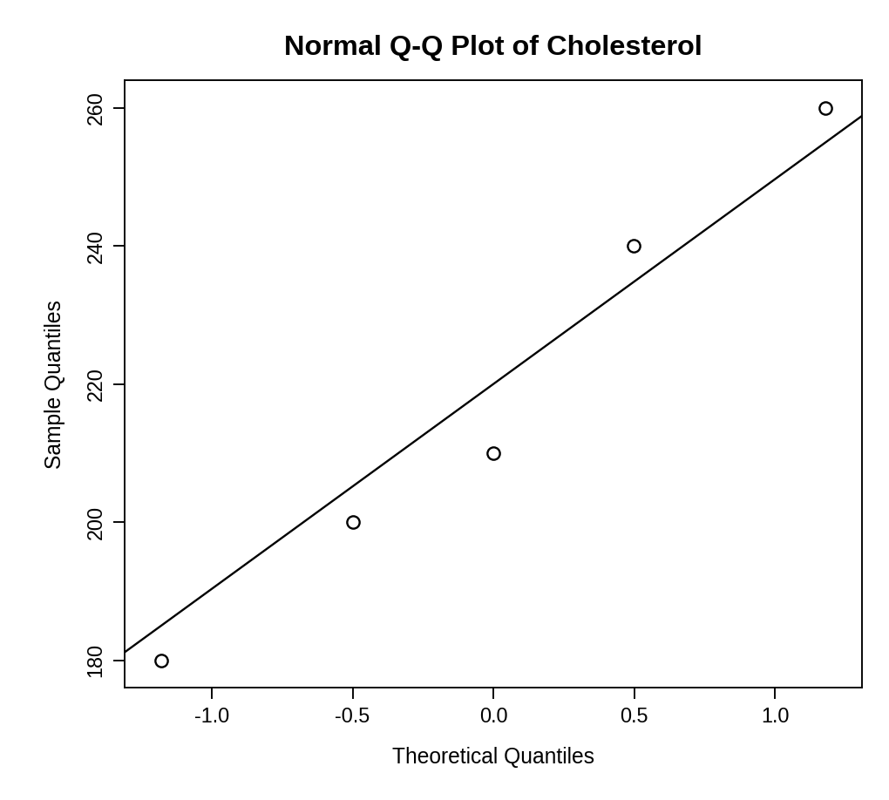
Output 2(a): Normal Q-Q Plot
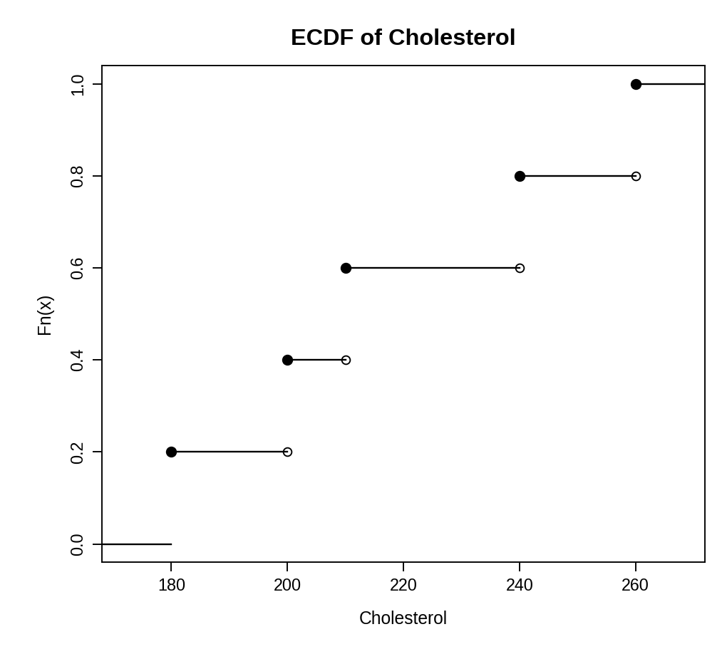
Output 2(b): ECDF of Cholesterol
> mean((cholesterol - mean(cholesterol))^3) /
+ mean((cholesterol - mean(cholesterol))^2)^1.5
[1] 0.2018051
> shapiro.test(cholesterol)

Shapiro-Wilk normality test

data: cholesterol
W = 0.96741, p-value = 0.8584

Comment: The points in the Q-Q plot lie close to the straight line, so the cholesterol values are close to a normal distribution. The skewness is about 0.20 (mean 218, median 210), a slight right skew caused by the highest value of 260. The ECDF rises in five equal steps of 0.2 with no large gap. The Shapiro–Wilk test gives p = 0.86, so normality is not rejected. With only five patients these checks have little power, so the normality assumption is acceptable but not strongly proven.
PROGRAM 3 — Bar Chart of Average Health Indicators
# Average of each indicator
averages <- colMeans(patients[, c("Age", "BMI", "BP", "Cholesterol")])
averages
# Bar Chart (a different shade for each bar)
barplot(averages,
xlab = "Health Indicator",
ylab = "Average Value",
main = "Average Health Indicators",
col = c("gray25", "gray50", "gray72", "gray88"))

Output: Bar chart showing the average value of each health indicator.
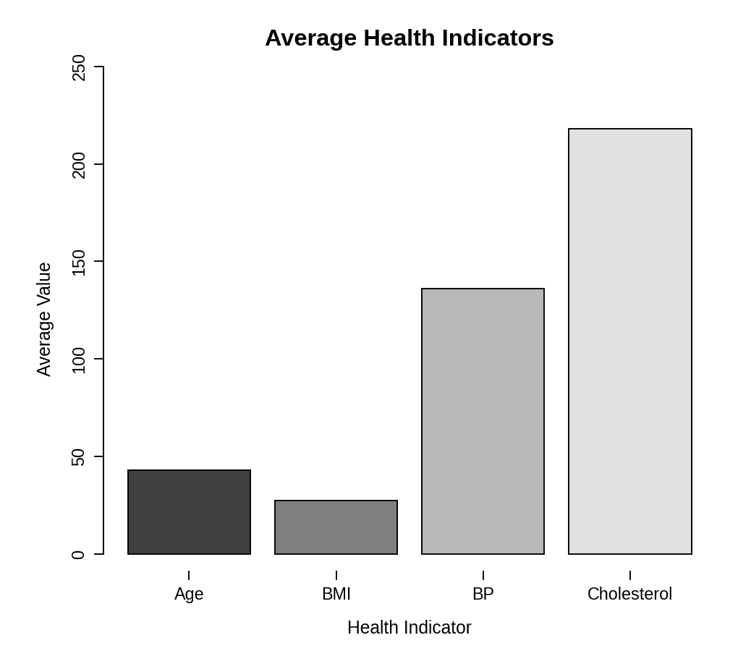
> averages
Age BMI BP Cholesterol
43.0 27.6 136.0 218.0

Interpretation: The averages are Age 43 years, BMI 27.6, BP 136 and Cholesterol 218. Compared with common reference ranges, an average BMI of 27.6 is in the overweight range (25–29.9), a blood pressure of 136 is above the normal value of about 120 and is in the elevated range, and a cholesterol of 218 is borderline high (200–239). So the group as a whole has a moderately raised health risk. The bars should not be compared by height, because the indicators have different units. (Different grey shades are used instead of colours.)
PROGRAM 4 — Tableau Dashboard for Patient Risk
Dashboard steps:
- Open Tableau and import the patient data (Patient_ID, Age, BMI, BP, Cholesterol).
- Create a calculated field Risk Score = the average of each indicator scaled from 0 to 1 using its minimum and maximum, multiplied by 100.
- Pivot Age, BMI, BP and Cholesterol into Indicator and Value fields. Drag Indicator to Columns, Patient_ID to Rows and Value to Color and Label, and set the mark type to Square to make the heatmap (use a dark-to-light colour legend so that high values stand out).
- Put Age, BMI, BP and Cholesterol on the Tooltip shelf so that hovering over a cell shows all the health indicators of that patient.
- Build a second sheet with a bar chart of Risk Score by Patient_ID, sorted in descending order, and add an Age range filter (Show Filter).
- Create a dashboard with the heatmap, the risk bar chart and the filters, and enable Use as Filter.

Output: An interactive Tableau dashboard with a risk heatmap, hover tooltip, risk score ranking and an Age filter.
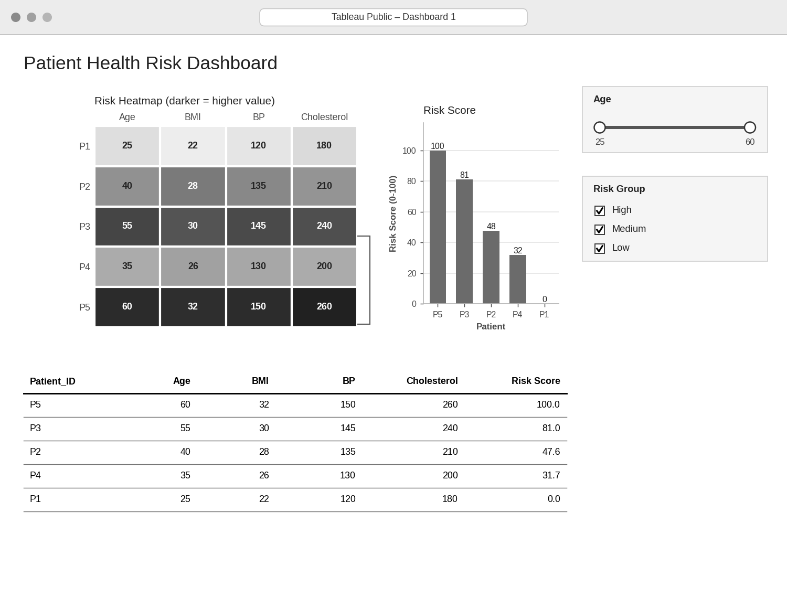
Analysis: Using the 0–100 risk score, the highest-risk patient is P5 (100: age 60, BMI 32, BP 150, cholesterol 260), followed by P3 (81), P2 (48), P4 (32) and P1 (0). Risk rises with age: the oldest patients (55 and 60) are in the top two places and the youngest (25) has the lowest risk. The dashboard helps healthcare professionals to see at a glance which patients need attention first, to filter by age group, and to read each patient’s exact values from the tooltip, so that care can be prioritised for high-risk patients such as P5 and P3.
PROCEDURE
- Create the patient data frame in R.
- Draw the scatterplot matrix with pairs() and calculate the correlation matrix with cor().
- Draw the Q-Q plot with qqnorm()/qqline() and the ECDF with ecdf(), and check skewness and normality.
- Calculate the average of each indicator with colMeans() and draw the bar chart with a different shade for each bar.
- In Tableau, create the risk score, the heatmap with tooltips and the Age filter.
- Analyse which patients are at highest risk and how age affects risk.
RESULT
The patient health data was successfully analysed using a scatterplot matrix, a Q-Q plot, an ECDF, a bar chart of averages and an interactive Tableau dashboard. All four indicators rise together with age, cholesterol is close to normal, and patients P5 and P3 are the highest-risk patients.
KEY FUNCTIONS / TOOLS USED
- pairs() – Creates the scatterplot matrix.
- cor() – Calculates the correlation matrix.
- qqnorm() / qqline() – Draw the normal Q-Q plot.
- ecdf() – Calculates and plots the empirical CDF.
- shapiro.test() – Tests for normality.
- colMeans() – Calculates the average of each indicator.
- barplot() – Creates the bar chart.
- Tableau Sheets – One worksheet for each chart or table.
- Tableau Dashboard – Combines the sheets with filters for interactive exploration.

