DSA0601 Data Handling and Visualization
Name: Lakshna Sree T S
Regno: 192524059
SET 28 — VEHICLE PERFORMANCE ANALYSIS
Dataset
Vehicle_ID | Engine_Size (L) | Horsepower | Fuel_Efficiency (km/l) | Top_Speed (km/h) | Safety_Rating
V1 | 1.5 | 110 | 18 | 180 | 4
V2 | 2 | 150 | 15 | 200 | 5
V3 | 3 | 250 | 12 | 250 | 5
V4 | 2.5 | 200 | 14 | 220 | 4
V5 | 1.8 | 130 | 17 | 190 | 3

PROGRAM 1 — Violin Plot of Fuel Efficiency by Safety Rating
library(ggplot2)

# Dataset
vehicles <- data.frame(
Vehicle_ID = c("V1", "V2", "V3", "V4", "V5"),
Engine_Size = c(1.5, 2.0, 3.0, 2.5, 1.8),
Horsepower = c(110, 150, 250, 200, 130),
Fuel_Efficiency = c(18, 15, 12, 14, 17),
Top_Speed = c(180, 200, 250, 220, 190),
Safety_Rating = c(4, 5, 5, 4, 3)
)

# Violin plot with the individual vehicles shown as points
ggplot(vehicles, aes(x = factor(Safety_Rating), y = Fuel_Efficiency)) +
geom_violin(fill = "gray75", colour = "gray20") +
geom_point(size = 2) +
theme_bw() +
labs(title = "Fuel Efficiency by Safety Rating",
x = "Safety Rating", y = "Fuel Efficiency (km/l)")

Output: Violin plot comparing the distribution of fuel efficiency across the safety ratings.
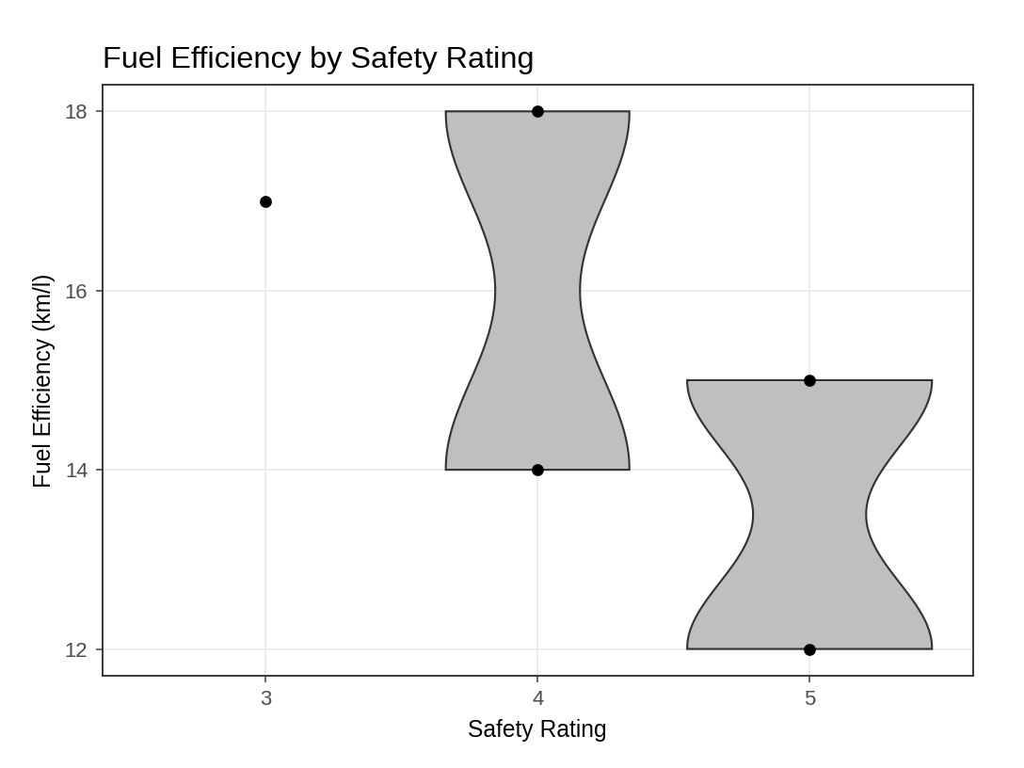
Interpretation: Rating 3 has only one vehicle (V5, 17 km/l), so ggplot cannot draw a violin for it and only the point is shown. Rating 4 (V1 18 and V4 14 km/l) has a centre near 16 km/l and the widest spread (4 km/l). Rating 5 (V2 15 and V3 12 km/l) has the lowest centre (13.5 km/l) with a spread of 3 km/l. The highest-rated vehicles are therefore the least fuel efficient, because they are the large, powerful vehicles. With only 1–2 vehicles per group the violin shapes are only a rough guide.
PROGRAM 2 — Scatter Plot of Horsepower vs Top Speed by Engine Size
library(ggplot2)

ggplot(vehicles, aes(x = Horsepower, y = Top_Speed,
colour = Engine_Size)) +
geom_point(size = 4) +
geom_smooth(method = "lm", se = FALSE, colour = "black",
linetype = "dashed") +
scale_colour_gradient(low = "gray70", high = "black") +
theme_bw() +
labs(title = "Horsepower vs Top Speed",
x = "Horsepower", y = "Top Speed (km/h)")

# Correlation
cor(vehicles$Horsepower, vehicles$Top_Speed)

Output: Scatter plot of horsepower against top speed, with a darker shade for a larger engine size.
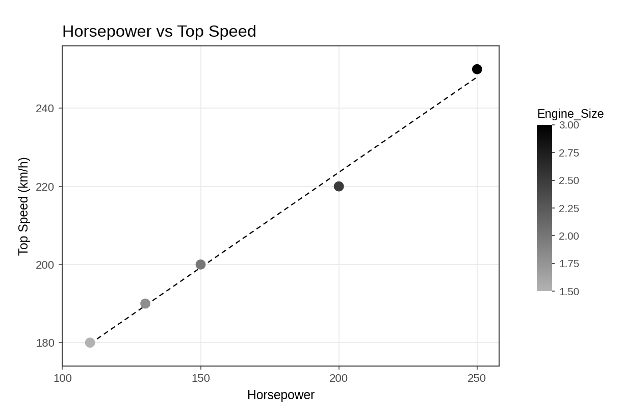
> cor(vehicles$Horsepower, vehicles$Top_Speed)
[1] 0.9970716

Analysis: The points lie almost exactly on the upward trend line and the correlation is 0.997, so the relationship is very strong and positive: every extra horsepower brings a higher top speed (about 0.5 km/h per hp). The shading shows that larger engines (darker points, 2.5 and 3.0 L) have both more horsepower and higher top speeds, so engine size, power and speed increase together in this data.
PROGRAM 3 — Correlation Heatmap of the Numerical Variables
library(ggplot2)

# Correlation matrix of all numerical variables
num <- vehicles[, c("Engine_Size", "Horsepower", "Fuel_Efficiency",
"Top_Speed", "Safety_Rating")]
cor_mat <- round(cor(num), 2)
print(cor_mat)

# Heatmap
cor_long <- as.data.frame(as.table(cor_mat))
ggplot(cor_long, aes(x = Var1, y = Var2, fill = Freq)) +
geom_tile(colour = "white") +
geom_text(aes(label = Freq, colour = Freq > 0.25)) +
scale_fill_gradient(low = "white", high = "gray15", limits = c(-1, 1)) +
scale_colour_manual(values = c("black", "white"), guide = "none") +
scale_y_discrete(limits = rev(levels(cor_long$Var2))) +
theme_minimal() +
labs(title = "Correlation Heatmap of Vehicle Variables",
x = "", y = "", fill = "Correlation")

Output: Correlation heatmap of the numerical variables in the vehicle dataset.
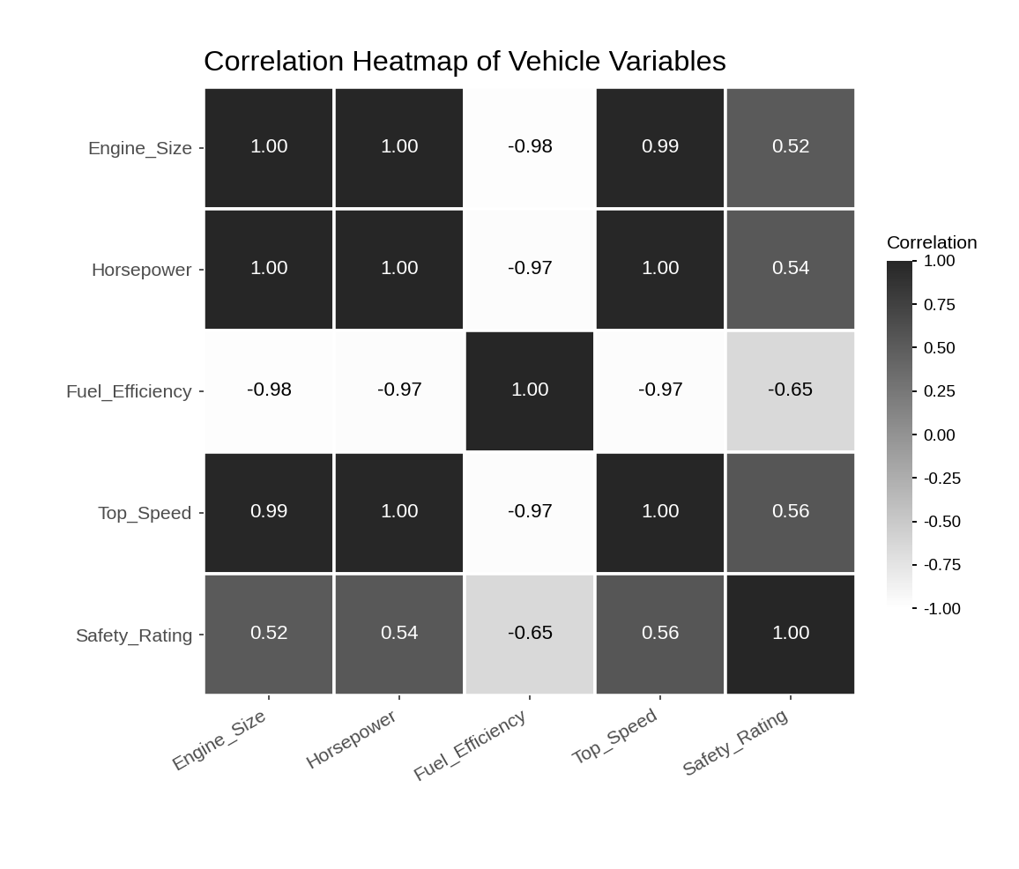
> print(cor_mat)
Engine_Size Horsepower Fuel_Efficiency Top_Speed Safety_Rating
Engine_Size 1.00 1.00 -0.98 0.99 0.52
Horsepower 1.00 1.00 -0.97 1.00 0.54
Fuel_Efficiency -0.98 -0.97 1.00 -0.97 -0.65
Top_Speed 0.99 1.00 -0.97 1.00 0.56
Safety_Rating 0.52 0.54 -0.65 0.56 1.00

Interpretation: Top_Speed is most strongly associated with Horsepower (0.997) and Engine_Size (0.995), and strongly negatively with Fuel_Efficiency (-0.97). Safety_Rating has only a moderate link with Top_Speed (0.56). A bigger engine and more horsepower therefore raise performance but cost fuel economy: Horsepower and Fuel_Efficiency have a correlation of -0.97. Performance depends mainly on engine size and power rather than on the safety rating.
PROGRAM 4 — Tableau Dashboard for Vehicle Performance
Dashboard steps:
- Open Tableau and import the vehicle data.
- Bar chart: drag Vehicle_ID to Columns and Fuel_Efficiency to Rows, and show the values as labels.
- Scatter plot: drag Fuel_Efficiency to Columns and Top_Speed to Rows (turn off Aggregate Measures), and drag Vehicle_ID to Label.
- Create a calculated field Balanced = [Fuel_Efficiency] >= 14 AND [Top_Speed] >= 200 and drag it to Color on both sheets to highlight vehicles that balance efficiency and performance.
- Show the Engine_Size (range) and Safety_Rating filters (Apply to Worksheets > All Using This Data Source).
- Create a dashboard with both sheets and the filters, and enable Use as Filter.

Output: An interactive Tableau dashboard with the fuel-efficiency bar chart, the efficiency vs top-speed scatter plot and Engine_Size and Safety_Rating filters.
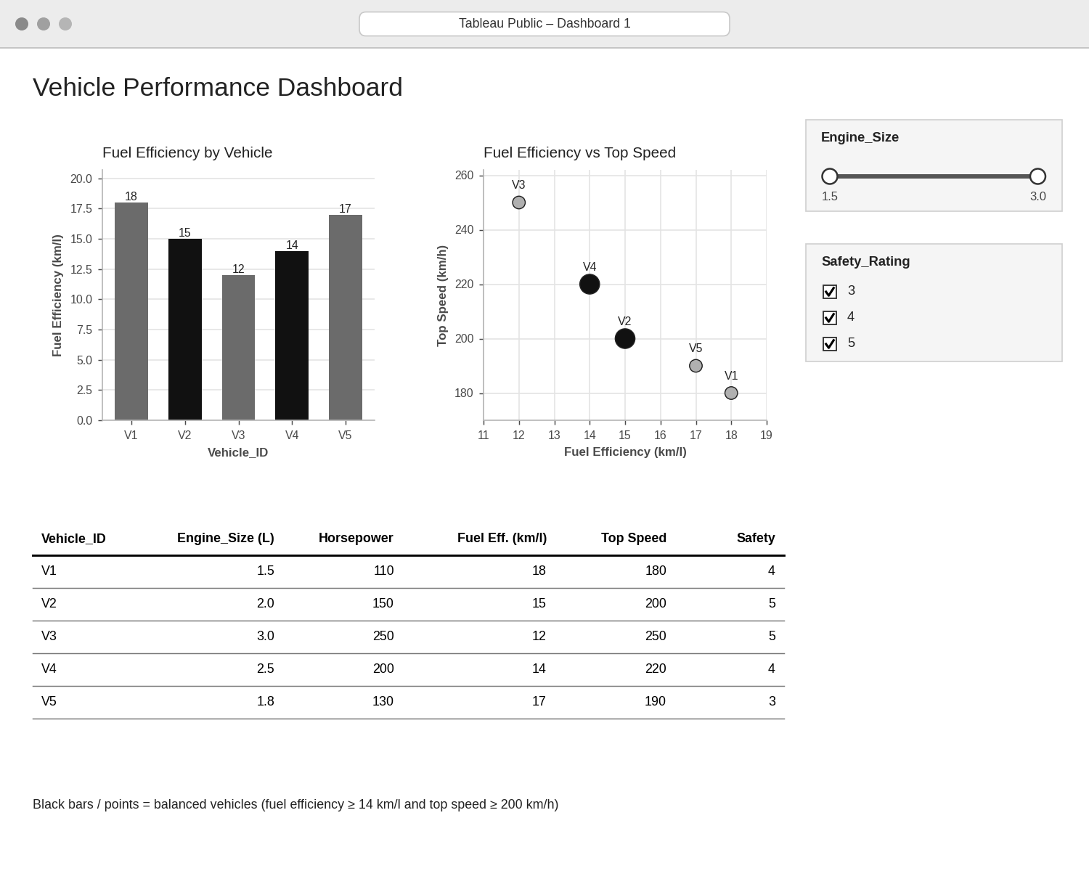
Analytical interpretation: The highlighted (black) vehicles are V2 (15 km/l, 200 km/h) and V4 (14 km/l, 220 km/h): they combine at least 14 km/l with at least 200 km/h. V1 and V5 are the most efficient (18 and 17 km/l) but slow (180–190 km/h), and V3 is the fastest (250 km/h) but the least efficient (12 km/l). The dashboard shows the trade-off between efficiency and speed, and the filters let a buyer restrict the choice by engine size or safety rating. V2 also has the top safety rating (5), making it the best overall balance.
PROCEDURE
- Create the vehicle data frame in R.
- Draw the violin plot of fuel efficiency by safety rating with ggplot2 and geom_violin().
- Draw the scatter plot of horsepower and top speed with a gradient for engine size and calculate the correlation.
- Calculate the correlation matrix with cor() and draw the heatmap with geom_tile().
- In Tableau, build the bar chart and the scatter plot with a Balanced highlight and the Engine_Size and Safety_Rating filters.
- Interpret the relationships between the vehicle variables and the dashboard results.
RESULT
The vehicle data was successfully analysed using a violin plot, a scatter plot, a correlation heatmap and an interactive Tableau dashboard. Top speed is almost perfectly related to horsepower (r ≈ 0.997), and vehicles V2 and V4 give the best balance of fuel efficiency and performance.
KEY FUNCTIONS / TOOLS USED
- ggplot() – Creates the plots (ggplot2 package).
- geom_violin() – Draws the violin plot.
- geom_smooth(method = "lm") – Adds the linear trend line.
- cor() – Calculates the correlation and the correlation matrix.
- geom_tile() / geom_text() – Draw and label the heatmap.
- Tableau Sheets – One worksheet for each chart or table.
- Tableau Dashboard – Combines the sheets with filters for interactive exploration.

